Creating an Invoice: Manual Handout

1. Creating an Invoice: Manual

1.1 Creating an Invoice: Manual
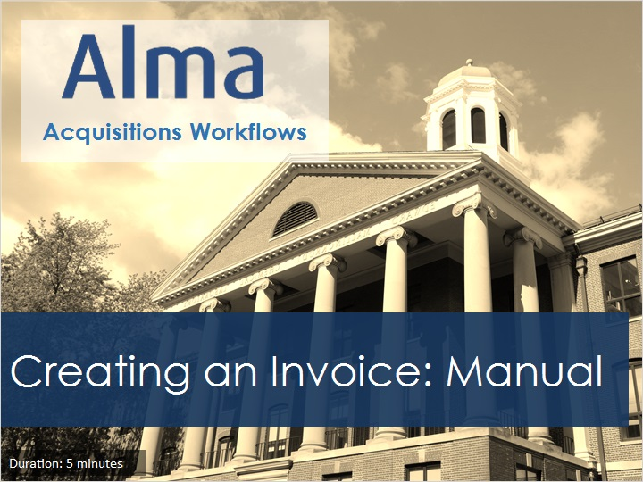
Notes:
Welcome to this tutorial, Creating an Invoice Manually.

1.2 Acquisitions Workflows Tutorials
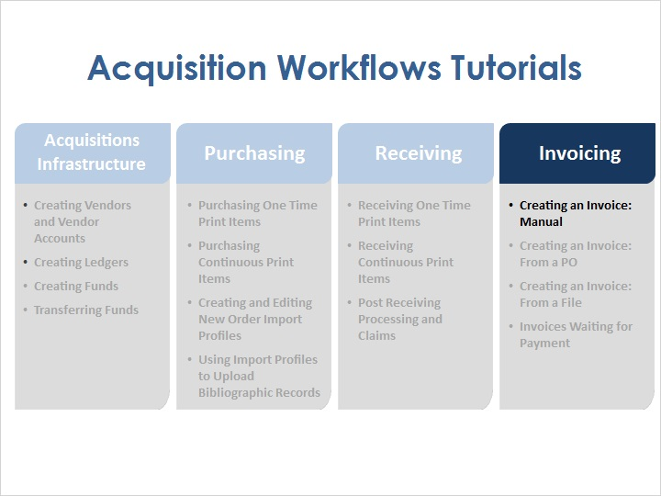
Notes:
Once physical items have been ordered, it is possible to create invoices for items using several different methods: manually, from a purchase order, and from a file. And once the invoices have been created, they enter the Waiting for Payment stage.

1.3 Objectives
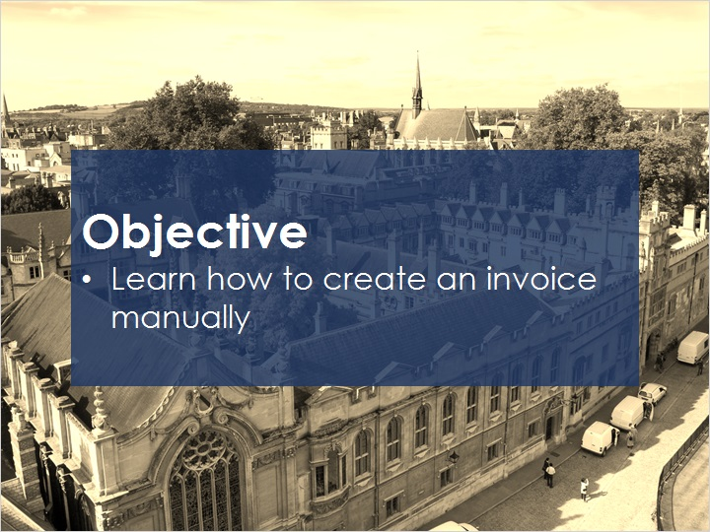
Notes:
In this session, you will learn how to create an invoice manually.

1.4 Creating Invoices Manually
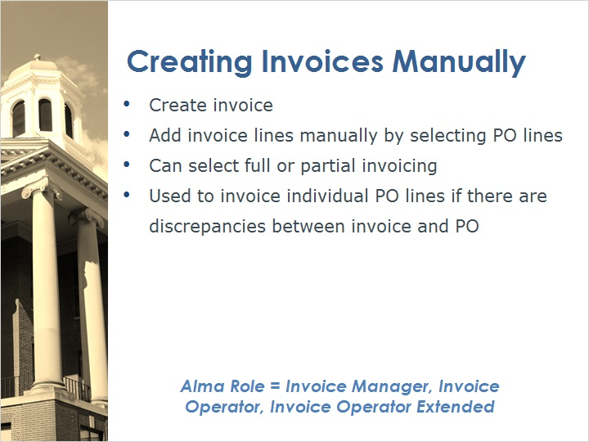
Notes:
When creating invoices manually, we create an invoice and add invoice lines by selecting PO lines.
It is possible to select full or partial invoicing this way, so this method is used to invoice individual PO lines if there are discrepancies between the invoice and the purchase order.
To create invoices, you will need to have an Alma user with the Invoice Manager, Invoice Operator, or Invoice Operator Extended role.

1.5 Accessing Create Invoice
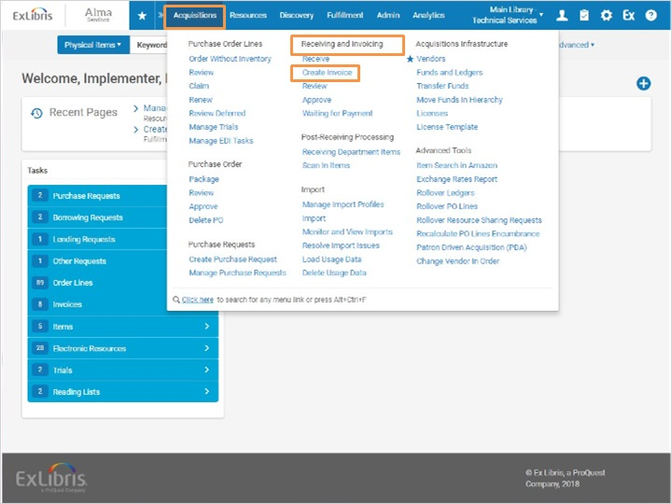
Notes:
To create a manual invoice, go to Acquisitions > Receiving and Invoicing > Create Invoice.

1.6 Select Invoice Creation Process
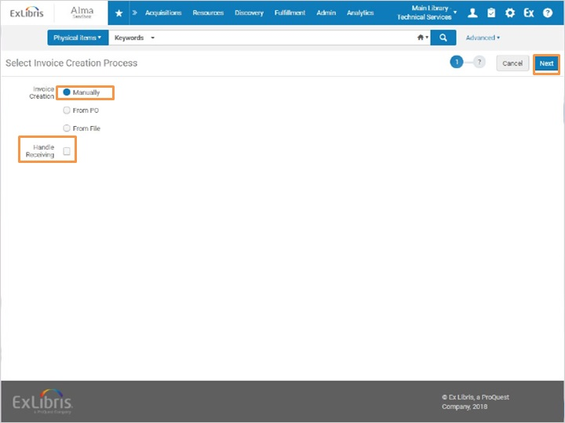
Notes:
Select the option to create the invoice Manually.
Note the Handle Receiving checkbox. Selecting the Handle Receiving checkbox allows receiving to happen immediately after the invoice is created. For this option, you’ll also need to have the Receiving Operator role and ensure that your location is set to the one associated with your Technical Services department. For this example, we will leave this box unchecked.
Let’s click Next to go to the next step.

1.7 Invoice Details
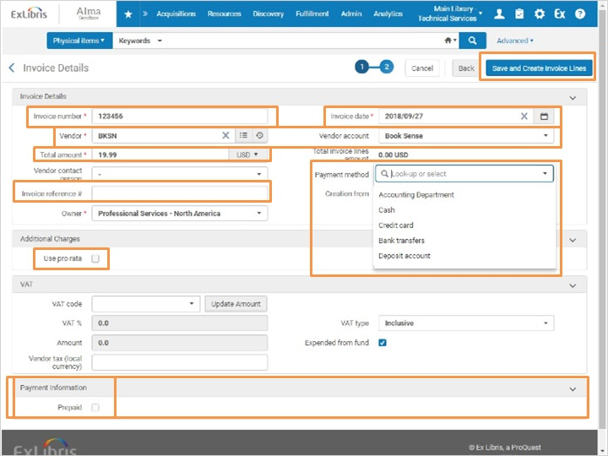
Notes:
This brings us to the Invoice Details page.
We will fill in the Invoice Number, which is provided by the vendor, and select the invoice date.
Then we’ll select our vendor and the vendor account.
Next we’ll enter in the Total Amount for the Invoice. A negative amount can be entered to indicate a credit invoice - for example, if something was overpaid.
The Invoice Reference Number field is an optional reference number for the invoice which can be used to enable grouping of invoices for reporting purposes.
Then select the Payment method. Note that if Accounting Department is selected, you cannot select the Prepaid option at the bottom of the screen.
Select the Uses Pro Rata check box to prorate the additional charges over all invoice lines, so the amounts indicated will be distributed among each of the invoice lines. If you do not select Use pro rata, each additional charge is displayed as an individual invoice line.
The Payment section allows you to indicate whether the invoice is prepaid, or an internal copy created in Alma for reference or tracking purposes. For more information on the options available for configuration in this section, please see the Alma documentation in the Knowledge Center.
Once all invoice details are entered, click the Save and Create Invoice Lines button to go to next step in the invoice creation wizard.

1.8 Add Invoice Line
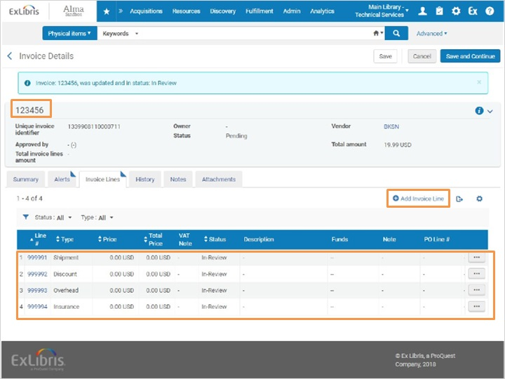
Notes:
The next step is to create invoice lines by selecting PO lines that should be associated with this invoice. We can see our invoice number and the default lines in the invoice for shipping, insurance, overhead and discounts.
I'll click Add Invoice Line to search for and select order lines.

1.9 Select Invoice Lines
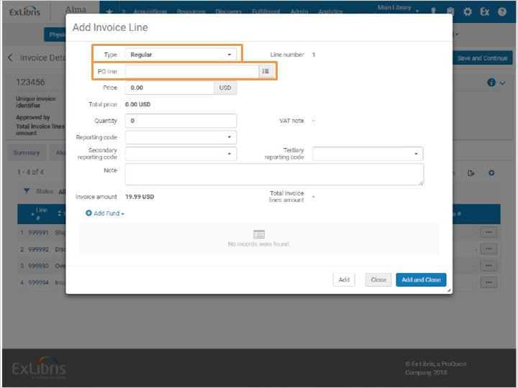
Notes:
This opens a new popup window. We'll select the Invoice Line Type: Regular. Regular refers to regular invoice lines. All other types refer to additional possible charges such as shipping, insurance, overhead and discounts.
In the PO line field, we will enter the PO line number or the title of the item. We could also use the search function to find the Purchase Order and select the desired PO Line. The search results will display active PO Lines that are awaiting an invoice, for the vendor indicated in the invoice.
Once the PO Line is filled in, the rest of the information will automatically appear below.
However, changes can be made if needed - for example, perhaps the amount that was invoiced is different than originally planned, or perhaps the fund needs to change.
Click Add and Close to add the invoice line.

Purchase Order selected (Slide Layer)
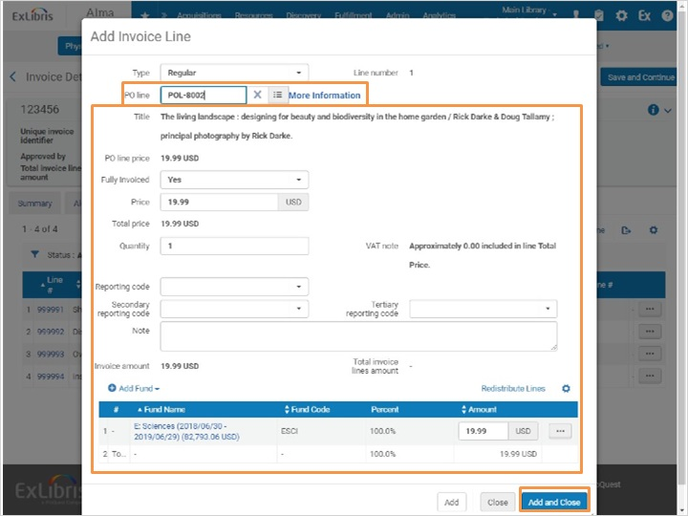

1.10 Save and Continue
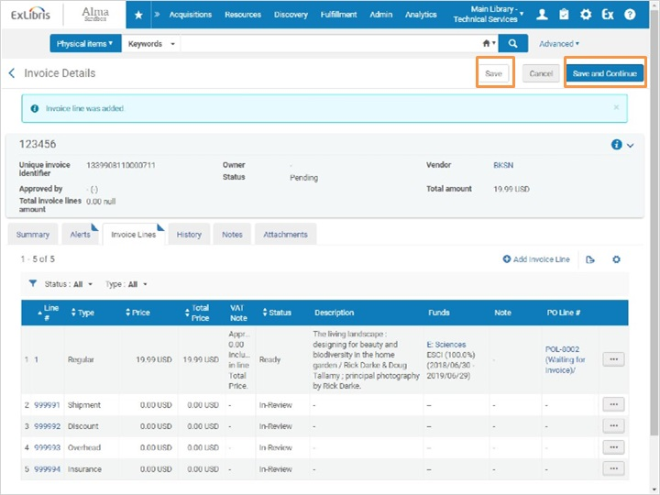
Notes:
Clicking on Save means that the invoice will stay in a Review status. We’d use this option if further editing was needed before the Invoice was ready for processing.

We’re ready to complete the invoice, so we will select Save and Continue to have Alma take the invoice through a validation process to make sure no information is missing.

1.11 Waiting for Approval Invoices
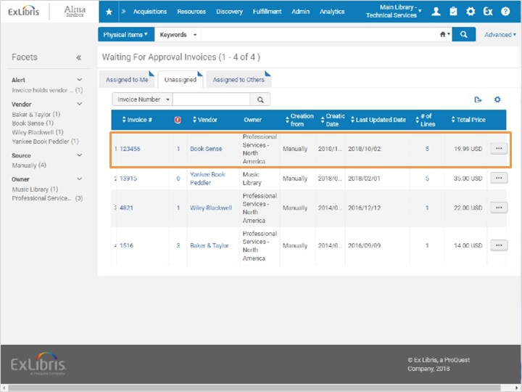
Notes:
This brings us to the Waiting for Approval Invoices screen. Let’s take a look at the details of this invoice now. I’m going to select Edit from the actions list.

Edit Invoice (Slide Layer)
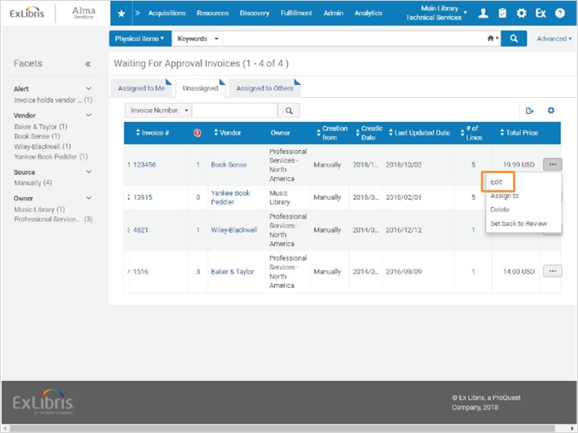

1.12 Select Invoice Type
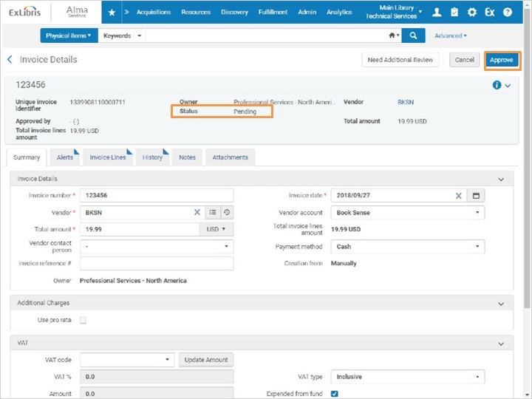
Notes:
Here in the Invoice details screen, we can see the status is pending. I'm going to Approve the invoice.
Once it is approved, we get a confirmation letting us know that it is now waiting for payment.

Approval Confirmed (Slide Layer)
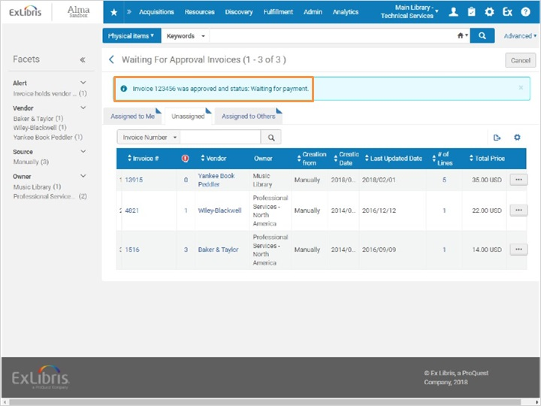

1.13 Review
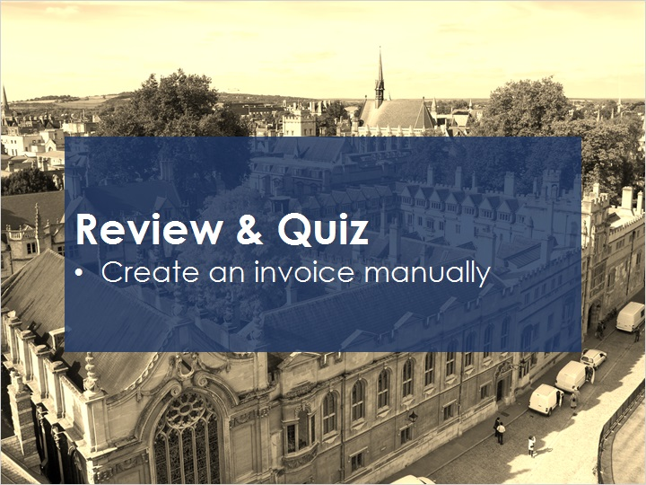
Notes:
Now that you’ve watched this session you should be able to create an invoice manually.

Please take the short quiz to test your knowledge.

1.14 Quiz: Creating an Invoice: Manual
(True/False, 10 points, 1 attempt permitted)
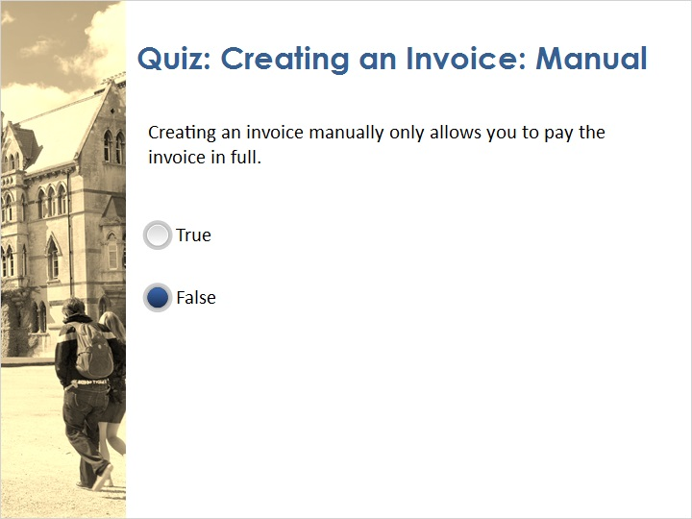
Correct | Choice
 | True
X | False
Feedback when correct:
That's right! When creating an invoice manually, you can select full or partial invoicing. Manual creation allows you to invoice individual PO lines if there are discrepancies between invoice and PO.
Feedback when incorrect:
No sorry, that’s not right. When creating an invoice manually, you can select full or partial invoicing. Manual creation allows you to invoice individual PO lines if there are discrepancies between invoice and PO.

Notes:

Correct (Slide Layer)
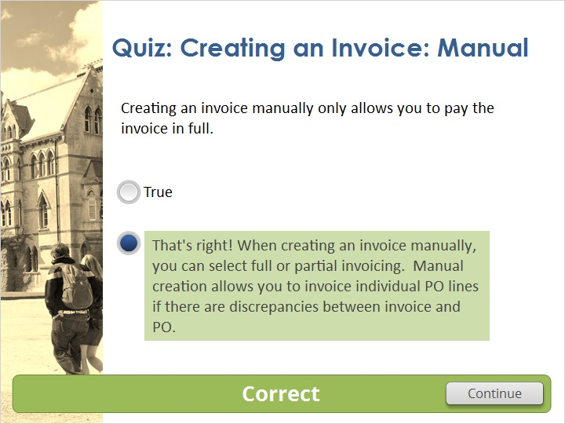

Incorrect (Slide Layer)
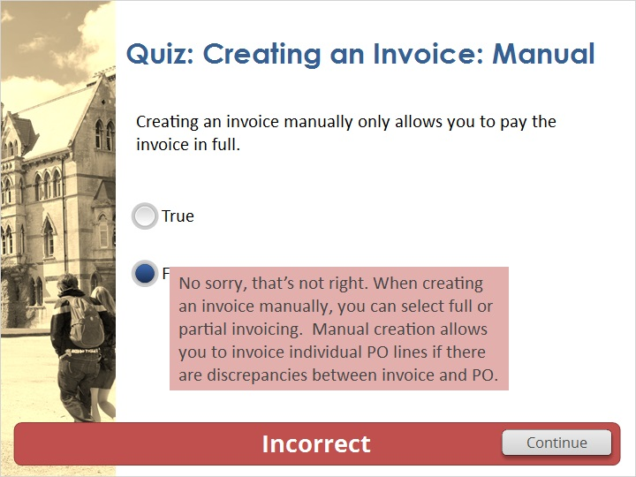

1.15 Thank You!

Notes:
Thank you for joining this session!

1.16 Copyrights

Notes:

2. Quiz Results

2.1 Results Slide
(Results Slide, 0 points, 1 attempt permitted)
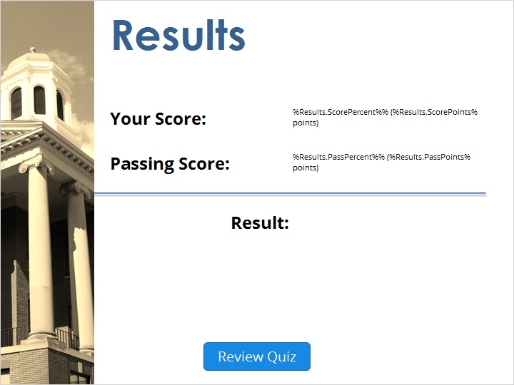

Notes:
fgsfdgsfdgfdg

Success (Slide Layer)
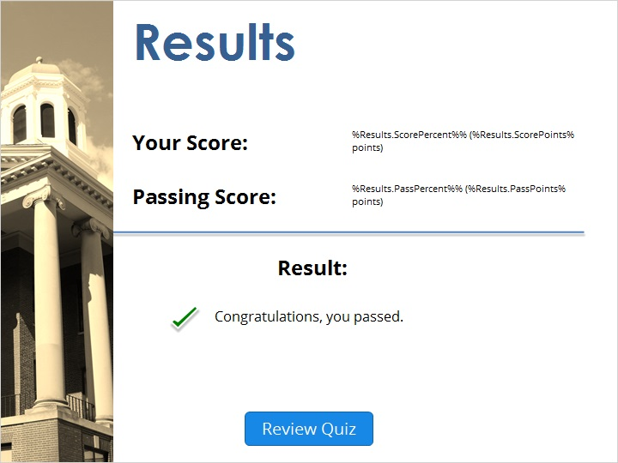

Failure (Slide Layer)


