Creating an Invoice: From File Handout

1. Creating an Invoice: From File

1.1 Creating an Invoice: From File
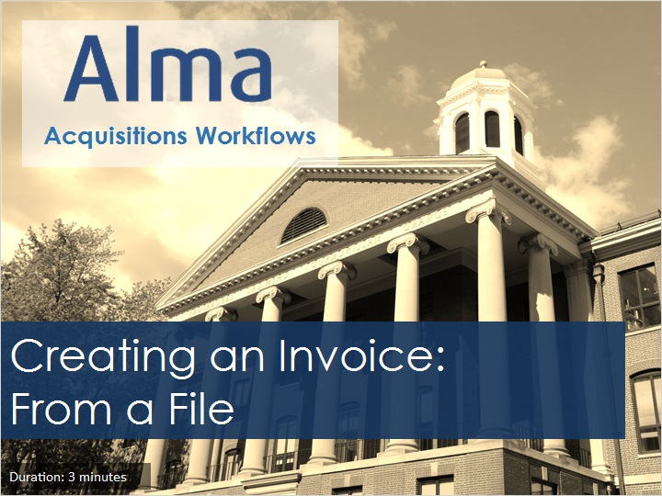
Notes:
Welcome to this tutorial, Creating an Invoice From a File.

1.2 Acquisitions Workflows Tutorials
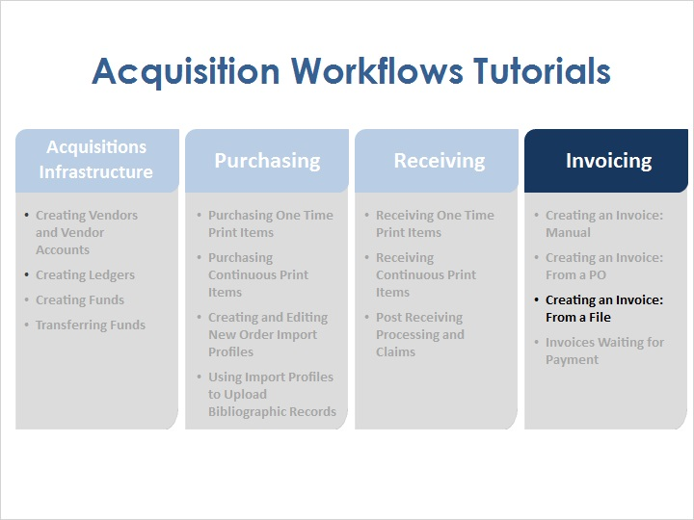
Notes:
Once physical items have been ordered, it is possible to create invoices for items using several different methods: manually, from a purchase order, and from a file. And once the invoices have been created, they enter the Waiting for Payment stage.

1.3 Objectives
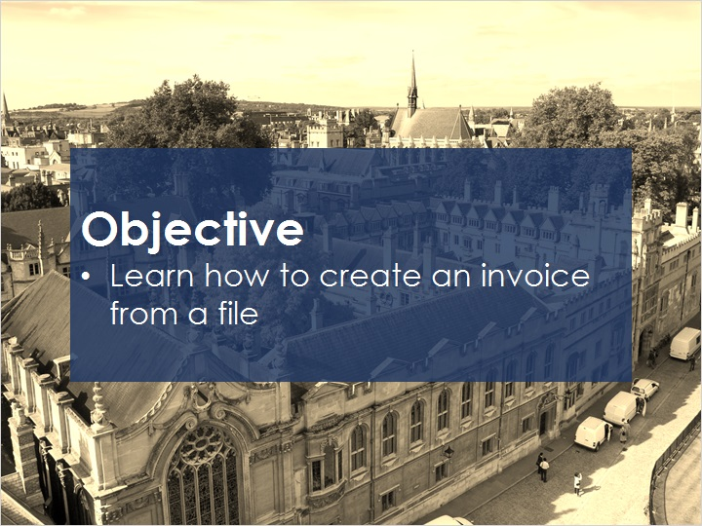
Notes:
In this session, you will learn how to create an invoice from a file.

1.4 Creating Invoices Manually
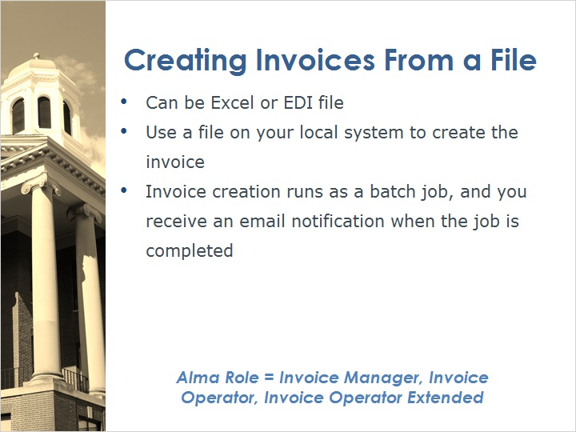
Notes:
When creating invoices from a file, we use either an Excel file or an Electronic Data Interchange, or EDI file. This invoice creation method relies on a file that is on your local system to create the invoice. It is also possible to set up a process with a vendor to automatically create invoices using EDI, but that method is not covered in this session.
After the file is uploaded, an invoice creation process runs as a batch job, and if configured, we would receive an email notification when the job is complete.
To create invoices by file upload, you will need to have an Alma user with the Invoice Manager, Invoice Operator, or Invoice Operator Extended role.

1.5 Accessing Create Invoice
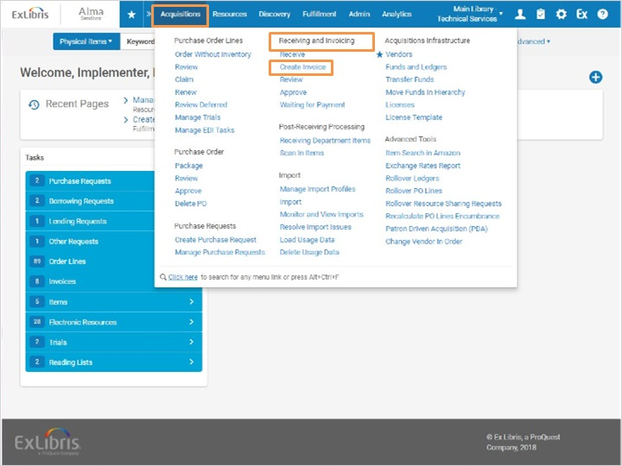
Notes:
To create an invoice using a file, go to Acquisitions > Receiving and Invoicing > Create Invoice.

1.6 Select Invoice Creation Process
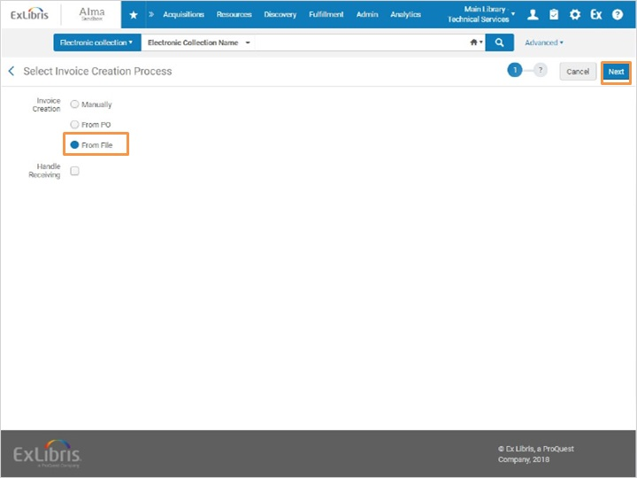
Notes:
Select the option to create the invoice From a File.
Then click Next to go to the next step.

1.7 Upload file
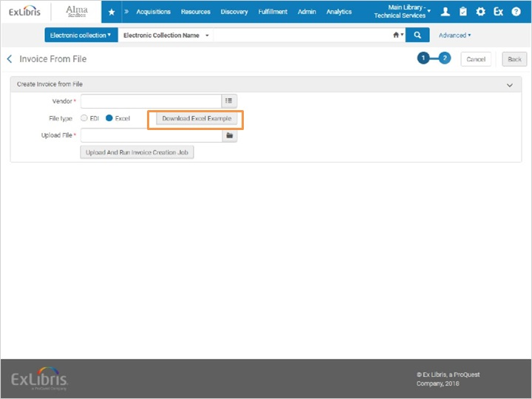
Notes:
This brings us to the Invoice From File screen where we can select the vendor and file to upload. By clicking on the Download Excel Example button, we can get a sample file to base our format on.

1.8 Parameters selected
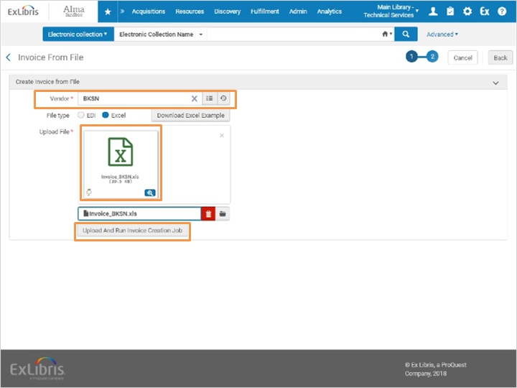
Notes:
Here we have our vendor filled in, and our file selected. To continue, we’d click the Upload and Run Invoice Creation Job button.

1.9 Run Batch Job
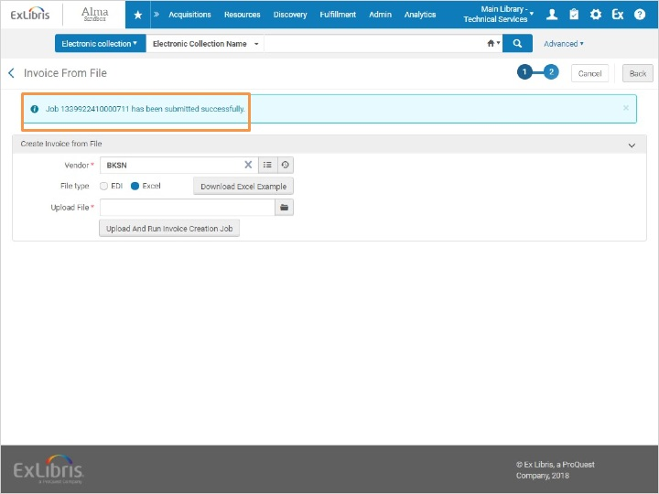
Notes:
Once the job has been submitted, a confirmation message appears.

1.10 Monitor Job
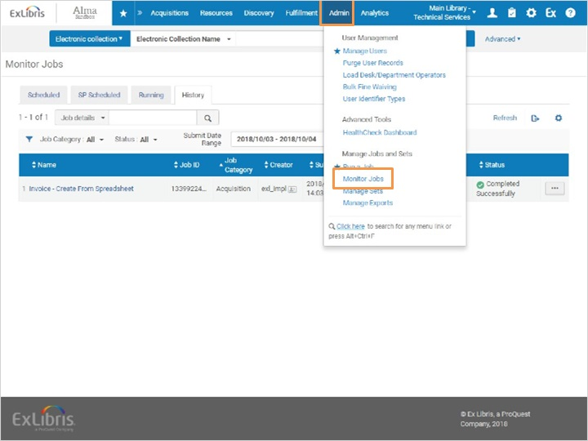
Notes:
If we go to Admin > Monitor jobs, we can check on the status of the job, and see that it has run successfully.

Completed Successfully (Slide Layer)
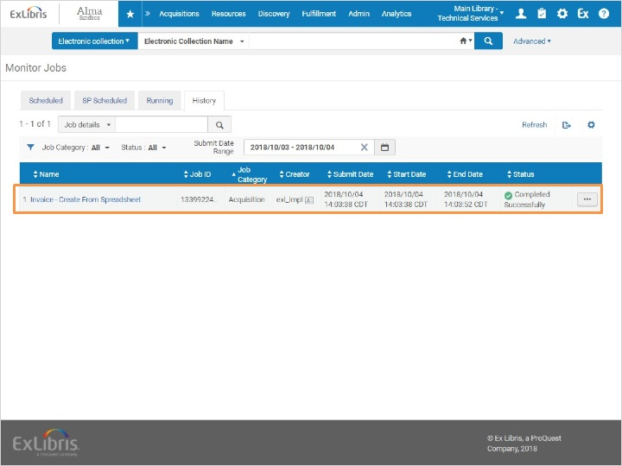

1.11 Review Invoice
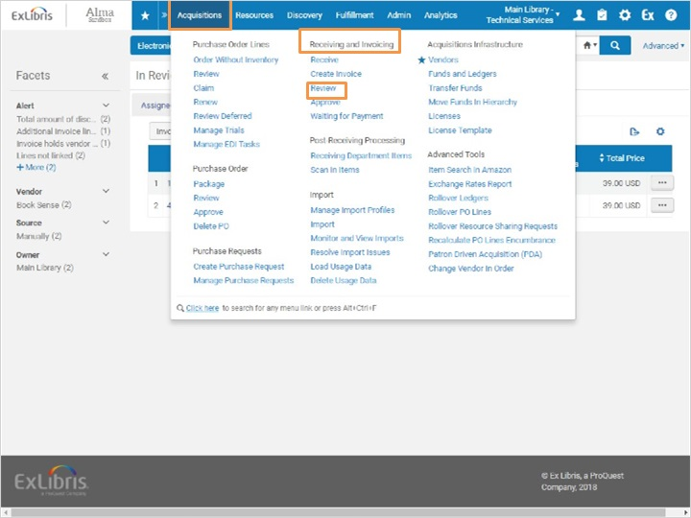
Notes:
If we go to Acquisitions > Receiving and Invoicing > Review, we can edit the invoice. Here we make adjustments if needed, then click save and continue to submit the invoice for approval.

In Review Invoices (Slide Layer)
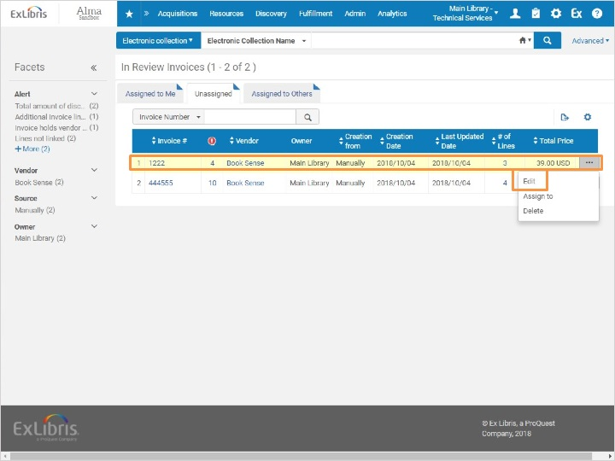

Invoice Details (Slide Layer)
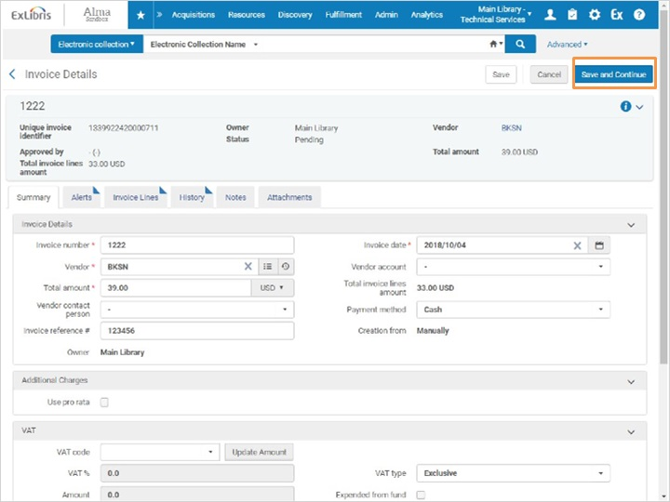

1.12 Review
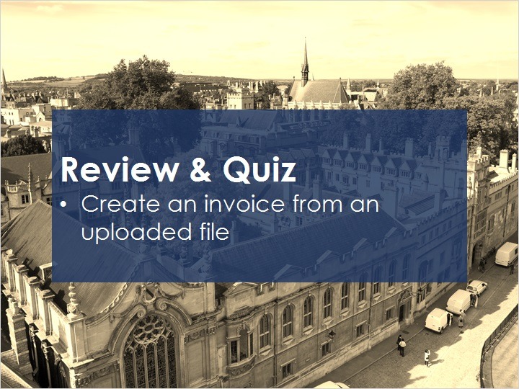
Notes:
Now that you’ve watched this session you should be able to create an invoice from an uploaded file.

Please take the short quiz to test your knowledge.

1.13 Quiz: Creating an Invoice: From File
(True/False, 10 points, 1 attempt permitted)
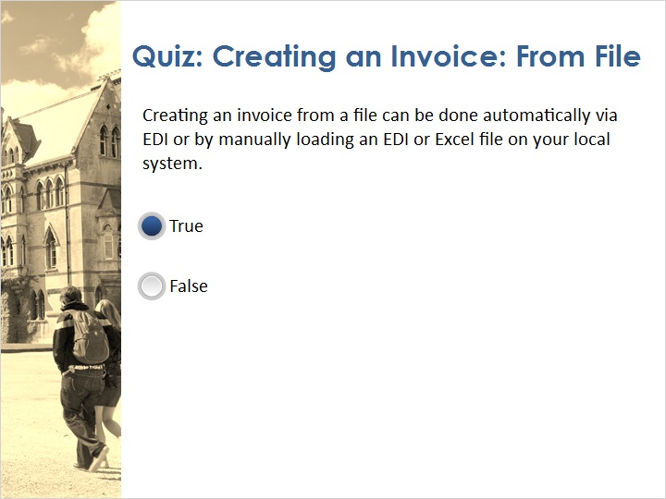
Correct | Choice
X | True
 | False
Feedback when correct:
That's right! Creating an invoice from a file can be done automatically via EDI or by manually loading an EDI or Excel file on your local system.
Feedback when incorrect:
No sorry, that’s not right. Creating an invoice from a file can be done automatically via EDI or by manually loading an EDI or Excel file on your local system.

Notes:

Correct (Slide Layer)
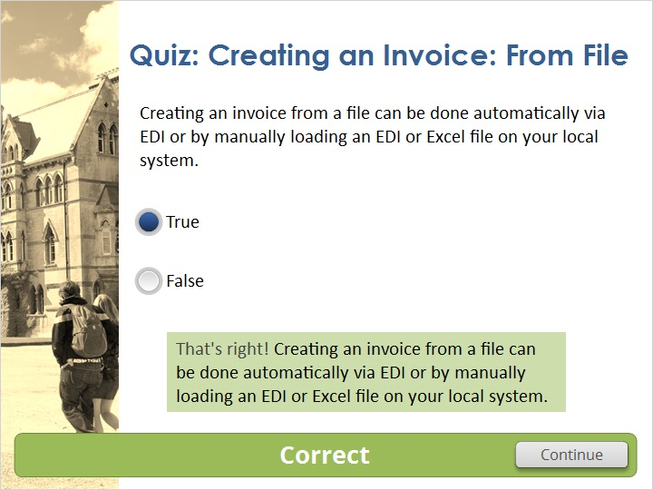

Incorrect (Slide Layer)
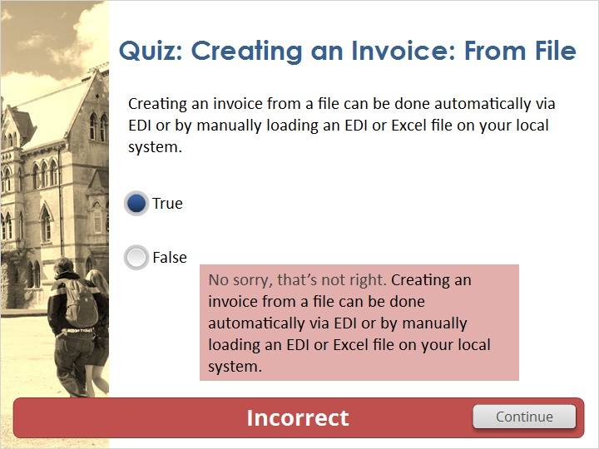

1.14 Thank You!

Notes:
Thank you for joining this session!

1.15 Copyrights

Notes:

2. Quiz Results

2.1 Results Slide
(Results Slide, 0 points, 1 attempt permitted)
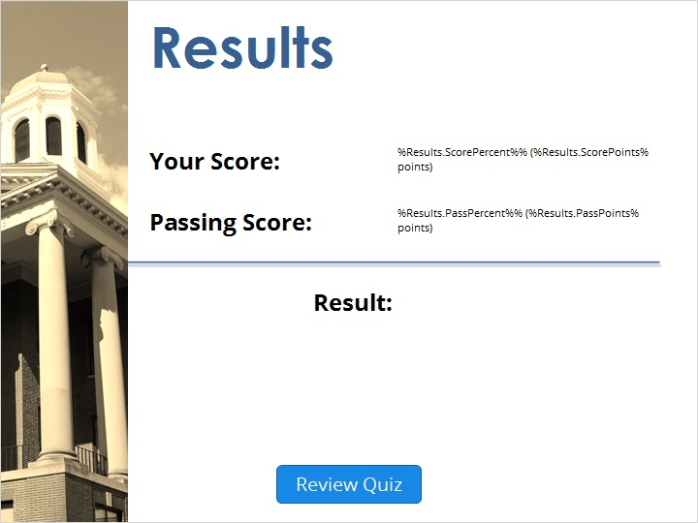

Notes:
fgsfdgsfdgfdg

Success (Slide Layer)
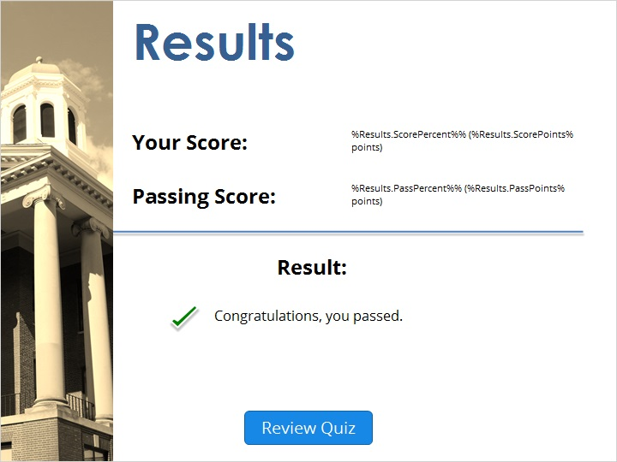

Failure (Slide Layer)


