Invoices Waiting for Payment Handout

1. Invoices Waiting For Payment

1.1 Invoices Waiting For Payment
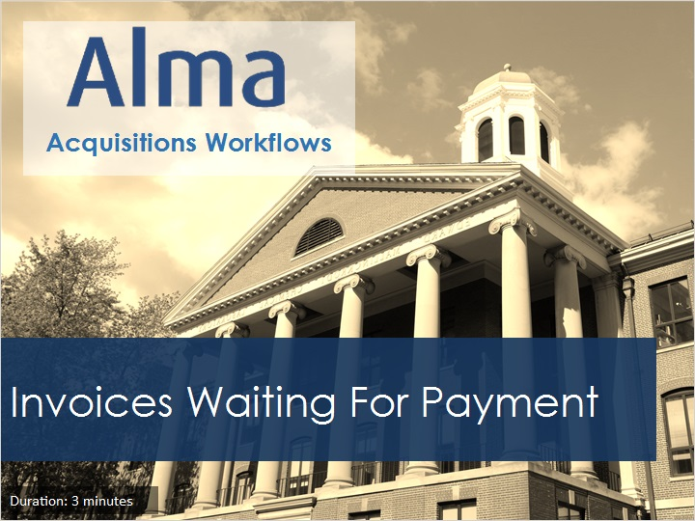
Notes:
Welcome to this tutorial, Invoices Waiting for Payment.

1.2 Acquisitions Workflows Tutorials
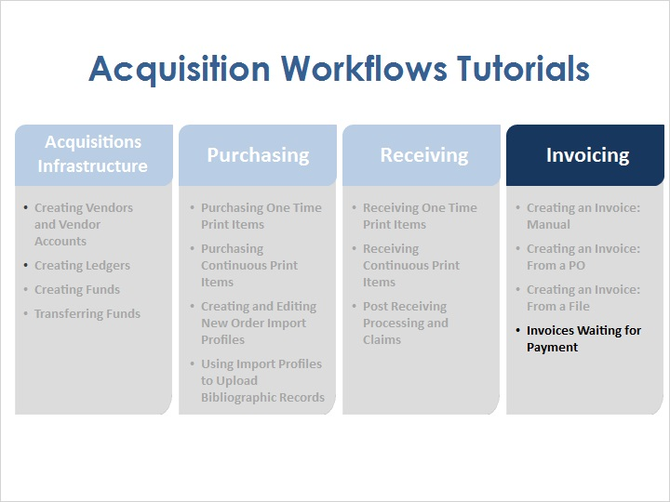
Notes:
Once physical items have been ordered, it is possible to create invoices for items using several different methods: manually, from a purchase order, and from a file. And once the invoices have been created, they enter the Waiting for Payment stage.

1.3 Objectives
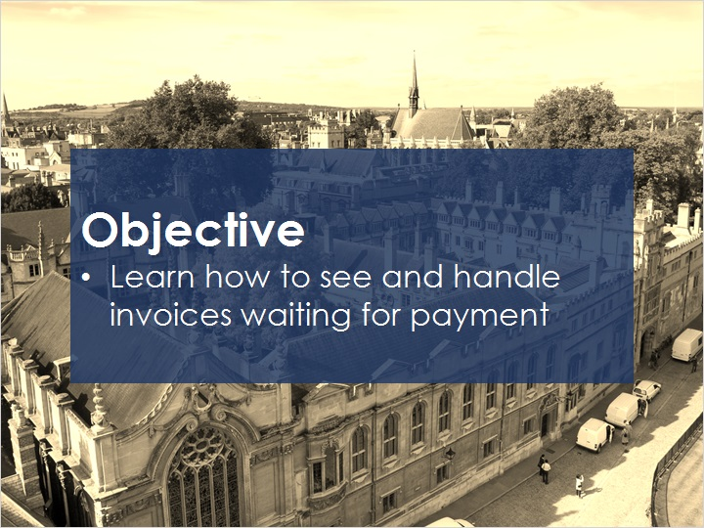
Notes:
In this session, you will learn how to see and handle invoices waiting for payment.

1.4 Invoices Waiting for Payment
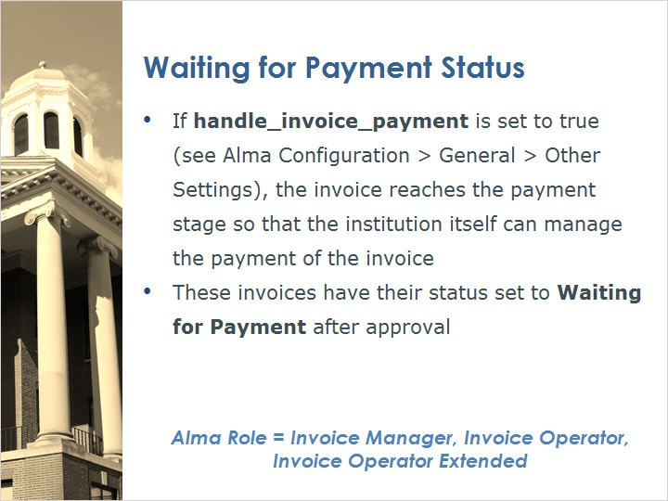
Notes:
In Alma’s configurations, there is a parameter under General > Other settings called handle_invoice_payment. When this parameter is set to true, the invoice reaches the payment stage so that the institution itself can manage the payment of the invoice. These invoices have their status set to Waiting for Payment after they are approved.
To work with invoices that will have the status of waiting for payment, you will need to have an Alma user with the Invoice Manager, Invoice Operator, or Invoice Operator Extended role.

1.5 Accessing Create Invoice
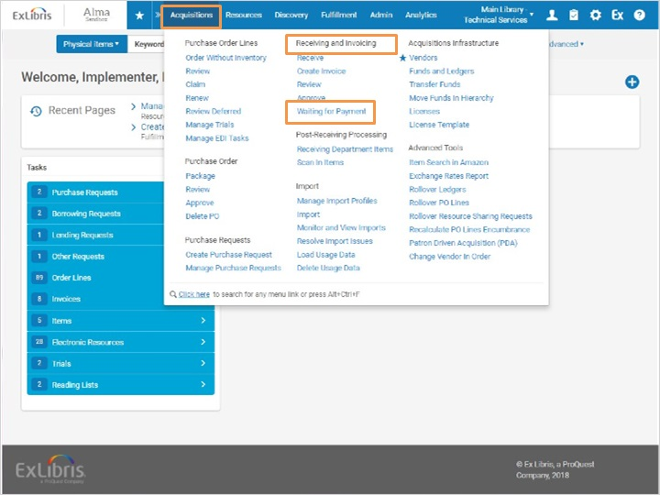
Notes:
To create a manual invoice, go to Acquisitions > Receiving and Invoicing > Waiting for Payment.

1.6 Waiting for Payment Invoices
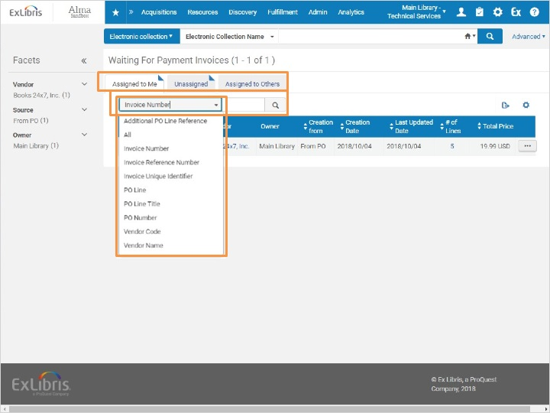
Notes:
This brings us to the Waiting for Payment Invoices screen. Note the three tabs - Assigned to Me, Unassigned, and Assigned to Others. We will stay on the Assigned to Me tab, but if we had not started working with the invoice yet, it would first appear on the Unassigned tab.
If we needed to search for an invoice at any stage of the workflow, we would use the Quick search box and search by the Invoice Number or other criteria available in the dropdown.

1.7 Edit Invoice
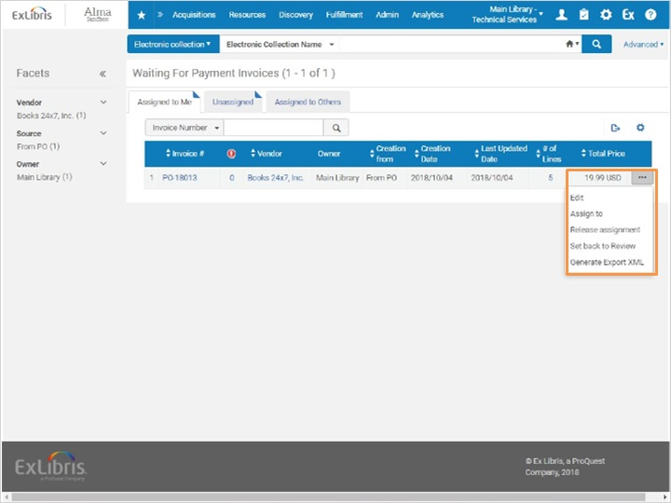
Notes:
Let’s select edit from the row actions list to start working with this invoice.

1.8 Accessing Waiting For Payment Screen
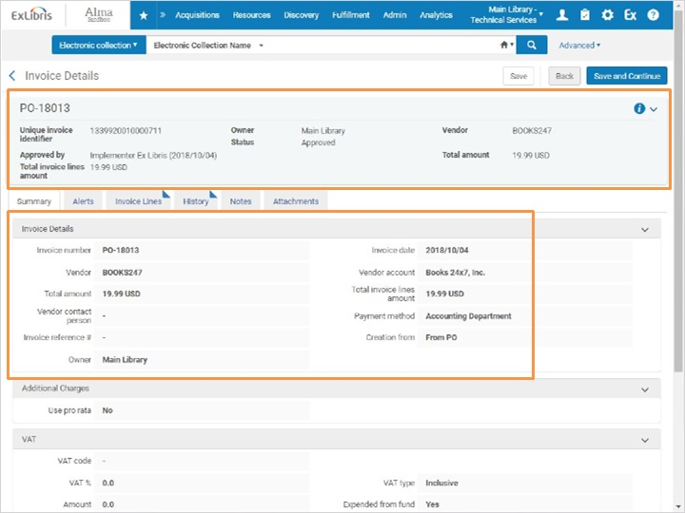
Notes:
Here we have the Invoice Details. We can see the Invoice number, the total amount, and the current status, which is approved. We can also see more detail in the Summary tab. If we scroll down the page, we can see the Payment Information section.

Scroll down (Slide Layer)
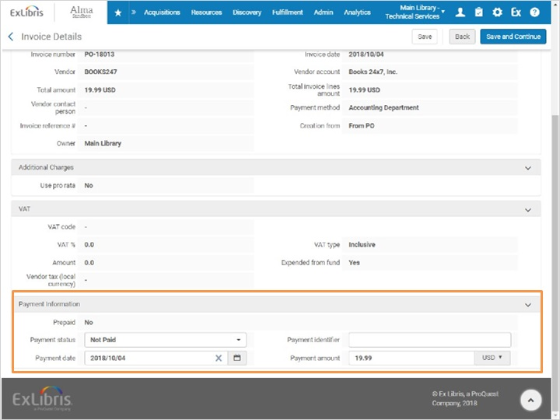

1.9 Entering Payment Information Manually
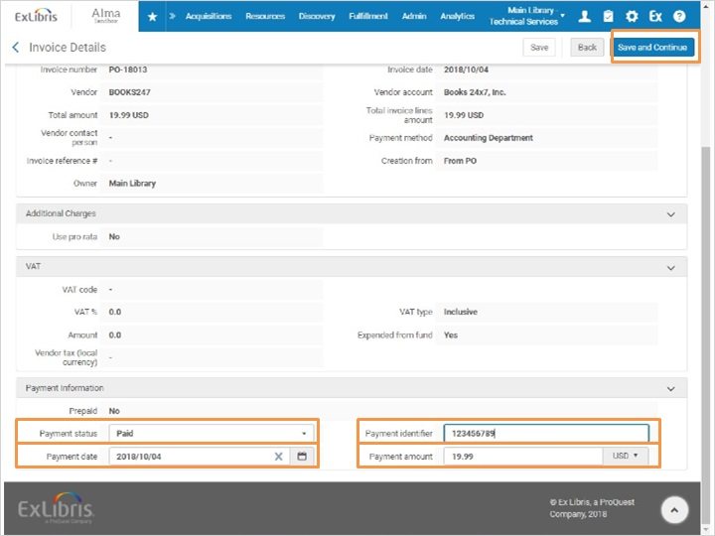
Notes:
Here in the Payment information section, we will change the payment status to Paid, and enter in the Payment Date. The Payment Identifier is the reference number for the payment, such as an invoice or check number. When you work with an integrated external system, this field could contain an external reference number from the ERP system. Then we confirm the amount is correct, and select Save and Continue.

1.10 Waiting for Payment Queue
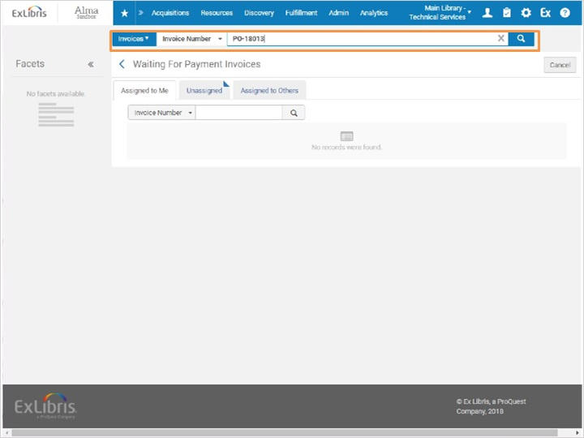
Notes:
We are brought back to the Waiting for Payment screen, and now the Invoice we were working with is no longer here. Let’s search for the Invoice to confirm its current status.

1.11 Invoice Closed
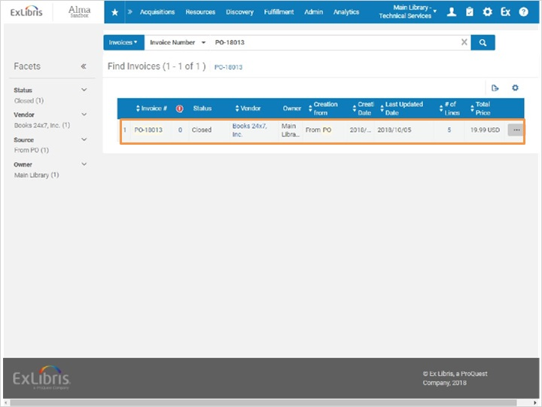
Notes:
And here’s the invoice, with the status now set to Closed.

1.12 Review
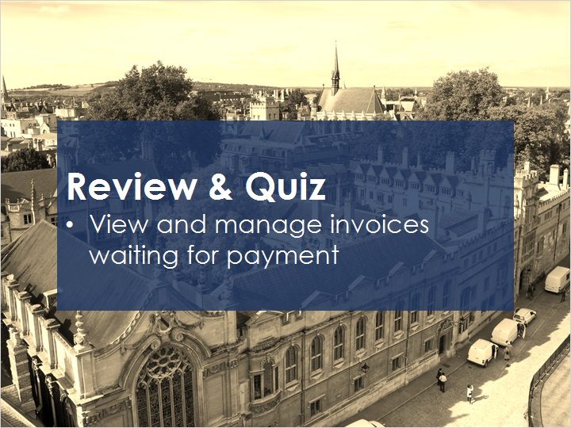
Notes:
Now that you’ve watched this session you should be able to view and manage invoices waiting for payment.

Please take the short quiz to test your knowledge.

1.13 Quiz: Creating an Invoice: Waiting for Payment
(True/False, 10 points, 1 attempt permitted)
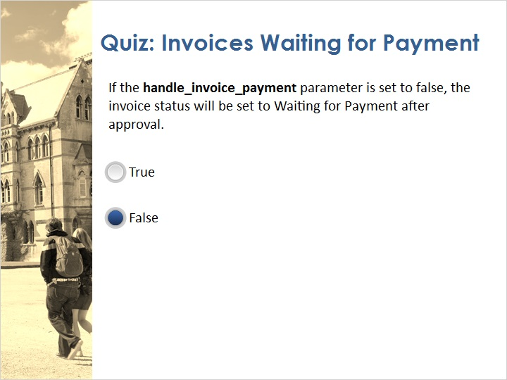
Correct | Choice
 | True
X | False
Feedback when correct:
That's right! If the handle_invoice_payment parameter is set to true, the invoice status will be set to Waiting for Payment after approval.
Feedback when incorrect:
No sorry, that’s not right. If the handle_invoice_payment parameter is set to true, the invoice status will be set to Waiting for Payment after approval.

Notes:

Correct (Slide Layer)
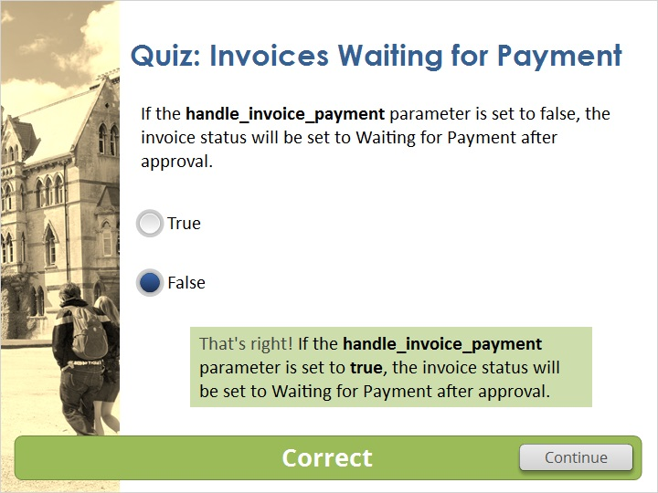

Incorrect (Slide Layer)
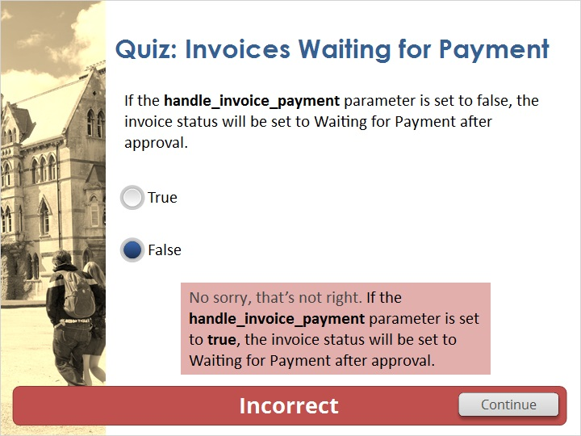

1.14 Thank You!

Notes:
Thank you for joining this session!

1.15 Copyrights

Notes:

2. Quiz Results

2.1 Results Slide
(Results Slide, 0 points, 1 attempt permitted)
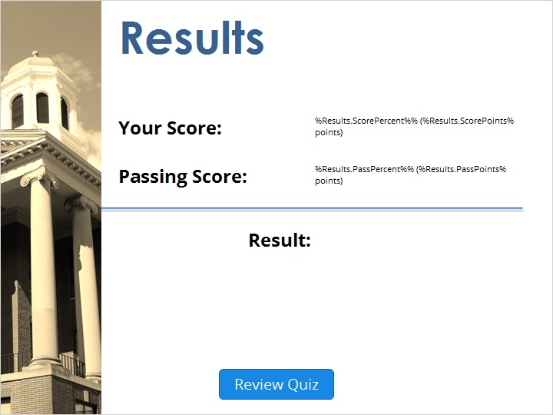

Notes:
fgsfdgsfdgfdg

Success (Slide Layer)
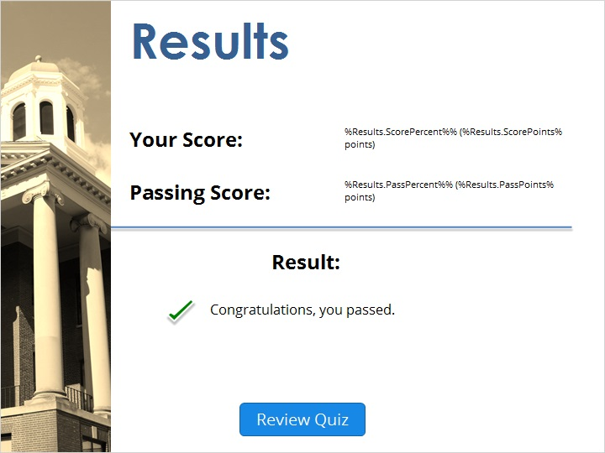

Failure (Slide Layer)


