Starting and Managing Trials in Alma

1. Starting and Managing Trials in Alma

1.1 Starting and Managing Trials in Alma

Notes:
Welcome to this session for Electronic Resources Management, where we’ll discuss how to start and manage trials in Alma.

1.2 Objectives
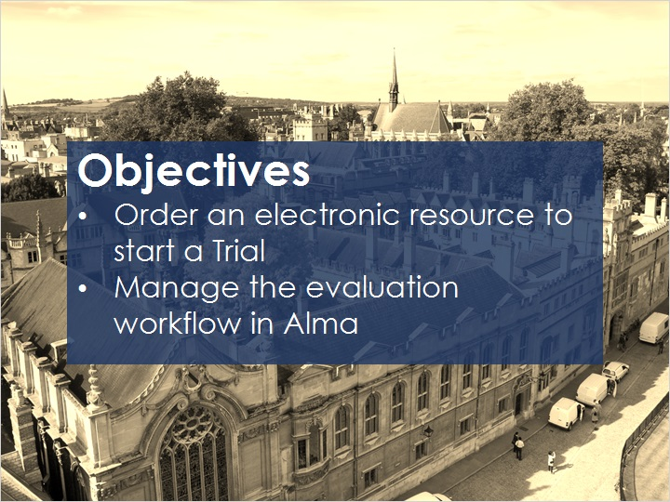
Notes:
In this training session, you’ll learn how to start a trial by creating a PO Line, and how to manage the evaluation workflow.

1.3 Setting up a Trial
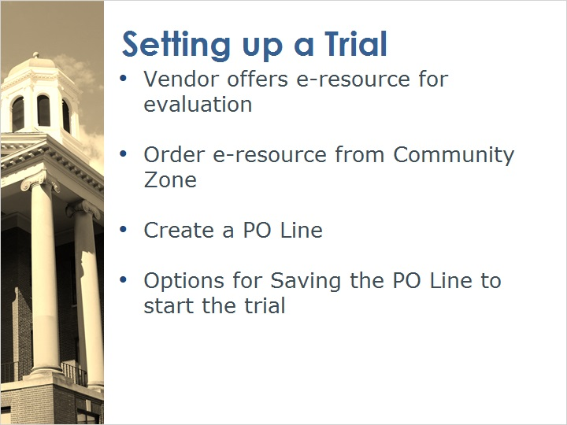
Notes:
Vendors offer electronic resources for evaluation, and as part of Alma’s evaluation workflow, a trial can be set up to manage the evaluation process and gather feedback to help with purchasing decisions.

To set up a trial, find the electronic resource for evaluation in the Community Zone and click “Order” to create a PO Line. **Complete the PO Line details as you would when ordering other electronic resources.

Once the PO Line is complete, there are two options for saving the PO Line to start the trial. The options available depend upon the roles assigned to your user.

A Purchasing Operator without a Trial Operator or Manager role can only save the PO line with the option “Save and Request Evaluation.” The PO line status is set to “under evaluation”, and a task is created on the Manage Trials page. A user with the role of Trial Manager or Operator can access the Manage Trials page and start the trial.

A Purchasing Operator who also has a Trial Operator role, can create a PO Line and will have the option to “Save and Start Trial.” Once again, the PO Line’s status is set to “under evaluation” but this time the Trial Details page will open for editing.

PO Line Saving Options (Slide Layer)
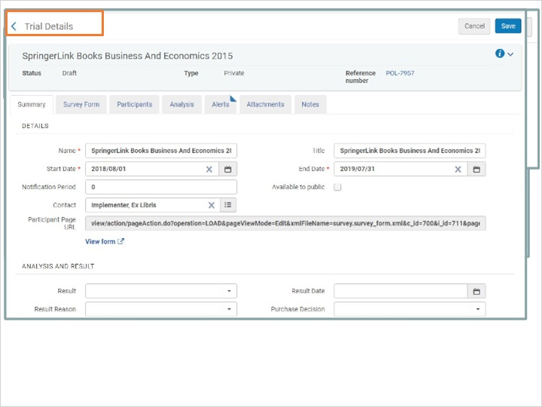

1.4 Manage Trials Summary
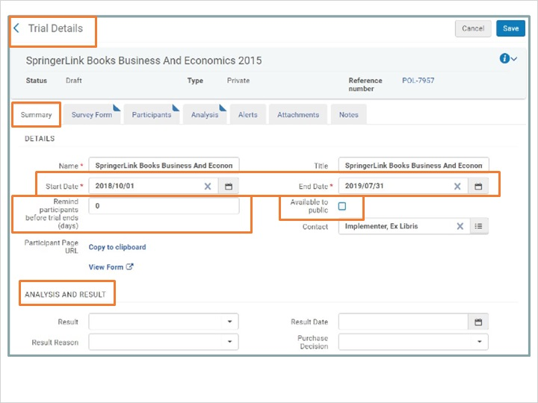
Notes:
When the trial details page opens, update information under the Summary tab, including the Start and End dates for the trial and decide if the trial will be private or open to the public by activating the Available to Public checkbox.
Enter the number of days before the trial is scheduled to end, to have an email sent to participants reminding them to complete their evaluation.
The Analysis and Results area at the bottom of the form can be completed by a Trial operator or manager as evaluation results become available.
On the Survey Form tab, add questions from a pre-configured list or add your own.
You can designate a question as mandatory and comments may be added as well.

Manage Trials -Survey Form (Slide Layer)
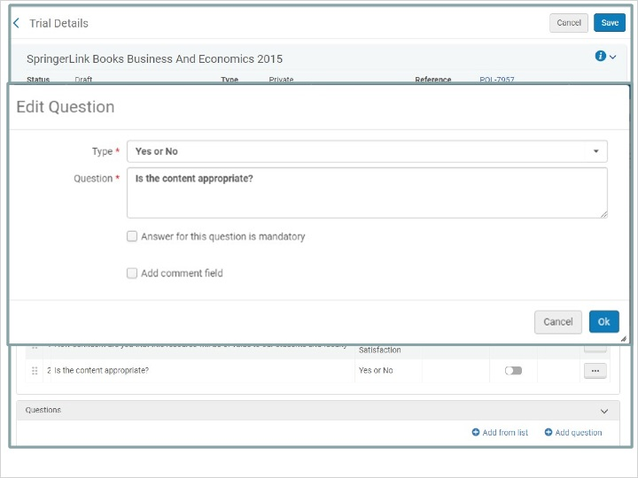

1.5 Manage Trials Participants
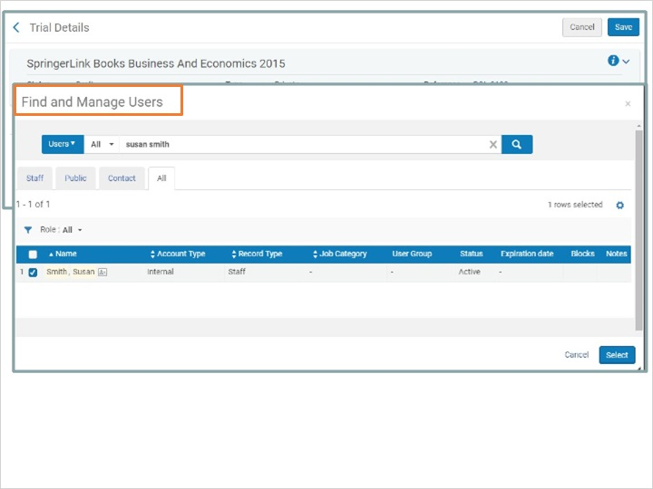
Notes:
Under the trial participants tab you can add multiple participants by creating a set of users in Alma and uploading the list from the Add from Set link.
Click the Add Participants link to add individual names from the Find and Manage Users page.
When the summary, survey form and participants tabs have been completed, click Save. The trial will remain in Draft status until the electronic resource is activated which is the next step in the trial setup process.

Trial Details- Save (Slide Layer)
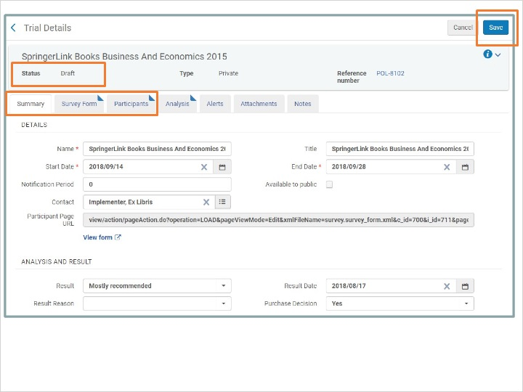

1.6 Activate the Trial
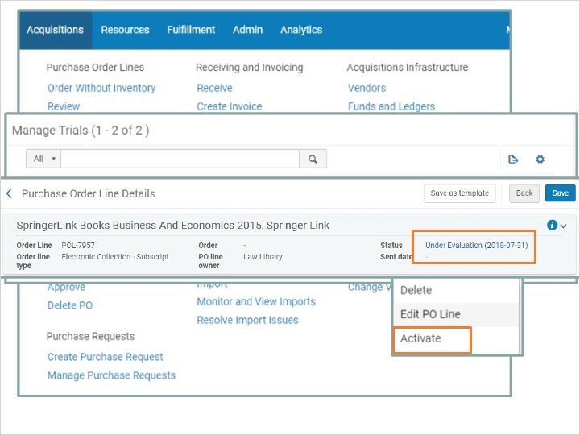
Notes:
Under the Acquisitions Menu, click on Manage Trials; when the page opens, choose Activate from the row actions.
Activate the electronic resource as you would any other electronic resource.
Once the electronic resource is activated, trial participants are notified that the trial has started. Participants won’t see the trial until the collection is activated.
The PO Line status will remain as “under evaluation” until a purchasing decision is made.

1.7 Trial Analysis
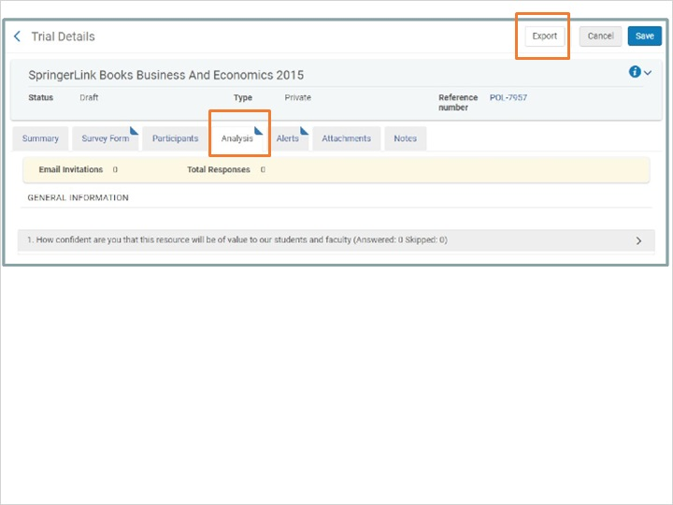
Notes:
Trial participants should submit their feedback to the trial operator before the trial’s end date.
When the trial ends, the trial operator can evaluate feedback which is recorded under the Analysis tab, the results can also be downloaded to Excel.
The trial operator will review the results and make the purchasing decision.
If no decision is made, the trial can remain on the manage trials page.
If the decision is not to purchase, a purchasing operator can cancel the PO Line.
If the decision is made to purchase- the PO Line continues to the next step of the purchasing workflow where it is packaged into a purchase order.

Purchasing Decisions (Slide Layer)
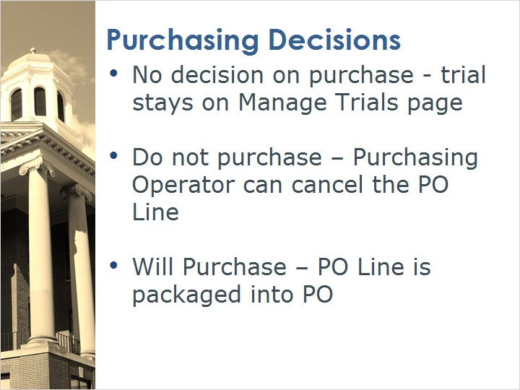

1.8 Review
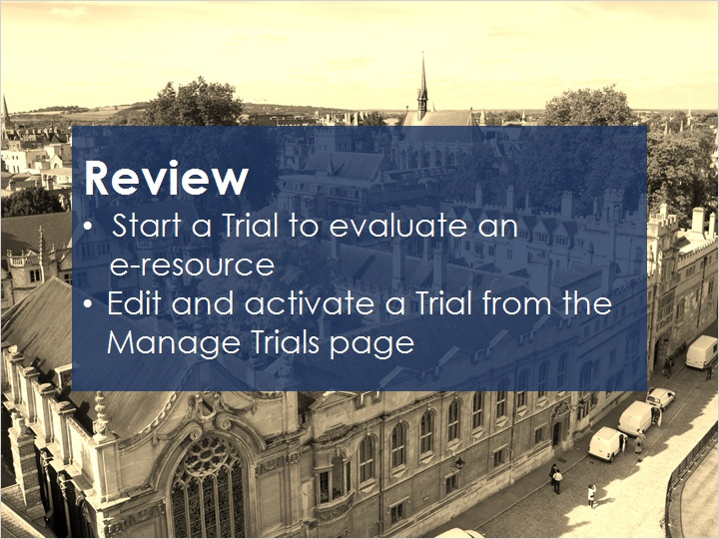
Notes:
Now that you’ve watched this session you should be able to start a trial or request the start of a trial, after a PO Line has been created. If you have a Trial operator role, you’ll also be able to edit and activate the trial details from the Manage Trials page.

After a short quiz that begins on the next page, you can practice this workflow in Alma, review any recommended articles and continue on to additional training sessions.

1.9 Quiz: Survey Questions
(True/False, 10 points, 1 attempt permitted)
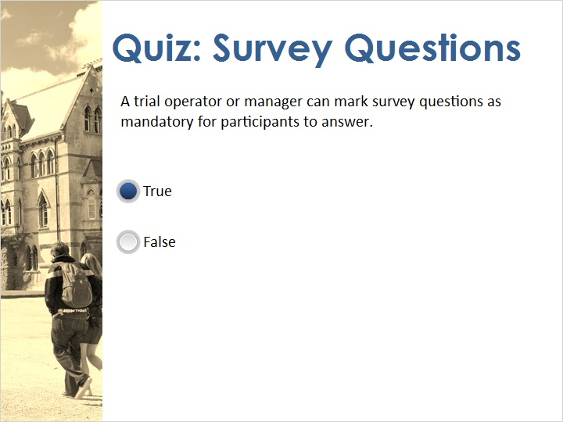
Correct | Choice
X | True
 | False
Feedback when correct:
That's right! The trial operator / manager can designate survey questions as mandatory.
Feedback when incorrect:
No sorry, that’s not right. The trial operator / manager can designate survey questions as mandatory.

Notes:

Correct (Slide Layer)
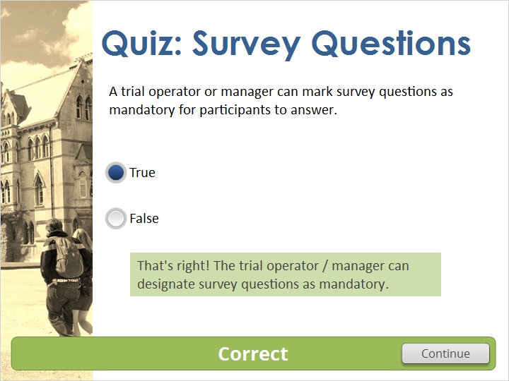

Incorrect (Slide Layer)
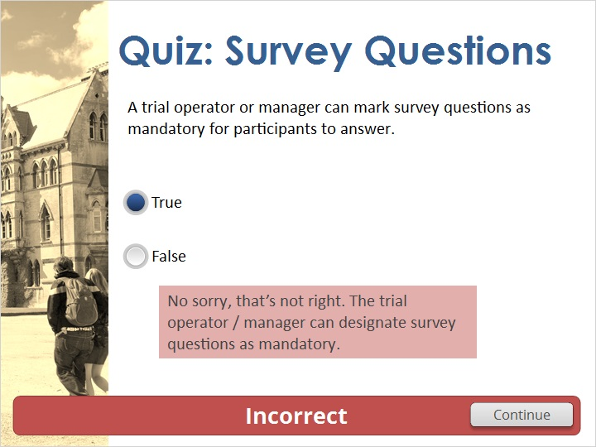

1.10 Quiz: User Roles & Trials
(Multiple Response, 10 points, 1 attempt permitted)
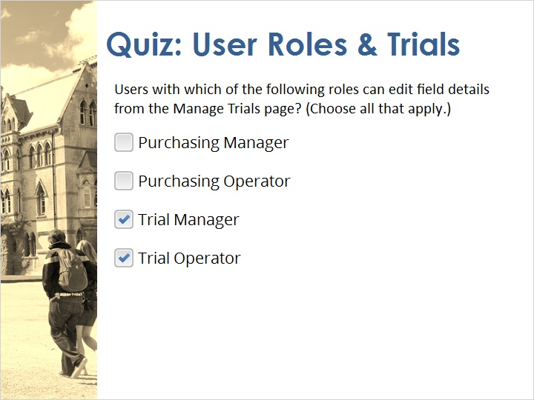
Correct | Choice
 | Purchasing Manager
 | Purchasing Operator
X | Trial Manager
X | Trial Operator

Correct (Slide Layer)
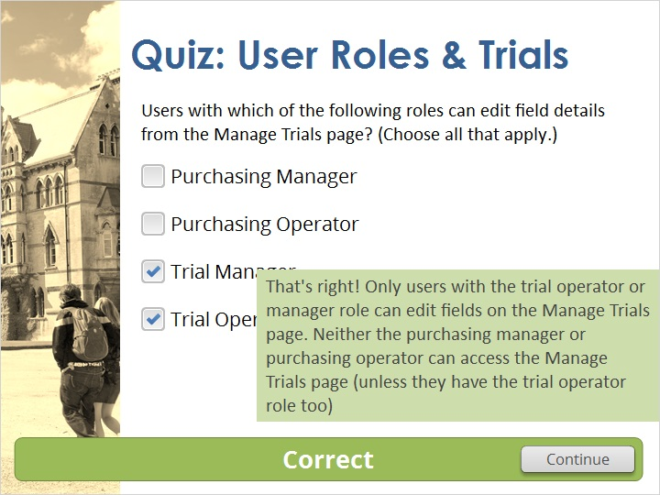

Incorrect (Slide Layer)
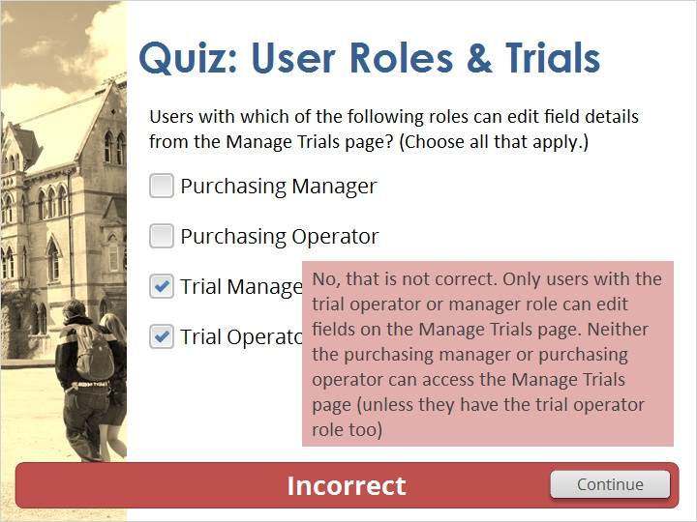

1.11 Thank You!

Notes:
Thanks for joining!

1.12 Copyrights
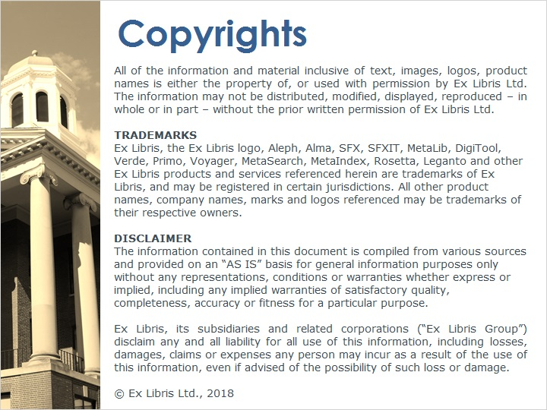
Notes:

2. Quiz Results

2.1 Results Slide
(Results Slide, 0 points, 1 attempt permitted)
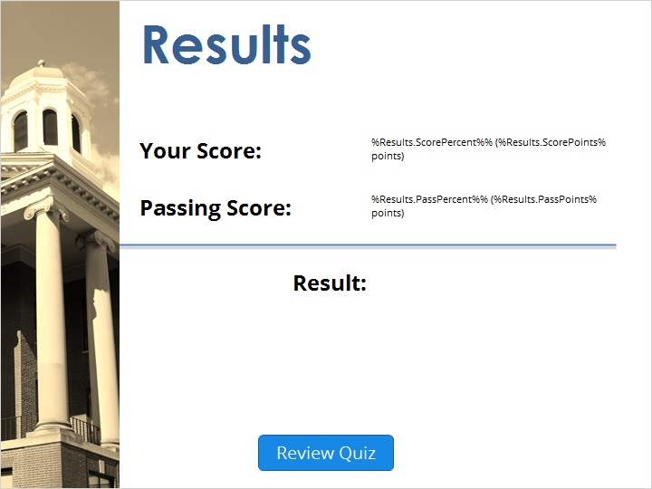

Notes:
fgsfdgsfdgfdg

Success (Slide Layer)
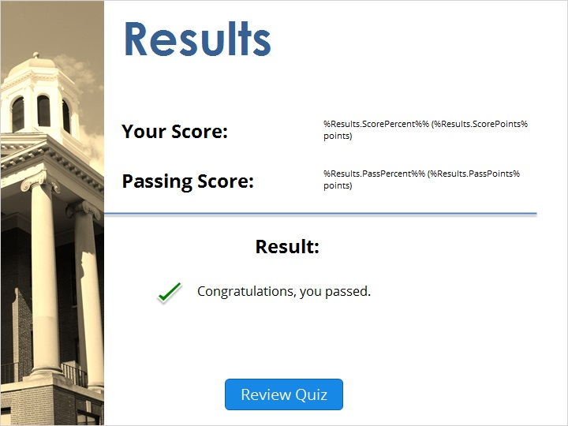

Failure (Slide Layer)


