Contributing Local Records to the Community Zone

1. Contributing Local Records to the Community Zone

1.1 Contributing Local Records to the Community Zone
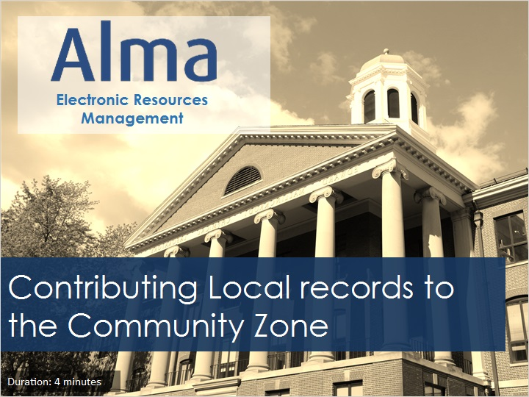
Notes:
Welcome to this session for Electronic Resources Management, where we’ll discuss how your Institution can contribute electronic resources to the Community Zone.

1.2 Objectives
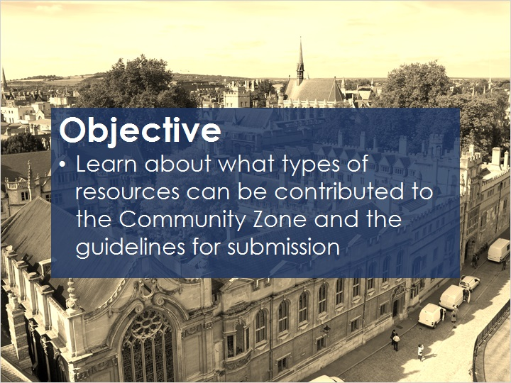
Notes:
In this training session you’ll become familiar the types of resources your Institution can contribute to the Community Zone, as well as the guidelines for making submissions.
Note: In order to be a contributor, your Institution must be in production with Alma.

1.3 Contribute Bibliographic Records to the CZ
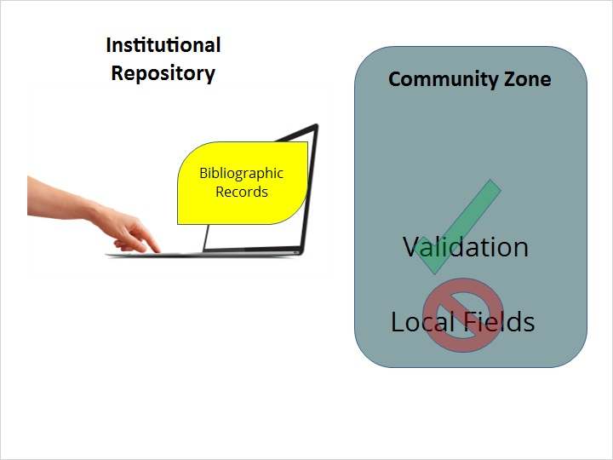
Notes:
You can contribute collection-level bibliographic records from your Institution directly to the Community Zone.
Any bib record that is submitted goes through a validation process.
Institutions should not add local fields to the bibliographic records that they are submitting to the Community Zone.

1.4 Contribute Portfolios to the CZ
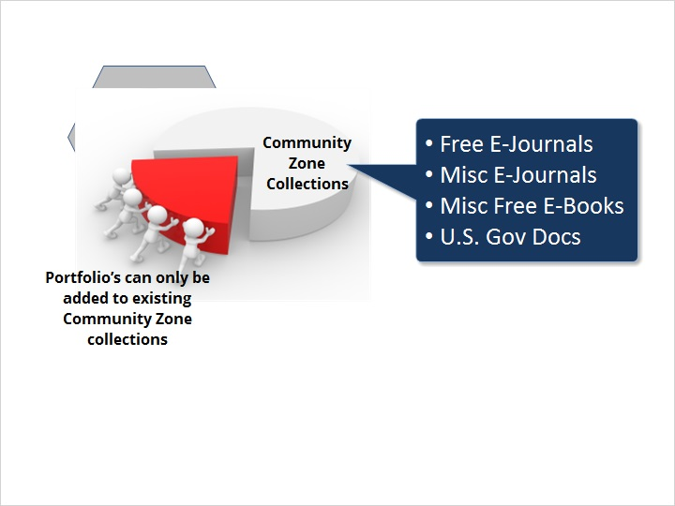
Notes:
Institutions cannot contribute stand-alone Portfolios to the Community Zone. Any Portfolio that is contributed, must be added to an existing electronic collection in the Community Zone. Portfolios can be contributed to the following types of collections: Free E Journals, Miscellaneous E-Journals, Miscellaneous Free E-books, and US. Government Documents.

1.5 Contribute Electronic Collections to the CZ
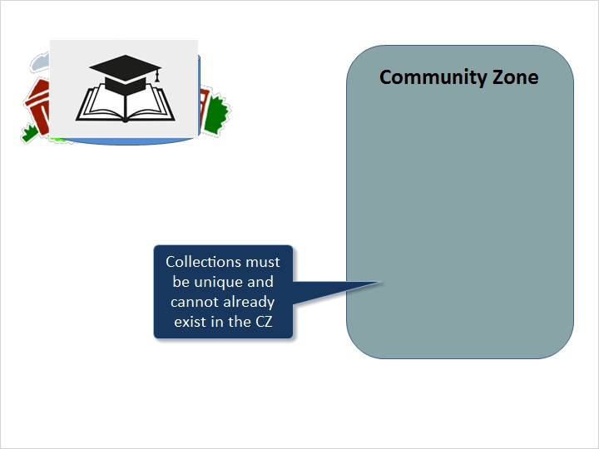
Notes:
Institutions may contribute entire collections of the following types to the Community Zone: selective or aggregator packages or databases. Collections should be academic in nature, and of interest to other institutions. Collections must also be unique, meaning that they cannot already be in the Community Zone.
Collections that are submitted, are reviewed by Ex Libris and should meet the following requirements:
For Aggregator Packages or Selective packages, a full bibliographic record that describes the collection must be contributed. Each portfolio that is part of the collection should also have a full bib record describing the portfolio as well as linking information for each portfolio. Portfolios that are serials, should also include coverage dates.
Databases submitted to the Community Zone must also have a full bibliographic record representing the collection-level bib and a URL to the database’s native interface.

Contribution Guidelines (Slide Layer)
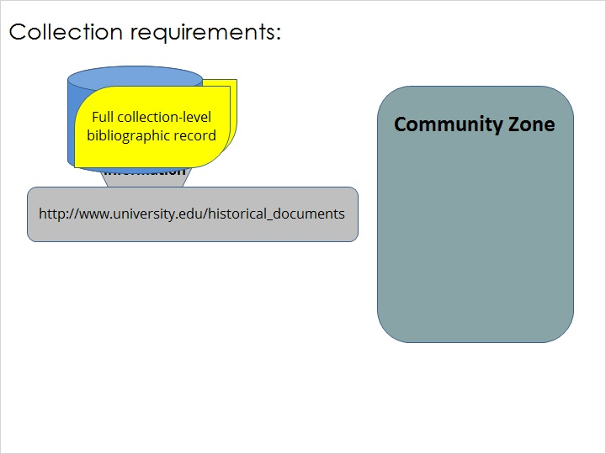

1.6 Guidlines and Upates
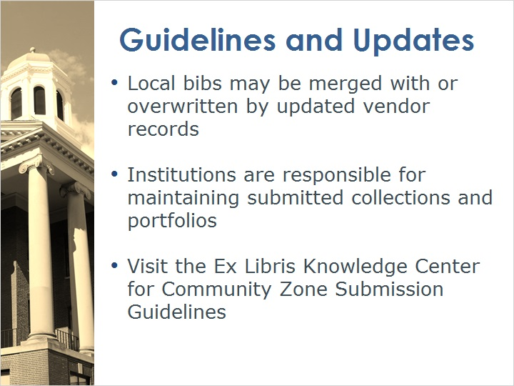
Notes:
Keep in mind the following guidelines when contributing to the Community Zone:
Any bib records that are contributed by your Institution, may be merged with or overwritten by updated vendor records.
Collections that are submitted by Institutions are not maintained by Ex Libris; updates remain the responsibility of the Institution that submitted the collections or portfolios.
For more information, consult the Community Zone Submission Guidelines, which are available in the Ex Libris Knowledge Center.

1.7 Review
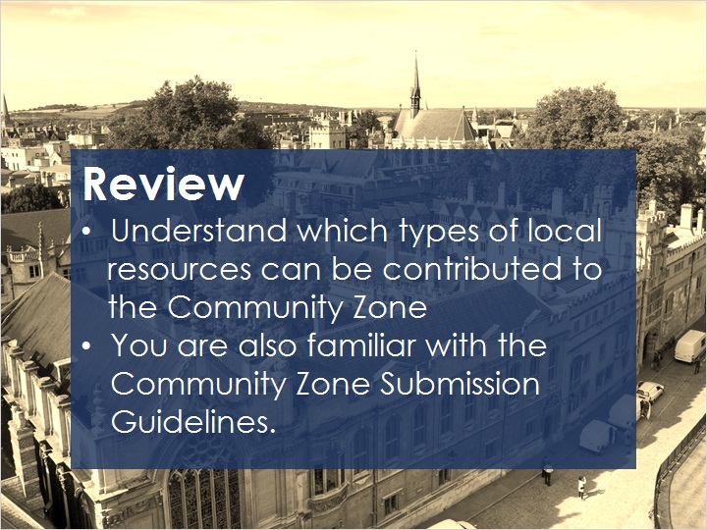
Notes:
Now that you’ve watched this session you know which types of local resources can be contributed to the Community Zone
and you’re also familiar with the Community Zone Submission Guidelines.

After completing a short quiz that begins on the next slide, you can review any recommended articles and continue on to additional training sessions.

1.8 Quiz: Collection Types
(Multiple Response, 10 points, 1 attempt permitted)
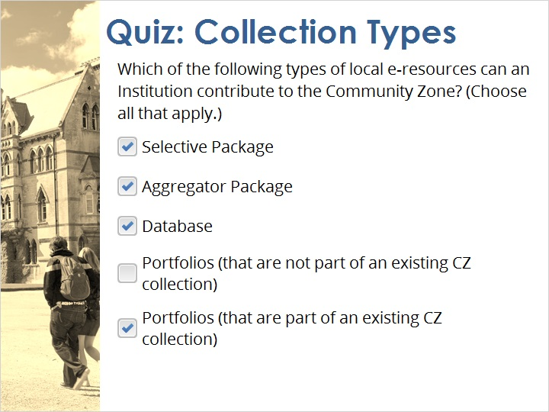
Correct | Choice
X | Selective Package
X | Aggregator Package
X | Database
 | Portfolios (that are not part of an existing CZ collection)
X | Portfolios (that are part of an existing CZ collection)

Correct (Slide Layer)
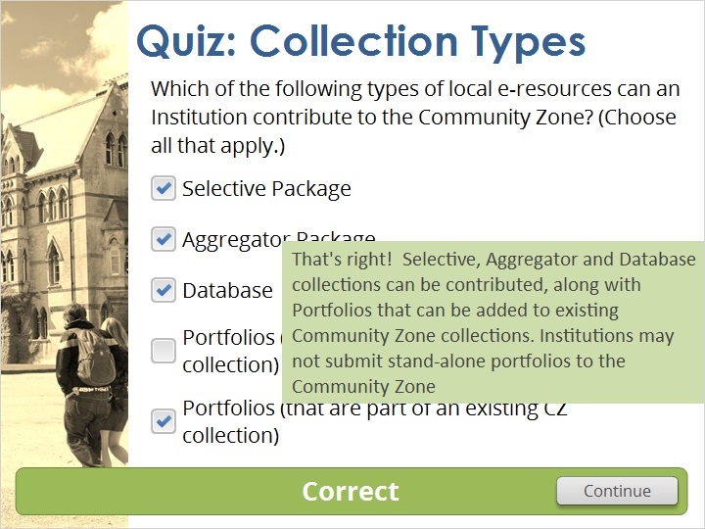

Incorrect (Slide Layer)
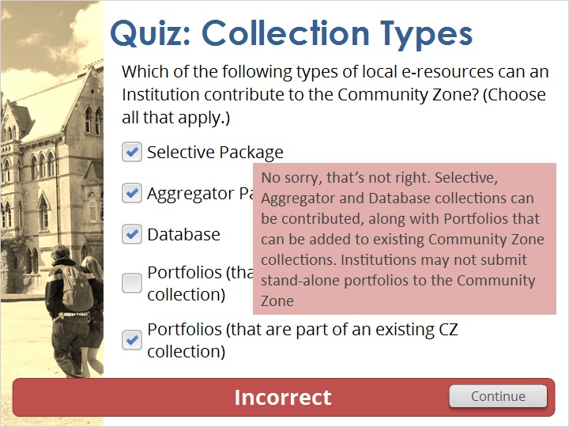

1.9 Thank You!

Notes:
Thanks for joining this session.

1.10 Copyrights
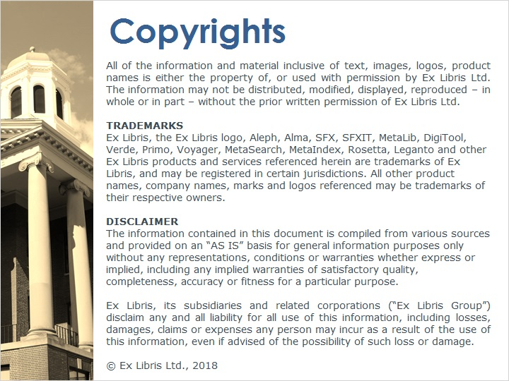
Notes:

2. Quiz Results

2.1 Results Slide
(Results Slide, 0 points, 1 attempt permitted)
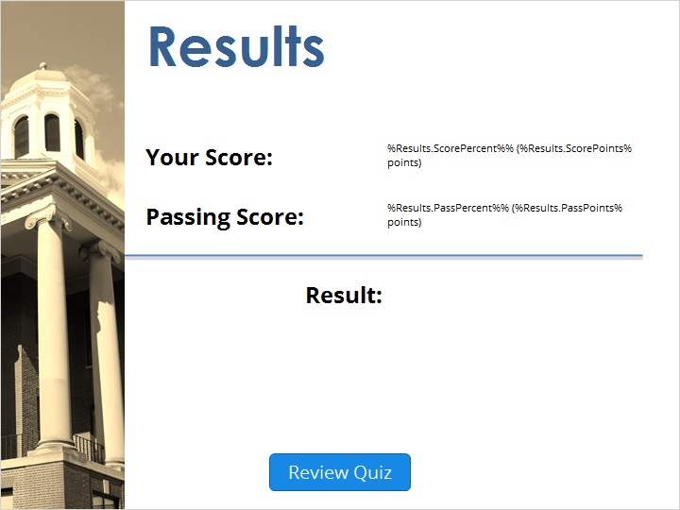

Notes:
fgsfdgsfdgfdg

Success (Slide Layer)
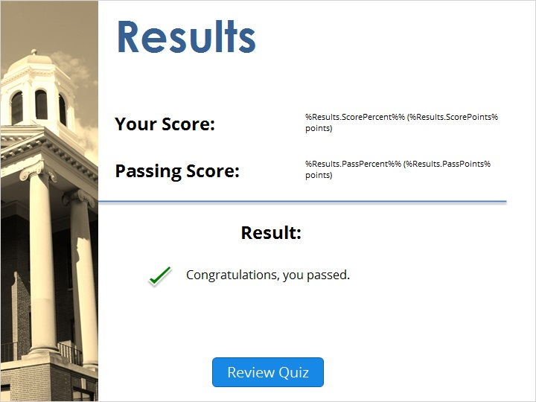

Failure (Slide Layer)


