Getting Started: Primo Central Index

1. Getting Started: Primo Central Index

1.1 Primo Central Index
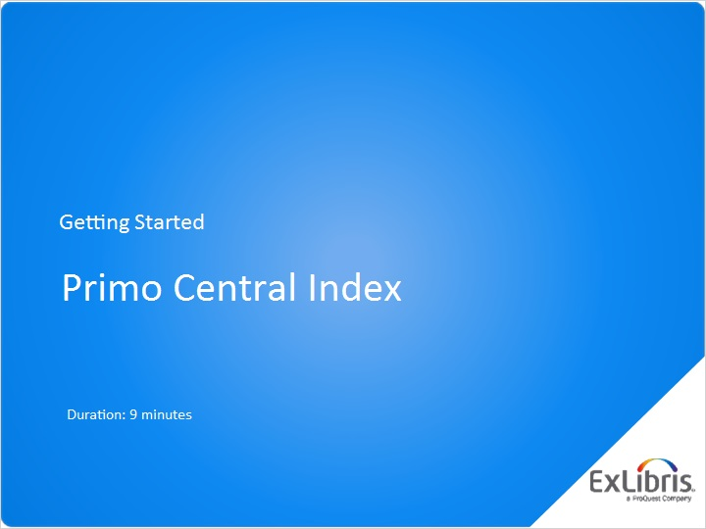
Notes:
Hello, and welcome to this session, the Primo Central Index.

1.2 Agenda
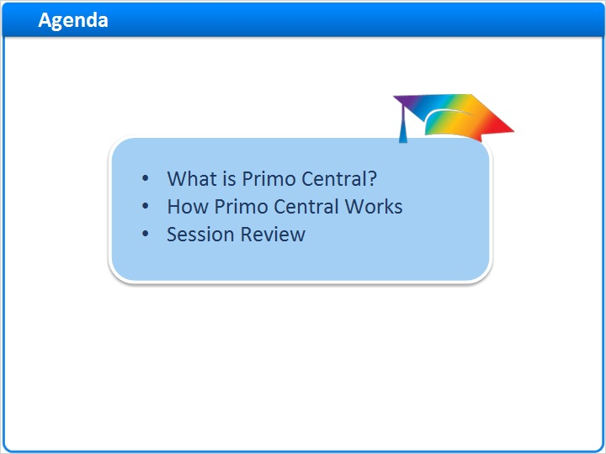
Notes:
In this session, we’ll start with a brief introduction to Primo Central. Then we will explore how Primo Central works. At the end of the session, we’ll have a brief review.

1.3 What is Primo Central?
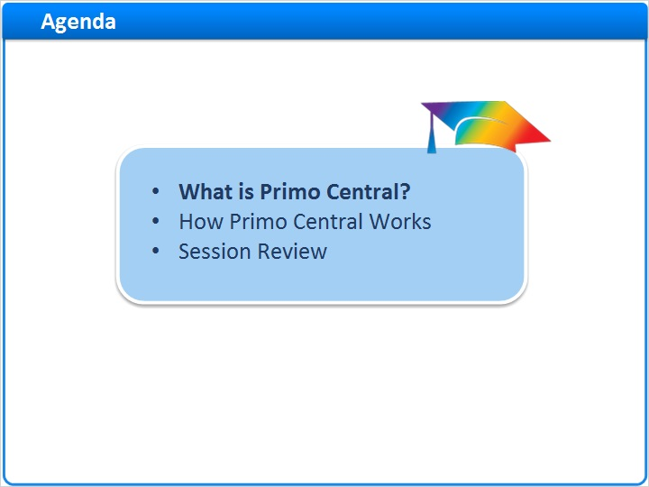
Notes:
What is Primo Central?

1.4 What is Primo Central?
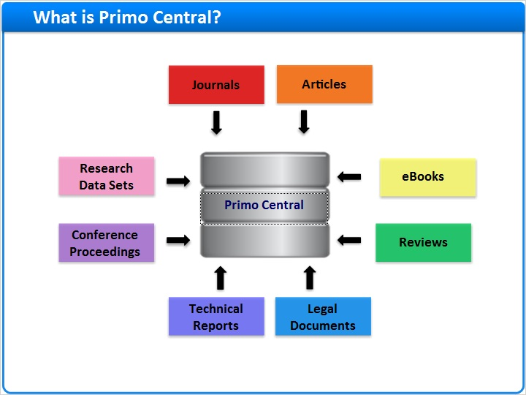
Notes:
The Primo Central Index (or just Primo Central) provides easy access to over a billion scholarly materials obtained from various aggregators, publishers, and open access repositories.

Primo Central includes citations for journals, articles, e-books, reviews, legal documents and technical reports, conference proceedings, research data sets and more.

1.5 Remote and Local Resources
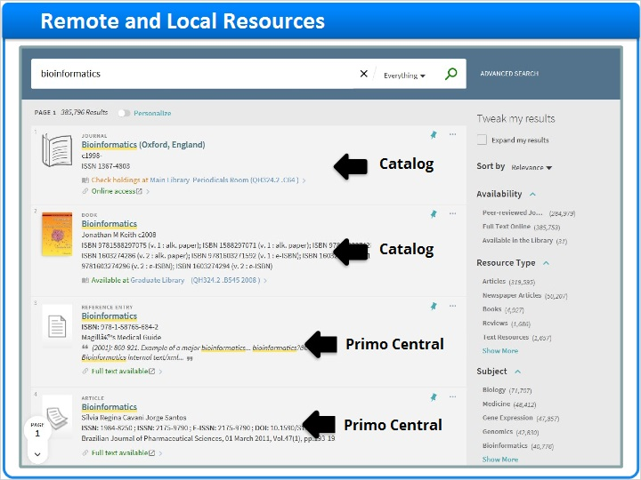
Notes:
The Primo Central database is shared with other Primo Central subscribers, so it’s considered a remote resource. Even so, these results can be blended with your local resources to produce one relevancy ranked list of results.

1.6 How Primo Central Works
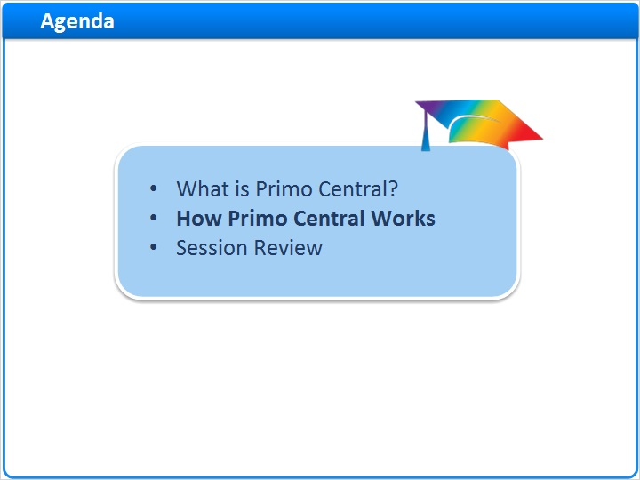
Notes:
How Primo Central Works

1.7 Discovering PC Resources
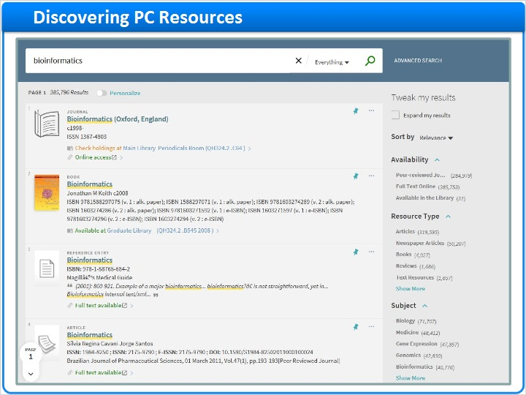
Notes:
Let’s take a closer look at a few Primo Central results.
Even though this list contains results from both the library catalog and Primo Central, there are a few ways I can identify a Primo Central record. The third and fourth results, for example. They are articles, and articles are usually coming from Primo Central. They are both online resources, and though you may have plenty of those in your catalog, Primo Central results are all accessed online.
But the definitive way to determine where the record is from is the Source in the details section of the full record. We can see here that this citation is from Gale Virtual Reference Library, which is a Primo Central collection.
If I were to look at the source of a local record, we can see here that it’s from the Alma catalog.

Full record - PC (Slide Layer)
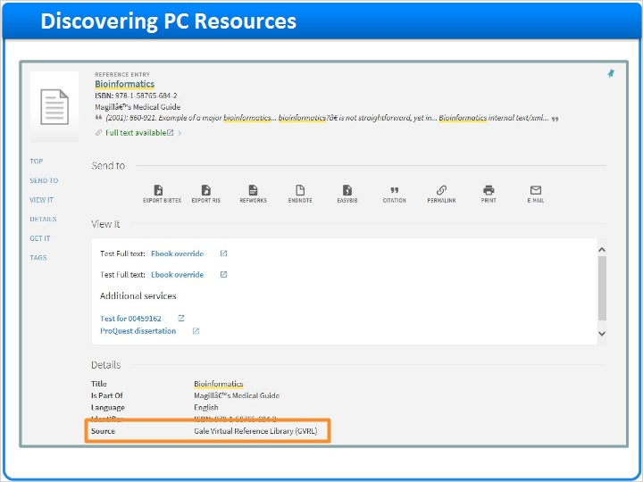

Full record - ILS (Slide Layer)
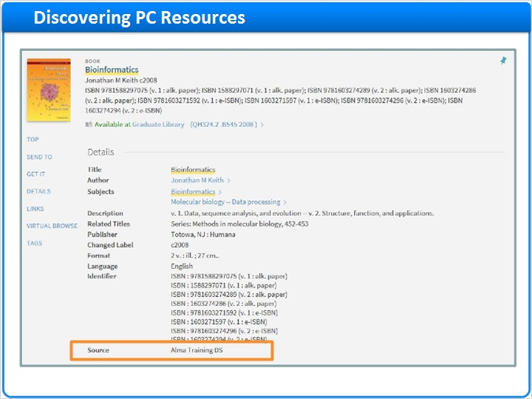

1.8 Identifying PC Records
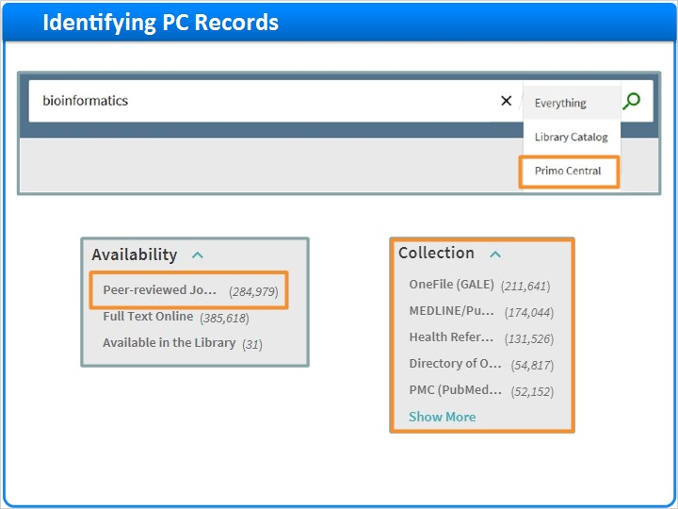
Notes:
If I only want to see Primo Central results, I have a few options.
If there’s a separate scope configured, we can search just the Primo Central resources
If we apply the peer review filter, we will just see the PC results from peer review journals
And, we can use the Collections facet. Here we can facet our results based on the Primo Central collection of our choosing.

1.9 Delivery of PC Records – Fixed Availability
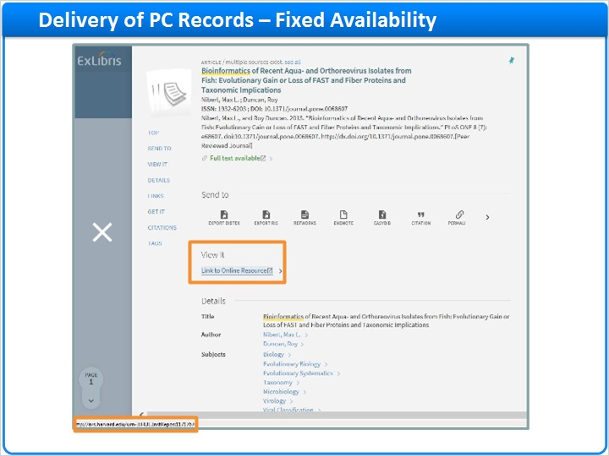
Notes:
For Primo Central records, there are several different delivery methods used; some use the link to the full text provided in the records the vendors gave us, while others use a link resolver to access the full text. Let’s look at each of these methods.
Here is an example of a Primo Central citation that links directly to the full text using the vendor’s link. We call this ’fixed availability’.
If we were to click on the Link to Online Resource in the View it section, we would access the full text in the DASH database directly, without using the link resolver. Notice that when I mouse over the link, I can see the URL at the bottom of the screen here.
In this case we have used the link the vendor provided with the citation. We do this because there is not enough information to generate a successful OpenURL for the records in this collection. Our Primo Central team, with considerable experience in testing these resources, determines the best delivery method for each Primo Central collection. The documentation center has a list of the resources that deliver full text using this method.

1.10 Delivery of PC Records – Link Resolver
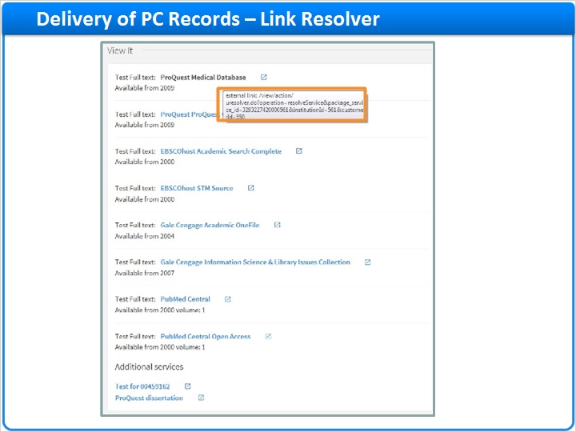
Notes:
Most of the resources from Primo Central, however, use your link resolver to bring the user to the full text. Here’s an example of a Primo Central citation that does just that.
In the View It section, we’re presented with a list of one or more databases where we can access the full text of this article. In this case, we can see the full text in a number of different subscription databases.
Notice that when I mouse over one of the links, the URL starts with the link resolver URL.

1.11 Delivery of PC Records – Full text vs No full text
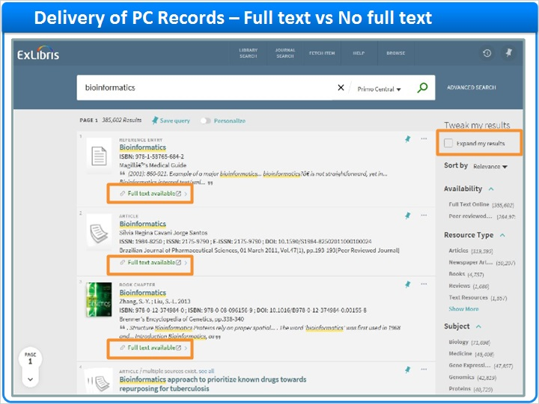
Notes:
Now that we have seen how Primo Central results are discovered and delivered in Primo, let’s go back to the Primo Central results list for a moment.
Notice that all of the results here show that full text is available. This is not a coincidence.
Primo Central works with its activation wizard, your link resolver, and Primo to determine what you have full text access to and if the results should be displayed.
It’s possible to see results that you do not have full text access to, and you can determine whether or not you would like to display this option to your users. By checking the Expand my results checkbox, you expand your results to include all citations that you have activated in the Primo Central database, including those that you do not have full text access to.

Delivery of PC Records – Full text vs No full text - Copy (Slide Layer)
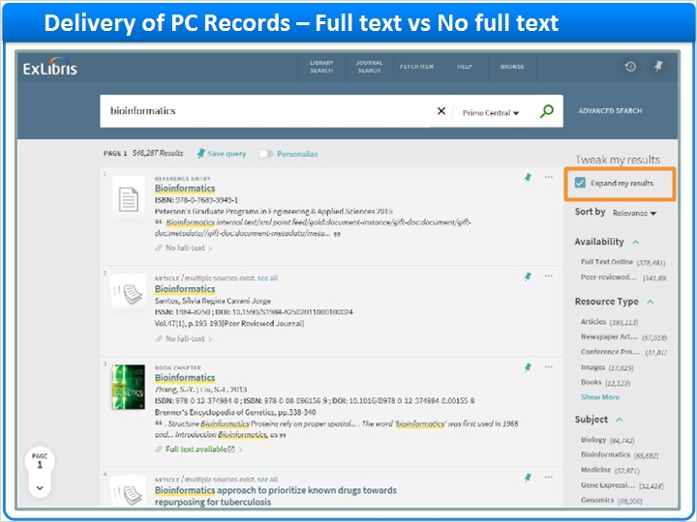

1.12 Primo Central Collections
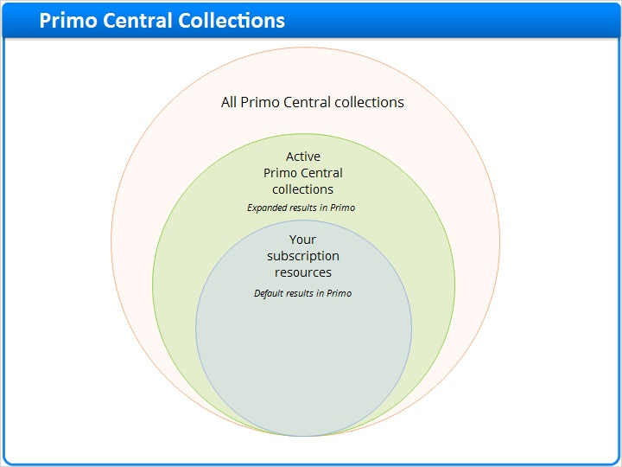
Notes:
We start with all of the Primo Central collections.
Then, a subset of these collections get activated. The citations in the collections activated appear in the expanded results in Primo.
And then, we have your subscription resources. During your implementation, we will use your link resolver to generate a list of all of the publications that you subscribe to. This list will be compared to the active collections in Primo Central to determine which publications you have full text access to. The result of this comparison will determine the default results you see in Primo.

1.13 Activation Wizard
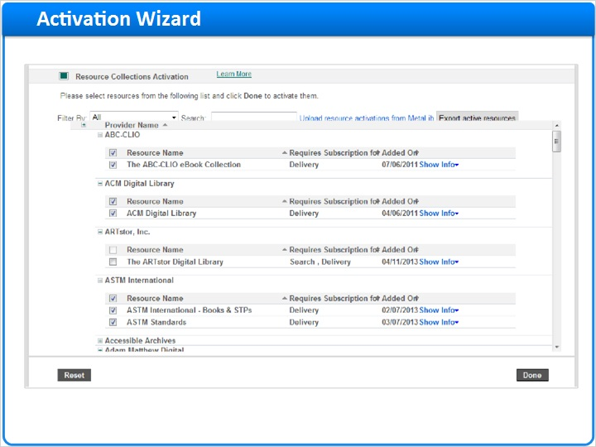
Notes:
The Activation Wizard is used to activate Primo Central collections.
In the Activation Wizard, we see a list of resources to activate. The idea here is to activate collections that you have access to, AND certain collections that are searchable but contain citations for publications you subscribe to in other databases.
In some cases, you may look in the Primo Central Activation wizard and see collections you subscribe to. But you may also have collections that aren’t represented in this list.
For those collections, you can refer to the Alternative Coverage guide to determine which collections to activate. For example, in the Alternative coverage guide, we can see that the citations for EBSCO’s Abstracts in Social Gerontology are not directly available from EBSCO. However, we have citations for 97% of the titles in this package through different vendors. So if I wanted to ensure that these citations were visible in Primo, I would want to activate the collections in this column.
The end result is that we see the citation from Gale, Medline, or any of these collections, but we would still be accessing the full text in the EBSCO database, because the link resolver would point us there.
In other words, the Primo Central activations drive discovery; users see search results based on what is activated in Primo Central. Your link resolver handles delivery, and brings the user to the full text regardless of where the Primo Central citation came from.

alternative coverage guide (Slide Layer)
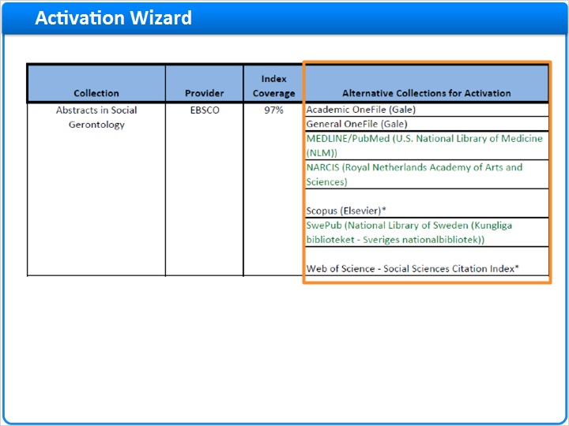

1.14 Institutional Holdings File
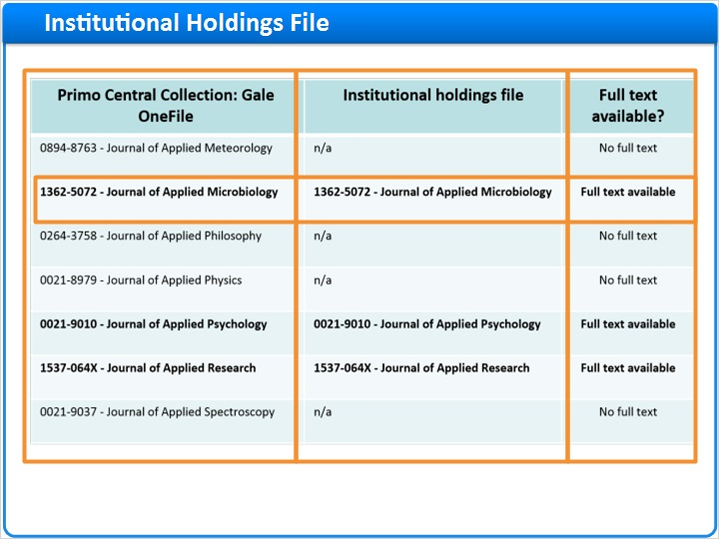
Notes:
Now that we’ve activated our collections in Primo Central, we can rely on the link resolver to do the rest.
During your implementation, your link resolver will be configured to generate a list of publications you subscribe to. This file is called the institutional holdings file.
Primo Central works with this list to determine what publications you have full text access to. If the collection is active in PC, and the publication is on this list, results from this publication will be displayed as ‘Full text available’ in Primo.
While collections are activated at the package level in Primo Central, full text access is determined at the publication level. So for example, if you do not subscribe to Gale Onefile and you activate that collection in PC, you can search all of those citations, but your initial search results will only include results from publications that you have full text access to in other databases.

1.15 Primo Central Updates
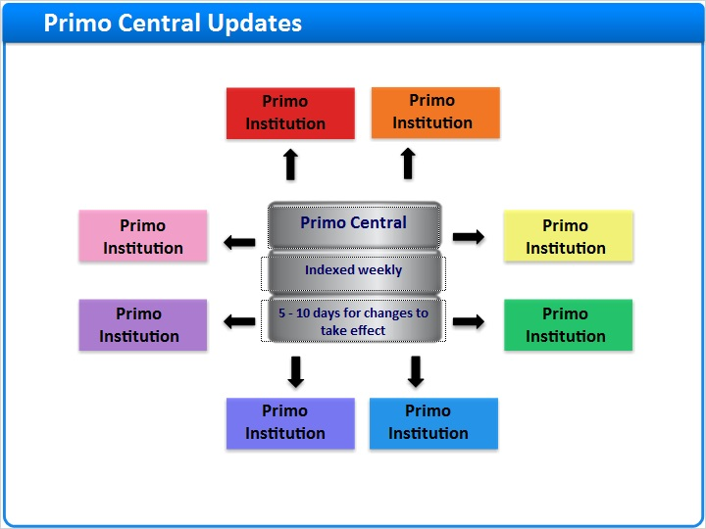
Notes:
Primo Central contains more than 1200 collections that include over one billion citations. Because of the size of this database, and because we have hundreds of institutions accessing it with their own unique sets of activations and holdings, we index this data on a weekly basis.
Generally speaking, if you make changes to your PC activations, or the active resources in your link resolver, it can take up to 5-10 business days for the change to be visible in Primo.

1.16 Summary
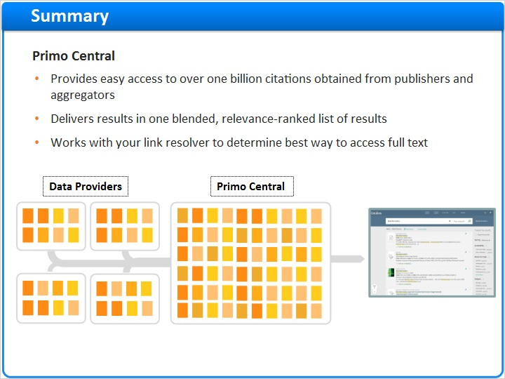
Notes:
And this is Primo Central - a database that
Provides easy access to over one billion citations obtained from publishers and aggregators
Delivers results in one blended, relevance-ranked list of results
Works with your link resolver to determine the best way to access full text content

1.17 Session Review
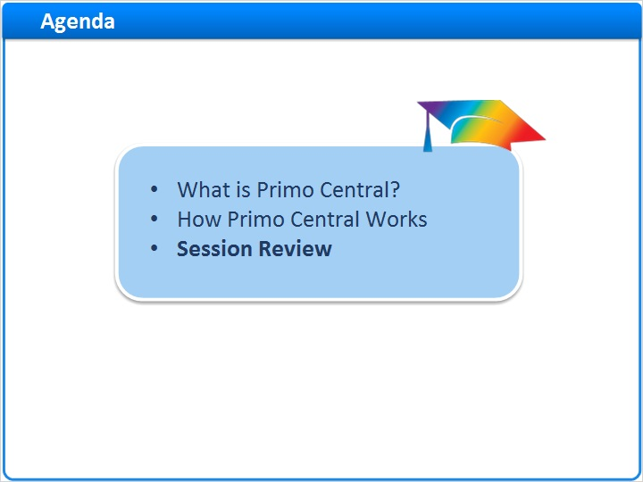
Notes:
Session Review

1.18 Session Review
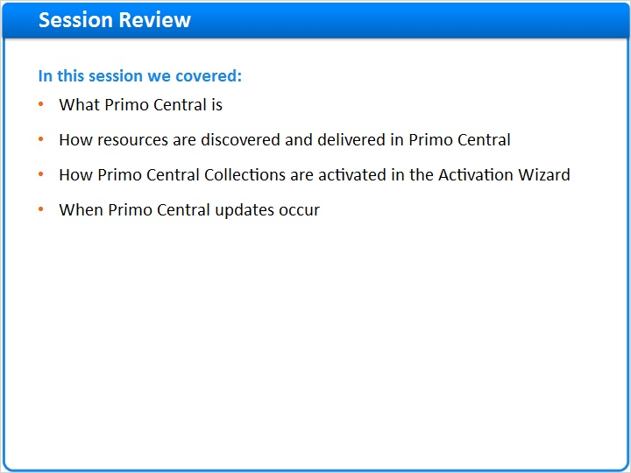
Notes:
In this session we covered what Primo Central is, how resources are discovered and delivered in Primo Central, how Primo Central Collections are activated in the Activation Wizard, and when Primo Central updates occur.

1.19 Thank You!

Notes:
Thank you for joining this session!

1.20 About this Training
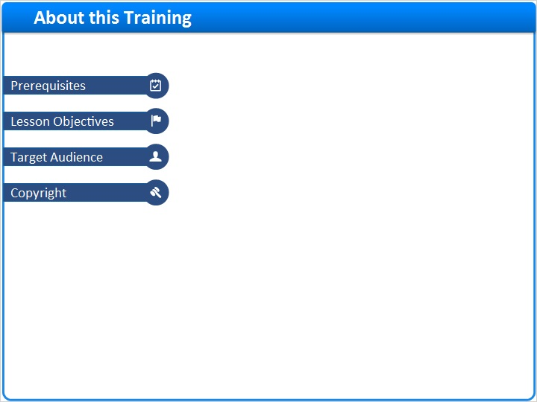
Notes:

1 (Slide Layer)
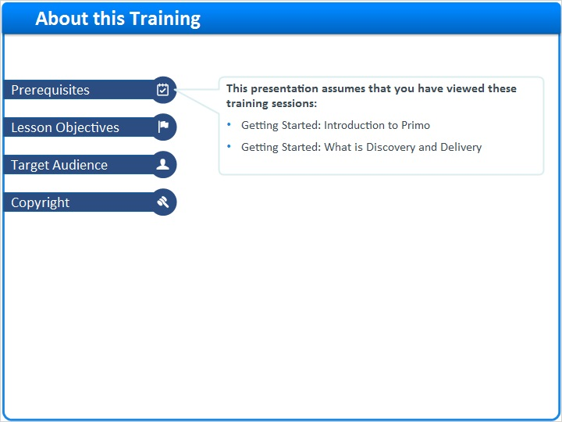

2 (Slide Layer)
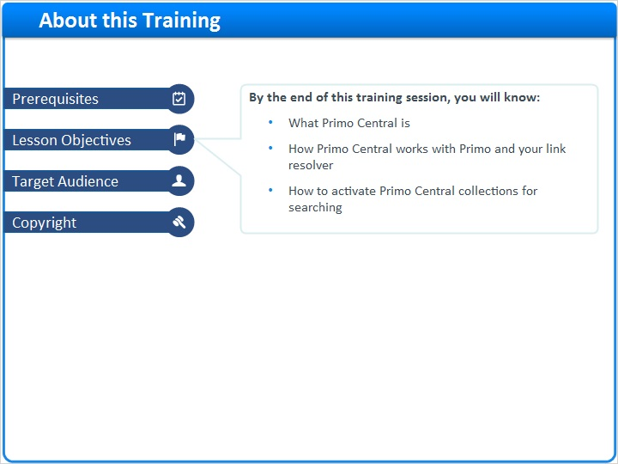

3 (Slide Layer)
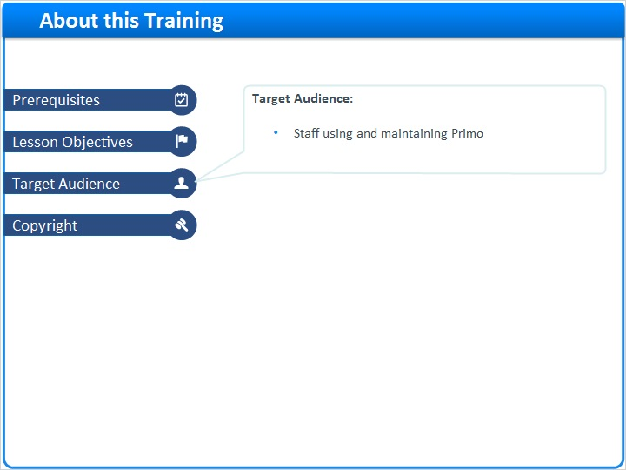

4 (Slide Layer)


