Primo Administration
Administrative Structure
Hands-on Exercise

Learning Objectives
To log into the Primo Back Office and review your institutional settings and libraries.

By the end of this exercise, you will be able to:
- Log into the Primo Back Office
- Access your institution in the Institution Wizard

Requirements
To complete this exercise, you will need to have a Super Admin or Admin level password to your configured Primo Sandbox Environment.

Your Primo Sandbox will need to have the following configurations for this exercise:
- Your Institution created
- Data source for your ILS created
- Normalization rule configured for your catalog data
- Pipe created and run at least once for your library catalog data
- View created for your institution
- Access to the Front End of your view and data visible

General Instructions
This exercise accompanies the Primo Administration: Administrative Structure training session. For help with the exercise, go to the training’s launch page where you can review the presentation, download the presentation Handout, and find links to Recommended Articles in the Knowledge Center.

Please use your library’s Primo Sandbox Environment to complete this exercise. Note that you will not be making changes to your Sandbox Environment, only viewing default settings and configurations that have already been made.

The Activity

Log into Primo Back Office
- Go to your Primo Sandbox Environment’s Back Office URL:
e.g.: http://university.exlibrisgroup.com:1601/primo_publishing/admin/acegilogin.jsp
- Type in username and password | 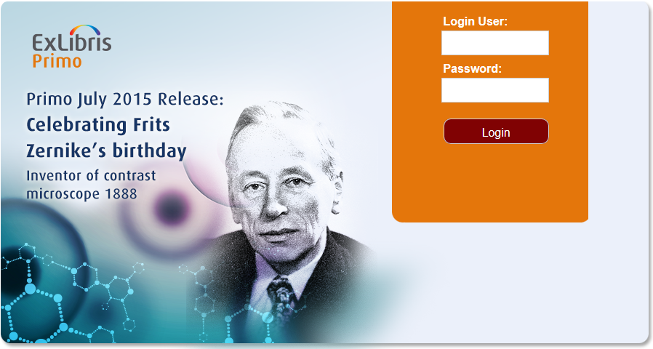
- See the Primo Back Office home page
See Your Institution
- Go to Ongoing Configurations
- Go to Institution Wizard
- Note the list of institutions.
If you are logged in at the Admin level, you will only see your institution and the demo Primo institution.

If you are in a consortium, have a dedicated direct/local Primo environment, and are logged in at the installation level, you may see and be able to edit more than one institution.
- Click Edit to edit your Institution
- Note these General Attributes:

Primo Institution Code and Name:

Alma Institution Code:
This will be your Alma institution code if you have Alma; if you have a different ILS it will be blank
Source ILS Institution Codes:
This will be the same as your Alma institution code if you have Alma; if you have a different ILS, it will be the institution code for your ILS (e.g. Voyager or Aleph database)
PC Key and Customer ID:
These values will be filled in during implementation, and allows this institution to interact with your Primo Central account.
bX Token:
This value will be filled in during implementation if you have subscribed to bX
Metalib username and password:
Ensure these are blank – if you auto saved your username/password, these will be filled

- Note the Delivery Base URLs.
The Primo software will use these delivery base URLs to form the links into these source systems.

Some of the fields will be blank, and others will be filled in by your implementation team.

More information on these libraries will be covered in the Normalization and Delivery Templates Mapping Tables session

- Note the Libraries section:
These libraries represent the libraries that are included in your Library Catalog data. For example, if you have Aleph or Voyager, these will be the libraries and library codes you have configured in the ILS.

More information on these libraries will be covered in the Normalization and Delivery Templates Mapping Tables session.

- Without making any changes, click Save & Continue to see the IP screen.

The IPs listed here will allow Primo to recognize whether users are on or off campus for the purposes of restricted search and delivery scopes and Primo Central restricted to search resources.

If you were making changes to either of these screens in the Institution Wizard, you would need to Save and Deploy to put the changes into effect.
- Go back to the Institution List by going to top navigation and selecting
General > Institution List

