Administrative Structure

1. Primo Administrative Structure

1.1 Primo Administration: Administrative Structure
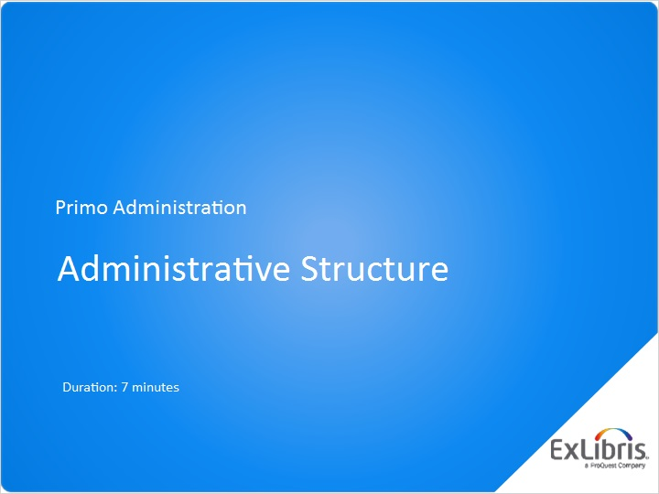
Notes:
Hello, and welcome to this session on the Primo Administrative Structure.

1.2 Agenda
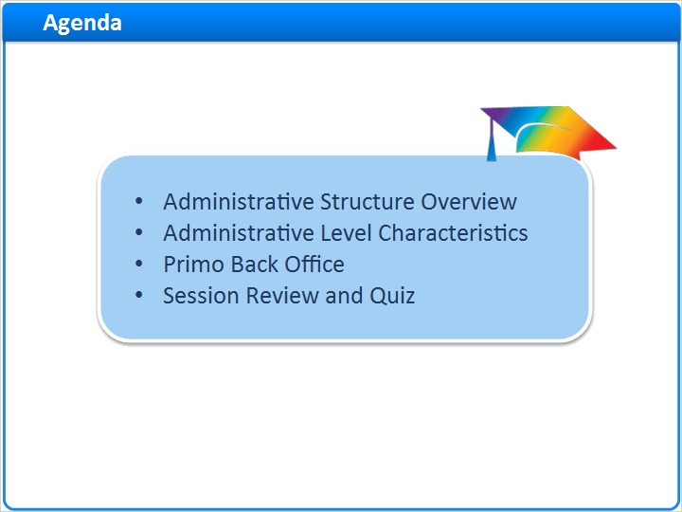
Notes:
We’ll start our session with a brief overview of the administrative structure in Primo. Then, we’ll explore each of the levels of the administrative interface further - specifically the installation, institution, and library levels. Then I’ll introduce you to the Primo Back Office, the administrative interface for Primo.

1.3 Administrative Structure Overview
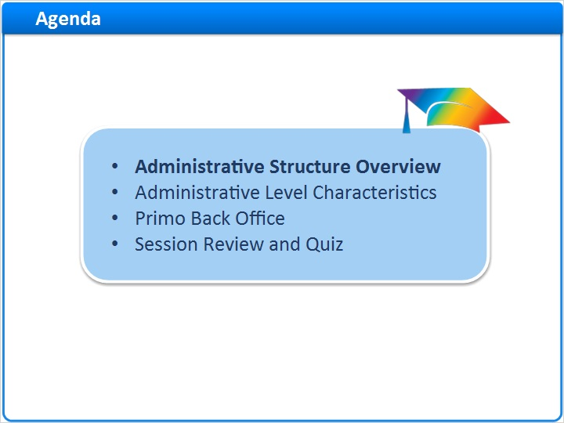
Notes:
Administrative Structure Overview

1.4 Administrative Structure Overview
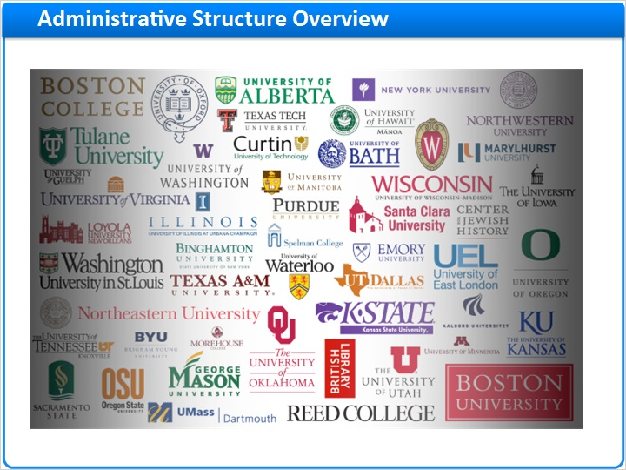
Notes:
Colleges, universities, consortia, and research centers all have different organizational structures that can be supported in Primo. For example, you may be in a consortium with several libraries that share an ILS, but license electronic resources separately. You may be at a university that has multiple libraries in different physical locations. Or, you may be one college or research center with one main library.

The Primo Administrative Structure refers to the way the Primo software is organized, and this allows us to support each of these scenarios, and more. This administrative structure can support single organizations with one library as well as large consortia with multiple institutions and multiple libraries.

consortium (Slide Layer)
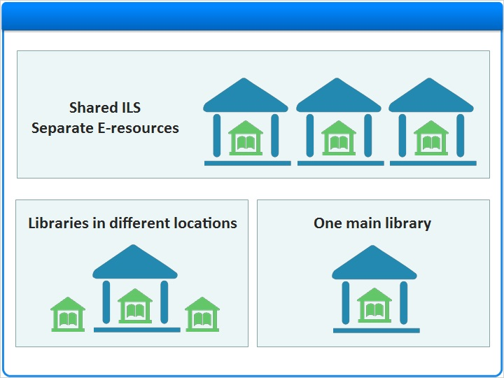

single sites (Slide Layer)
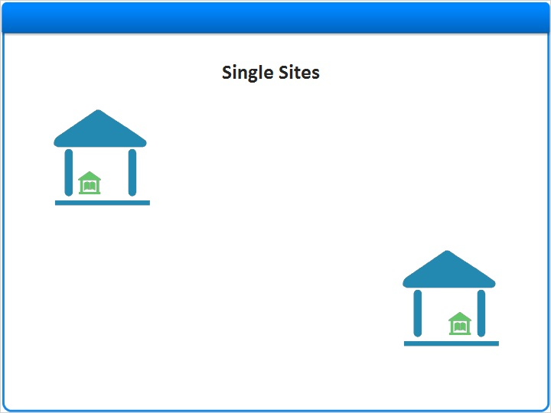

multiple sites (Slide Layer)
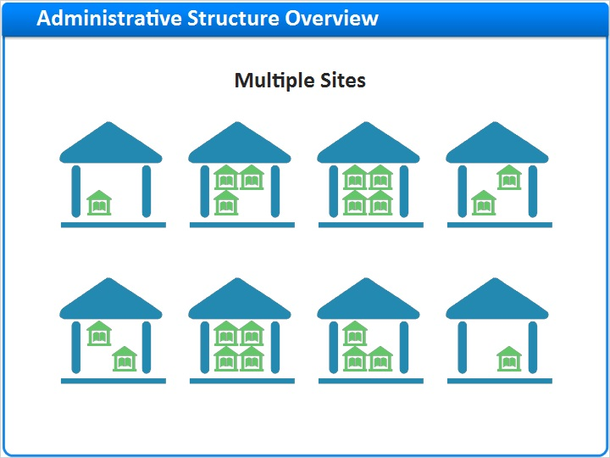

1.5 Installation Level
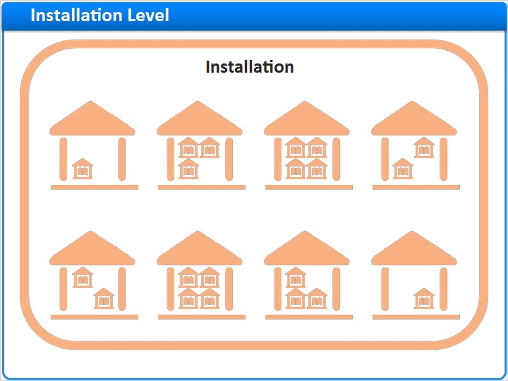
Notes:
In Primo, the administrative structure starts at the installation level.

One installation of Primo can provide dozens of different libraries and institutions with the Primo software application.

1.6 Institution Level
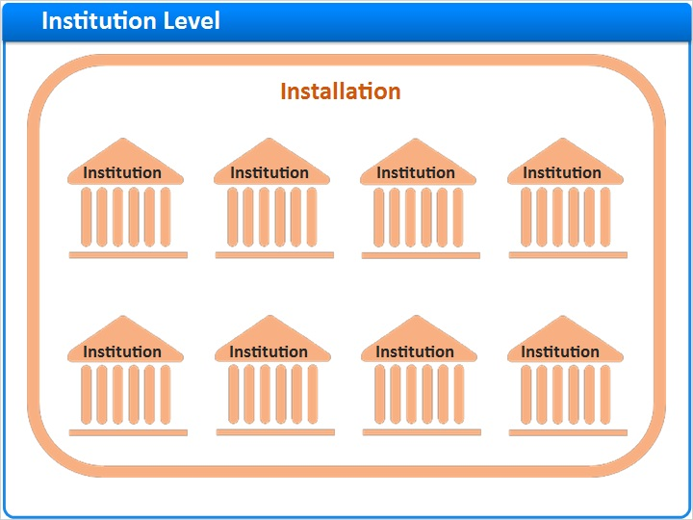
Notes:
In order to do this, the installation contains distinct and separate entities that we call ‘institutions’.

Depending on your organization’s needs, you may have one or more institutions created for you during your implementation.

1.7 Library Level
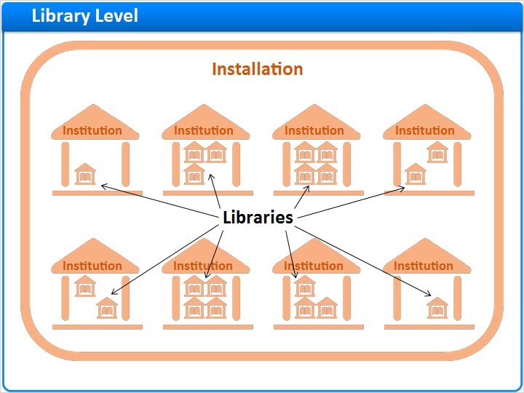
Notes:
Each Primo institution in turn can contain one or more libraries. The library is the smallest administrative unit in Primo.

1.8 Administrative Level Characteristics
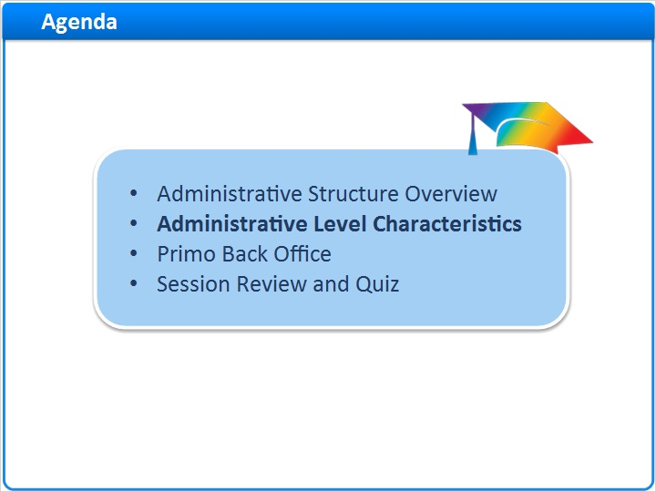
Notes:
Administrative Level Characteristics

1.9 Installation Characteristics
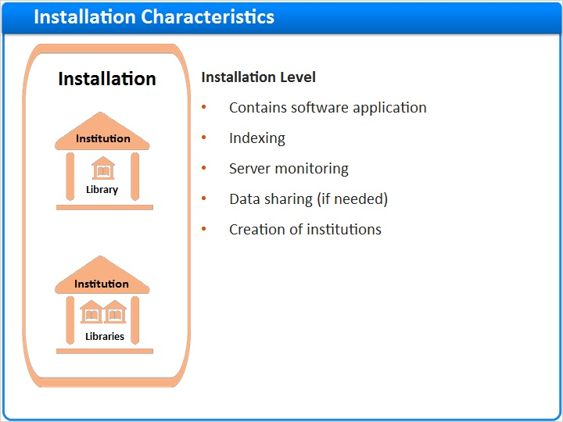
Notes:
So what happens at each of these levels?

The installation contains all of the Primo software needed to run the application.

There are a few processes that happen at the installation level such as indexing data and server monitoring, and a few installation-specific configurations and settings, such as how data is shared or not shared across institutions. And because there can be multiple institutions in one installation of Primo, the institution creation process is also at this level.

1.10 Institution Characteristics
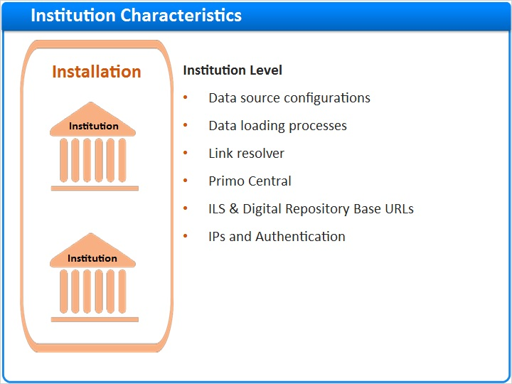
Notes:
At the institution level, we have our data source configurations, and our data loading processes. This is also where we define which link resolver will be used for delivery, which Primo Central account you have, and any other base URLs that are needed to access your ILS and digital repositories.

Your IPs and authentication are also defined and configured at the institution level.

1.11 Library Characteristics
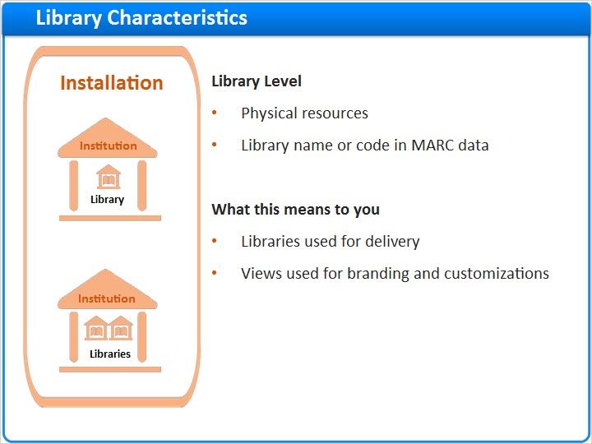
Notes:
The Primo library is associated with physical resources (books, journals, AV materials). If you have multiple libraries, usually you will have a library name or code in the MARC record.

In Primo, libraries are used for delivery - in other words, the libraries indicate the physical location where that resource resides.

If you decide to have different Primo Front Ends for each of your libraries this is accomplished by implementing multiple views in Primo. Views are discussed in a later session.

1.12 Primo Back Office
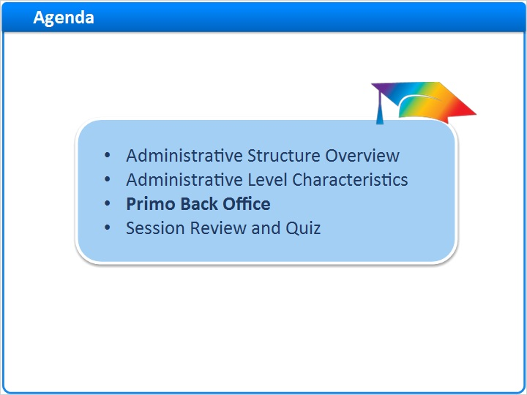
Notes:
The Primo Back Office

1.13 Login
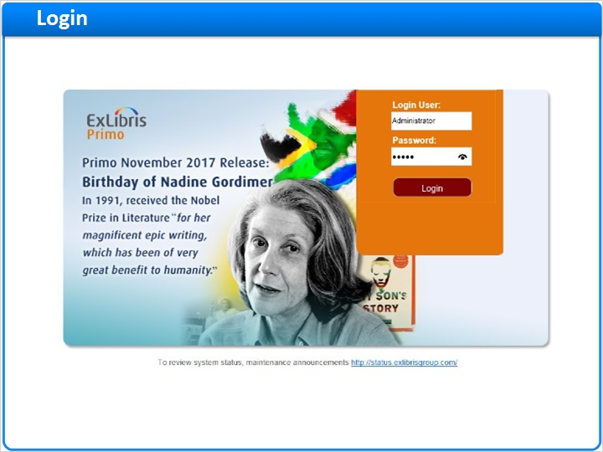
Notes:
When you access the Primo Back Office, your login will determine what level or levels you have access to.

If you have installation-level access, you will have the ability to see and edit all of the institutions and libraries on the server.

In most cases, you’ll be given access to the institution level - or ‘Admin’ access, which means that your institution has already been created by Ex Libris staff before you log in, and you will have the ability to see and edit your institution and libraries.

1.14 Institutions List
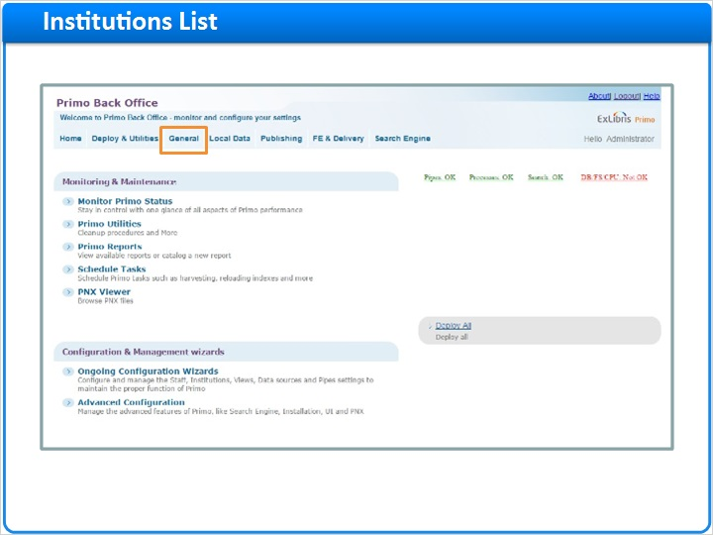
Notes:
Once you are logged in, you can see the institutions list by selecting ‘General’ in the navigation menu at the top of the screen, then ‘Institutions List’.

The Institutions List can also be found in the Ongoing Configuration Wizards, in the Institution Wizard.

Here I can see two institutions. The Primo Institution is the default institution - and though it is not editable, you can still view it. The institution that we are interested in is the ‘University of Primo’ institution. You’ll notice that there is a description, and we have the ‘edit’ button on the right.

Menu navigation (Slide Layer)
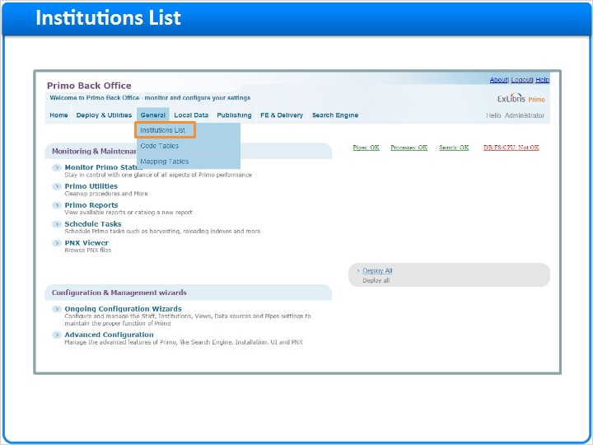

Ongoing Configuration (Slide Layer)
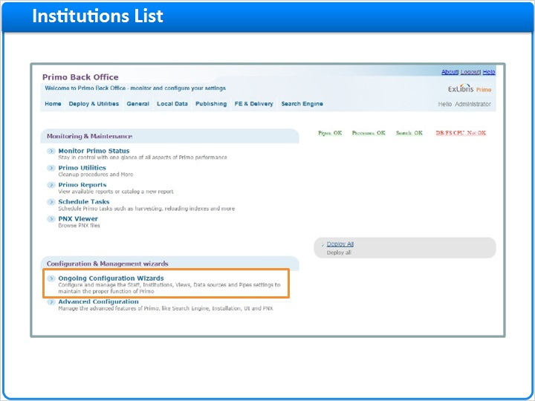

Institution Wizard (Slide Layer)
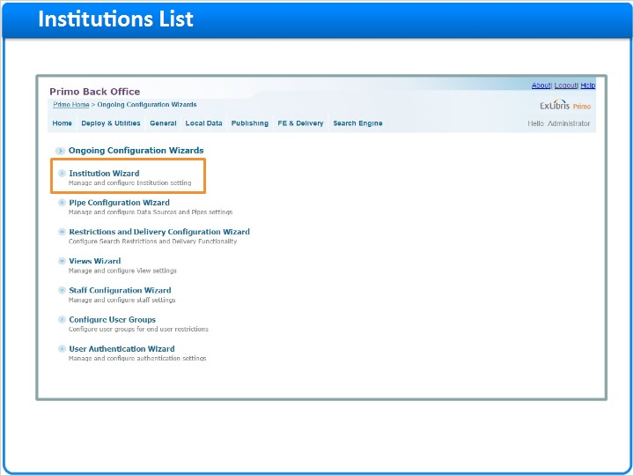

List of Institutions (Slide Layer)
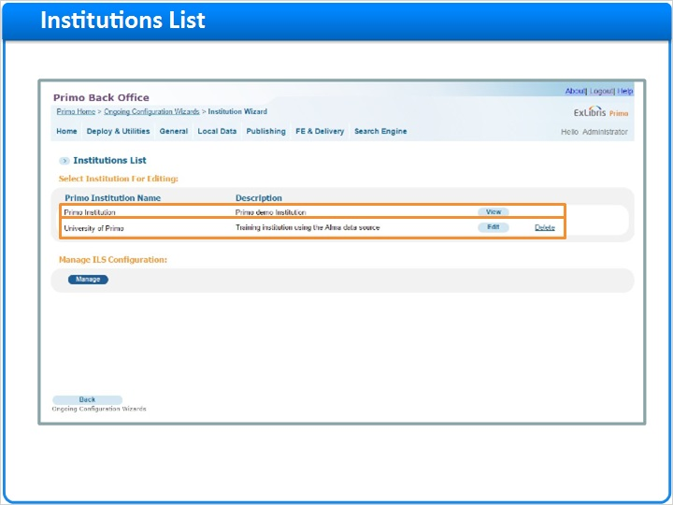

1.15 Edit Institution
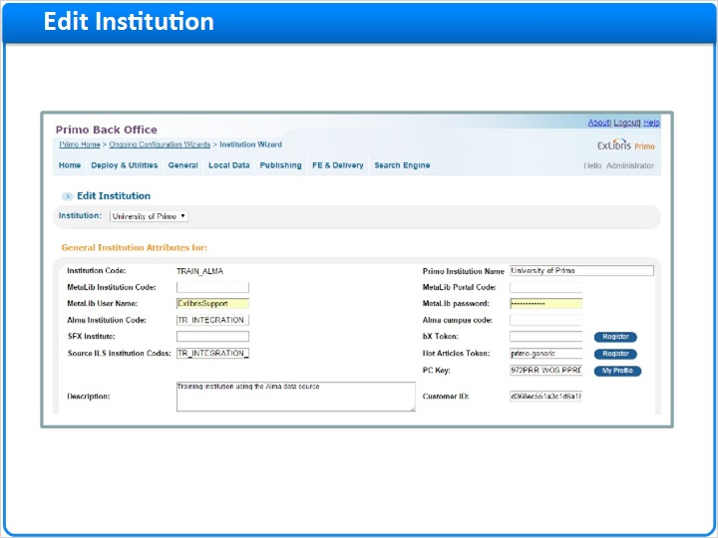
Notes:
The Edit Institution screen has several different sections.

The first is the General Institution Attributes. In this section, we have our institution code, name, and description, along with the associated Alma, MetaLib, SFX and Primo Central information if it exists.

The next section is the Delivery Base URLs, including URLs for your ILS, link resolver, and digital repositories.

Below that we have our Library configuration.

During your implementation, Ex Libris staff will configure your institution and libraries for you, though you may need to make additions or adjustments here later on.

Delivery base URLs (Slide Layer)
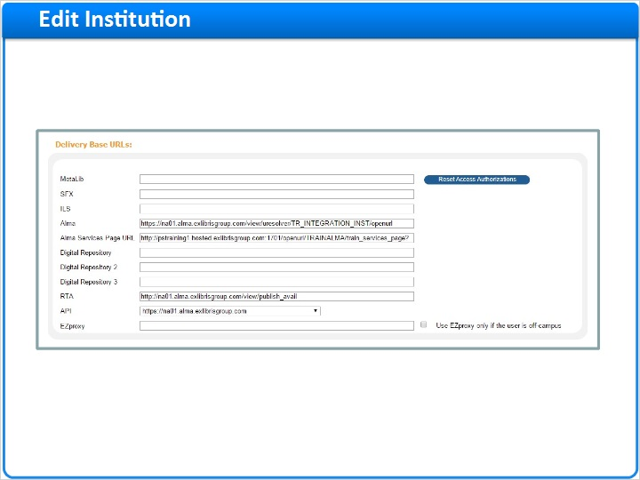

Libraries (Slide Layer)
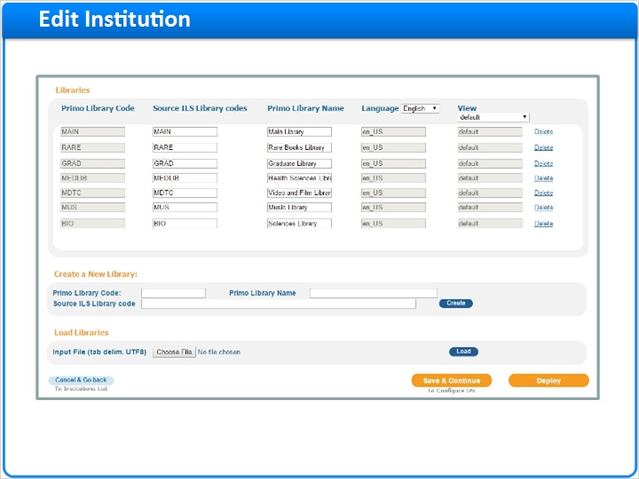

1.16 Summary
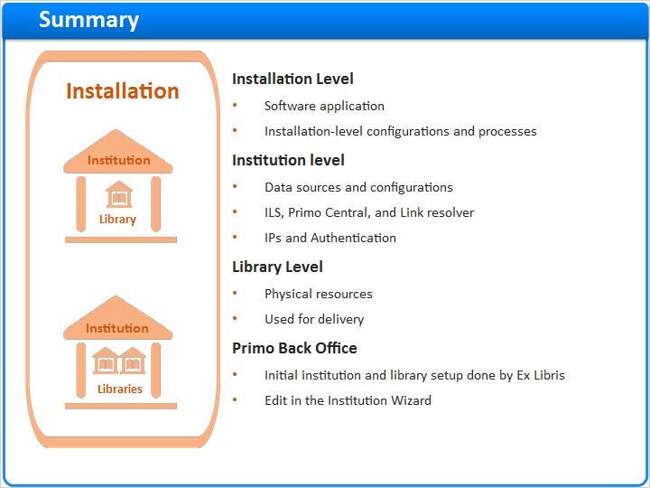
Notes:
The Primo administrative structure consists of an installation, one or more institutions, and a library or libraries that exist within each institution. Each level has its own set of characteristics and configuration options, and your access level will determine which levels you can see and edit.

When you are implementing Primo, the institutions and libraries will be configured for you initially, but you will be able to edit them by accessing the Institution Wizard.

This administrative structure allows Primo to support the relationships between your own administrative units, your library or libraries, and your physical and electronic resources.

1.17 Session Review and Quiz
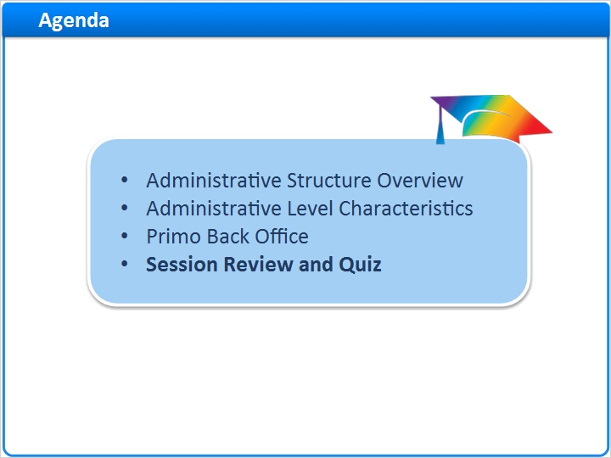
Notes:
Session Review and Quiz

1.18 Session Review
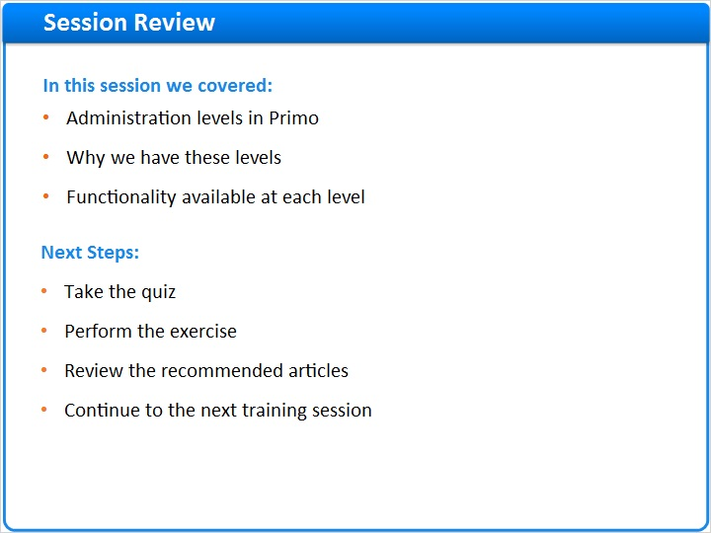
Notes:
In this session we covered the administration levels in Primo, why we have these levels, and the functionality available at each level.
After the brief quiz that begins on the next page, please complete the exercise that is provided in the Knowledge Center where you launched this training. Please refer to the Recommended Articles section for additional information.

After finishing the exercise, you can continue on to the next training session in this series.

1.19 Question 1
(Multiple Choice, 10 points, 1 attempt permitted)
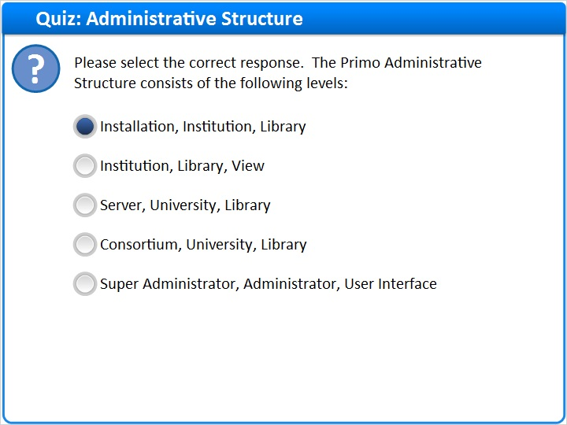
Correct | Choice
X | Installation, Institution, Library
 | Institution, Library, View
 | Server, University, Library
 | Consortium, University, Library
 | Super Administrator, Administrator, User Interface
Feedback when correct:
The Primo Administrative Structure consists of the installation, institution and library levels.
Feedback when incorrect:
The Primo Administrative Structure consists of the installation, institution and library levels.

Notes:

Correct (Slide Layer)
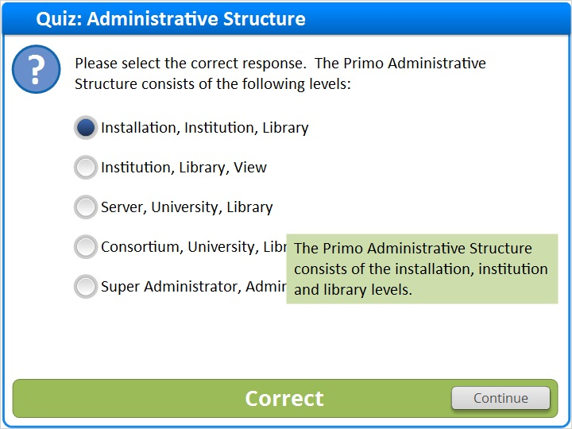

Incorrect (Slide Layer)
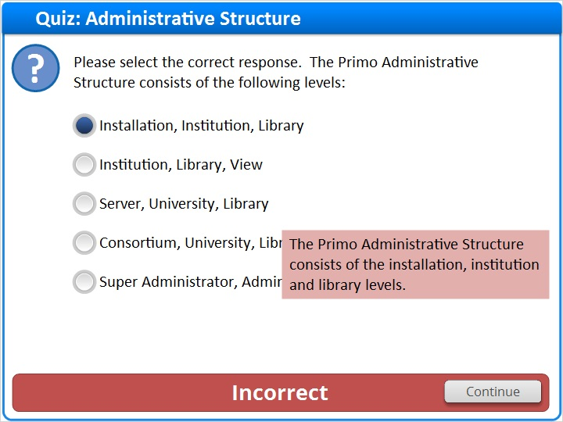

1.20 Question 2
(Multiple Response, 10 points, 1 attempt permitted)
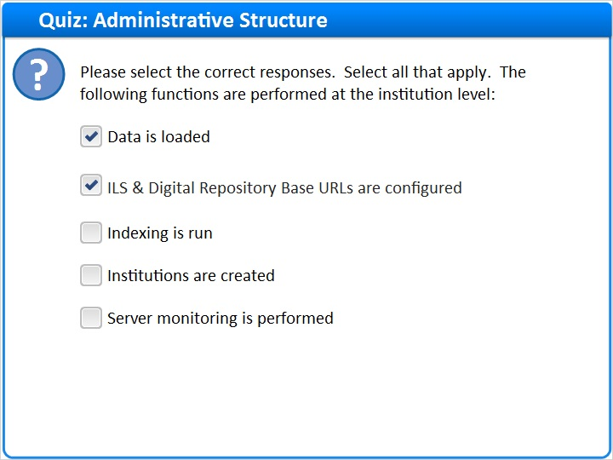
Correct | Choice
X | Data is loaded
X | ILS & Digital Repository Base URLs are configured
 | Indexing is run
 | Institutions are created
 | Server monitoring is performed

Feedback when correct:
The following functions are performed at the institution level: Data sources are configured, data is loaded, ILS & Digital Repository Base URLs are configured, IPs and authentication are configured, and the link resolver and Primo Central are configured. Indexing, institution creation and server monitoring happen at the installation level.
Feedback when incorrect:
The following functions are performed at the institution level: Data sources are configured, data is loaded, ILS & Digital Repository Base URLs are configured, IPs and authentication are configured, and the link resolver and Primo Central are configured. Indexing, institution creation and server monitoring happen at the installation level.

Correct (Slide Layer)
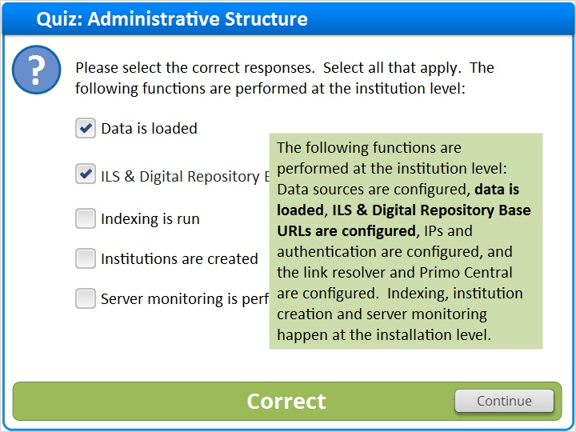

Incorrect (Slide Layer)
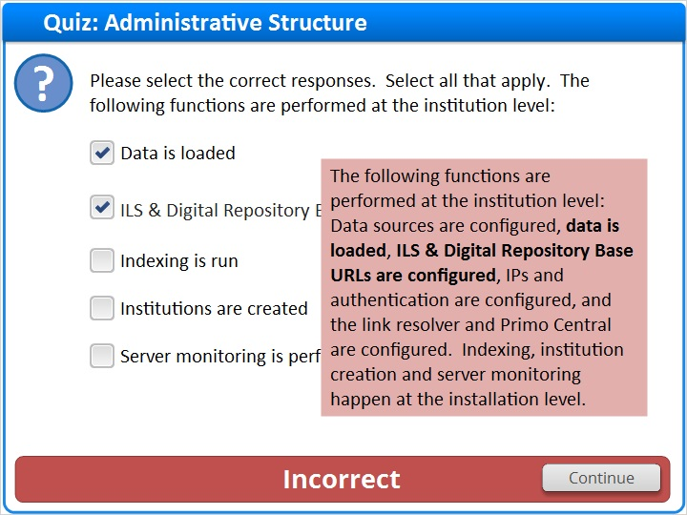

1.21 Question 3
(True/False, 10 points, 1 attempt permitted)
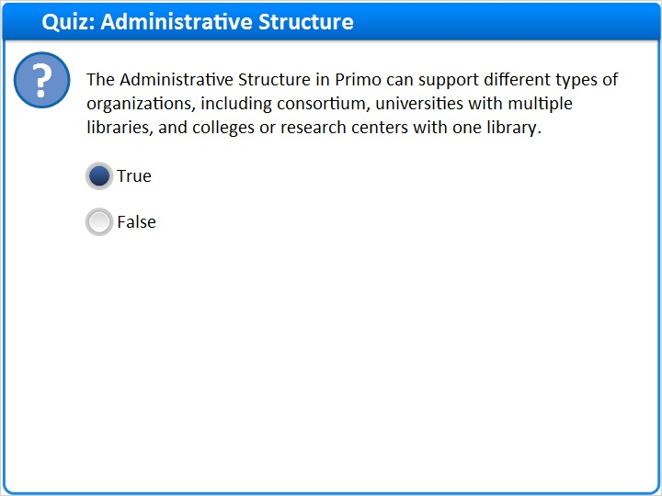
Correct | Choice
X | True
 | False

Feedback when correct:
The Administrative Structure in Primo can support different types of organizations, including consortium, universities with multiple libraries, and colleges or research centers with one library.
Feedback when incorrect:
The Administrative Structure in Primo can support different types of organizations, including consortium, universities with multiple libraries, and colleges or research centers with one library.

Notes:

Correct (Slide Layer)
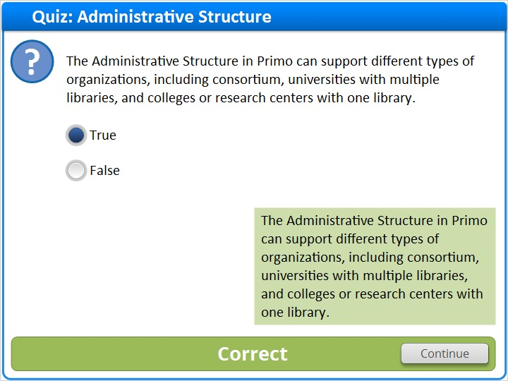

Incorrect (Slide Layer)
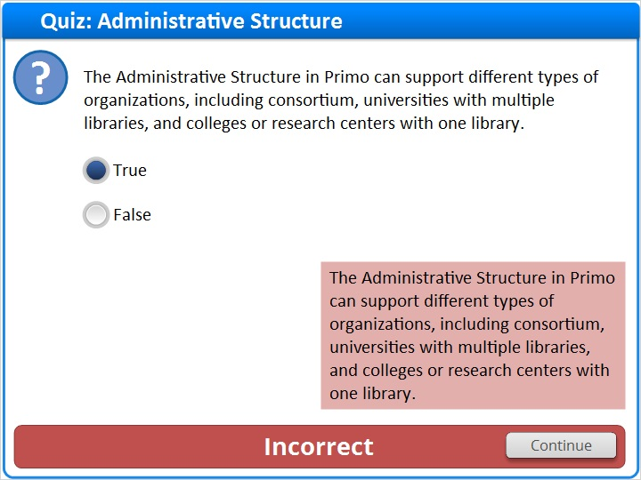

1.22 Thank You!

Notes:
Thank you for joining this session!

1.23 About this Training
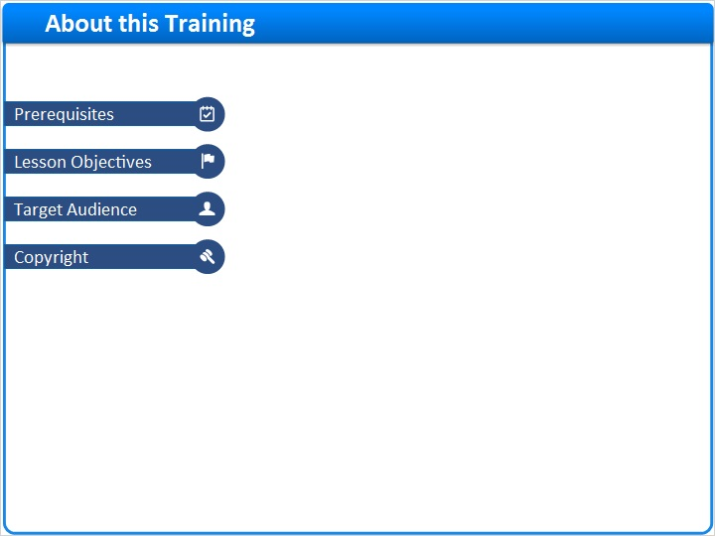
Notes:

1 (Slide Layer)
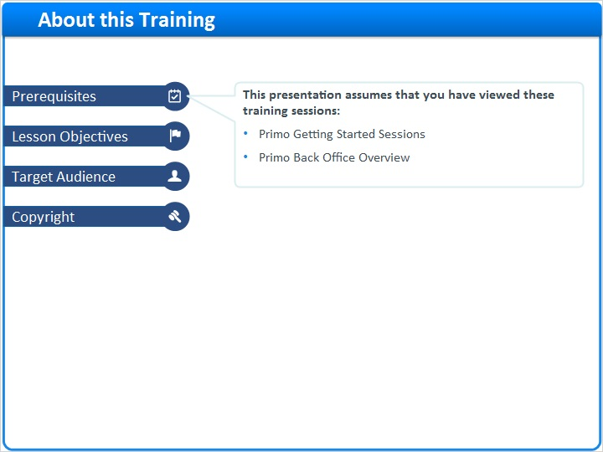

2 (Slide Layer)
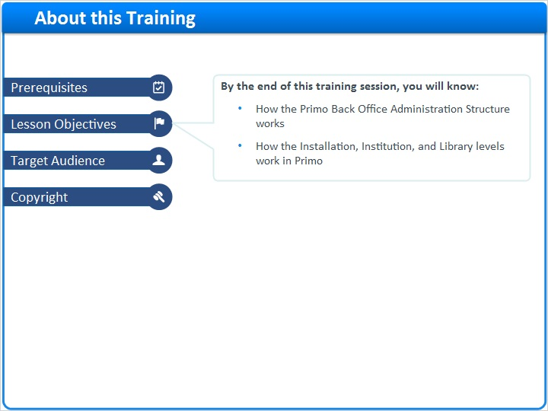

3 (Slide Layer)
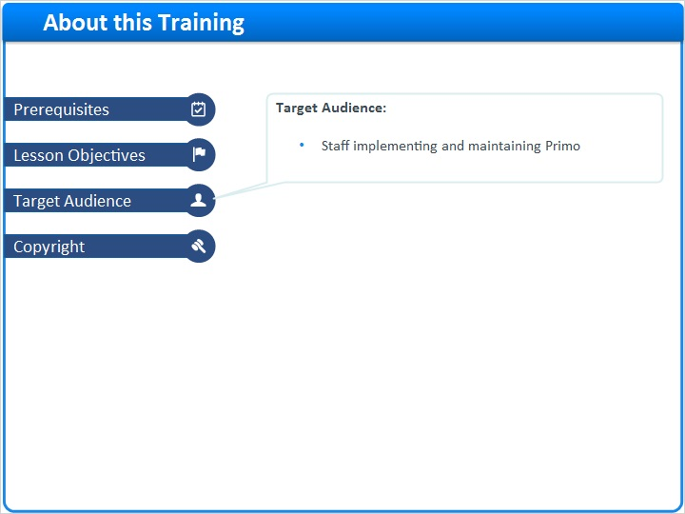

4 (Slide Layer)


