Primo Administration: Pipes Configuration

1. Primo Administration: Pipes Configuration

1.1 Primo Administration: Pipes Configuration
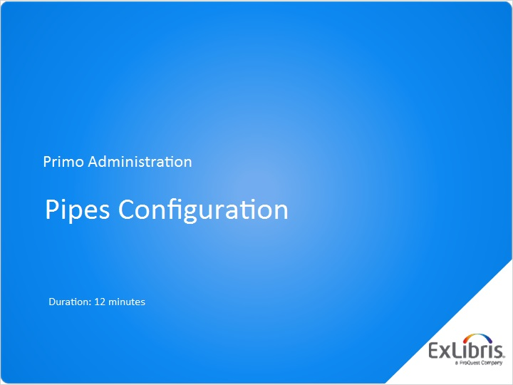
Notes:
Hello, and welcome to this session on Primo Pipes Configuration.

1.2 Agenda
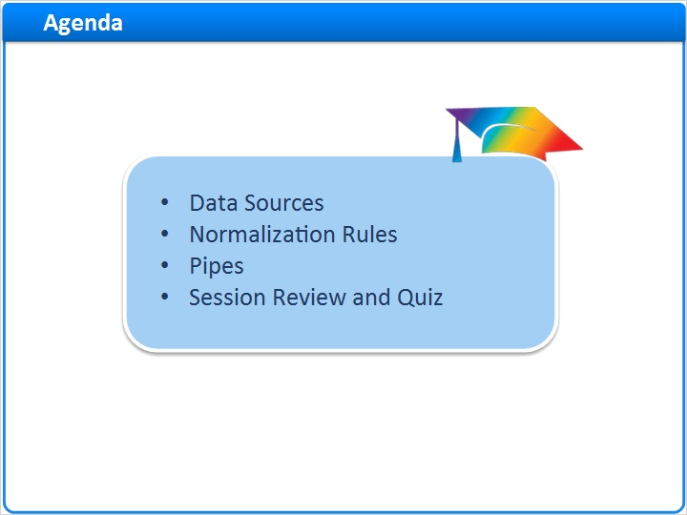
Notes:
In this session, we’ll walk through the steps needed to load data into Primo. First, a data source must be created, a normalization rule must be in place, and a pipe needs to be configured to instruct Primo where to harvest and how to load the data.

After a session review, there will be a short quiz to test your knowledge.

1.3 Data Sources
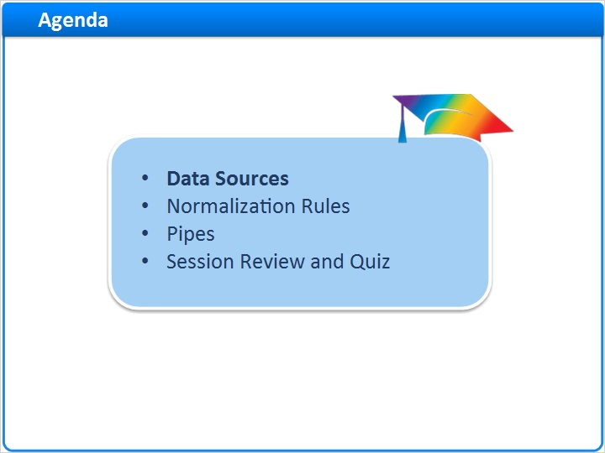
Notes:
Data Sources

1.4 Data Source Configuration
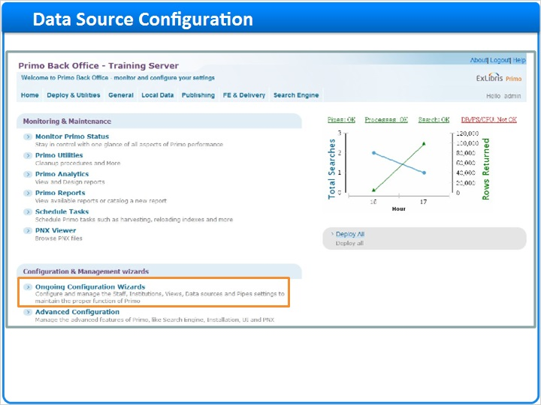
Notes:
To configure the data source, we can go to Ongoing Configurations > Pipe Configuration Wizard > Data Sources Configuration. We can also get to the Data Sources list by selecting Local Data > Data Sources in the navigation bar at the top of the screen.

In the Data Sources List, we can see any data sources that have already been created in our institution. Our list is currently blank, so let’s create one.

Pipe Configuration Wizard (Slide Layer)
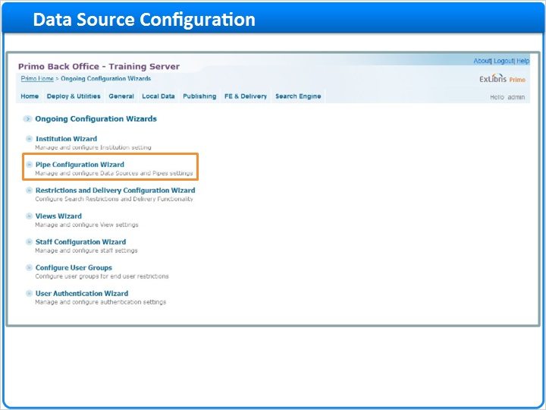

Data Sources Configuration (Slide Layer)
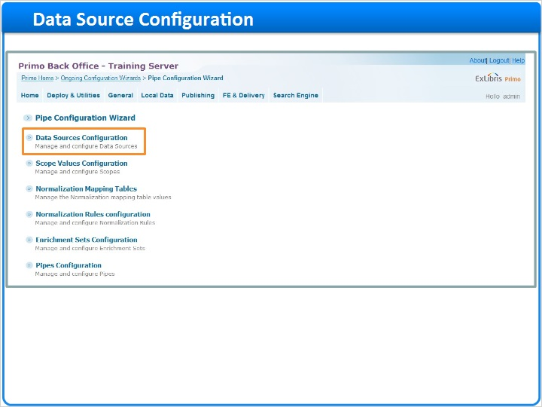

Data Sources List (Slide Layer)
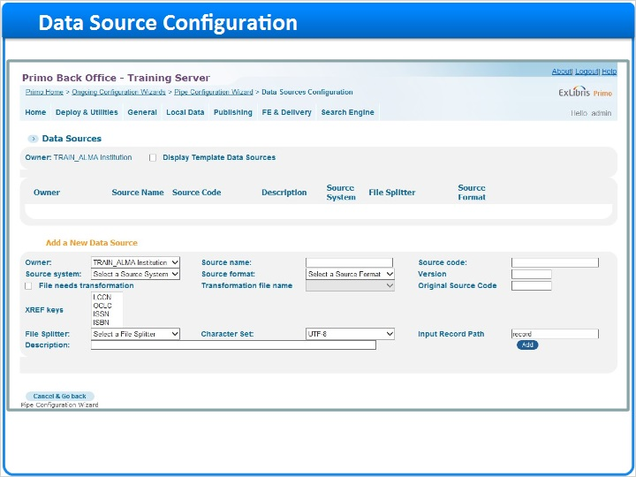

Navigation path (Slide Layer)
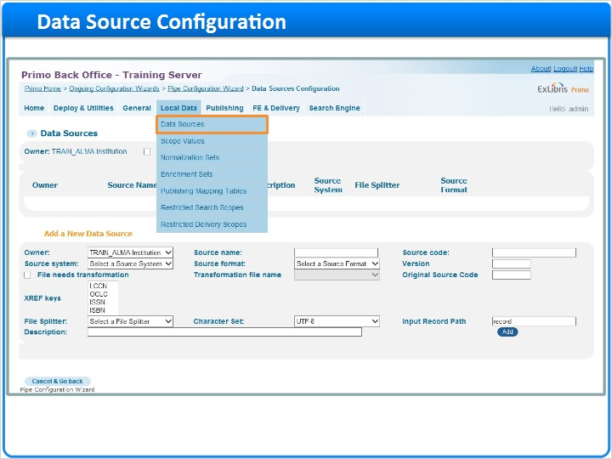

Data sources list default (Slide Layer)
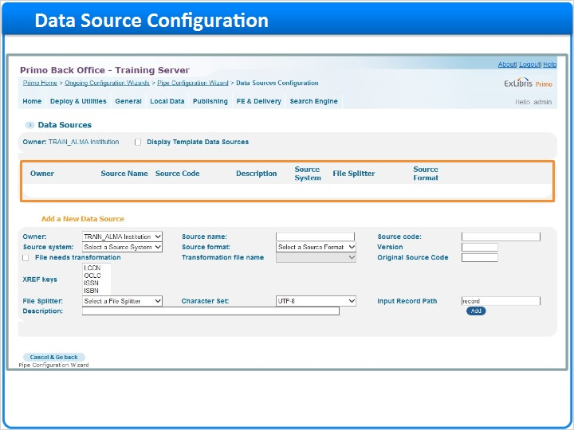

1.5 Adding a Data Source
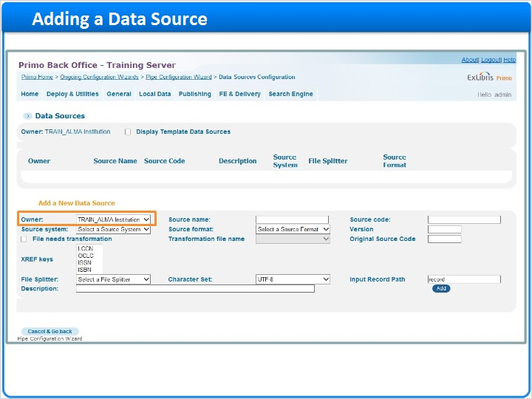
Notes:
To add a new data source, we would ensure the Owner is set to the correct institution, and then enter in a Source Name (TRAIN_ALMA_DS) and a Source Code (TRAIN_ALMA_DS). Since the source code is used as the prefix for the Primo Record ID, it should not contain spaces.

Then we would select the Source System, in this case, Alma, and the source format, which in this case is MARC 21.

The Version refers to the source system’s version, and is not required.

The ‘File Needs Transformation’ checkbox and transformation filename drop down allow you to specify an XSL transformation routine to apply to the source records if needed. For the data source we’re configuring here, it is not needed.

The original source code, however, is necessary - for this data source, we’ll be using the Alma institution code (TR_INTEGRATION_INST) as our original source code.

We can leave the crossref keys set to their defaults, but we will need to select a file splitter. The file splitter is used to identify the beginning and ending of each record in the file. For Alma data, the OAI splitter is used. We can keep UTF-8 for the character set, and the input record path is automatically filled in based on the source format, so we can keep the default value here as well.

Finally, we can enter in a description here before clicking ‘Add’ to create the new data source.

Enter source name (Slide Layer)
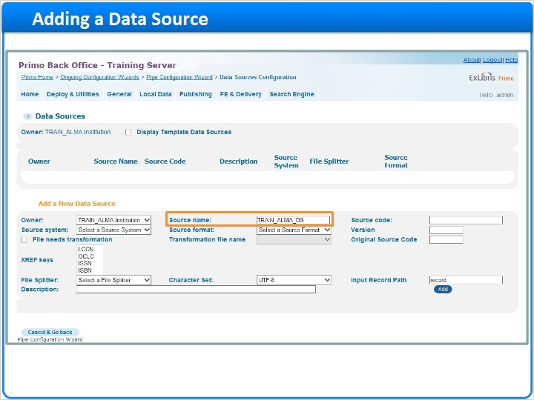

Enter source code (Slide Layer)
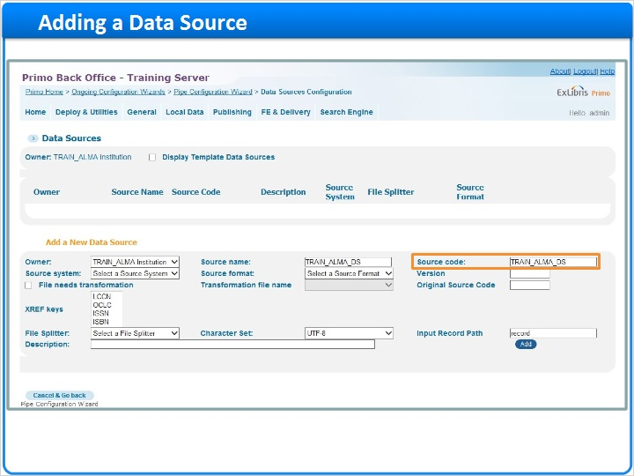

Select source system (Slide Layer)
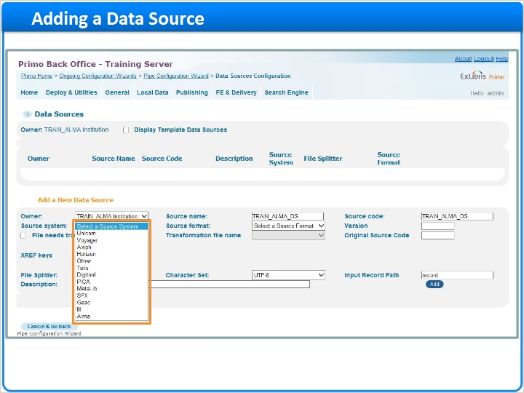

Select source format (Slide Layer)
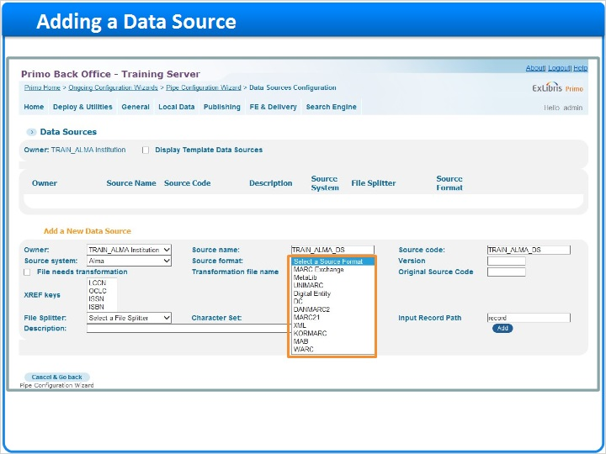

Version (Slide Layer)
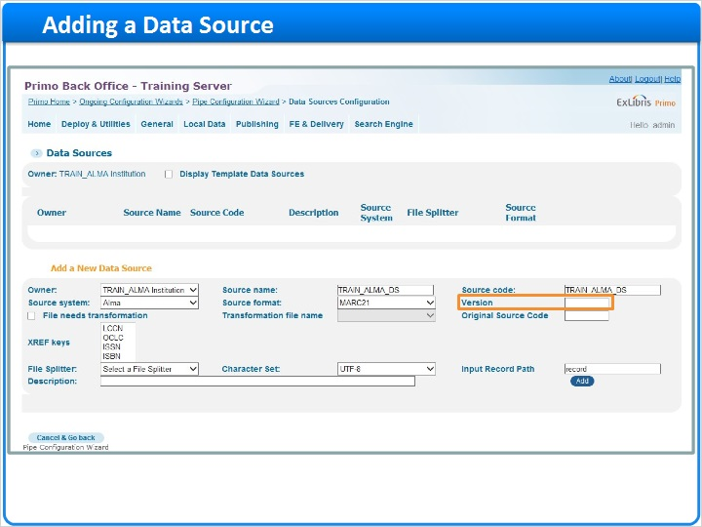

File needs transformation (Slide Layer)
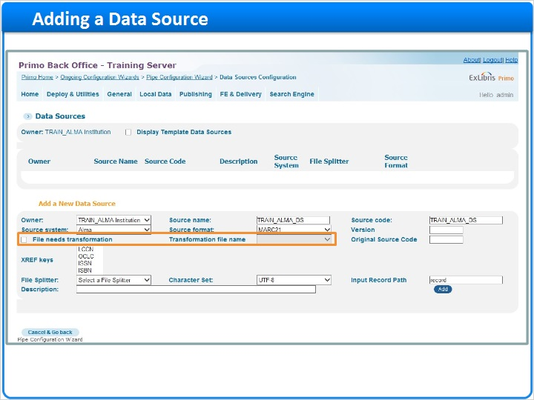

Original source code (Slide Layer)
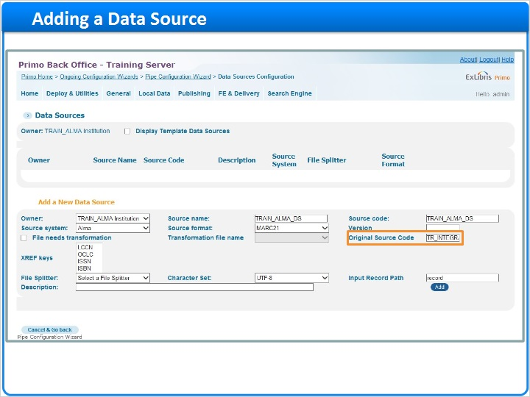

Xref keys (Slide Layer)
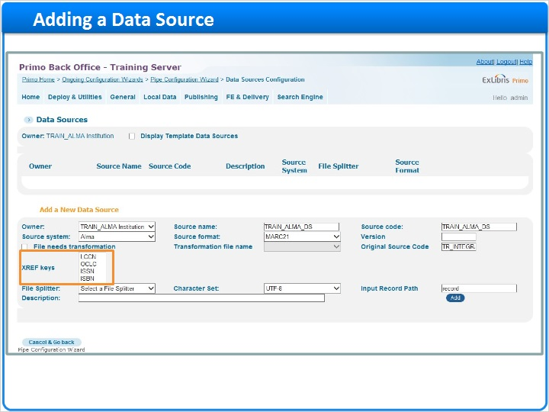

Select file splitter (Slide Layer)
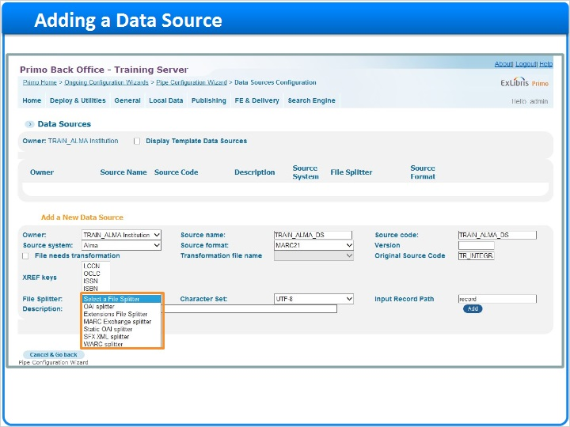

UTF-8 char set (Slide Layer)
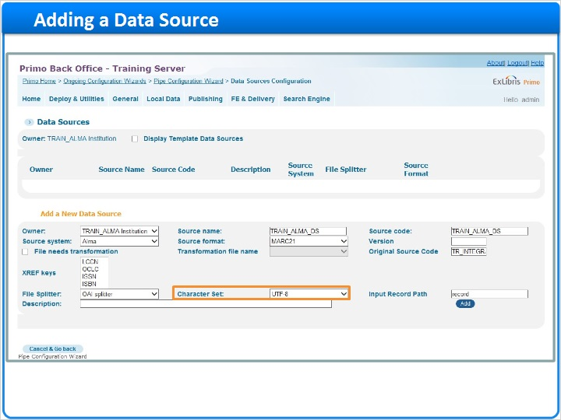

Input record path (Slide Layer)
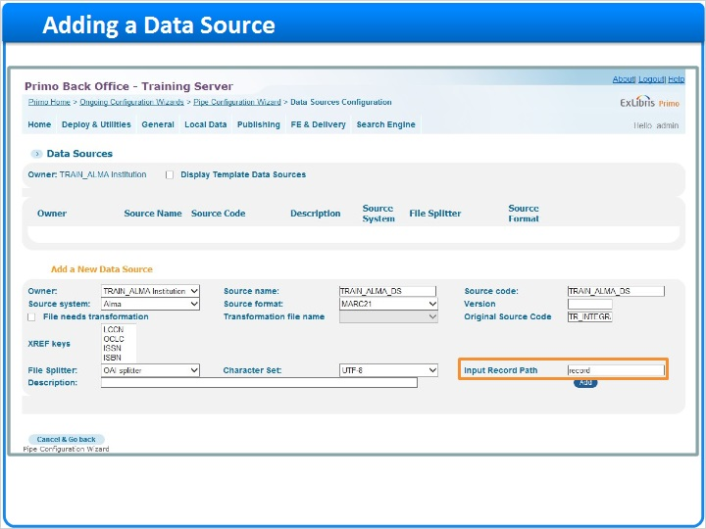

Description (Slide Layer)
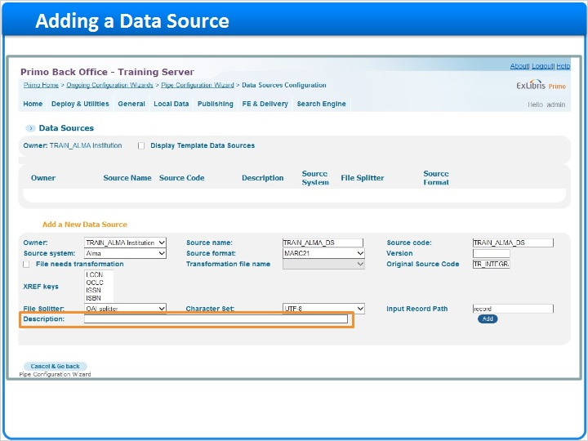

Add data source (Slide Layer)
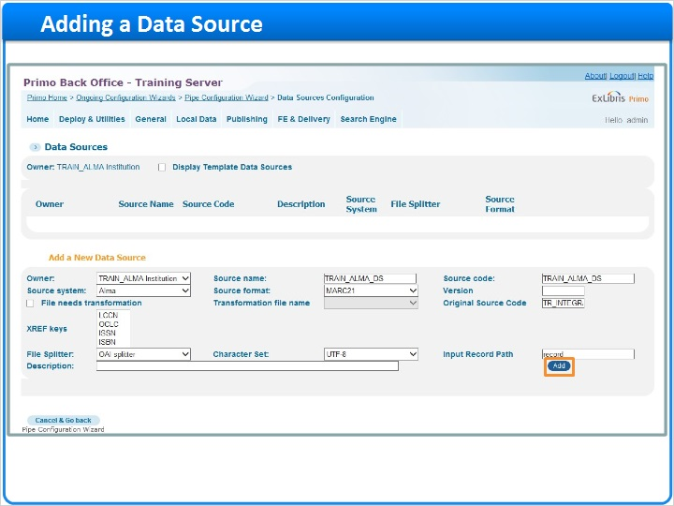

1.6 Editing a Data Source
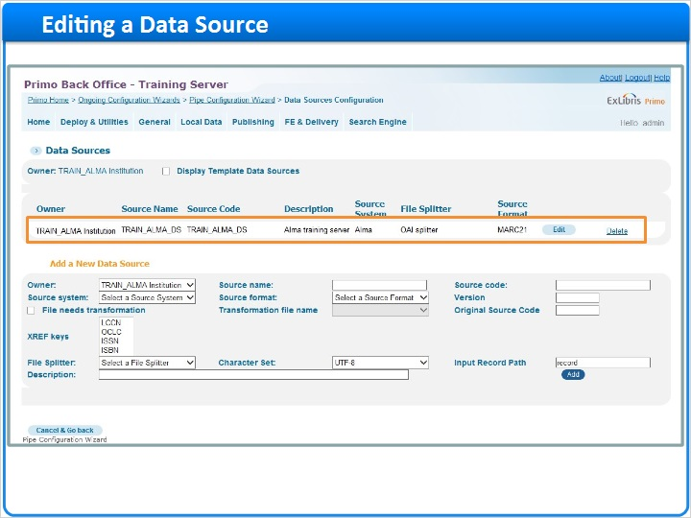
Notes:
Now we can see the data source we’ve created in the list. I can edit and see the details of this data source after it has been created by clicking edit here in the list. If I wanted to edit any of the parameters I’ve entered, I would do so and click Save and Continue to go back to the Data Sources list.

Now that we’re done configuring the data source, I’m going to click ‘Cancel and Go Back’ to return to the Primo Home page.

Click edit (Slide Layer)
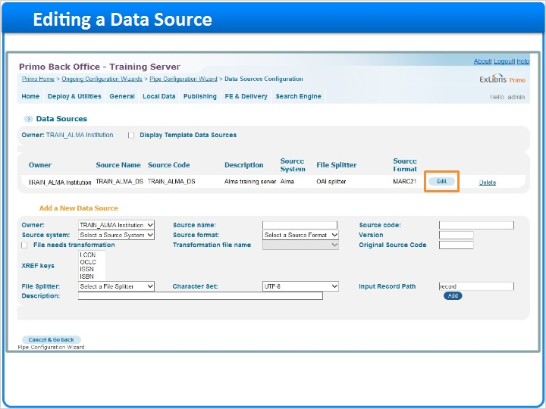

Edit screen (Slide Layer)
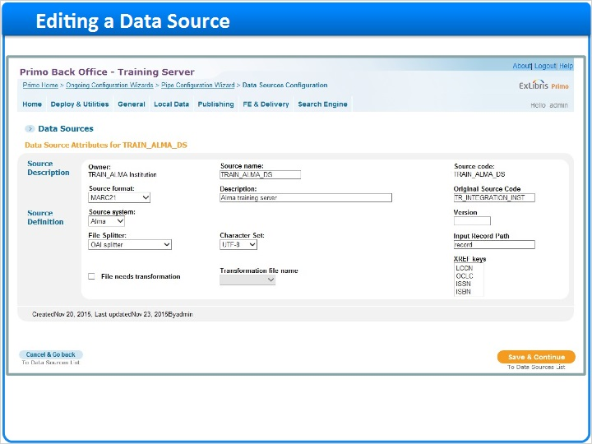

Save and continue (Slide Layer)
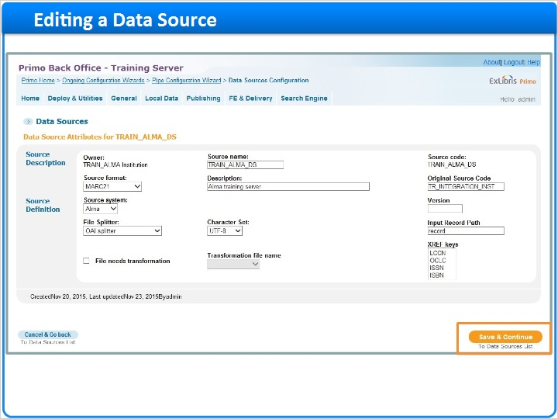

Data sources list (Slide Layer)
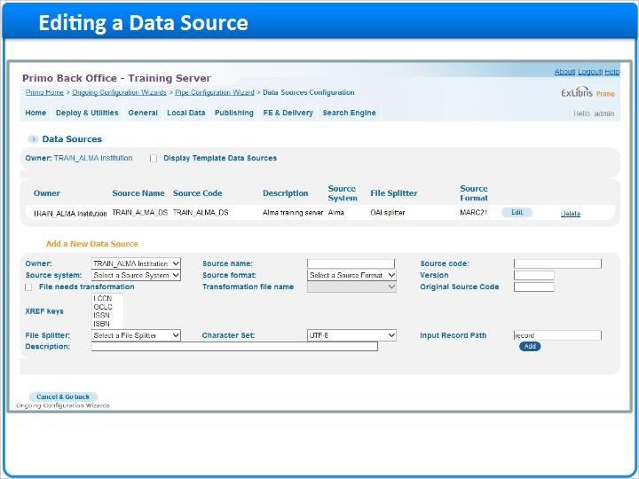

Cancel and go back (Slide Layer)
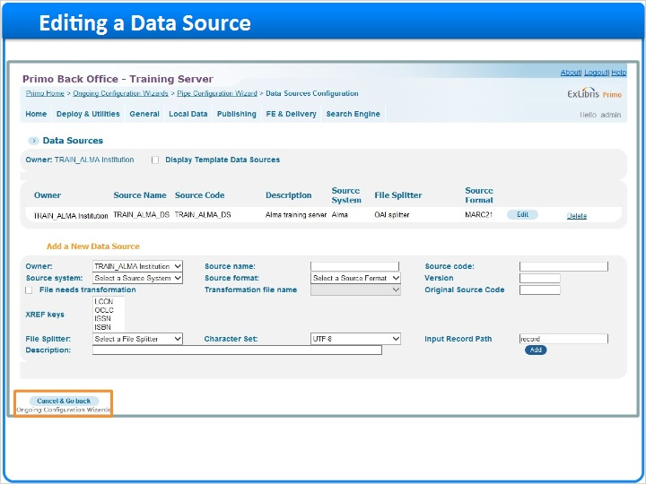

Primo home page (Slide Layer)
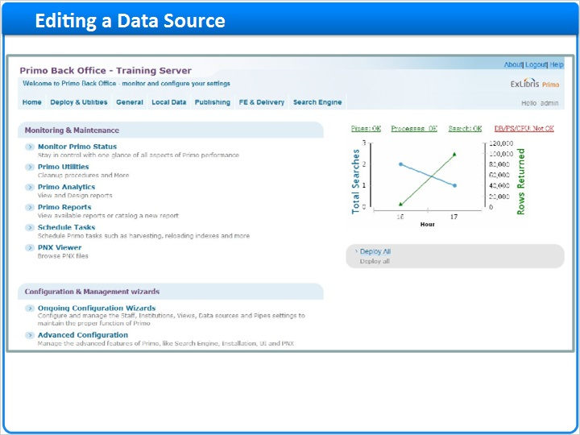

1.7 Normalization Rules
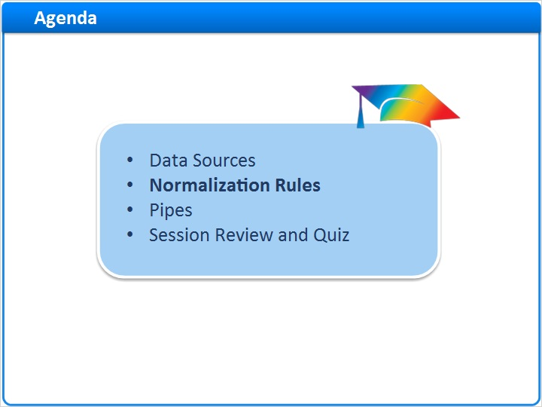
Notes:
Normalization Rules

1.8 Normalization Rules Configuration
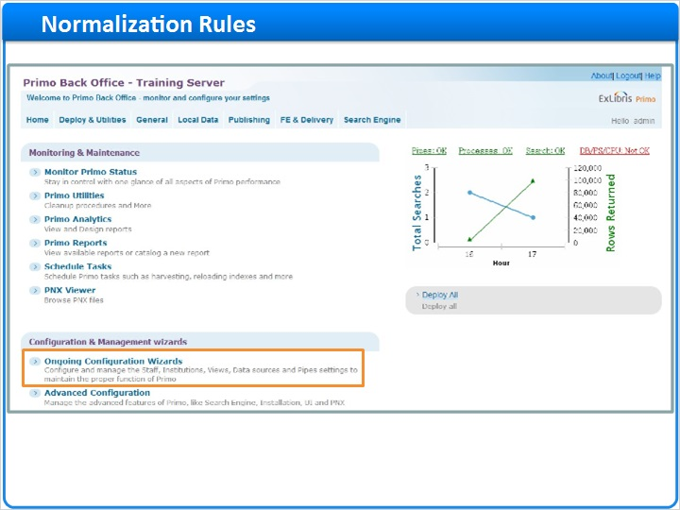
Notes:
The next step in loading data into Primo is to determine which normalization rules will be used to process the data.

To access the normalization rules, we go to Ongoing Configurations > Pipe Configuration Wizard > Normalization Rules Configuration. We can also get to the Normalization Rules by selecting Local Data > Normalization Sets in the navigation bar at the top of the screen.

As part of the publishing process, the data from our source systems needs to be transformed, or normalized, into Primo’s standard format, the Primo Normalized XML.

To perform the normalization, the system applies a set of rules to the source data. Right now, we do not have a customized normalization rule in place, but If I select ‘Display Template NR’, we can see the list of template normalization rules. Near the bottom of the page, we can see a normalization rule for the Alma MARC data. For today’s session we will be using this template, but it is possible to copy the template and customize it based on your institution’s needs.

Now that I’ve confirmed which normalization rule we’re going to use, I’m going to click ‘Back’ to return to the Primo Home Page.

Pipe configuration (Slide Layer)
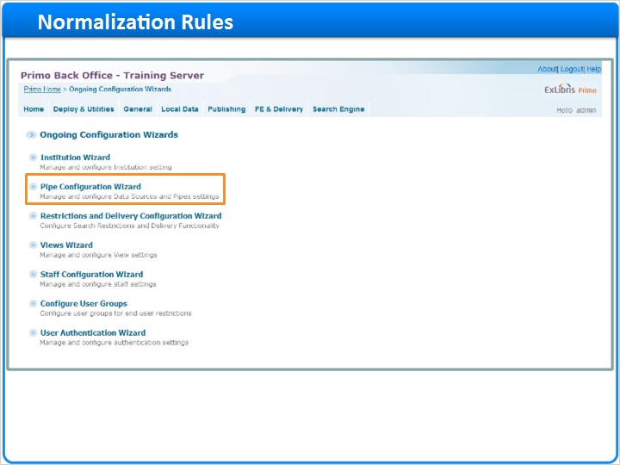

Norm rules configuration (Slide Layer)
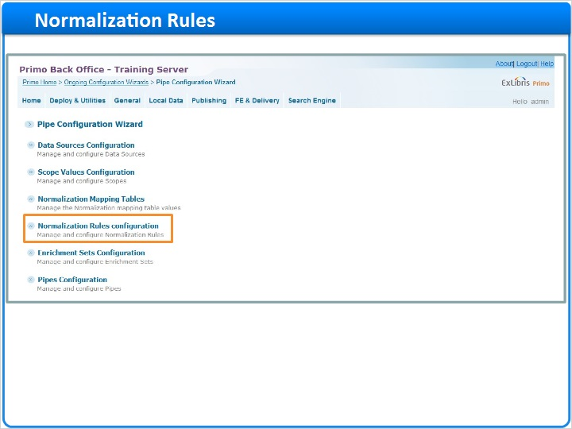

Normalization rules list (Slide Layer)
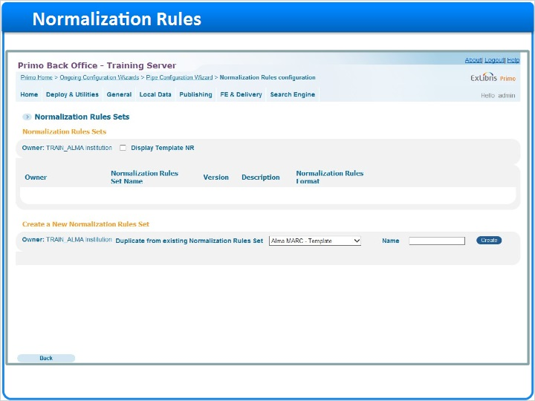

Navigation menu (Slide Layer)
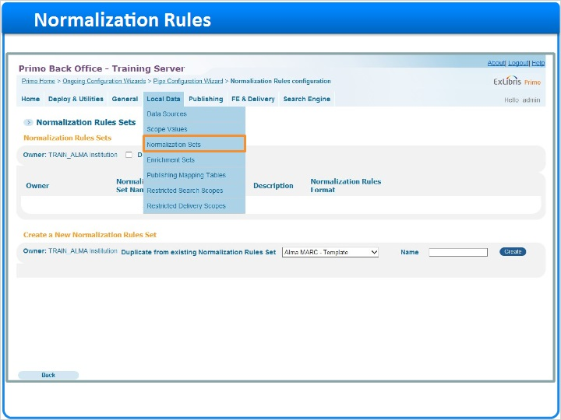

Norm rules list (Slide Layer)

Display template NR (Slide Layer)
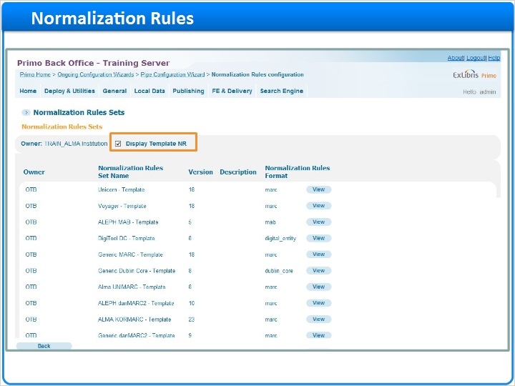

List of template NR (Slide Layer)
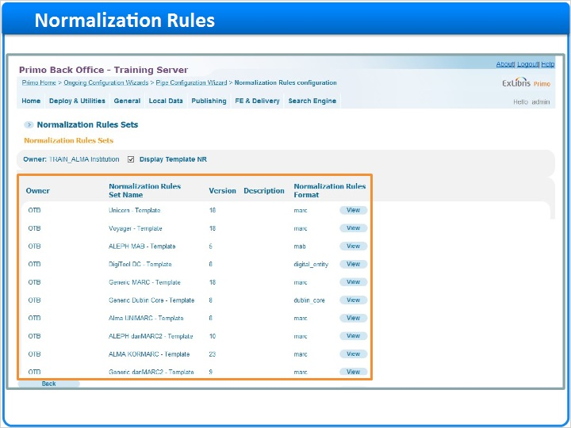

Scroll down (Slide Layer)
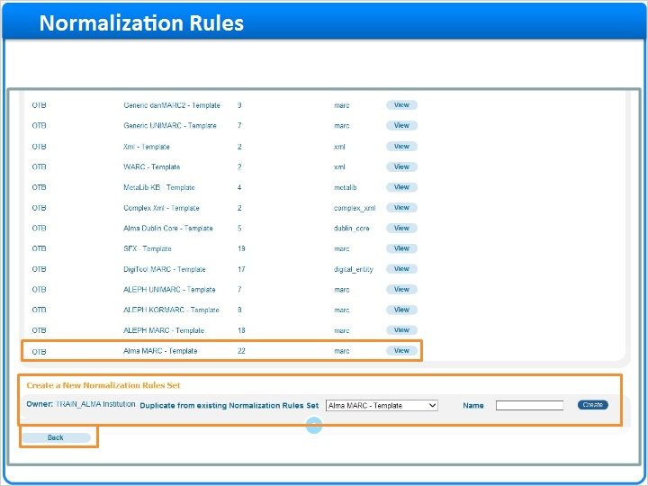

Primo home (Slide Layer)
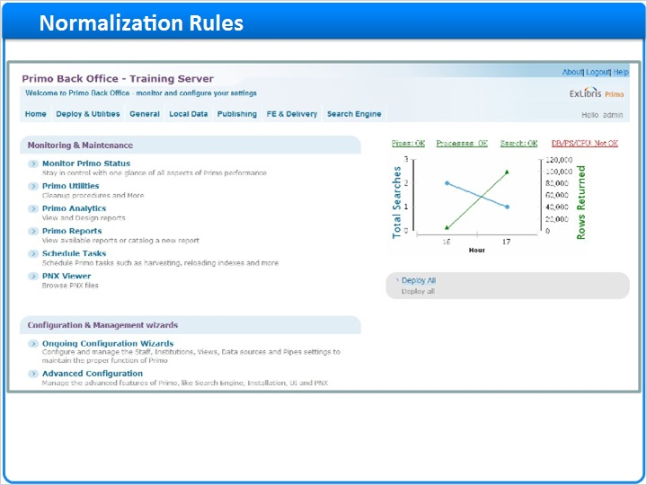

1.9 Pipes
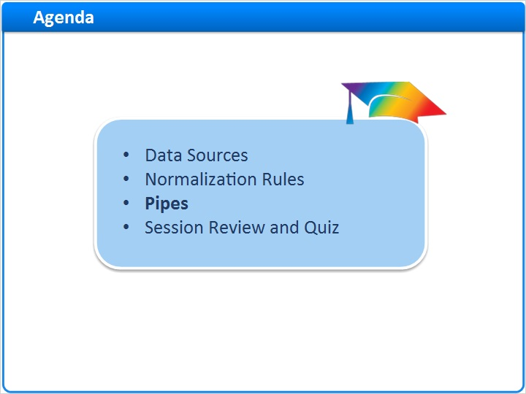
Notes:
Pipes

1.10 Pipes Configuration
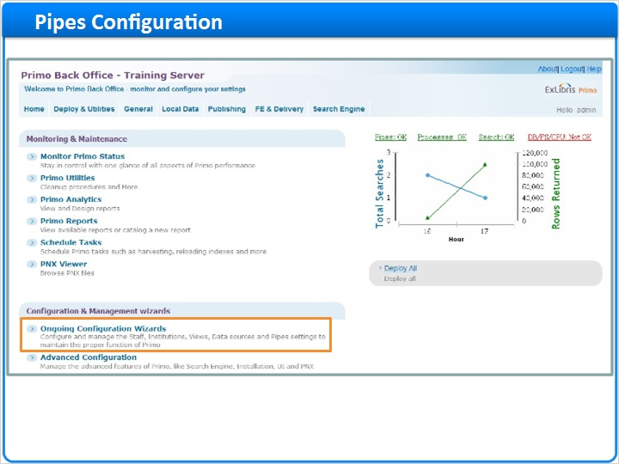
Notes:
Now we’re ready to configure the pipe to load the data into Primo.

To access the pipe configuration, we go to Ongoing Configurations > Pipe Configuration Wizard > Pipes Configuration, Define Pipe. You’ll notice that I am brought immediately into the pipe creation screen. We can also get to the Pipes creation by selecting Publishing > Create a New Pipe in the navigation bar at the top of the screen.

If we wanted to see the list of pipes that have already been created, we could use the Pipe List link here in the navigation bar, or we could use the ‘Back to Pipes List’ link at the bottom of the screen.

For now, let’s stay in this screen and see how a pipe is created.

Pipe configuration wizard (Slide Layer)
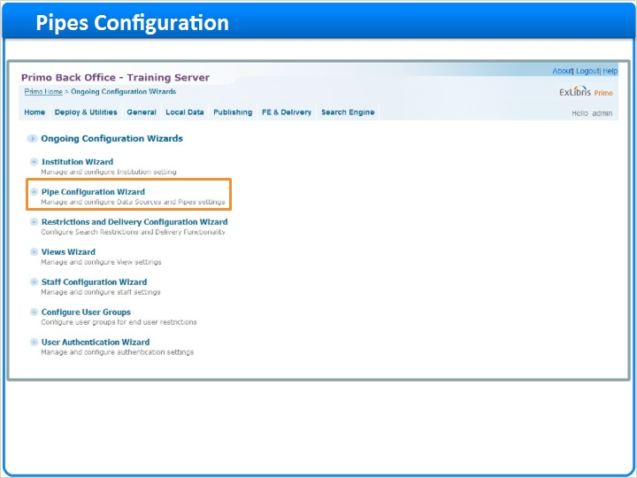

Manage and configure pipes (Slide Layer)
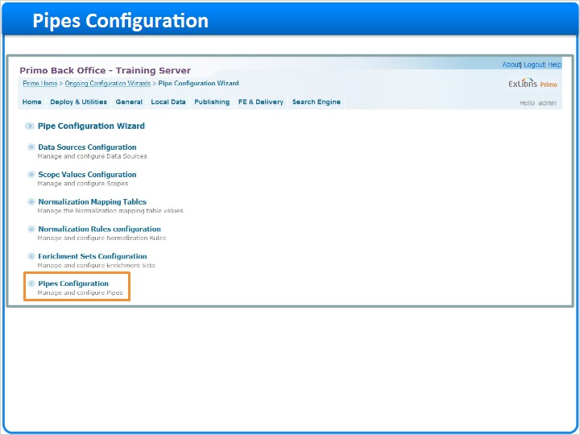

Define a pipe (Slide Layer)
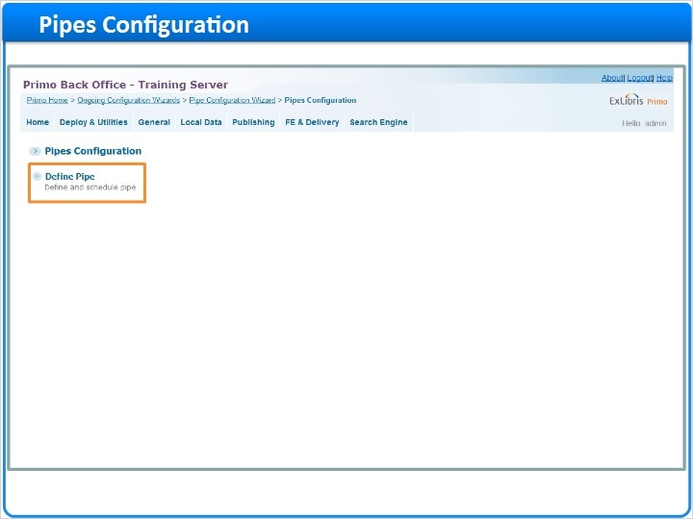

Define pipe screen (Slide Layer)
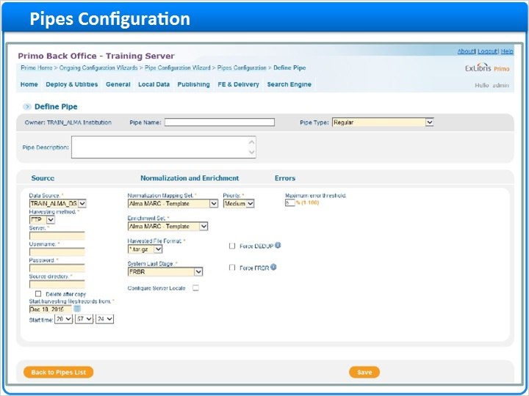

Top nav - create (Slide Layer)
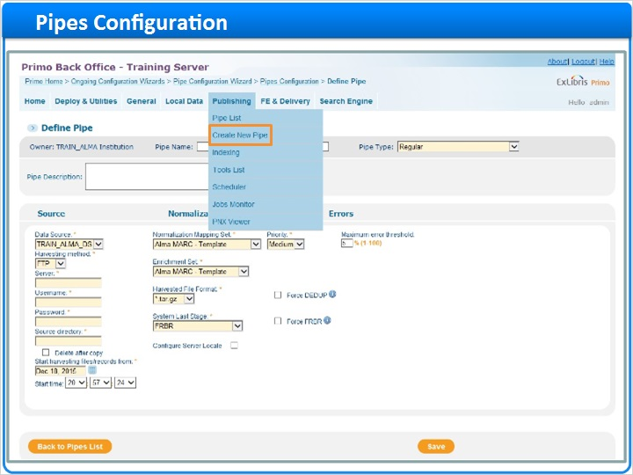

Top nav - pipe list (Slide Layer)
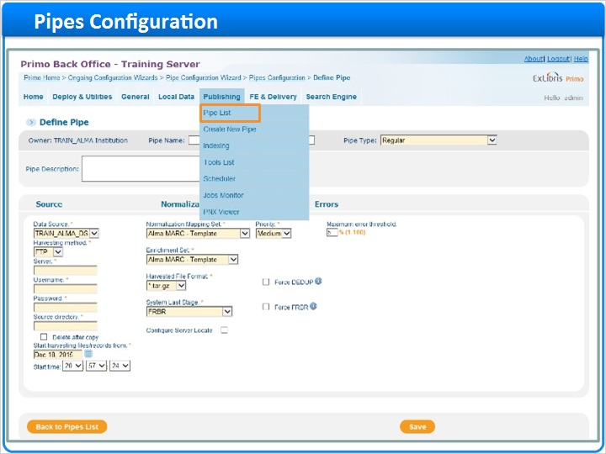

Back to pipes list (Slide Layer)
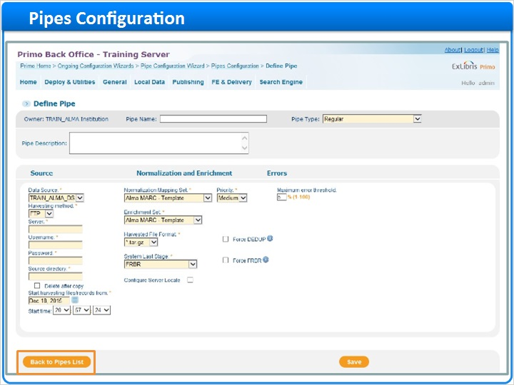

1.11 Adding a Pipe
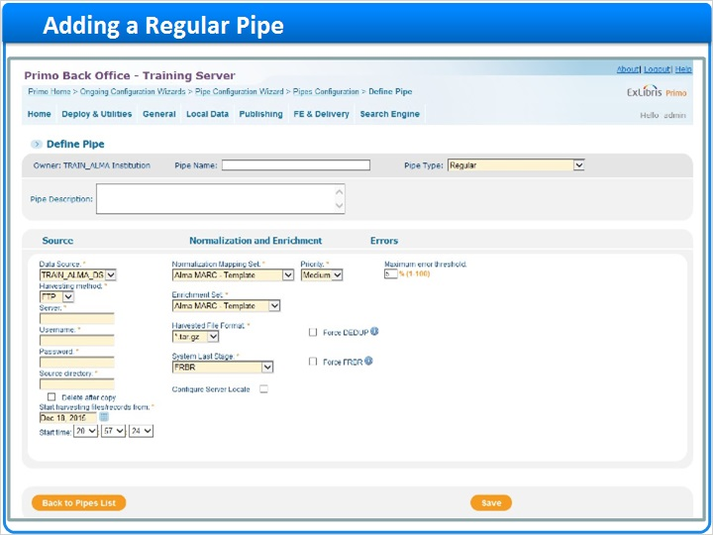
Notes:
First, we want to determine the type of pipe we want to create, then name it.

There are several different types of pipes, and the configuration for each pipe differs depending on which type we are setting up. Today we will create a regular pipe, so the pipe will be named TRAINALMA_Regular, and the pipe type will be set to Regular. If we wanted to enter a description, we could do so here.

Regular pipes are used to load data from the data source, whether it’s the full data set or ongoing updates to the data.

To configure a regular pipe, we select the data source, which in our case is TRAINALMA_DS and the normalization mapping set, ALMA MARC Template.

We can leave the priority set to medium, and the maximum error threshold set to 5%.

The enrichment set can be selected based on the source system. If we did not see our source system, we could select ‘No Enrichments’, but in our case we can select Alma MARC - template.

Next, we select the harvesting method. We can use FTP or SFTP if we need to access a different server to pick up the extracted files. Notice that I’m also prompted to fill in the server name, credentials, and source directory with these selections. If I was harvesting data using OAI, I would select this method, and note that the parameters change to server, metadata format, and set. If I am putting the extracted files onto the Primo server, I would use the Copy harvesting method, and would fill in the directory where the files were being placed. Since the Alma data is being transferred to the Primo server after it’s extracted, I’m going to use this method, and fill in the directory.

Next I can choose whether or not to delete the records after they’ve been harvested - I am going to leave this unchecked for now.

The first time you run a regular pipe, you are most likely loading the full data set. You will want to set the date here to a date prior to when those data files were extracted. Once the pipe is run, this date will automatically adjust to ensure that the next time the pipe runs it will be only picking up new data, and not picking up all of the files in the directory.

The harvested file format will always be some form of compressed file, whether it is a tar.gz, warc, or zip. Our Alma data is in tar.gz format, so I will keep that selected.

The system last stage allows us to set the last stage of the publishing process. I am going to keep this set to FRBR. Please visit Ex Libris’ Knowledge Center If you are interested in more information regarding this setting, or the Force DEDUP and FRBR settings.

Before we click save, let’s see the other types of pipes that are possible.

Pipe Type (Slide Layer)
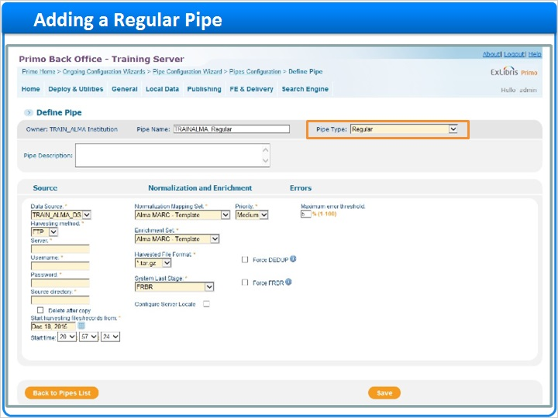

Pipe Name (Slide Layer)
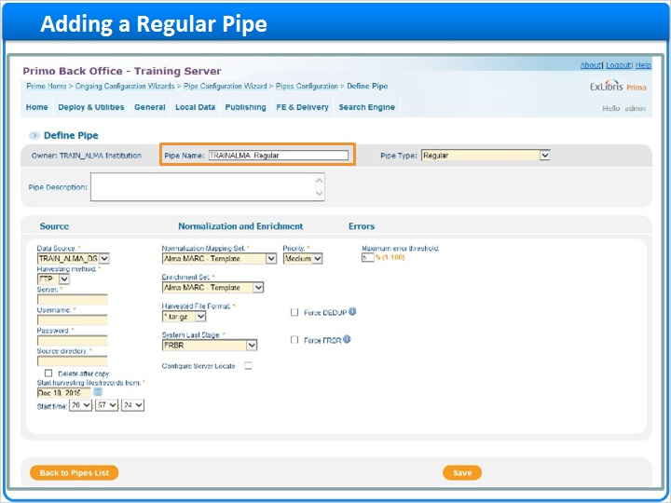

Pipe Description (Slide Layer)
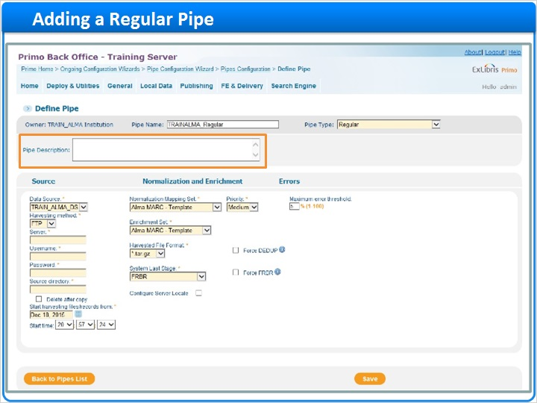

Data Source (Slide Layer)
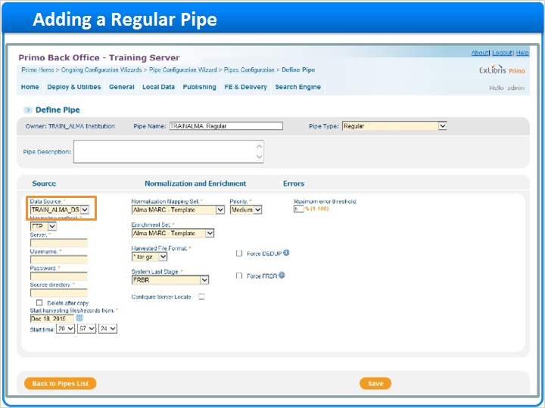

Normalization mapping set (Slide Layer)
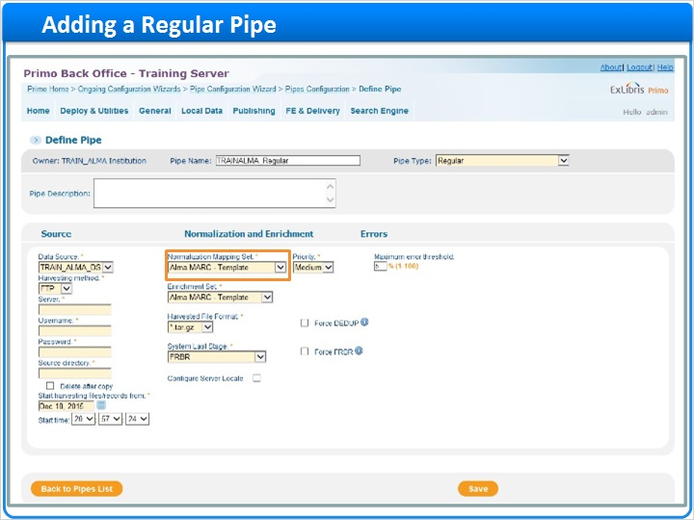

Priority and max error (Slide Layer)
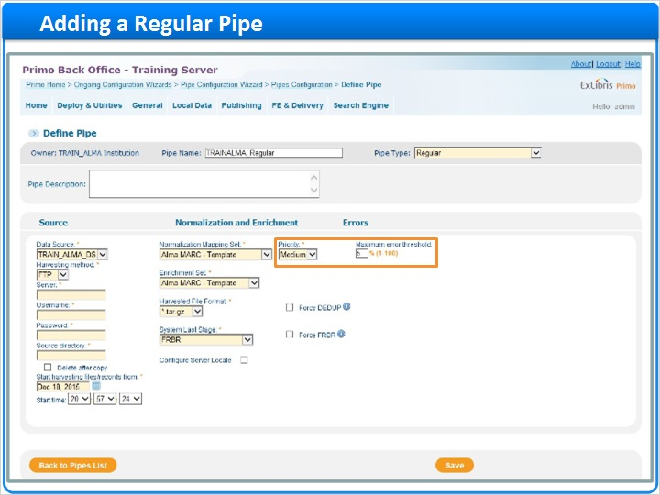

Enrichment set dropdown (Slide Layer)
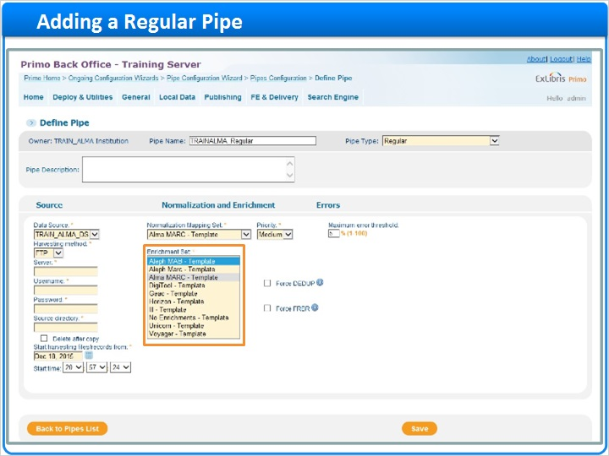

Enrichment set (Slide Layer)
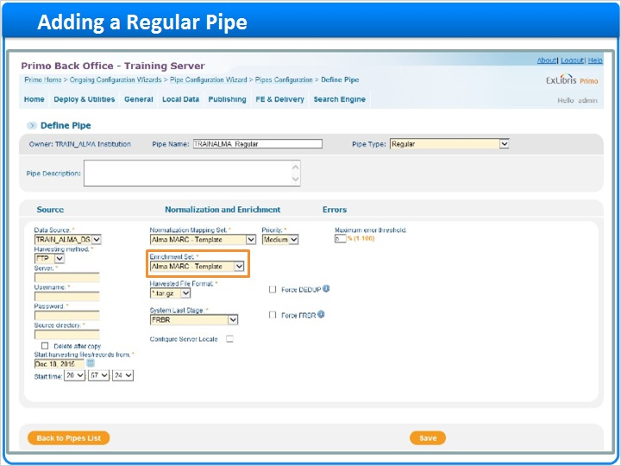

Harvesting method FTP (Slide Layer)
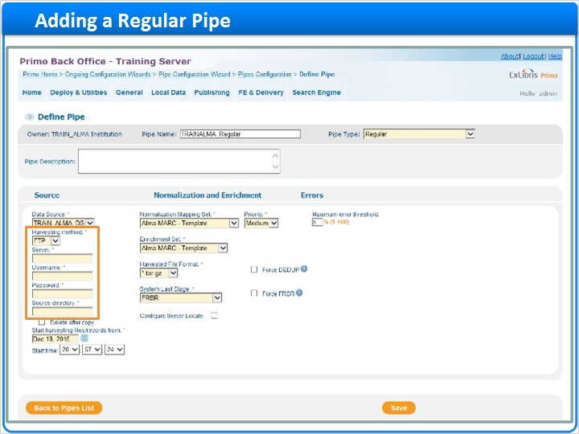

Harvesting method OAI (Slide Layer)
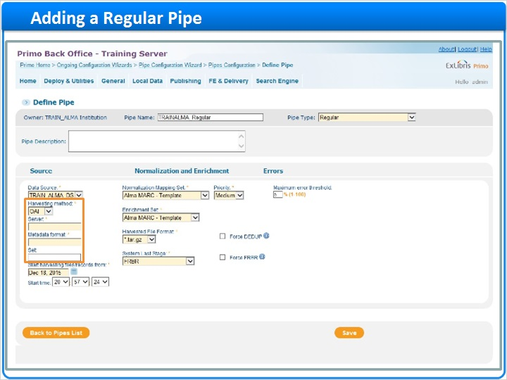

Harvesting method Copy (Slide Layer)
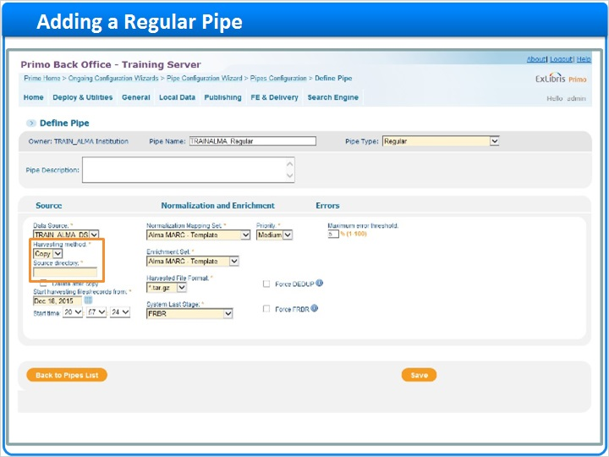

Harvesting method filled in (Slide Layer)
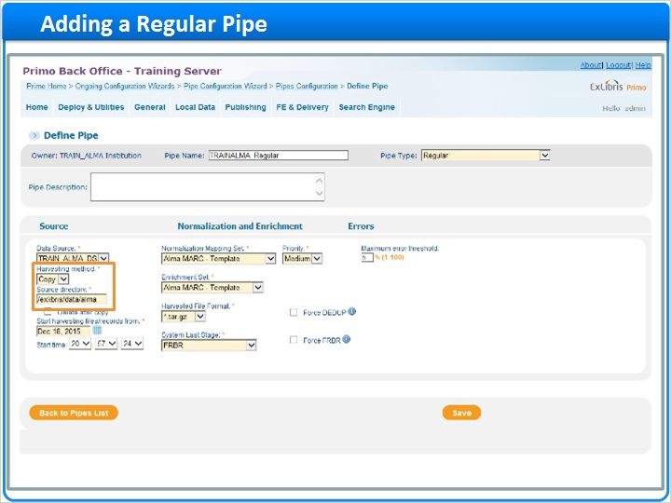

Delete records (Slide Layer)
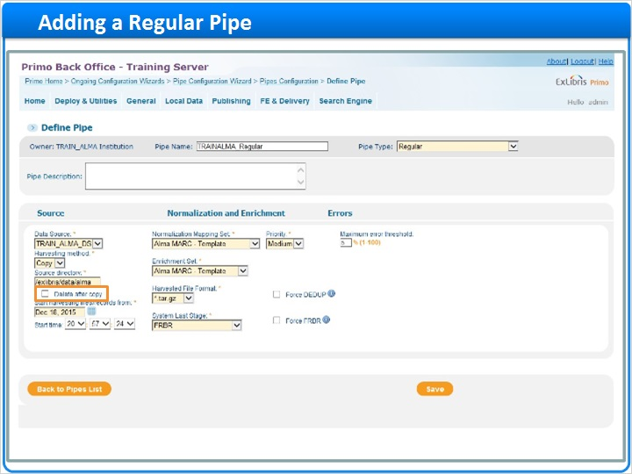

Date (Slide Layer)
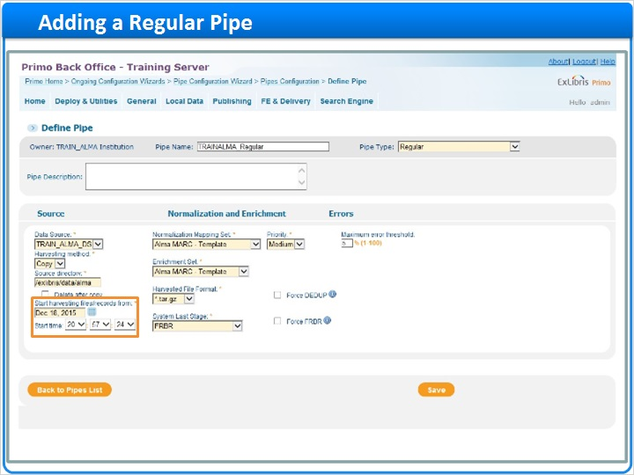

Format (Slide Layer)
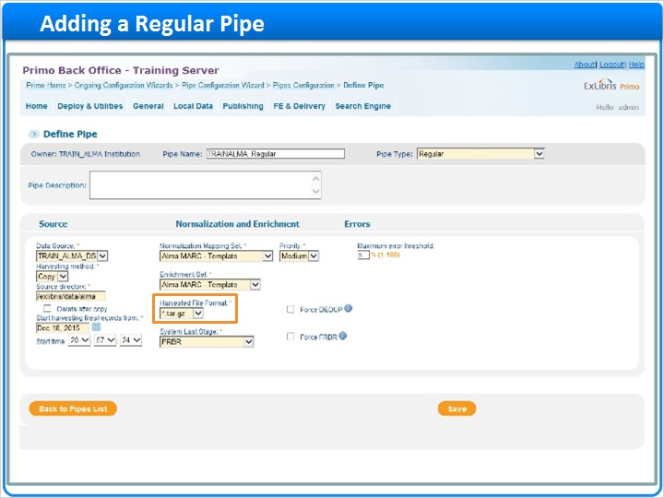

System last stage (Slide Layer)
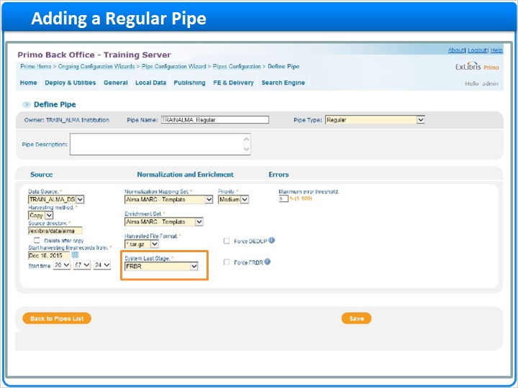

Last stage and force (Slide Layer)
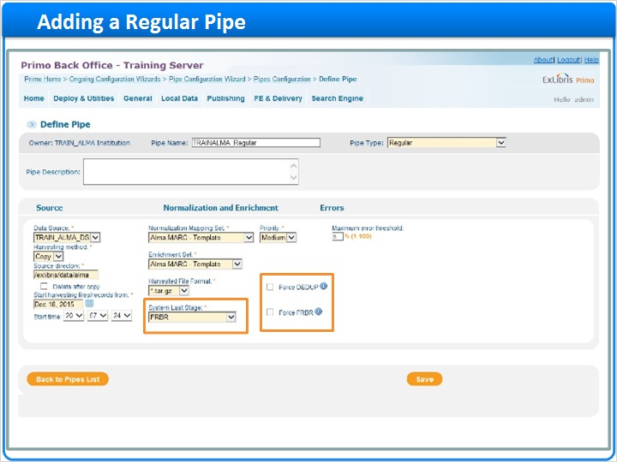

1.12 Pipe Types
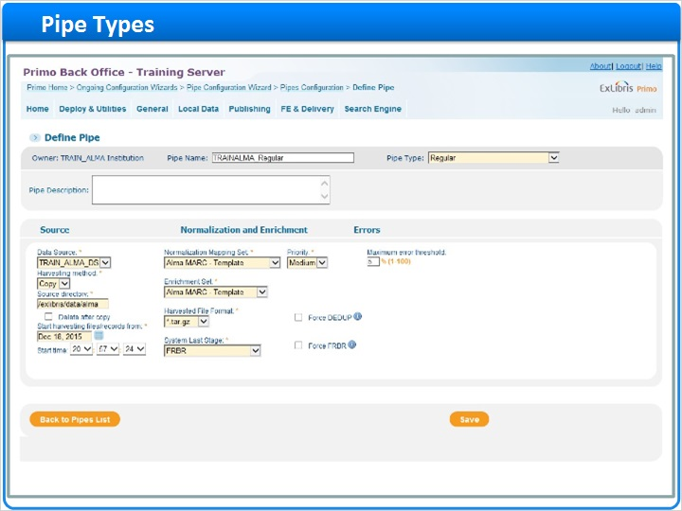
Notes:
While Regular pipes are used to load data from the data source, No Harvesting - Update Data Source pipes are used when updates have been made to the normalization rules and we want to apply those updates to the data. Since this pipe does not harvest the data from the source, you’ll note that when I have this type selected, I do not see the harvesting options, and only need to select the appropriate data source, normalization mapping set, and system last stage.

Delete Data Source does just that - it deletes any data associated with that data source. Notice that I only need to determine the data source for this type of pipe.

Delete Data Source and Reload deletes the data associated with the data source first, then reloads the data from the source system. Because of this, we have the harvesting options, and would need to ensure we set the date to include all of the files at the pickup site.

Now that we’ve seen each of the pipe types, let’s go back to the Regular pipe. Notice that my original parameters are still selected, so I can click save, and be brought back to the pipes list.

No harvest pipe (Slide Layer)
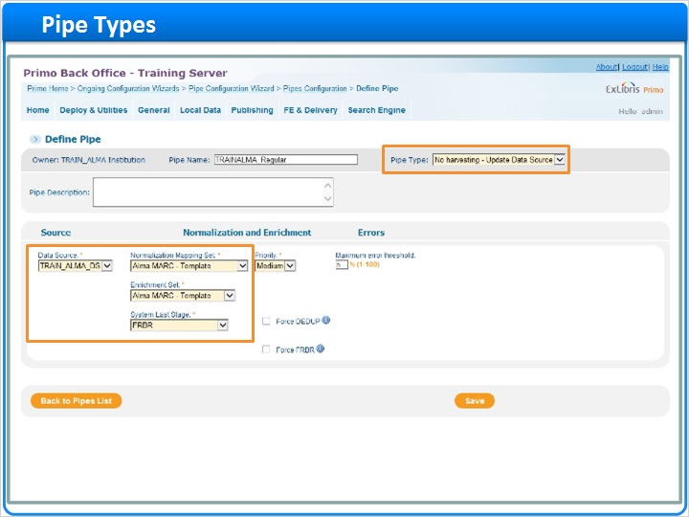

Delete Data Source Pipe (Slide Layer)
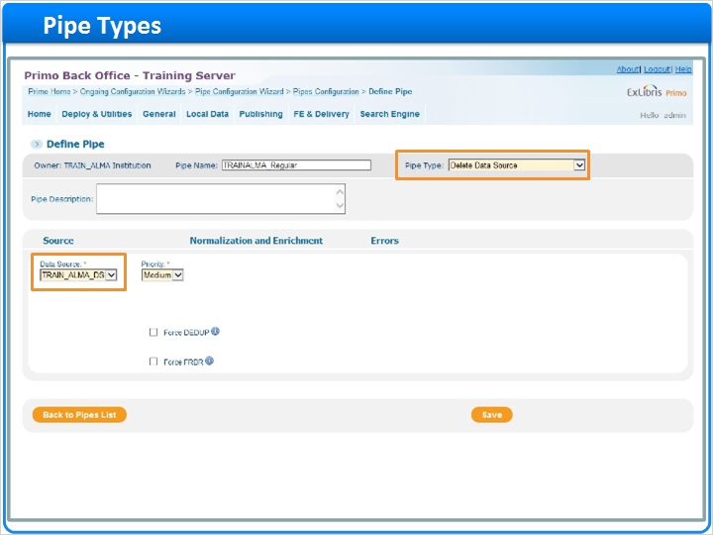

Delete Reload Pipe (Slide Layer)
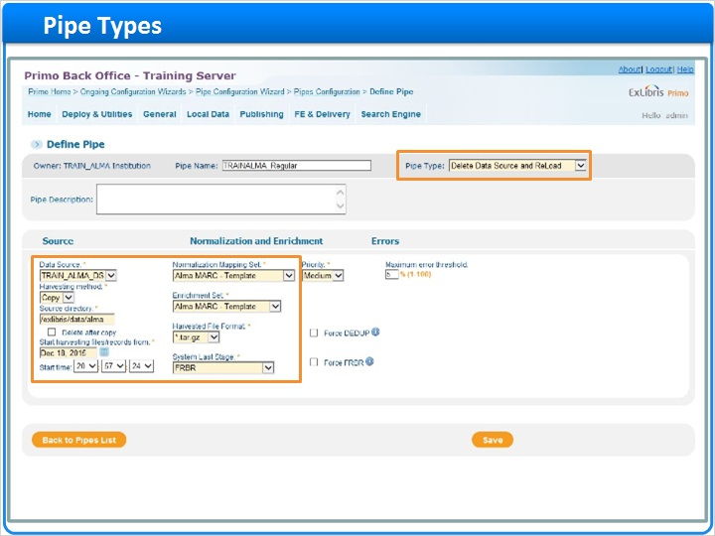

Regular Pipe (Slide Layer)
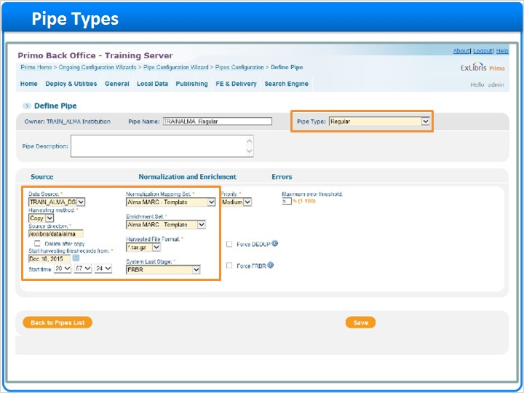

Save (Slide Layer)
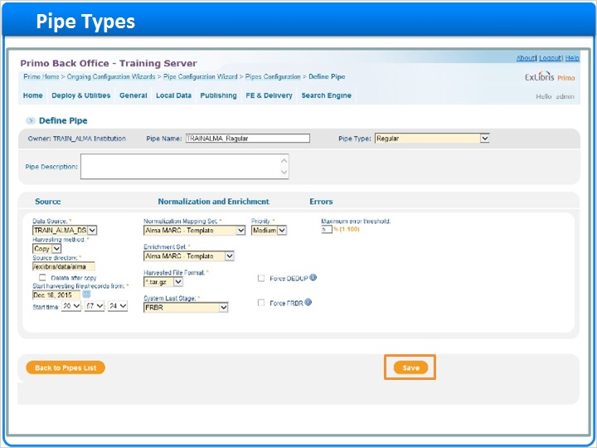

Pipes List (Slide Layer)
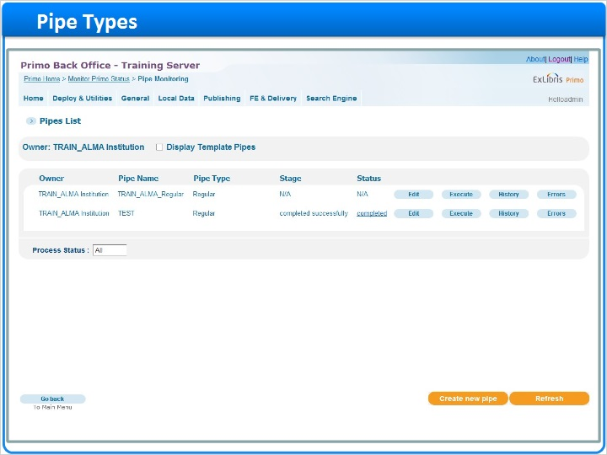

1.13 Editing a Pipe
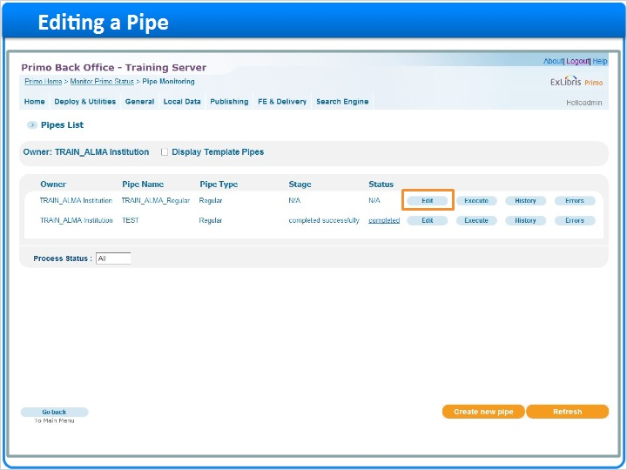
Notes:
Here in the pipes list, if I want to edit an existing pipe, I can select Edit. I won’t be able to change the type of the pipe, but I can change any of the other parameters, and click save to apply those changes.

Define pipe (Slide Layer)
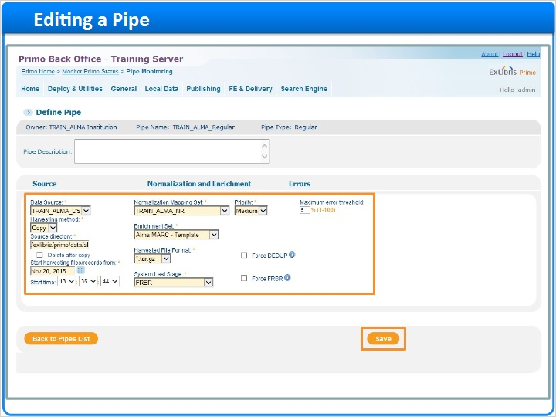

1.14 Running a Pipe
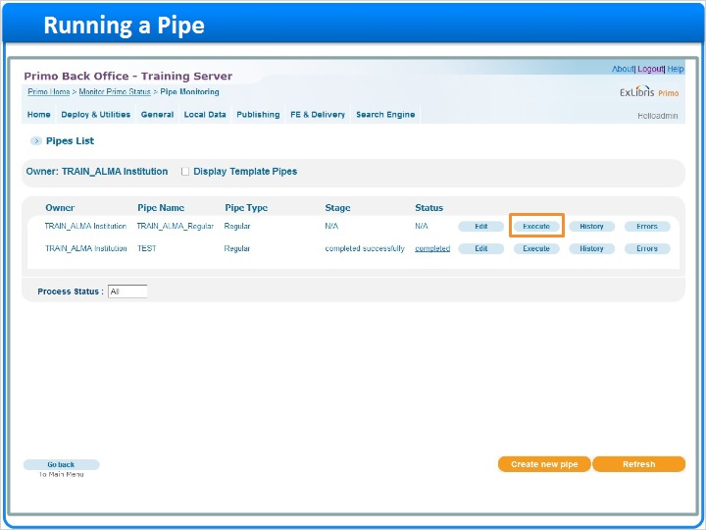
Notes:
From the pipes list, I can run any of the configured pipes. To run a pipe, I click Execute.

Once I’ve executed the pipe, I can see the stage and status here in the pipes list, and I can click on the status for more information.

In the Job Details screen, I have access to various log files, the stage and status information, and I can either terminate or suspend the pipe if needed.

The next few sections down provide details about each stage of the publishing process, including the harvesting stage, the normalization-enrichment-persistence stages, and the DEDUP and FRBR stages. I can click Refresh at the bottom of the page to update the information on the page. When the pipe is finished running, the stage show completed successfully, and the status will show completed. If the pipe does not finish for some reason, the stage will reflect where the process stopped, and the status will indicate the pipe has stopped.

When a pipe completes successfully, we still need to wait for the indexing and hotswapping processes to run before the records can be seen in the front end.

I can return to the pipe list at any time by clicking Back to Pipes List.

Stage and status (Slide Layer)
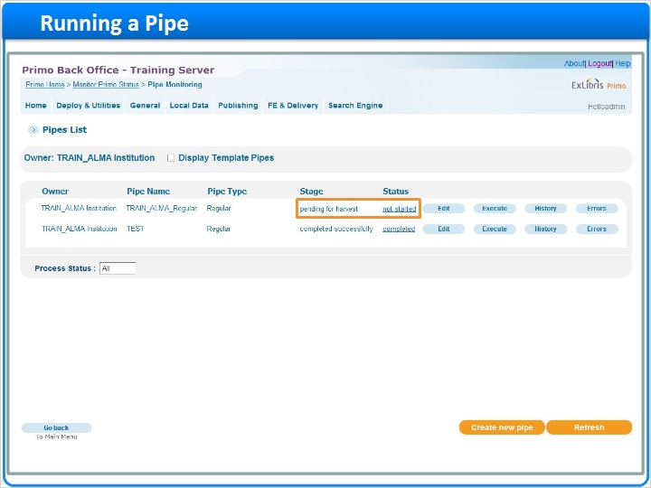

Job details screen (Slide Layer)
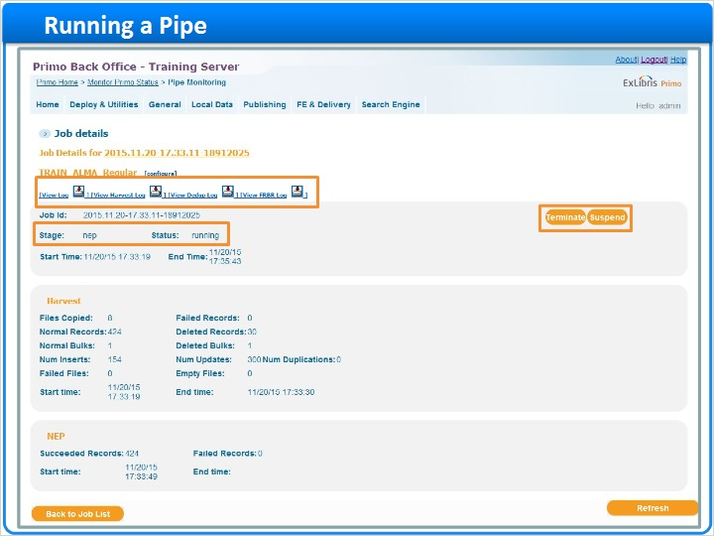

Harvesting stage (Slide Layer)
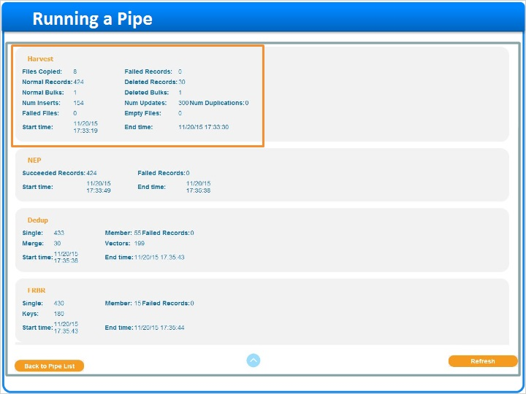

NEP stage (Slide Layer)
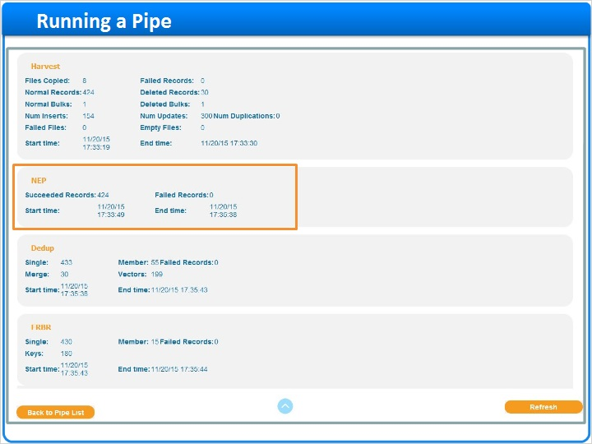

Dedup and FRBR stage (Slide Layer)
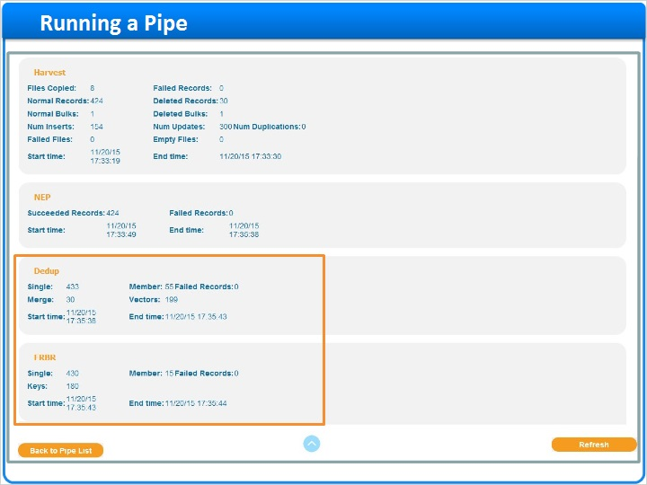

Refresh (Slide Layer)
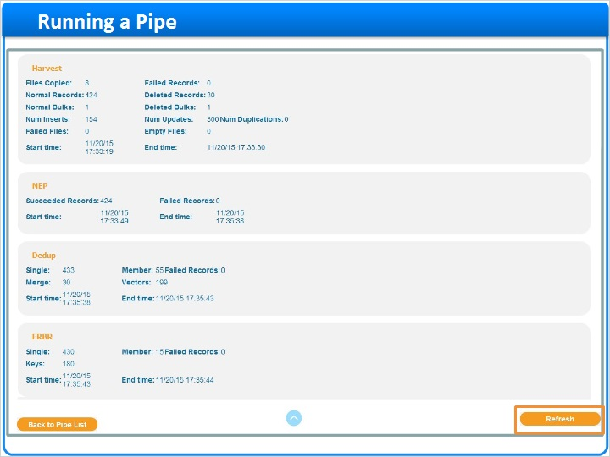

Completed status (Slide Layer)
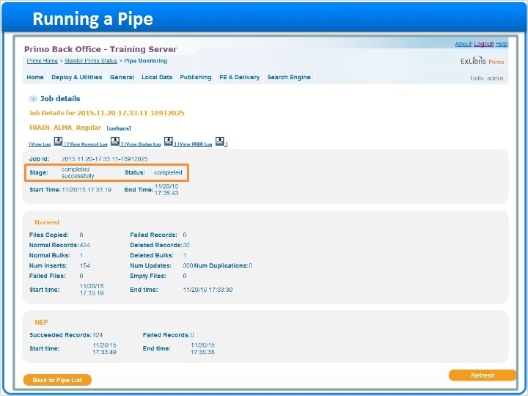

Back to pipes list (Slide Layer)
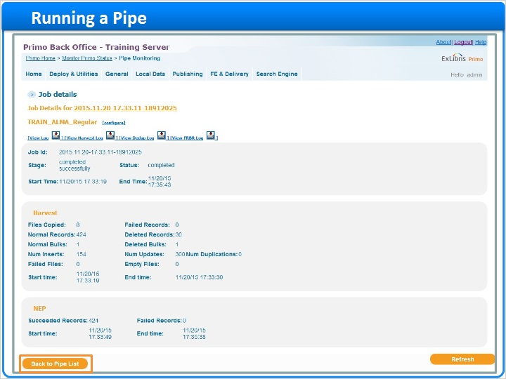

1.15 Pipe History
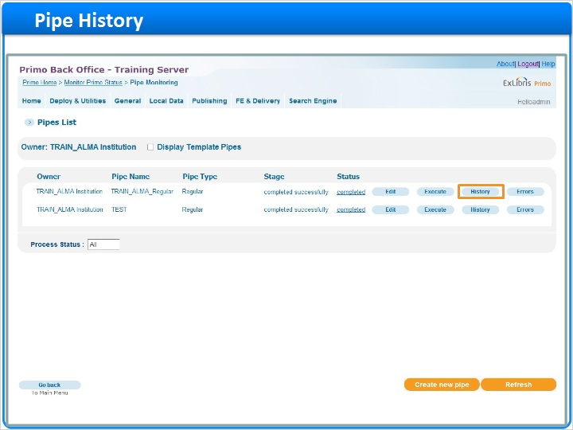
Notes:
From the pipes list, I can see the history of this pipe by clicking History.

Each time this pipe was run, the job details are saved in this list. We can see the stages and statuses for each job, as well as the start and end times.

To get back to the job details for any of these pipe runs, I can click on the name in this column.

Records that produced errors can be found here, by clicking on Errors, or by clicking on Errors in the Pipes List.

History (Slide Layer)
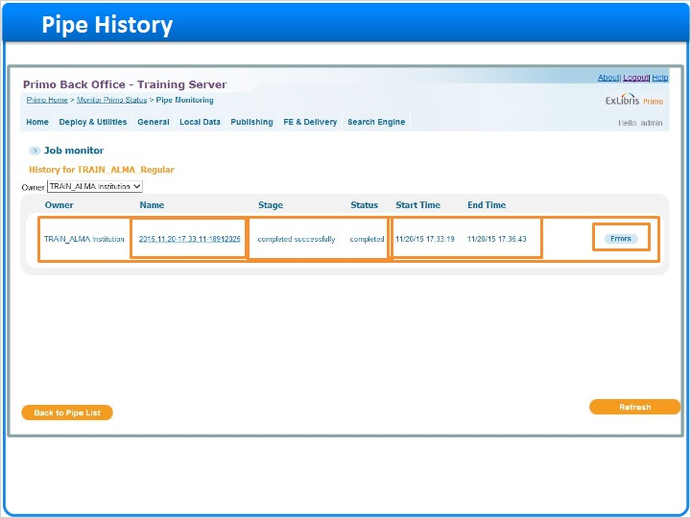

Errors in pipe list (Slide Layer)
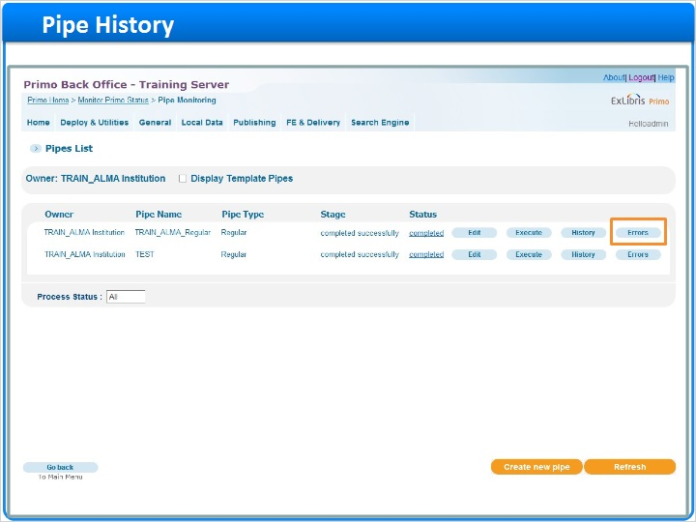

1.16 Summary
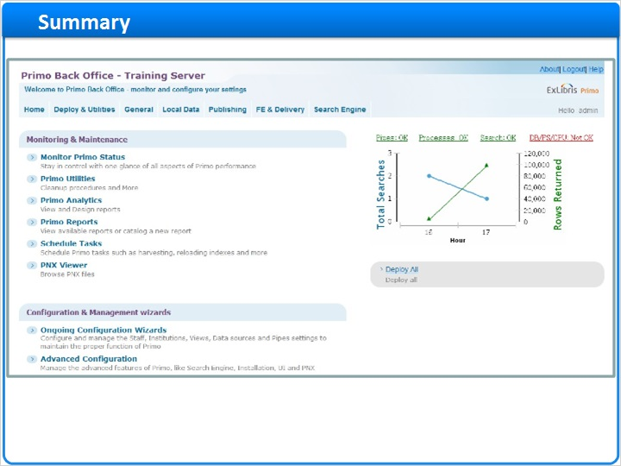
Notes:
And that is how data is loaded into Primo! By creating a data source, using a normalization mapping set, and configuring a pipe, we can harvest data from your source systems and convert it into PNX records for use in Primo.

1.17 Session Review and Quiz
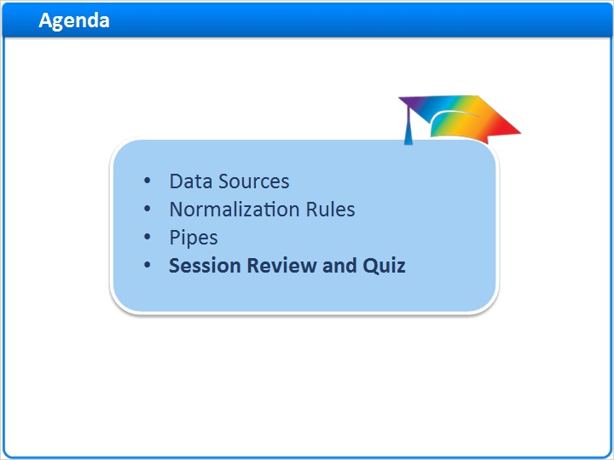
Notes:
Session Review and Quiz

1.18 Session Review
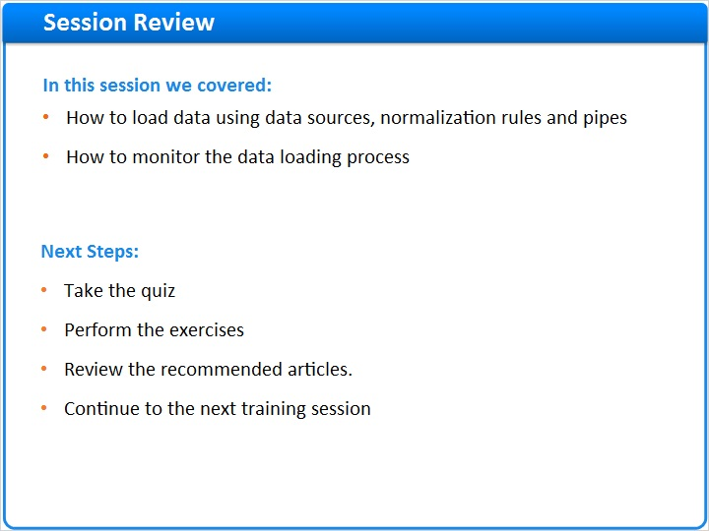
Notes:
In this session we covered how to load data into Primo using data sources, normalization rules and pipes, and how to monitor the data loading process.
After the brief quiz that begins on the next page, please complete the exercises that are provided in the Knowledge Center where you launched this training. Please refer to the Recommended Articles section for additional information.
After finishing the exercise, you can continue on to the next training session in this series.

1.19 Question 1
(Multiple Choice, 10 points, 1 attempt permitted)
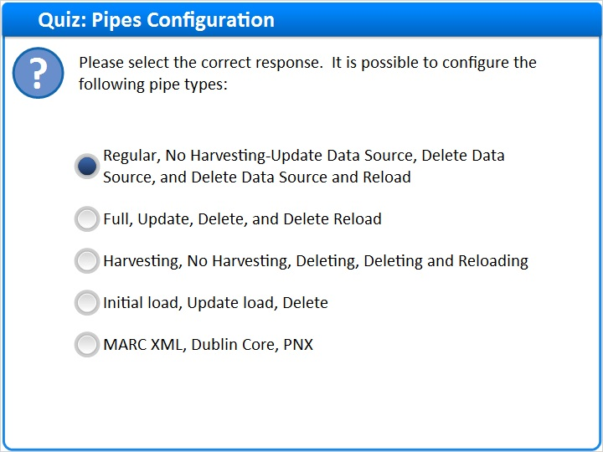
Correct | Choice
X | Regular, No Harvesting-Update Data Source, Delete Data Source, and Delete Data Source and Reload
 | Full, Update, Delete, and Delete Reload
 | Harvesting, No Harvesting, Deleting, Deleting and Reloading
 | Initial load, Update load, Delete
 | MARC XML, Dublin Core, PNX
Feedback when correct:
The pipe types are: Regular, No Harvesting-Update Data Source, Delete Data Source, and Delete Data Source and Reload
Feedback when incorrect:
The pipe types are: Regular, No Harvesting-Update Data Source, Delete Data Source, and Delete Data Source and Reload

Notes:

Correct (Slide Layer)
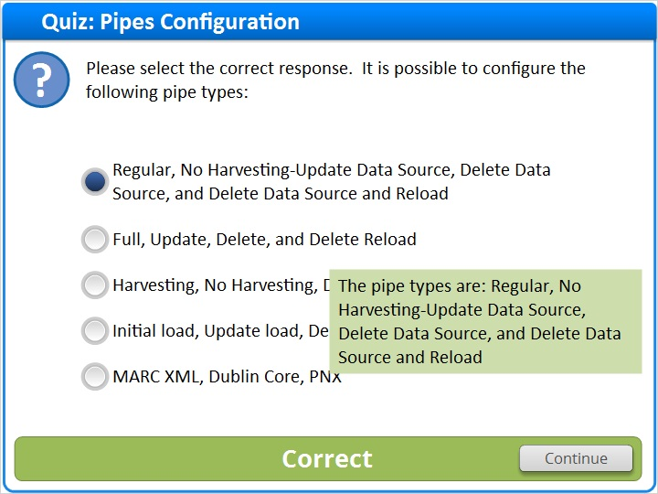

Incorrect (Slide Layer)
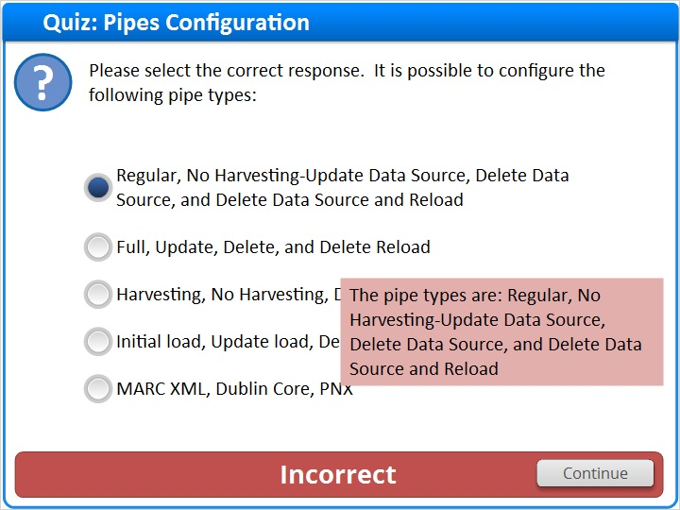

1.20 Question 2
(Multiple Response, 10 points, 1 attempt permitted)
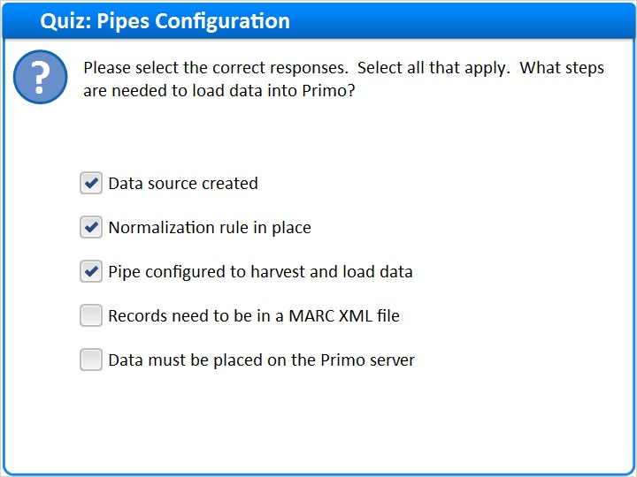
Correct | Choice
X | Data source created
X | Normalization rule in place
X | Pipe configured to harvest and load data
 | Records need to be in a MARC XML file
 | Data must be placed on the Primo server

Feedback when correct:
In order to load data into Primo, a data source needs to be created, a normalization rule needs to be in place, and a pipe needs to be configured to harvest and load data.
Feedback when incorrect:
In order to load data into Primo, a data source needs to be created, a normalization rule needs to be in place, and a pipe needs to be configured to harvest and load data.

Correct (Slide Layer)
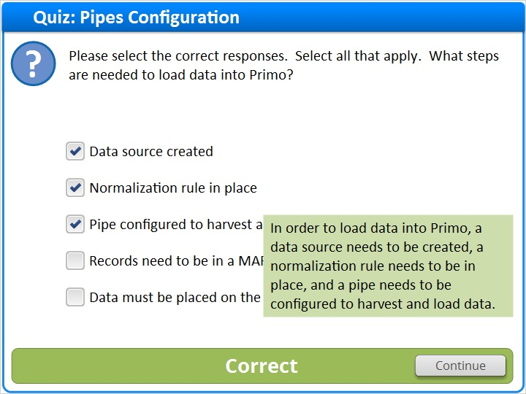

Incorrect (Slide Layer)
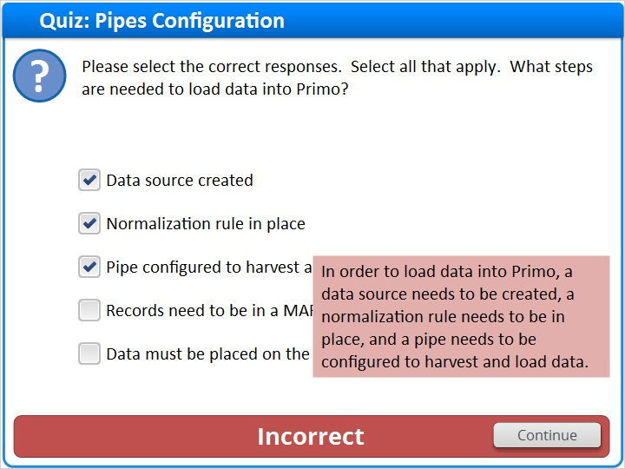

1.21 Question 3
(True/False, 10 points, 1 attempt permitted)
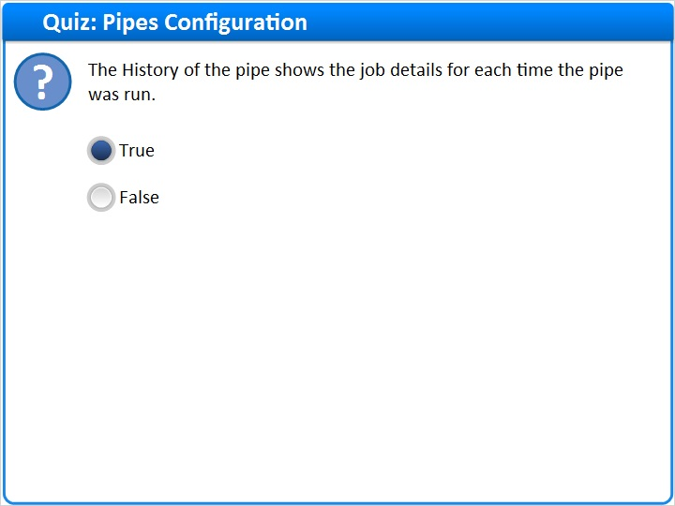
Correct | Choice
X | True
 | False

Feedback when correct:
The History of the pipe shows the job details for each time the pipe was run.
Feedback when incorrect:
The History of the pipe shows the job details for each time the pipe was run.

Notes:

Correct (Slide Layer)
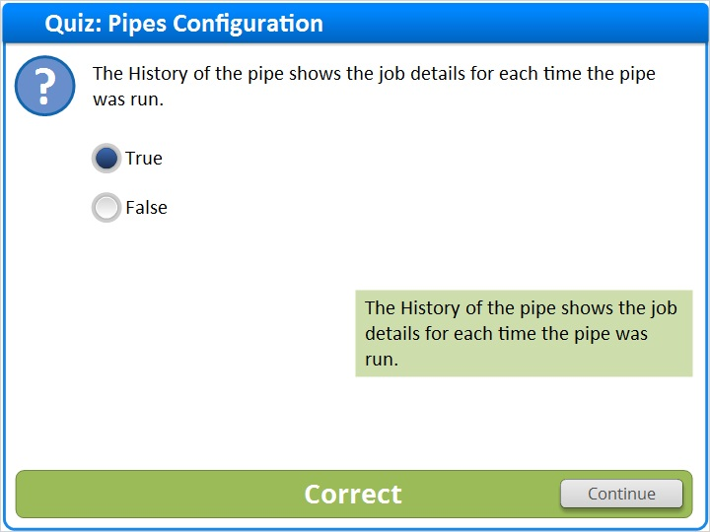

Incorrect (Slide Layer)
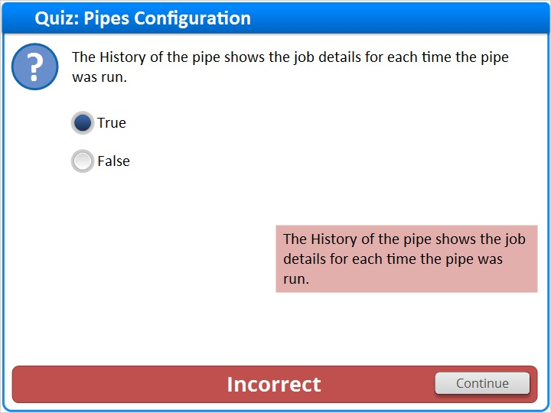

1.22 Thank You!

Notes:
Thank you for joining this session!

1.23 About this Training
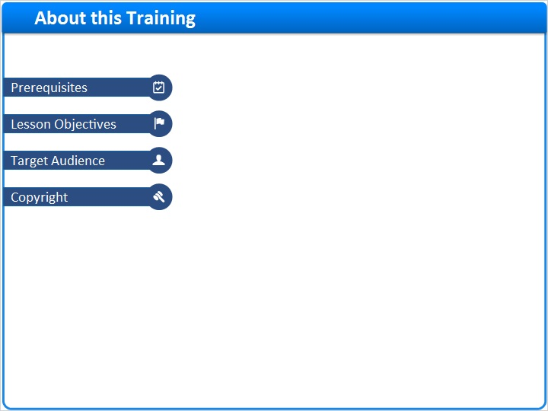
Notes:

1 (Slide Layer)
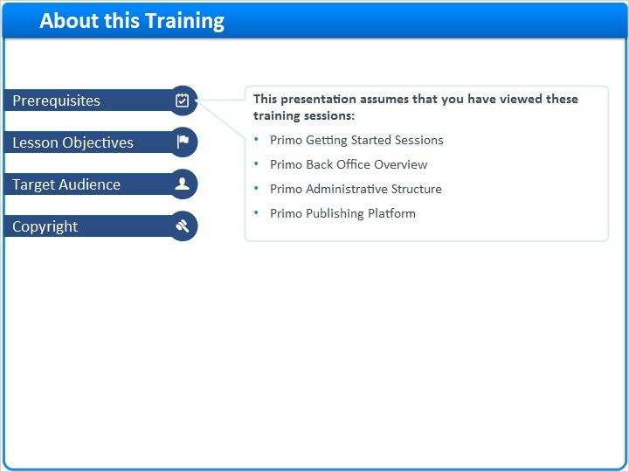

2 (Slide Layer)
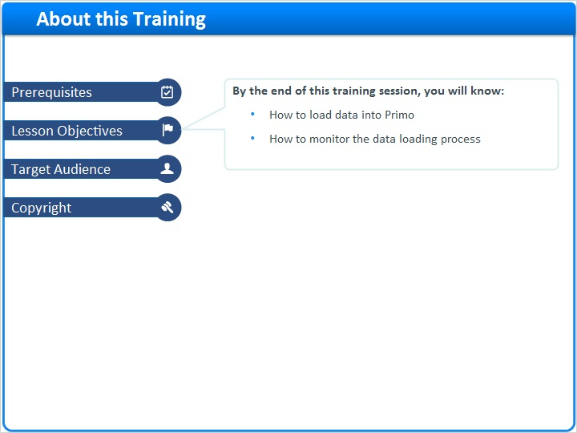

3 (Slide Layer)
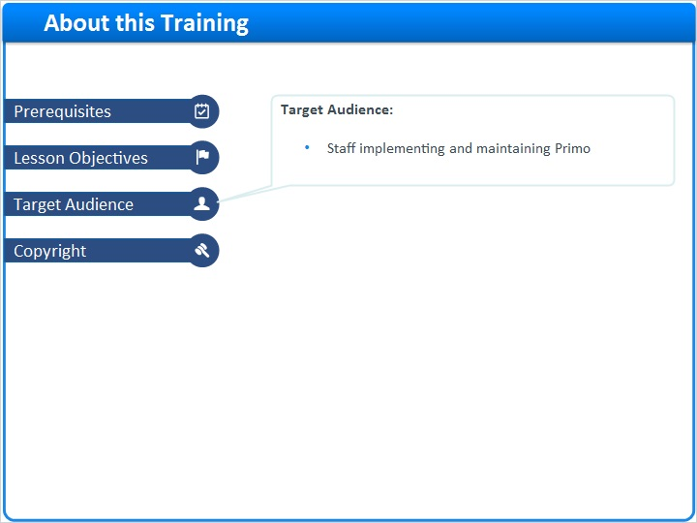

4 (Slide Layer)


