Primo Administration: Local Search Scopes

1. Local Search Scopes

1.1 Primo Administration: Local Search Scopes
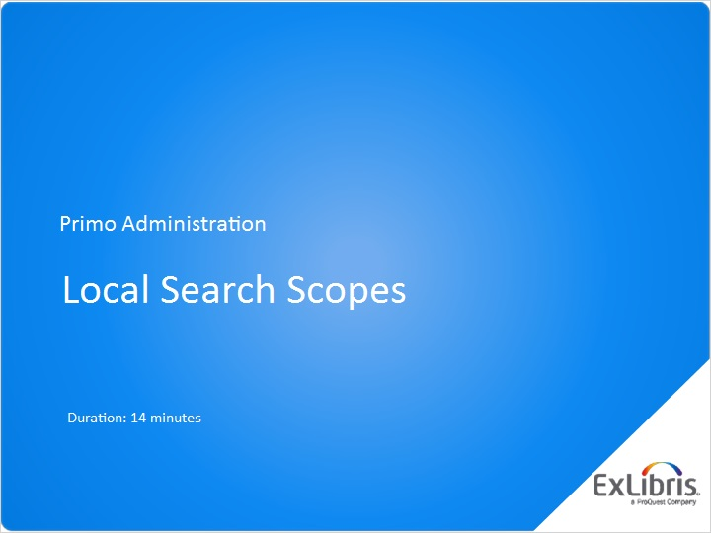
Notes:
Hi, and welcome to this session on Local Search Scopes in Primo.

1.2 Agenda
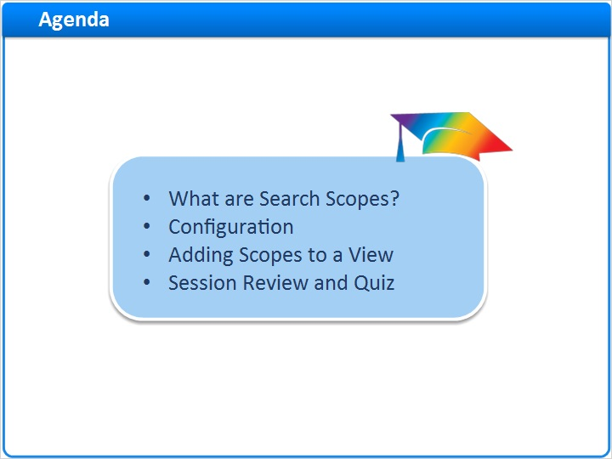
Notes:
Today we’ll explain the concept of local search scopes;
Then guide you through the different phases of their configuration
And finally we’ll show how to assign search scopes to a particular view in Primo, using the Views Wizard.
Our session’s agenda reflects the natural order of these topics, and its recommended to follow this order.

1.3 What are Search Scopes?
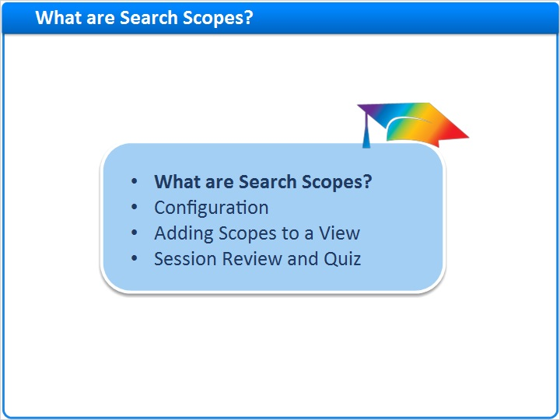
Notes:
So, what are search scopes?

1.4 Definition
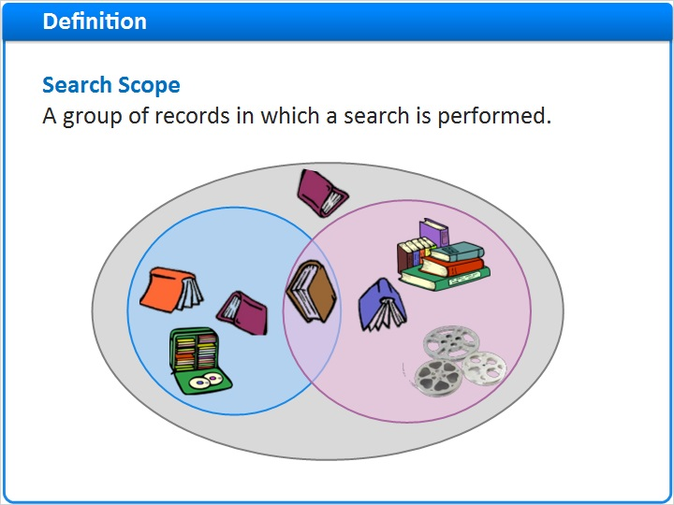
Notes:
A Search Scope in Primo is a group of records on which a search is performed. This allows users to ‘pre-filter’ their search, limiting it to a specific group as opposed to searching the full catalogue.
Several search scopes can be configured for an institution, for example the entire repository, a particular library, a collection and more.

In the diagram we can see three scopes represented. The external gray circle represents the entire library collection, while the smaller inner circles represent smaller logical groups or subsets within.
These logical groups can be defined as needed by any common denominator, such as: all records of the records in the Law library, or all of the records in the new media collection.
As you can see in the diagram, one record can belong to multiple scopes, as is the case with the book in the middle.

1.5 Selecting a Search Scope in the UI
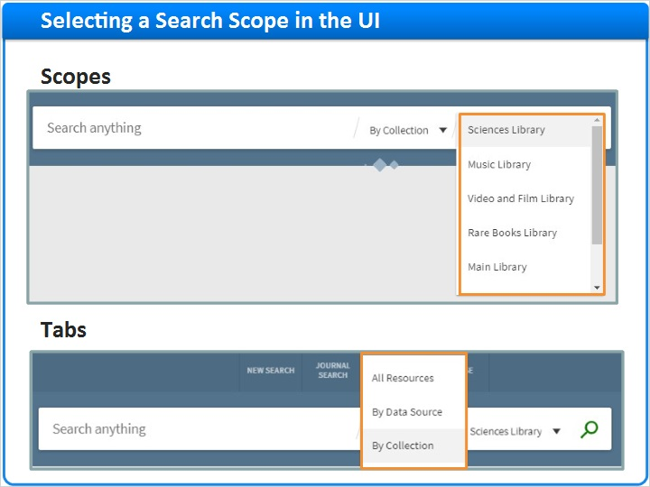
Notes:
The end user uses scopes in order to pre-filter their search. For example, they can select whether to search across the whole collection, or only in the Law library, or only in the Music library.
You can configure how selected scopes are presented to the end user in the search-box. Either from a drop-down list or from multiple tabs. Selecting any of these will run the query on a the corresponding subset.

Note that in this session we discuss only local search scopes, the ones relating to your own institution’s resources. There are other types of search scopes for external indexes such as Primo Central, which are defined slightly differently.

1.6 Linking a Record to a Scope
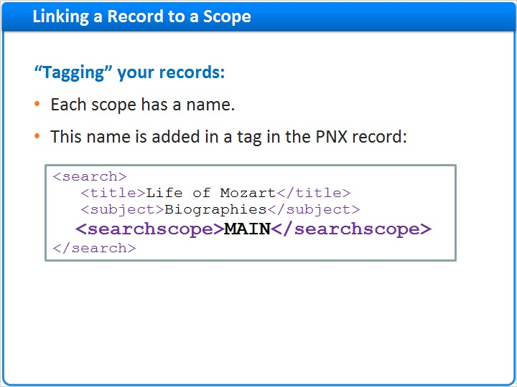
Notes:
So, how do you associate a given record with a search scope, given that your library can have many such scopes?
First give each scope a name and code.
Then define a normalization rule, or set of rules, that tags relevant records with the search-scope code, upon loading the records into Primo.
This example shows a PNX record tagged with the search-scope MAIN, allowing Primo users to search to the main library scope.
If the subset "MAIN" includes 1,000 records, then each of these 1,000 records must have this exact MAIN tag.
When a patron searches exclusively in the MAIN scope, only these 1,000 records will be considered by Primo.

1.7 Defining a Local Search Scope
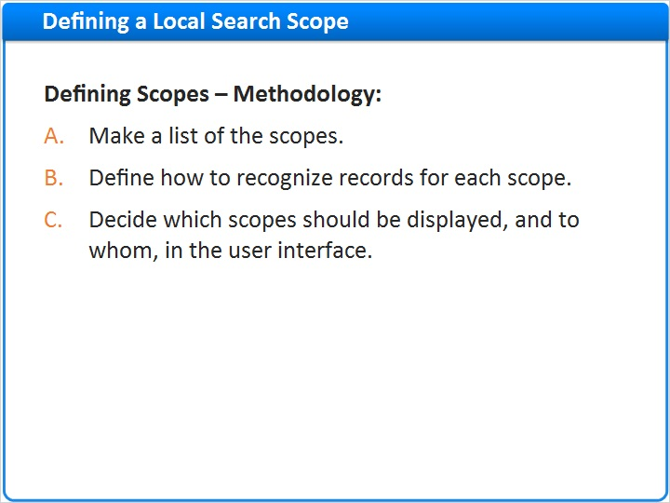
Notes:
How do we define our local search scopes?
The first step is to make a list of the scopes relevant to our users
The next step is to define which records belong to which scopes. This could be based on any metadata or holdings information. For example 950 subfield a= exams or holdings library code = LAW.
The third step is to define how to display the scopes in the User interface.
This is the conceptual flow, and each step corresponds to a Primo Back office configuration.

1.8 Configuration
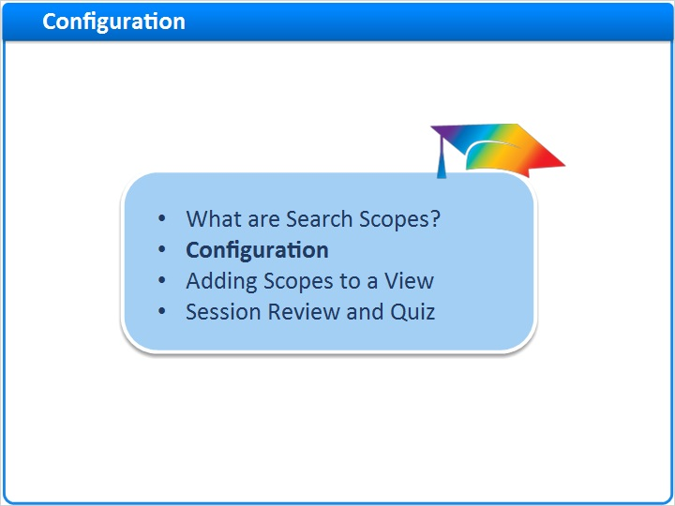
Notes:
So let’s see how we configure scopes in the Primo Back Office

1.9 Relevant Back Office Pages
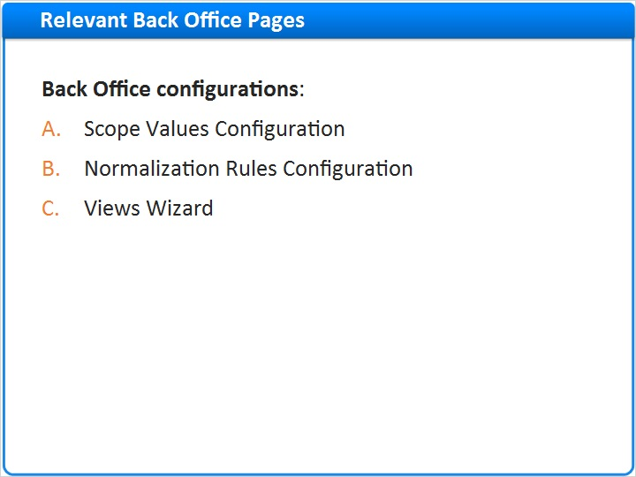
Notes:
These are the areas in the Primo back office where we need to make configurations:

Scope Values Configuration - here we define the list of search scopes
Normalization Rules Configuration - here we set up the rules that tag the imported records with their relevant scopes
Views Wizard - where we define how to actually display the scopes to our front end users

1.10 Scope Values
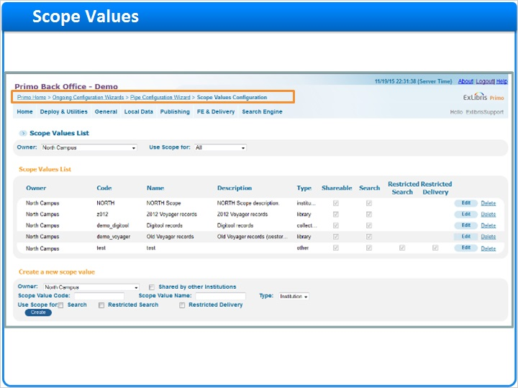
Notes:
This is the Scope Values Configuration page.

You can get here from: homepage > Ongoing Configuration Wizards > Pipe Configuration Wizard > Scope Values Configuration

You can see here that we have multiple scopes already set up and we can add additional scopes as well.

1.11 Scope Values - Parameters
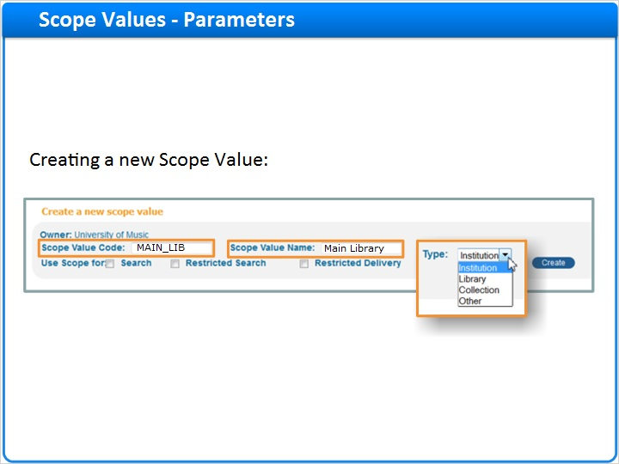
Notes:
Lets look at the parameters to create new scope values.

The Scope Value code - should be meaningful and unique. This is the code that we add to the record via the Normalization rules. In this example MAIN_LIB represents the Main library. It is best practice to use only uppercase letters, and to avoid meaningless codes such as M1, S1 etc. The code cannot contain spaces or special characters but can include underscores.

For the Scope Value Name - type a name or short description, later to be seen in the views wizard.

For the Type of the scope choose one from the drop-down list:
Is our scope an institution, a library, or any another type of scope? Note that the scope type of your ‘entire’ institution exists as a default out of the box value.

1.12 Scope Values – Use Scope For
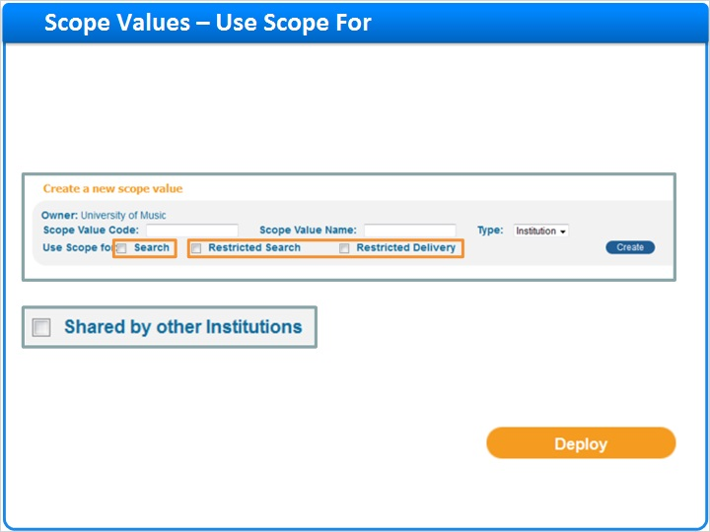
Notes:
Under Use Scope For we have several options:
In order to have the scope value seen in the views wizard and later displayed in the front end, you need to define that the scope is used for ‘search’.
There are 2 other types of scopes which are for special cases where local records are Restricted from some users. We will discuss these options in a separate session.
An additional parameter Shared by other Institutions is only seen in cases of consortia and shared institutions, to define whether this specific scope can be seen by other members of the network.
Once you have saved your scope values - make sure to click on the deploy button.

1.13 Normalization rules
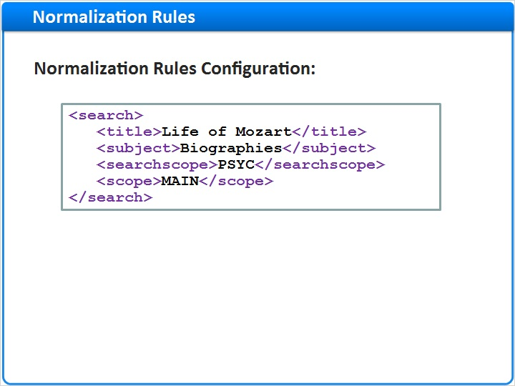
Notes:
Now that we have set up the search scope and its code, let’s make sure that this code will be added to the PNX.

1.14 Normalization rules
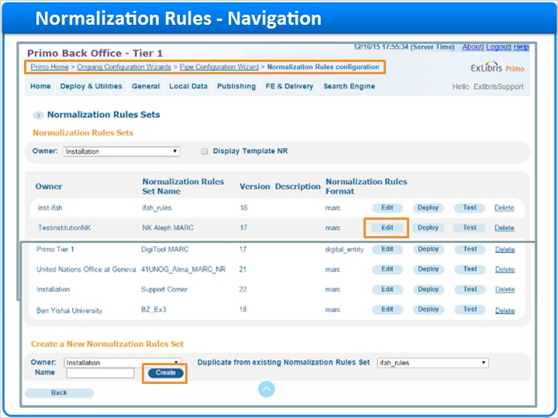
Notes:
For this we need to modify the Normalization rules.

Go to Primo Home > Ongoing Configuration Wizards > Pipe Configuration Wizard > Normalization Rules configuration.

Click on Edit button to modify an existing rule set, or Create to add a new one.

1.15 Normalization rules
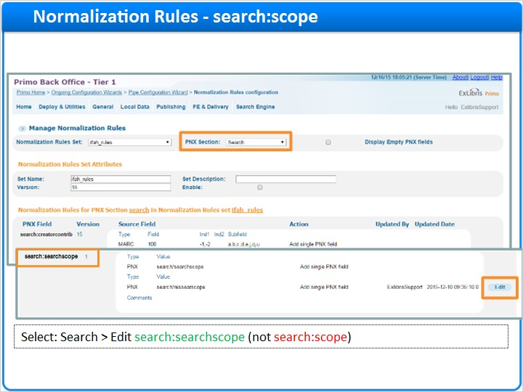
Notes:
Select the PNX Section search, Then scroll down to the search:searchscope rule (not search:scope!) and click Edit.

1.16 Normalization Rules
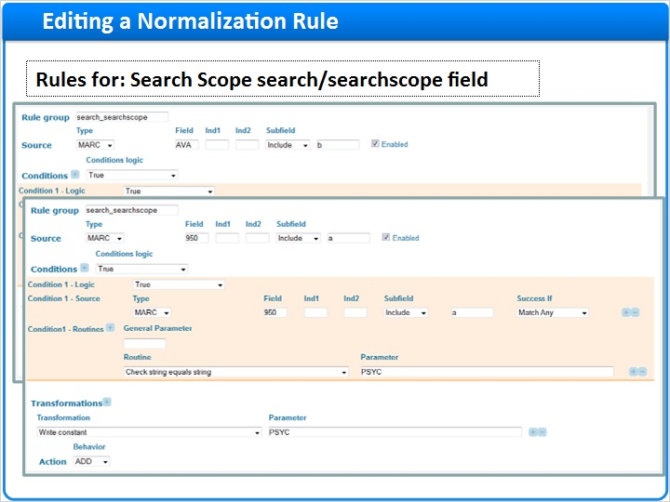
Notes:
Once in the Editor for the search:searchscope section, If you see the Advanced button, click on it in order to display rules with advanced options (if you see the Basic button, don’t press it).
To add a new rule, click the Create button. A new rule will appear at the bottom.
In these examples, we will add the codes for both MAIN and PSYC views.
This first example adds the MAIN search scope to the target record, if it finds the string MAIN in the AVA field subfield b in the source record.
Feel free to pause and look at the parameters.
The second example checks if the 950 field subfield a includes the code PSYC and adds the code PSYC to the search:scope field as well.
After filling in the rule parameters, click save, and then deploy the Normalization rules.
Once the rule is ready, we can run our pipe to apply this in the PNX of our records.
After the pipe completes its run, the index job needs to run and complete before the records are ready for use in the User interface.

1.17 Normalization rules
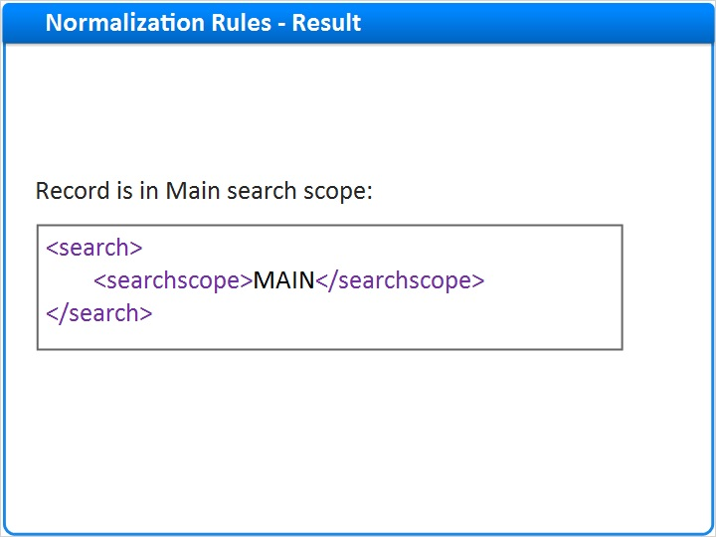
Notes:
This is how the search:searchscope section appears in the PNX after the normalization rule was applied to the record, adding to it the scope code.

Now Primo will consider this record when searching in the MAIN scope.

1.18 Adding Scopes to a view
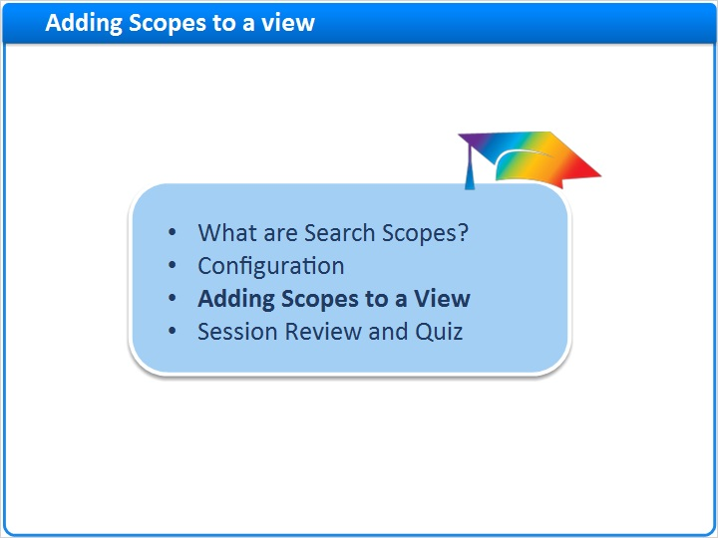
Notes:
To Display the option of searching a local scope to the user, we need to configure the Views Wizard accordingly.

Let’s see how this is done.

1.19 Navigation
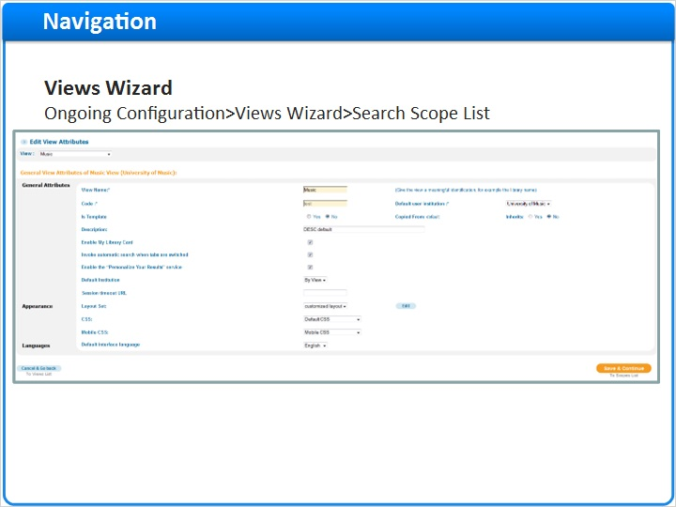
Notes:
This is the Views wizard. We’ll learn more about it later in a dedicated session. For now, let’s focus only on the sections relevant to scopes.

From Primo Home Go to Ongoing Configuration > Views Wizard, and from the Views list click to Edit the desired view.

On the first page of the wizard, click on Save & Continue to the Scopes List.

1.20 Search Scope List
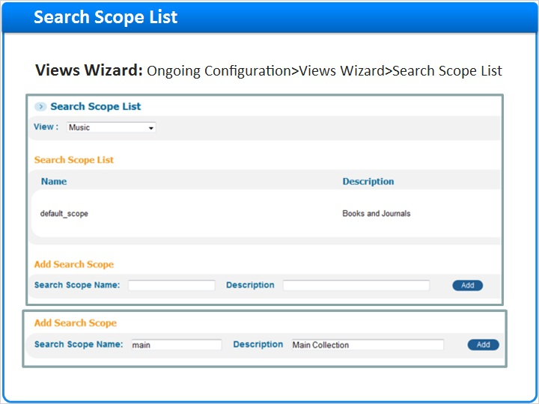
Notes:
The Search Scope List page is where we define the scopes displayed to the end user in this view.
You can add as many scopes to this view as you desire.
Each scope added to the view will correspond with one or more of the scope values we’ve previously defined in the system. In other words, we can group multiple scope values together here - for example we may allow a combined search of the Arts and the New Media collection.
To create a new search scope in the view - enter the desired name for the search scope, and click the Add button.

1.21 Edit Search Scope
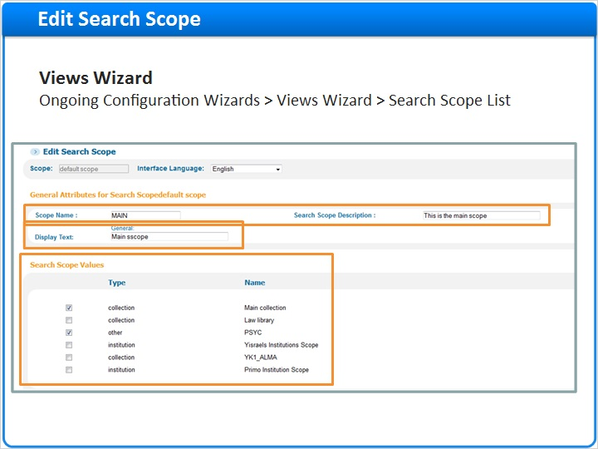
Notes:
Now in the Search Scope Editor, we can once again modify the Scope name and description.

The Display Text is what the user sees in the front end.

In the Search Scope values section we select one or more local search scope values to correspond with this new search scope in the view.

1.22 Remote or Deep Search Scopes
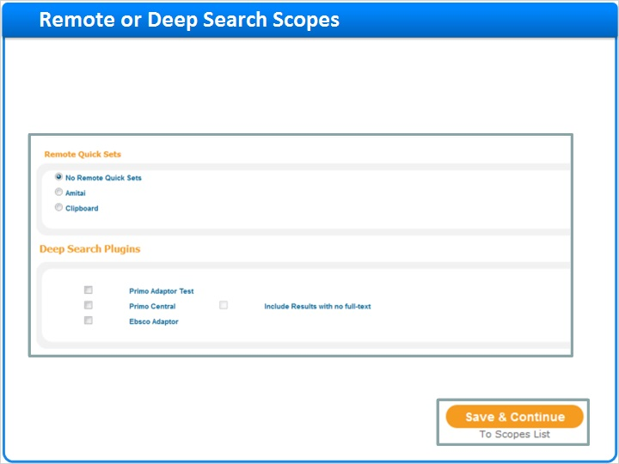
Notes:
Still in the Search Scope Editor, scroll down to the Remote Quick Sets and Deep Search Plugins sections.

If you have Primo Central, MetaLib or EBSCO adaptors configured you, you can choose to have these searched together with you local data.

Of course, you can also create a new scope instead, with only the remote or deep search options.

Click on Save & continue to the Scopes List.

1.23 Search Scopes List Review
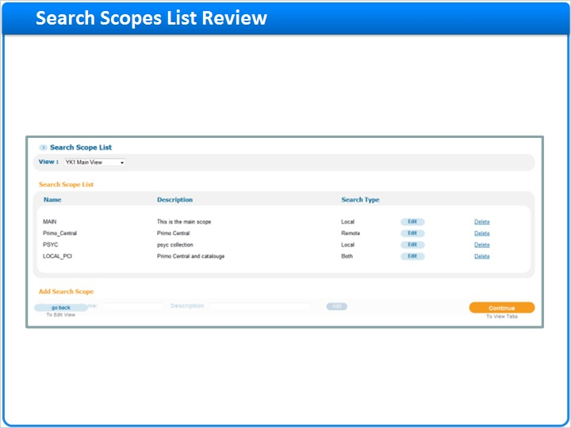
Notes:
Back at the Search Scope List. You can see we have created multiple search scopes - each containing different scope values.
In this example we have:
- Two scopes based on local scope values: MAIN and PSYC (the first and third on the list).
- One scope that searches only remotely in Primo Central (the second on the list)
- And the final scope combines Primo Central together with our local catalogue.

Now we still need to define how these scopes are presented to the end-user, in a drop-down list, in tabs, or in both; and also in what order.
Click Continue to proceed to the View Tabs setup page.

1.24 Tabs Configuration
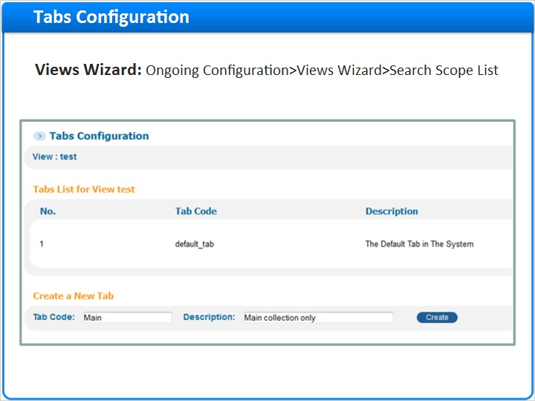
Notes:
We are now in the Tabs Configuration for our view.
Here you can define if you want the scopes available in one single tab in the search-box, or whether to have multiple tabs.
You can edit an existing tab; or to create a new tab, enter it’s name and description, and click Create.
This will take you to the Tab Editor
Now let’s assign scopes to each tab.

1.25 Adding Scopes to Tab
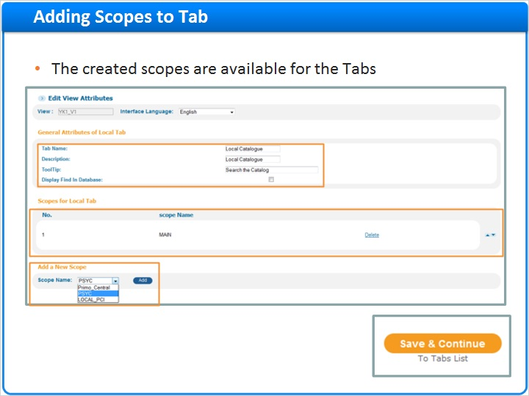
Notes:
We are now editing the tab.
In the general attributes section you can:
Enter the Tab Name as it is displayed in the user interface, the Description and the ToolTip (i.e. the Mouse hover message presented to the user).
Next add a New scope for the tab from the drop-down list. Select the desired scope and click on Add.
The scope will be added immediately to the tab’s list of scopes.
Add all the scopes you wish to display in this tab - then define their order with the up and down arrows.
Click Save & Continue to the Tabs list.

1.26 Tabs Configuration Review
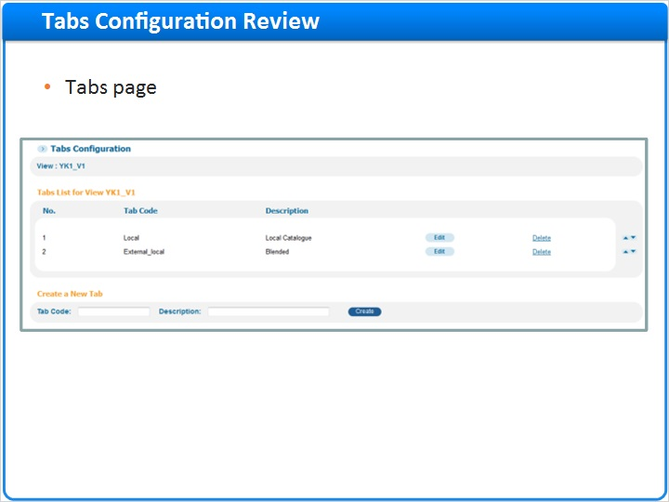
Notes:
In this example we created 2 tabs to display - each tab contains different scopes available from a drop-down list.
You can reorder the tabs as you wish using the up and down arrows
Click Continue to tile list.

1.27 Deploy the View Configuration
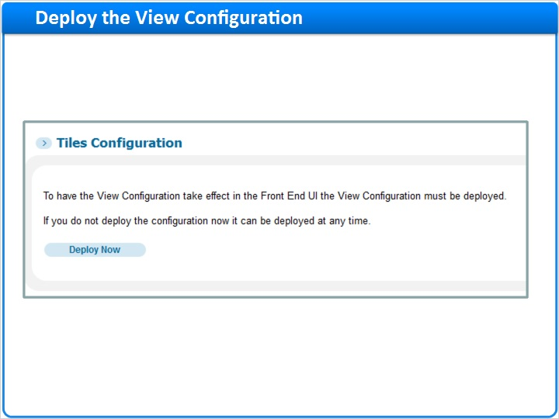
Notes:
Click twice more on the Save & Continue button (to jump over the tiles edit options) and then click on the Deploy Now button.
Wait for the deploy to finish; and then you can check the outcome in the Front-End.

1.28 Deploy the View Configuration
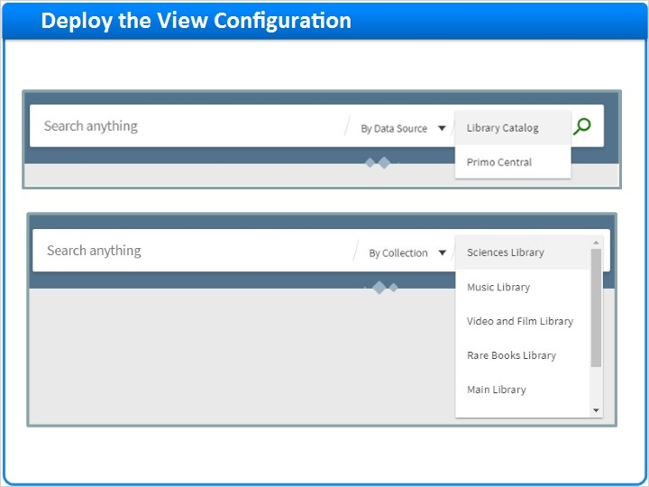
Notes:
In this example, we can see a Front End with two tabs: Local Search and Remote Search
The Local Search Tab has several scopes available from the drop-down list.

1.29 Summary
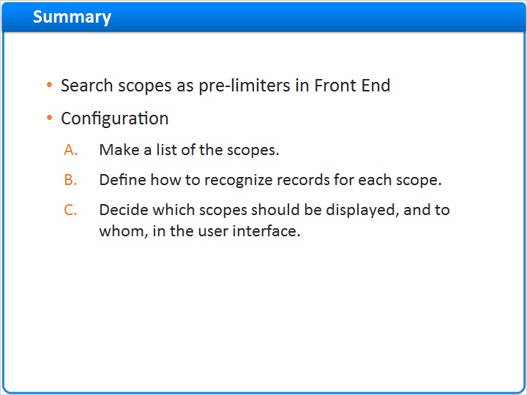
Notes:
So now lets recap.
In this session we discussed search scopes and how they are used as pre-limiters in the front end.
Then we demonstrated the configuration - according to the following flow:
First make a list of the scopes you want.
Then define how to recognize records for each scope.
And finally decide which scopes should be displayed and to whom, in the user interface.

1.30 Session Review and Quiz
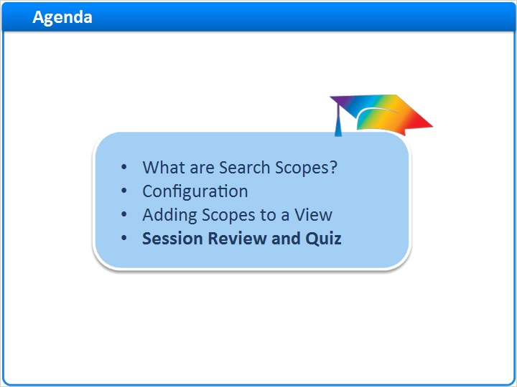
Notes:
Session Review and Quiz

1.31 Session Review
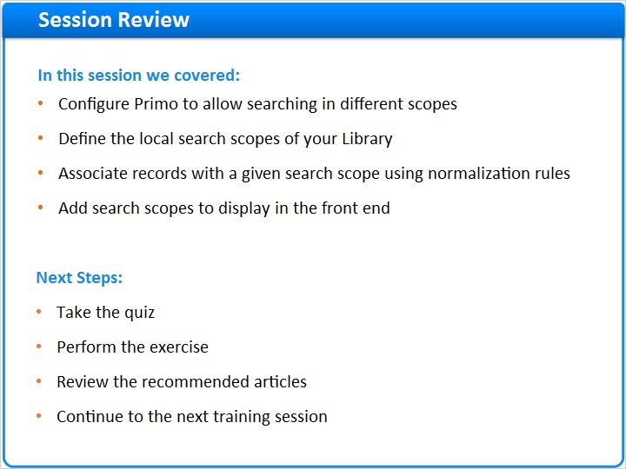
Notes:
In this session we learned how to configure Primo to allow searching in different scopes, how to define the local search scopes of your library, how to associate records with a given search scope using normalization rules, and how to add search scopes to the display in the front end.

After the brief quiz that begins on the next page, please complete the exercise that is provided in the Knowledge Center where you launched this training. Please refer to the Recommended Articles section for additional information.

After finishing the exercise, you can continue on to the next training session in this series.

1.32 Question 1
(Multiple Choice, 10 points, 1 attempt permitted)
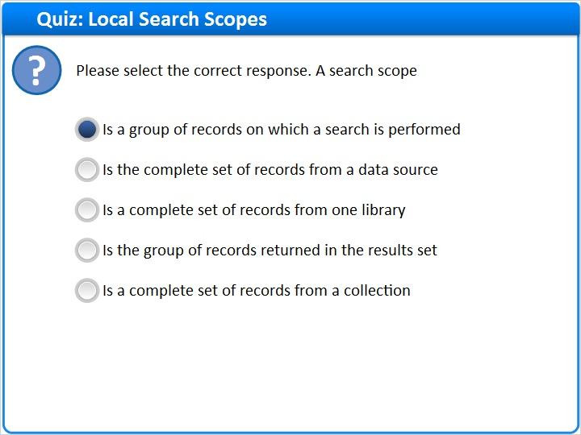
Correct | Choice
X | Is a group of records on which a search is performed
 | Is the complete set of records from a data source
 | Is a complete set of records from one library
 | Is the group of records returned in the results set
 | Is a complete set of records from a collection
Feedback when correct:
A search scope is a group of records on which a search is performed. It can contain all or a subset of records from a local data source, library, or collection.
Feedback when incorrect:
A search scope is a group of records on which a search is performed. It can contain all or a subset of records from a local data source, library, or collection.

Notes:

Correct (Slide Layer)
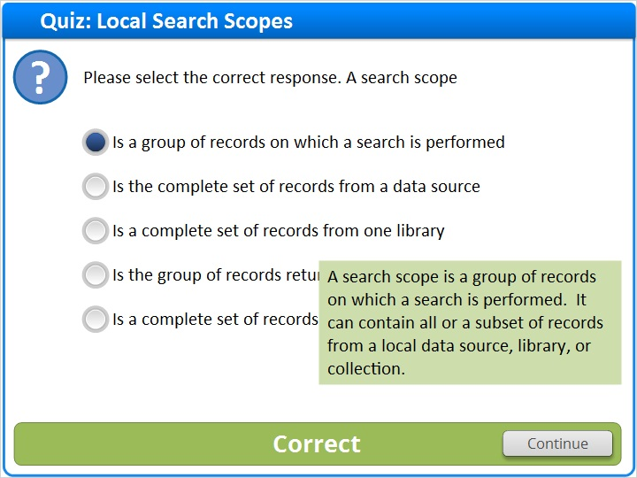

Incorrect (Slide Layer)
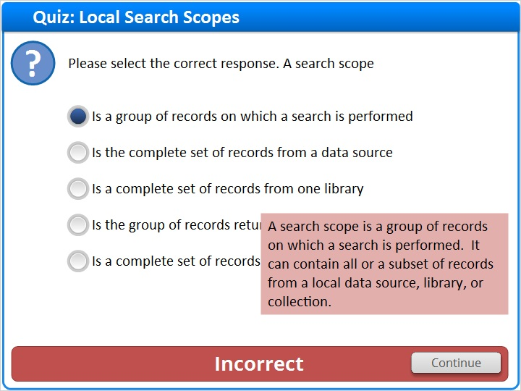

1.33 Question 2
(Multiple Choice, 10 points, 1 attempt permitted)
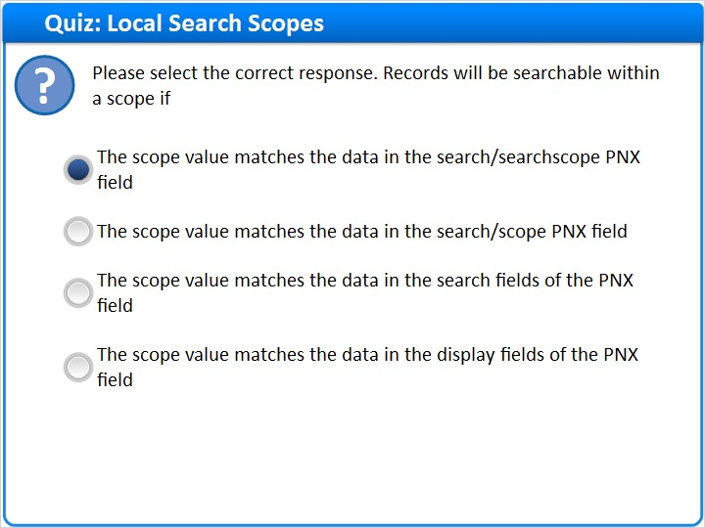
Correct | Choice
X | The scope value matches the data in the search/searchscope PNX field
 | The scope value matches the data in the search/scope PNX field
 | The scope value matches the data in the search fields of the PNX field
 | The scope value matches the data in the display fields of the PNX field

Feedback when correct:
Records will be searchable within a scope if the scope value matches the data in the search/searchscope PNX field
Feedback when incorrect:
Records will be searchable within a scope if the scope value matches the data in the search/searchscope PNX field

Notes:

Correct (Slide Layer)
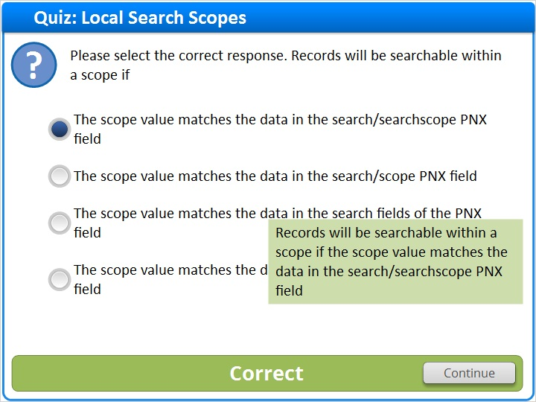

Incorrect (Slide Layer)
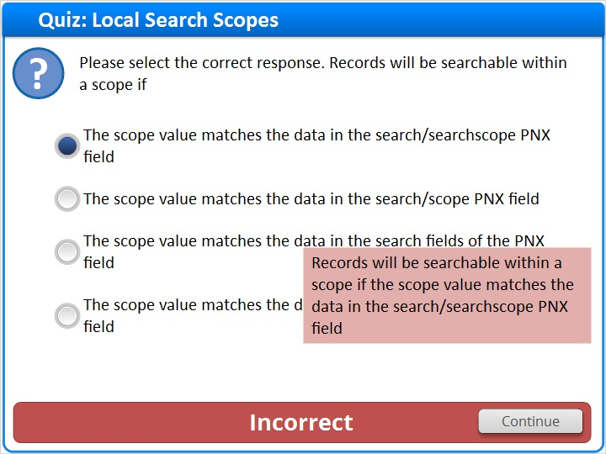

1.34 Question 3
(True/False, 10 points, 1 attempt permitted)
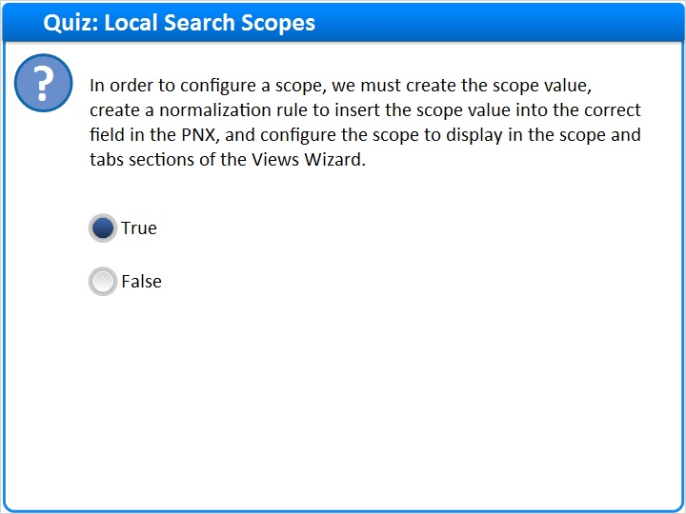
Correct | Choice
X | True
 | False

Feedback when correct:
In order to configure a scope, we must create the scope value, create a normalization rule to insert the scope value into the correct field in the PNX, and configure the scope to display in the scope and tabs sections of the Views Wizard.
Feedback when incorrect:
In order to configure a scope, we must create the scope value, create a normalization rule to insert the scope value into the correct field in the PNX, and configure the scope to display in the scope and tabs sections of the Views Wizard.

Notes:

Correct (Slide Layer)
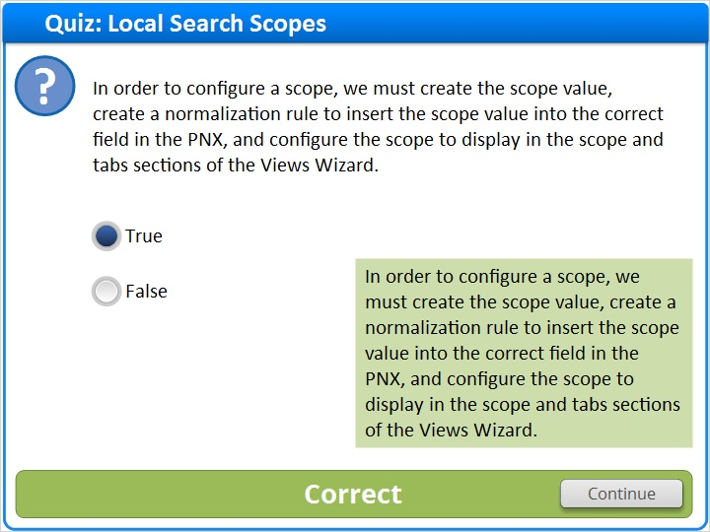

Incorrect (Slide Layer)
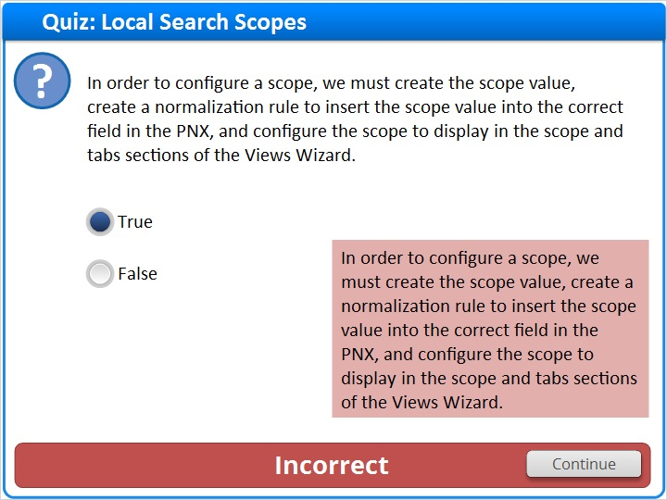

1.35 Thank You!

Notes:
Thanks for joining this session!

1.36 About this Training
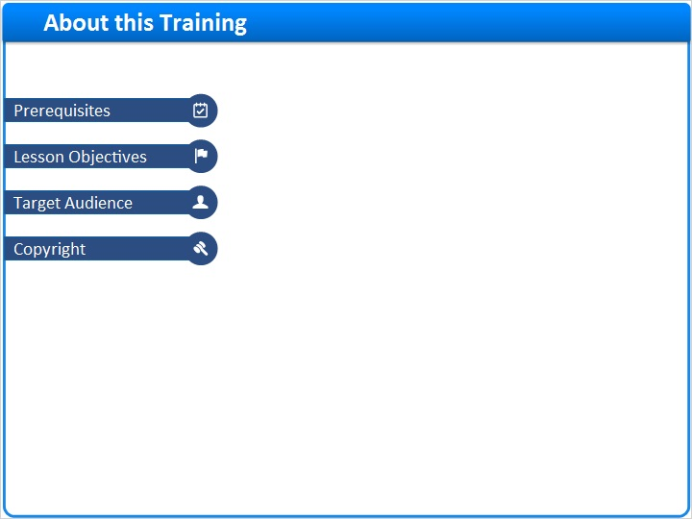
Notes:

1 (Slide Layer)
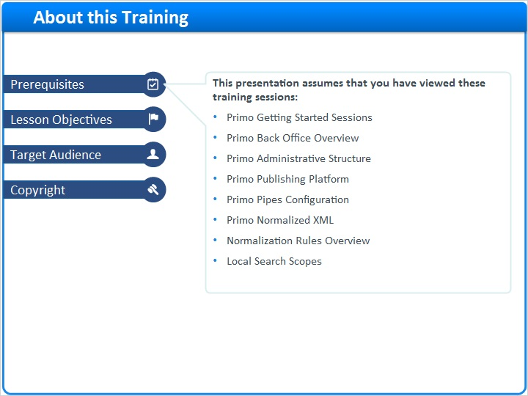

2 (Slide Layer)
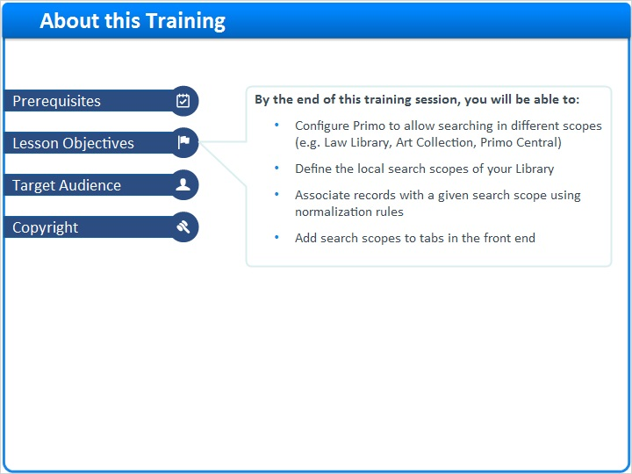

3 (Slide Layer)
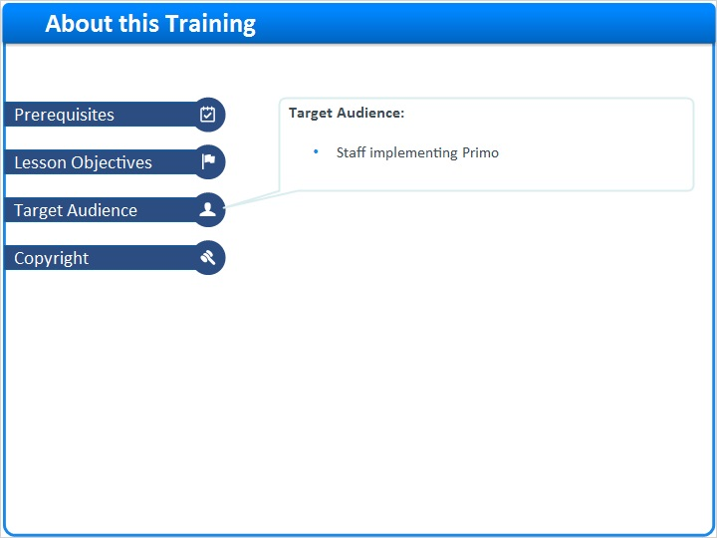

4 (Slide Layer)


