Primo Administration: Views

1. Views

1.1 Primo Administration: Views
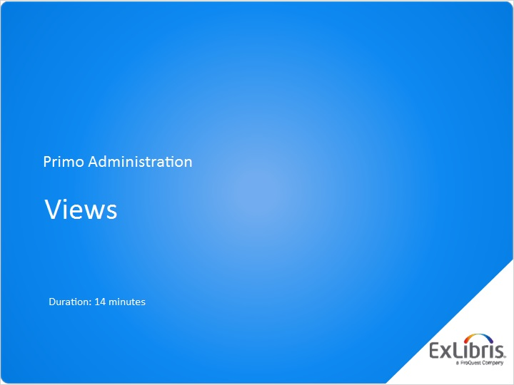
Notes:
Hello, and welcome to this session on Primo Views

1.2 Agenda
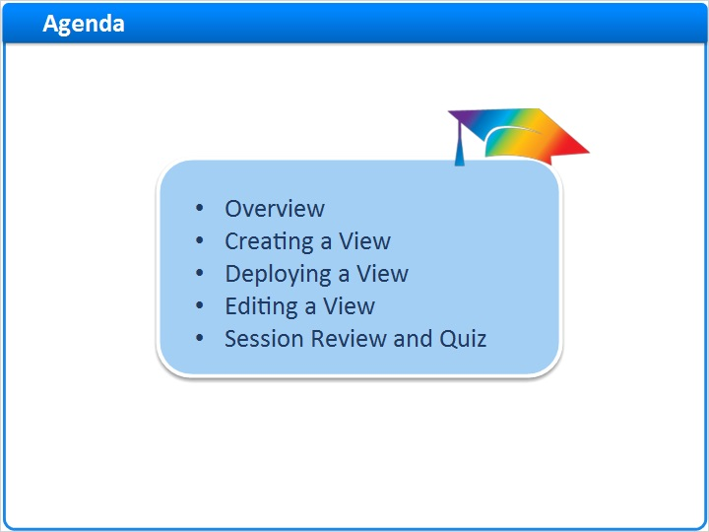
Notes:
First I’ll introduce you to the concept of Primo Views. Next, we’ll create a view in Primo, walking through each of the screens that set up and customize that view. We’ll deploy the view, and then discover how the view can be edited moving forward.

1.3 Overview
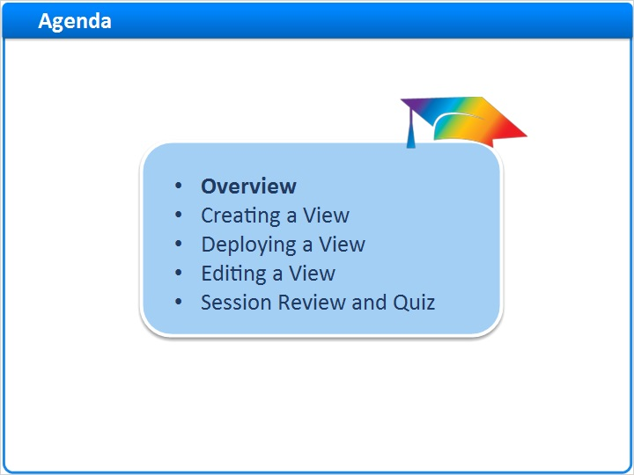
Notes:
Overview

1.4 Overview
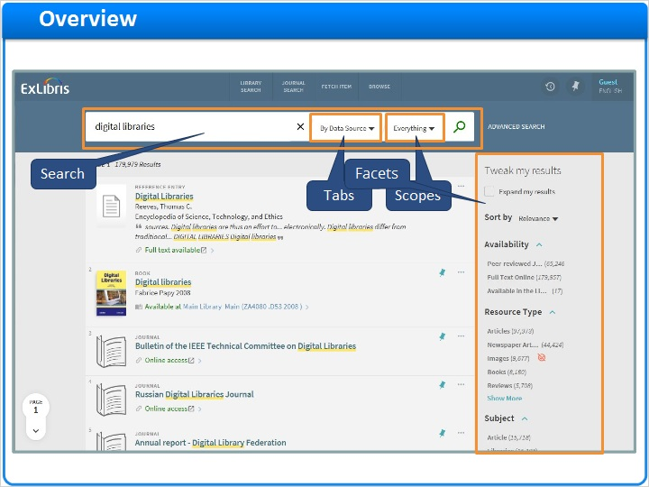
Notes:
The end user interface of Primo is called a View. While the institution and libraries form Primo’s administrative structure, the view is what gives your patrons access to Primo’s discovery and delivery services.

And while it’s possible to brand the end user interface using CSS and HTML, the View can be configured to display or hide settings, present scopes and tabs based on your organization’s preferences, and even customize how the search and facets function.

1.5 Views List
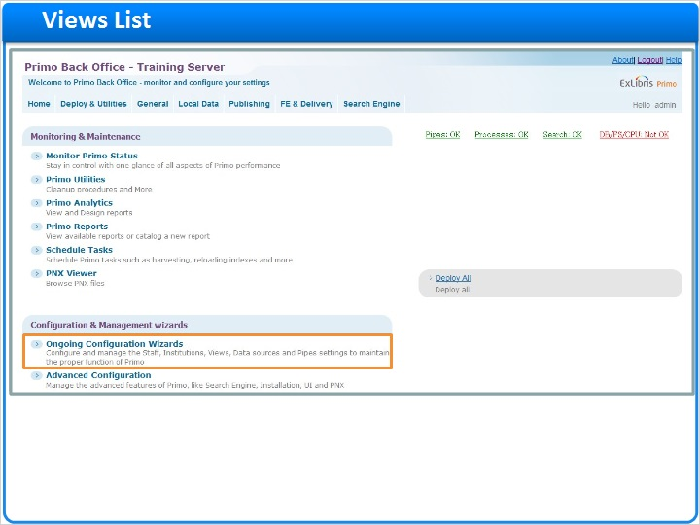
Notes:
To create or edit views, we need to use the Views Wizard.

We can find the Views Wizard under Ongoing Configuration Wizards, Views Wizard, or we can use the top navigation and select FE & Delivery, then Views List.

Views Wizard (Slide Layer)
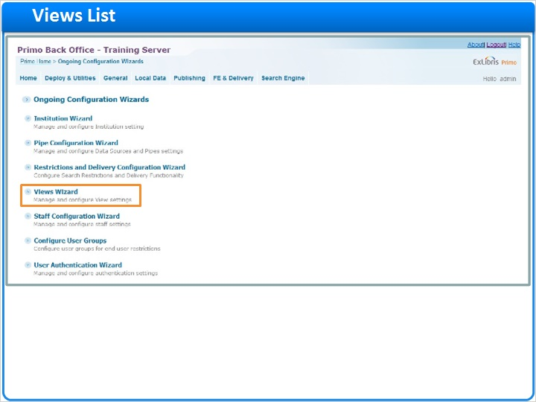

Navigation Menu (Slide Layer)
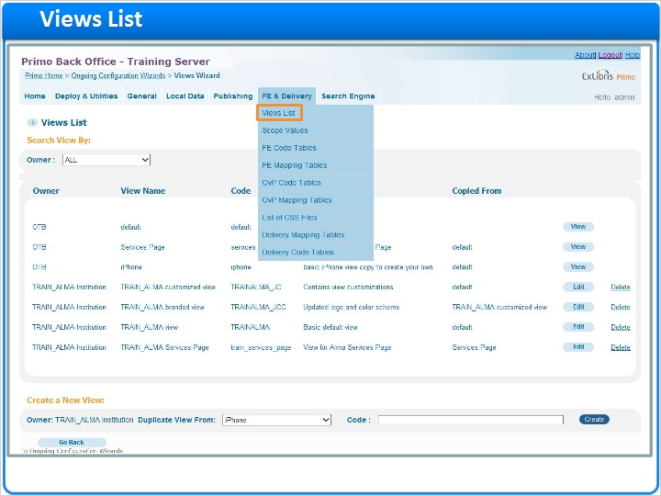

1.6 Views List
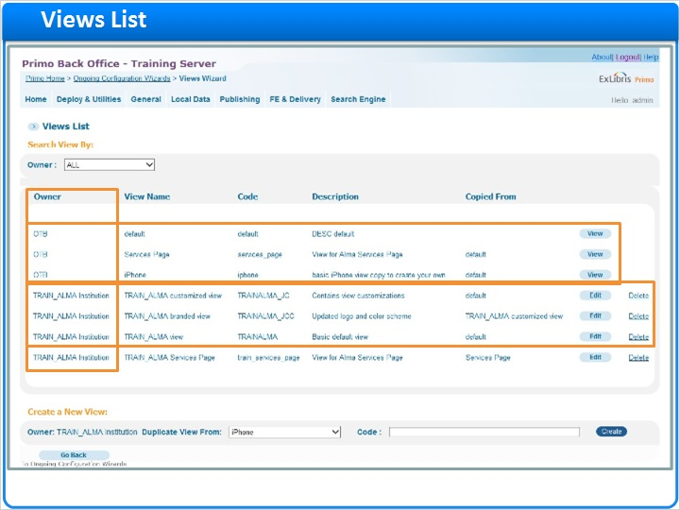
Notes:
The Views List contains all of the views that are currently configured for my institution. You’ll notice that in the first column we have the Owner information. OTB stands for out-of-the-box - so these views are here by default, and we are not allowed to edit them.

The other views in this list belong to the TRAIN_ALMA Institution. It’s possible to have more than one view for each institution; here we have a basic default view, a branded view that has CSS and HTML changes, and another that contains view customizations. If we go to the Front End of each of these views, we would see that the view code at the end of the URL in the Front End matches the view code in this column.

View code in URL (Slide Layer)
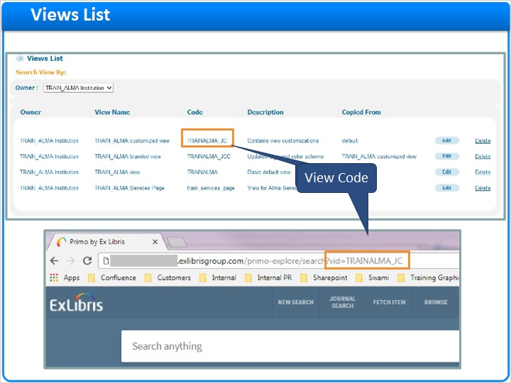

1.7 Creating a view
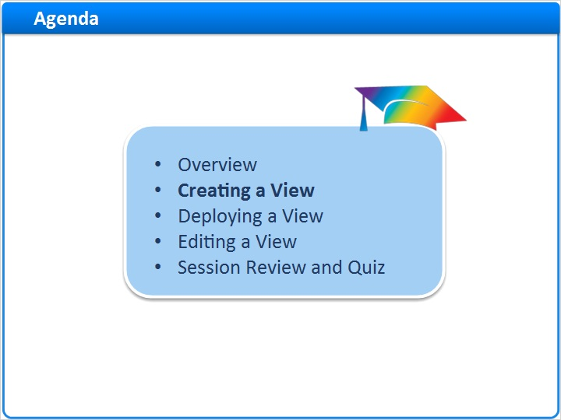
Notes:
Creating a View

1.8 Creating a view
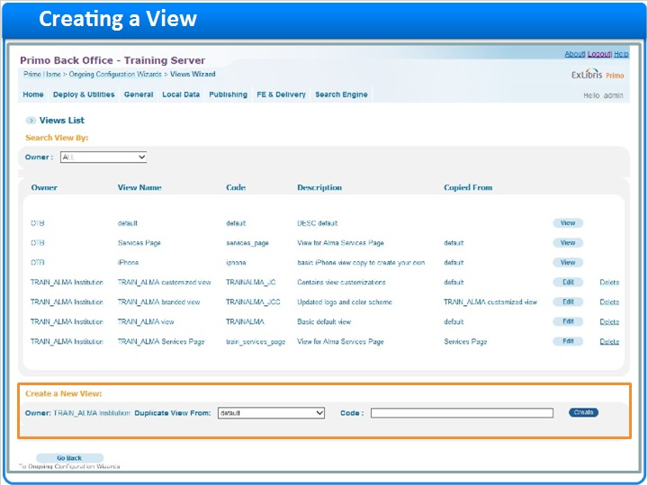
Notes:
I can create a new view at the bottom of the screen by duplicating an existing view, then defining a new code. This is why we have access to the out-of-the-box views; if you want to create a new view from scratch, you would duplicate the ‘default’ OTB view. Let’s create a new view, and name it TRAIN_ALMA_NEW. The code itself can be whatever you’d like, though it should not contain spaces. Once we click ‘Create’, we are brought to the first screen of the Views Wizard.

View duplication (Slide Layer)
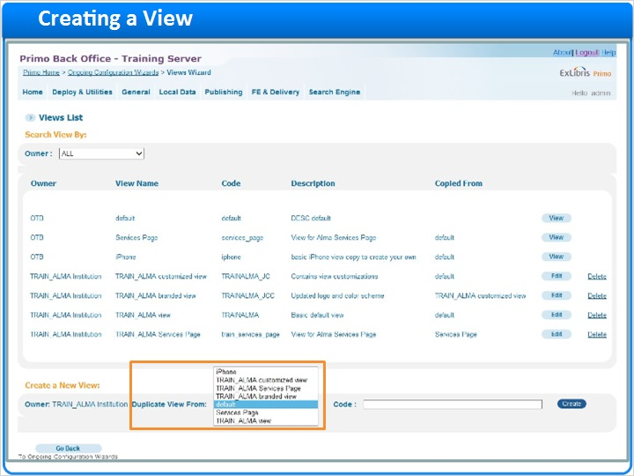

View creation code (Slide Layer)
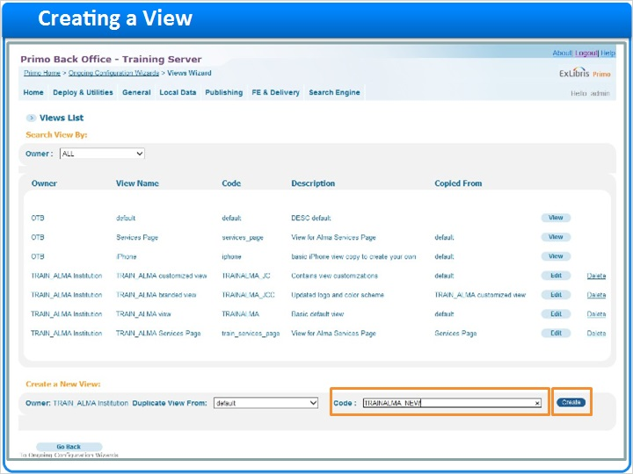

First screen of views (Slide Layer)
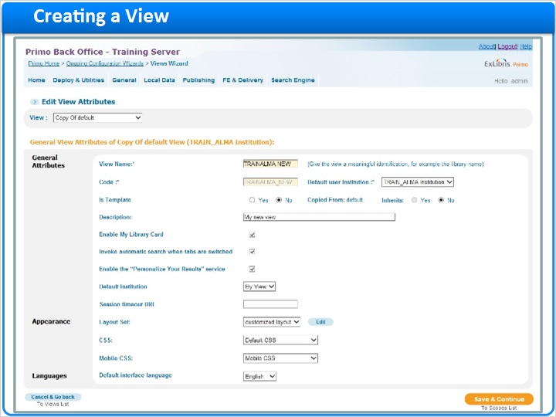

1.9 View attributes
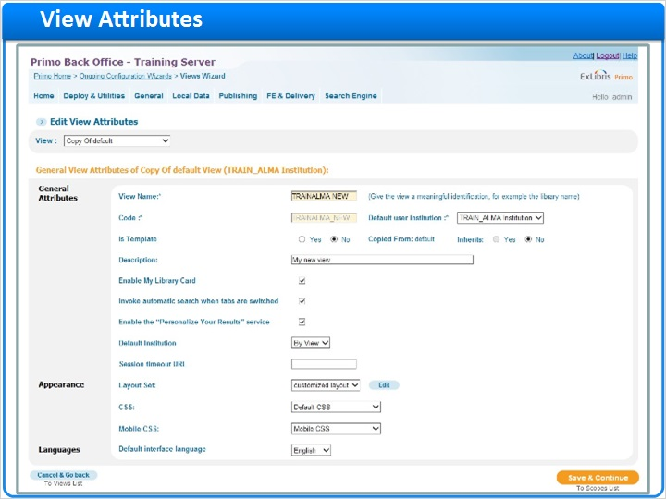
Notes:
In the View Attributes screen, I can name my view, and enter a description of that view. Both the View Name and Description are seen only in the Primo Back Office.

The Default user institution shows which institution this view is affiliated with.

The next few settings control whether or not this view will serve as a template. A template view serves as a parent view - and if a new view is created using a template view, it is considered a ‘child’ view. The child view can then inherit attributes and settings from the parent template view. Please see the Primo Back Office Guide if you would like additional information on this functionality.

The Enable My Library Card service allows us to see our Library account information in the e-Shelf if we are using Aleph or Voyager as an ILS, and OPAC via Primo is configured.

Invoking an automatic search when tabs are switched means that if you have entered a search term in one type of search, the search term will be retained if you move to a different tab. If this box is checked, I can enter a search for digital media here in the By Data Source tab, conduct the search, then move over to the By Library tab without having to type the search in again.

The default institution is used with consortia. There are two options - By View, and By IP. We recommend that you keep this set to By View unless your institution and libraries have specific configuration requirements.

The session timeout URL is blank by default, but needs to be filled in. The URL you enter here will control where the browser goes when the session ends. You might want to enter the Primo View URL here, or your library’s home page. Today we’ll use our new view’s URL.

The layout set, by default is set to customized layout. The edit button gives us access to the layout editor, where we can rearrange sections of Home Page and Search Results screens. For today, we’ll be using the default layout.

The CSS and Mobile CSS drop downs control which Cascading Style Sheet sets are used for this view. The selections here correspond to the sets defined in the CSS Mapping Table.

And last we have a setting that allows us to select the default interface language.

Once these parameters are defined, we can save and continue on to the scopes list.

Fill name and description (Slide Layer)
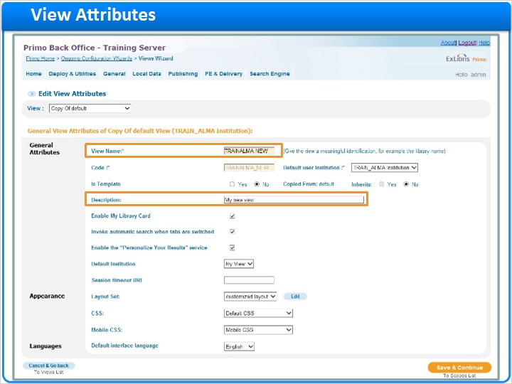

Default user institution (Slide Layer)
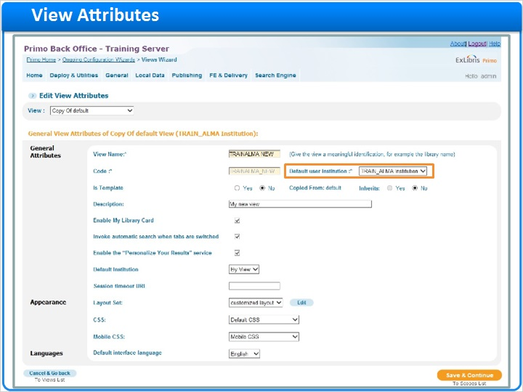

Is template line (Slide Layer)
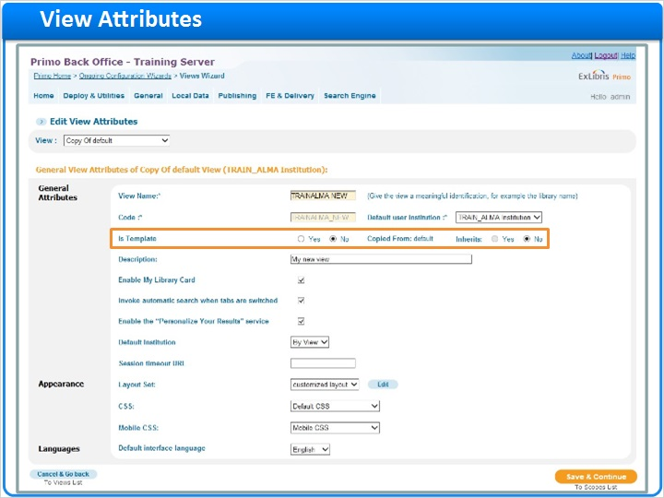

Enable my library card (Slide Layer)
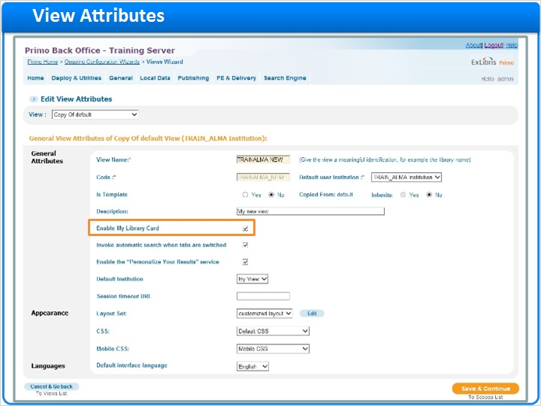

Enable automatic search show in FE (Slide Layer)
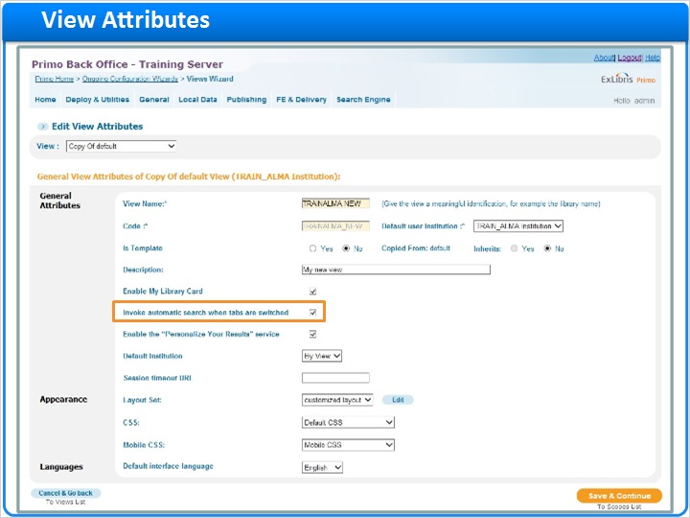

enable automatic search show in FE1 (Slide Layer)
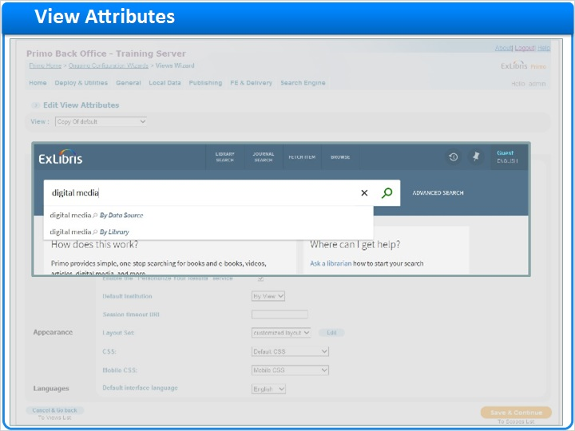

enable automatic search show in FE2 (Slide Layer)
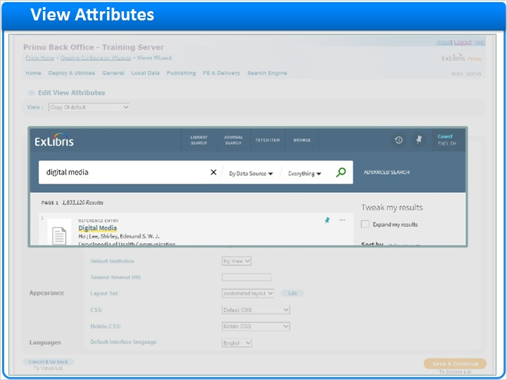

enable automatic search show in FE3 (Slide Layer)
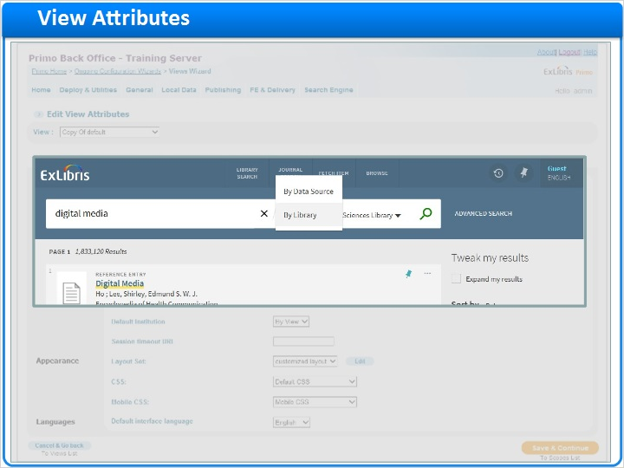

Default institution (Slide Layer)
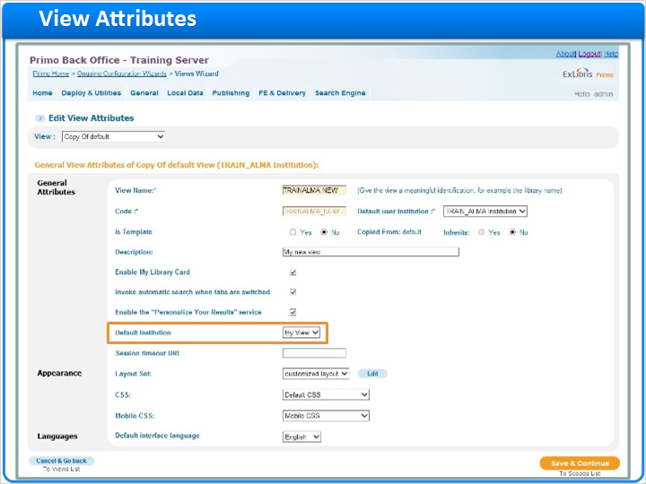

Session timeout URL (Slide Layer)
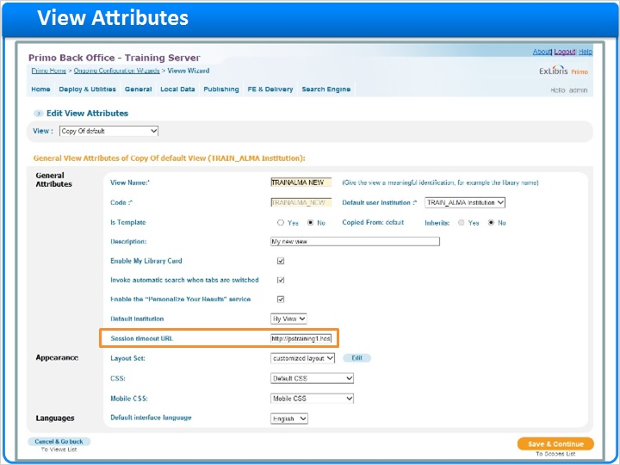

Layout set (Slide Layer)
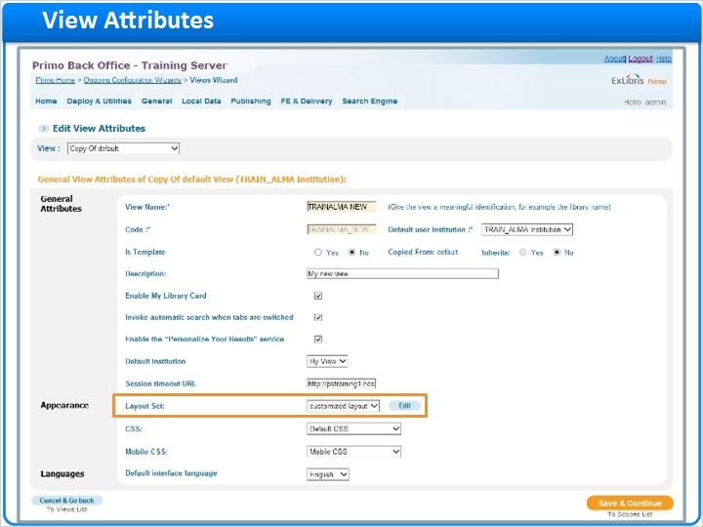

CSS dropdowns (Slide Layer)
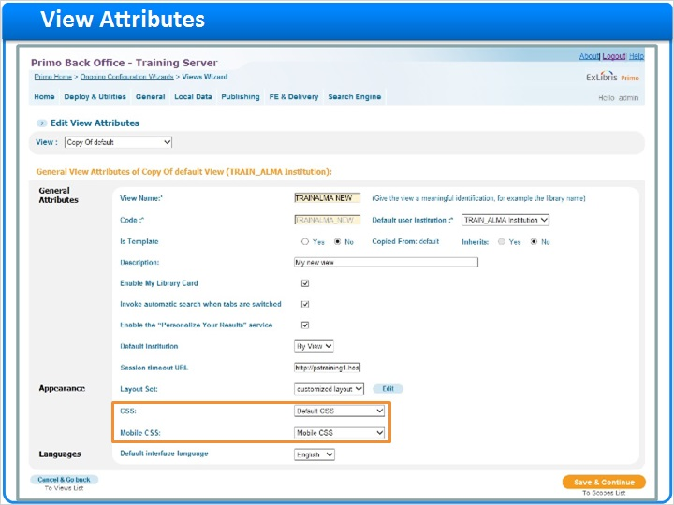

Default language interface (Slide Layer)
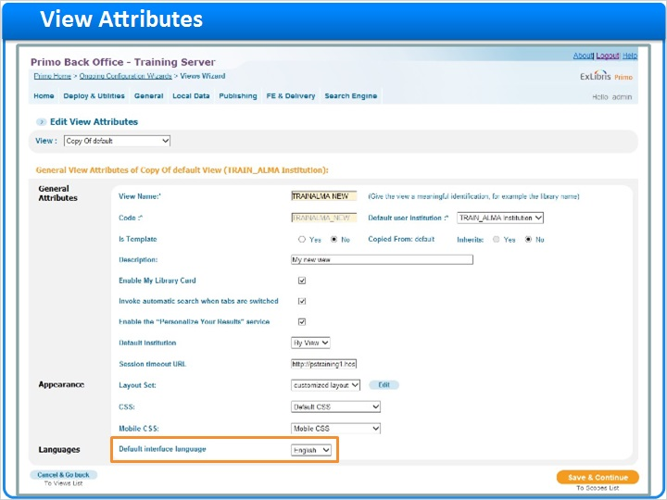

Save and continue button (Slide Layer)
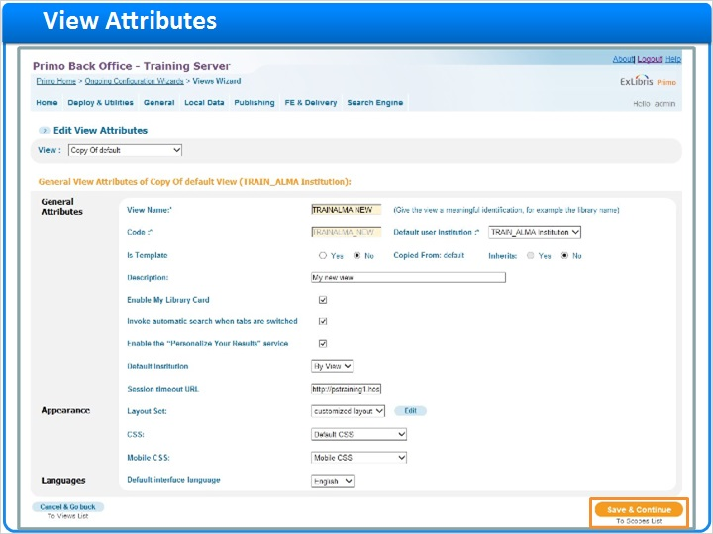

1.10 Editing a scope
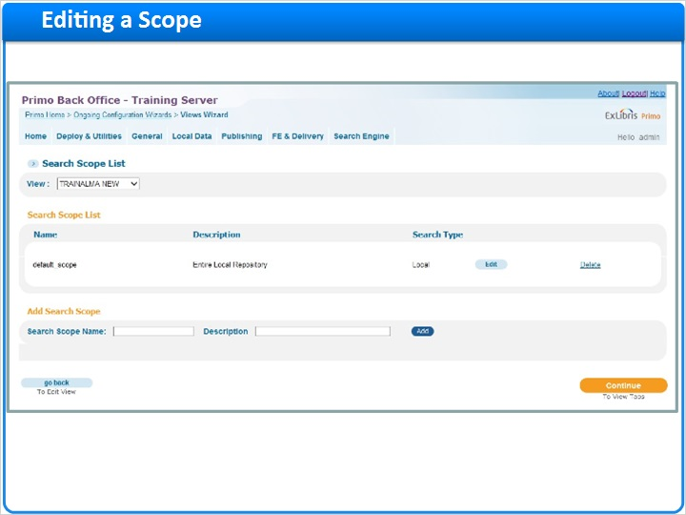
Notes:
To understand what we’re configuring, let’s take a look at the front end of one of our existing views.

Scopes are sets of records that are grouped for searching. Here in the Basic Search, I can see that I’ve grouped the records by data source, and I can search the library catalog records, the Primo Central records, and I can search both at the same time. For the new view that we’re creating, I’d like to configure the scopes in the same way.

Back in the search scopes list in the views wizard, there is a default scope container. If I click Edit, I am able to change the scope description to Local and Remote Resources, and change the text that will display in the dropdown in the front end to Everything.

Then I can select my scope values. These values were defined in the Scope Values area of the Primo Back Office, and have also been written to the PNX records during the normalization process. Here in the Views Wizard we are configuring them for to display. It’s possible for me to select multiple scope values here, but since one of these values contains the resources I’m looking for, I am going select the institution scope, which includes all of the local data that was loaded for this institution.

If you have configured MetaLib, Ex Libris’ federated search product, to work with Primo, the MetaLib quicksets would be available to search.

Next, we have our Deep Search Plugins. Since this scope container is searching both local and remote resources , I’m going to select Primo Central. By default, the search results from Primo Central will only include those that I have full text access to - unless I select the include results with no full-text. In that case I’d be seeing all of the search results from all of the active collections in Primo Central. Since my users will have the option to expand their results in the view, I’m going to leave this unchecked for now.

Once I’m finished here, I can save this scope and go back to the scopes list.

Scopes in FE (Slide Layer)
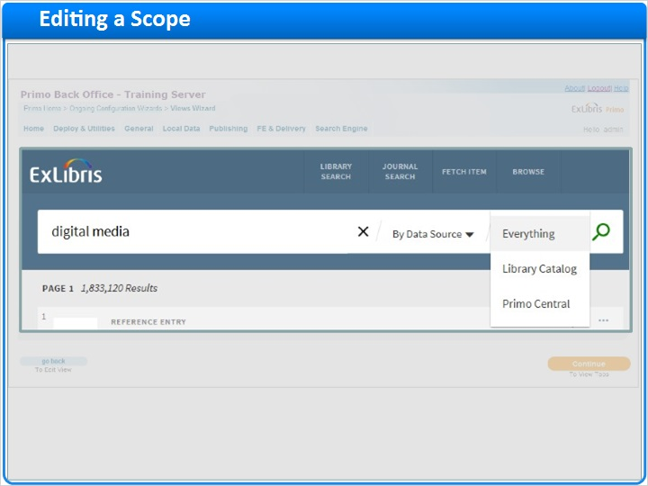

Scopes list in BE (Slide Layer)
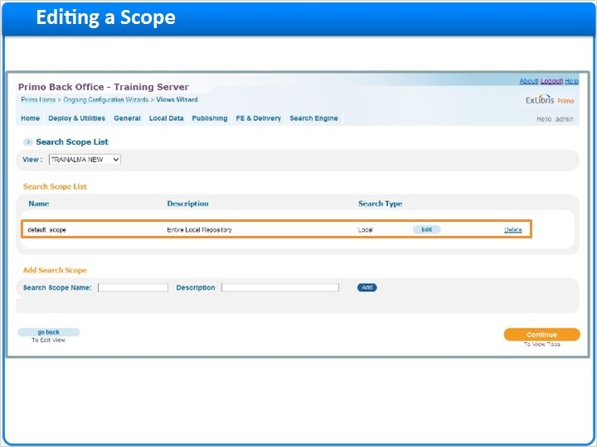

Select Edit default scope (Slide Layer)
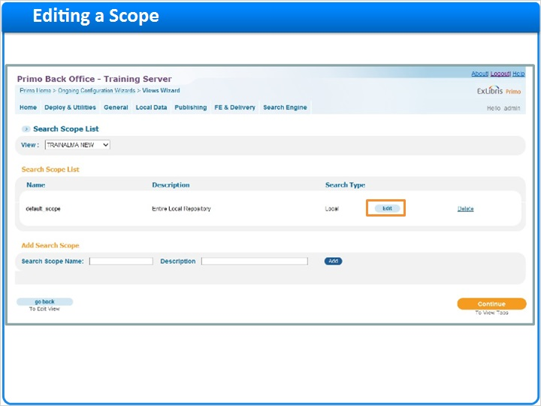

Edit default scope (Slide Layer)
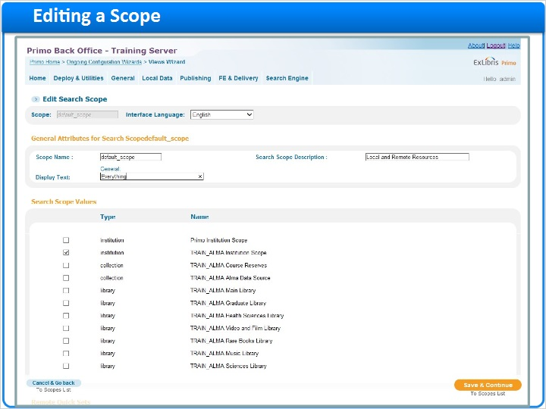

Edit scope description (Slide Layer)
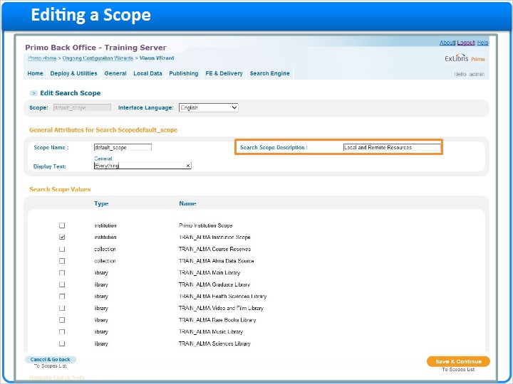

Edit scope display (Slide Layer)
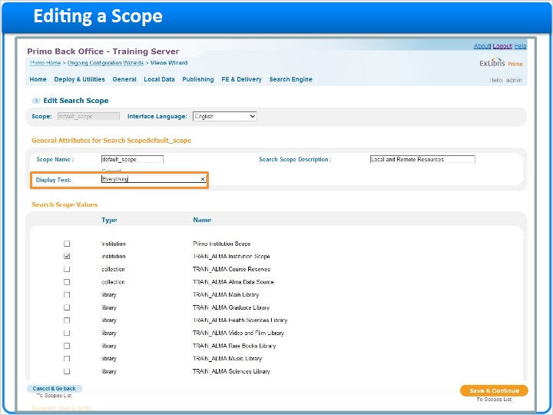

Scope values (Slide Layer)
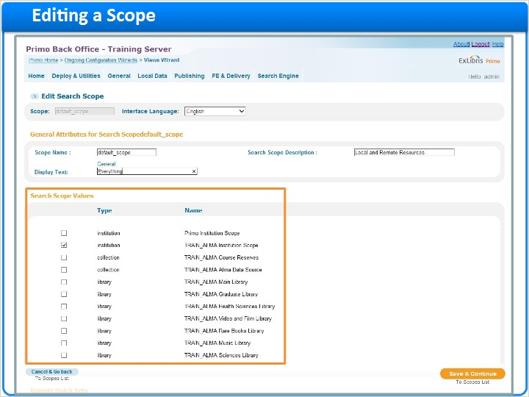

Check institution scope (Slide Layer)
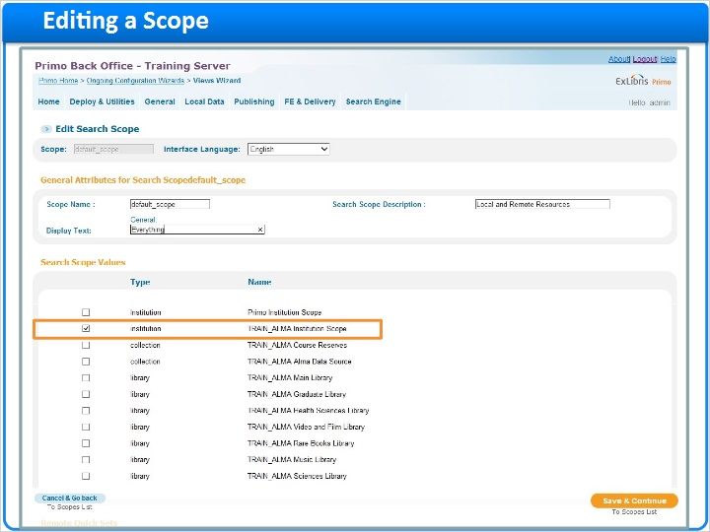

Remote search scopes (Slide Layer)
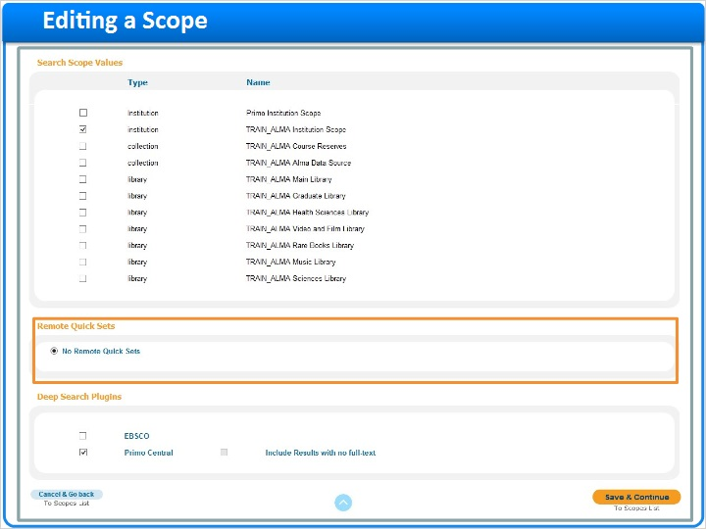

Deep search (Slide Layer)
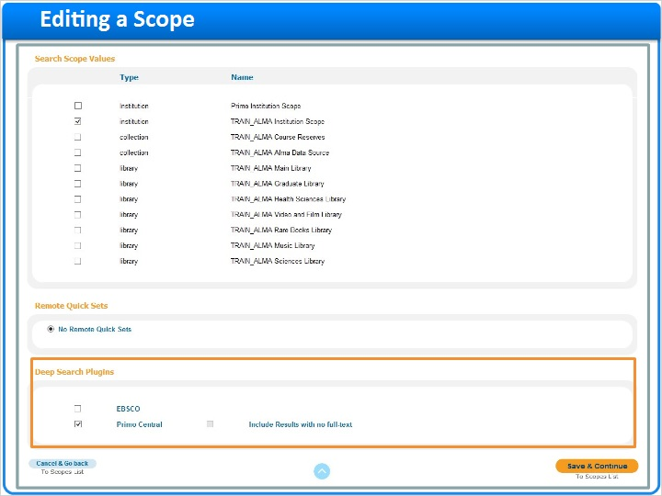

Check Primo Central (Slide Layer)
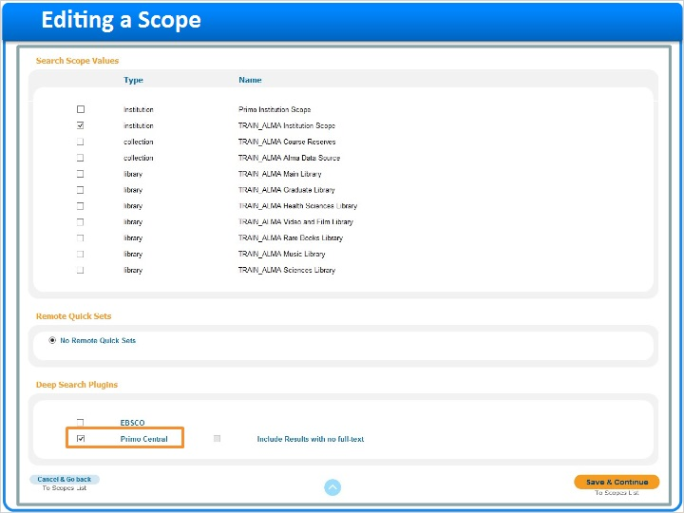

Include no full text (Slide Layer)
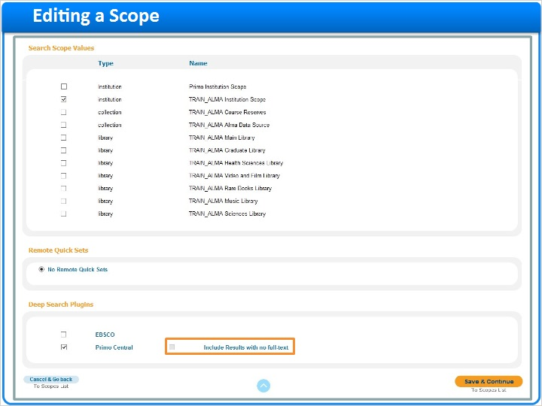

Save (Slide Layer)
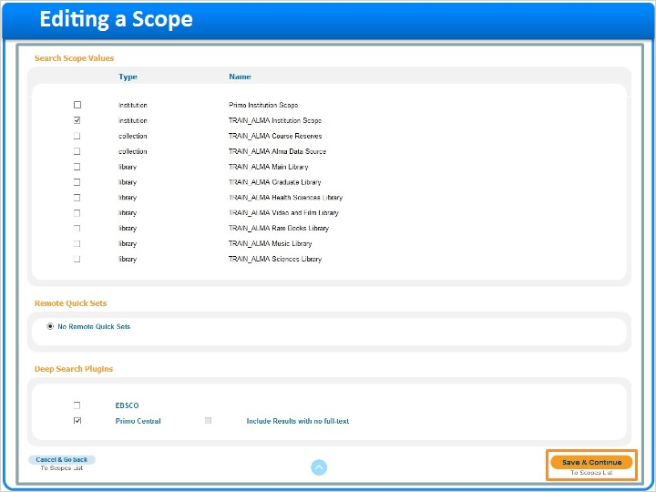

Scopes list (Slide Layer)
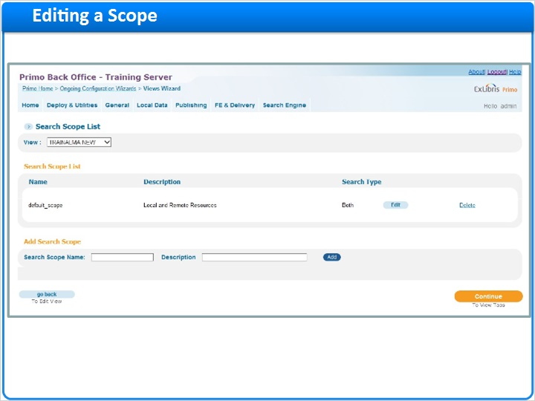

1.11 Creating a new scope
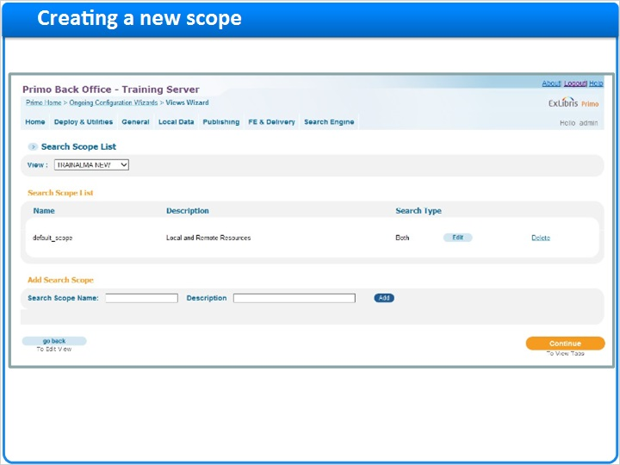
Notes:
Now that I’ve edited my default scope, I’d like to add another that will just search the library catalog.

To create a new scope container, I name the scope, type in a description, then click Add. I’m then brought to the edit search scope screen where I can enter in my display text (Library Catalog), and select the scope values I’m looking for (TRAIN_ALMA Alma Data Source). I’m not adding any remote resources this time, so now I can save and continue to be brought back to the scopes list.

I’m going to create another scope, this time just selecting Primo Central.

Ok - now that I’m finished creating my scopes, we continue onto tabs.

Scope name (Slide Layer)
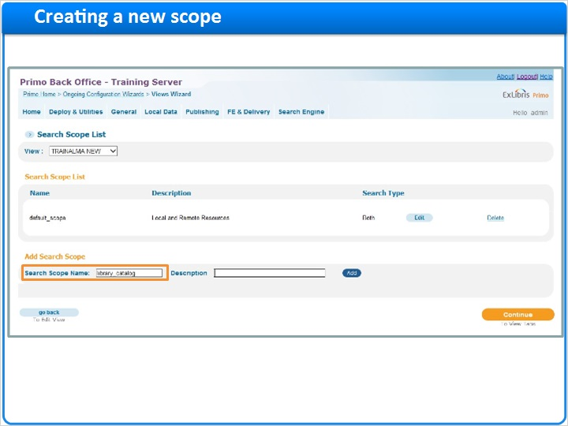

Scope description (Slide Layer)
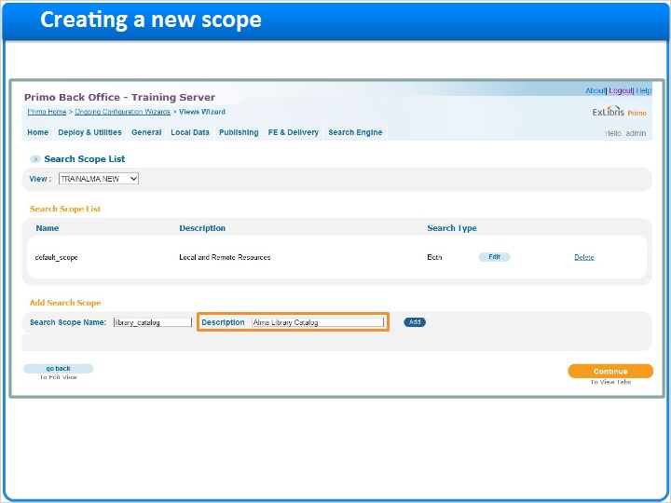

Click add (Slide Layer)
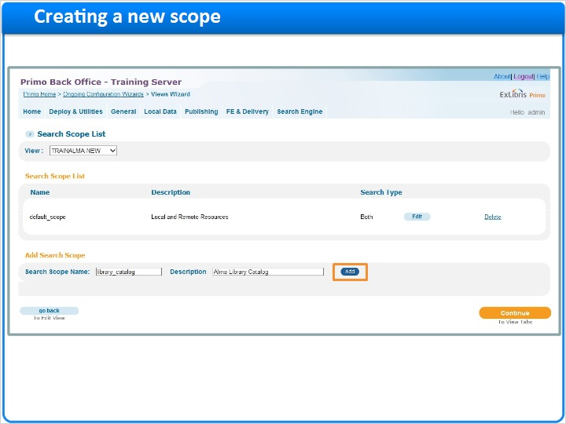

Edit search scope (Slide Layer)
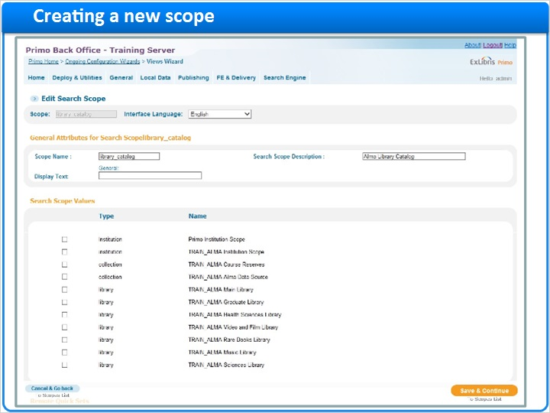

Display text (Slide Layer)
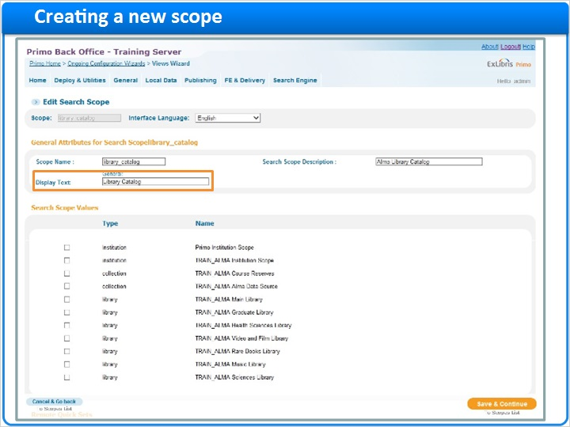

Scope values (Slide Layer)
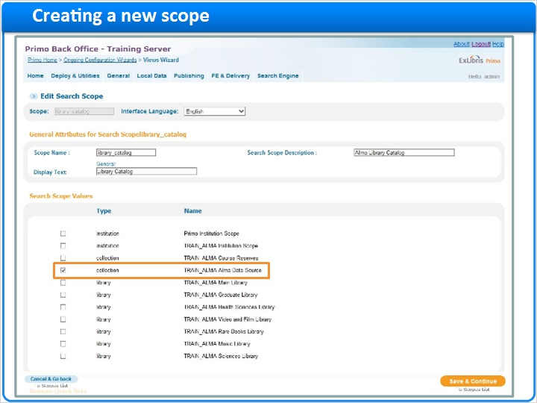

Save (Slide Layer)
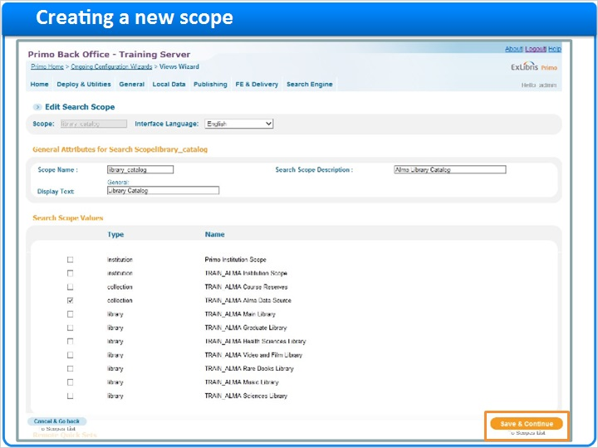

Scopes list 2 scopes (Slide Layer)
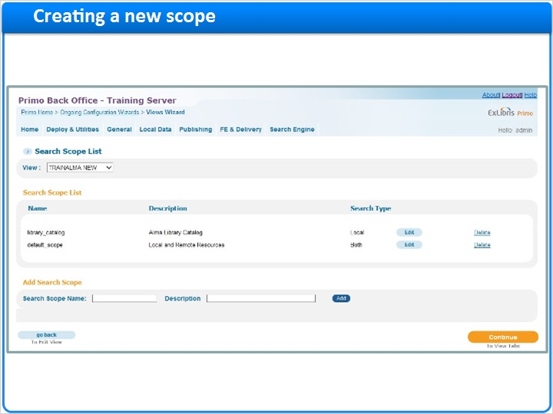

Scopes add pc scope (Slide Layer)
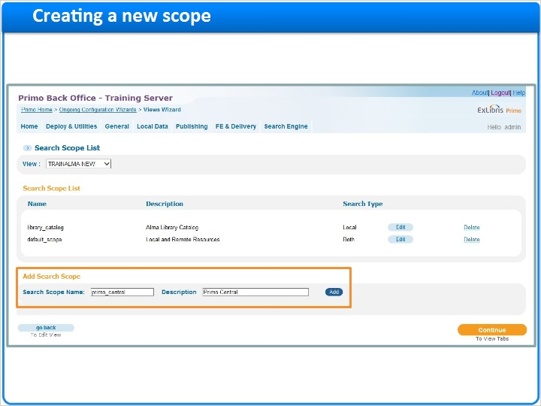

Display text pc (Slide Layer)
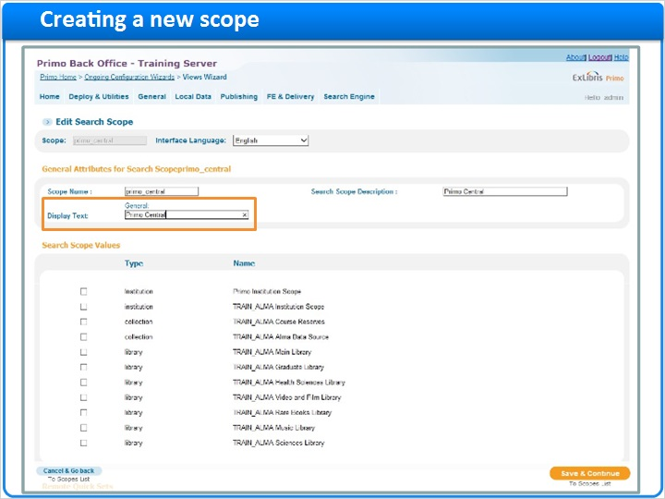

Scope value pc (Slide Layer)
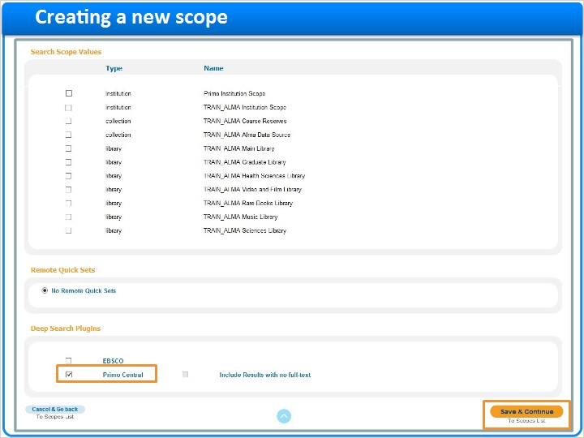

Scopes list 3 scopes (Slide Layer)
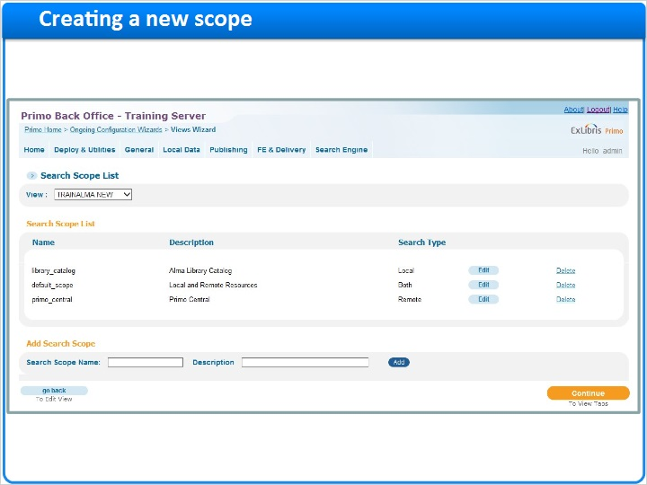

Continue to tabs (Slide Layer)
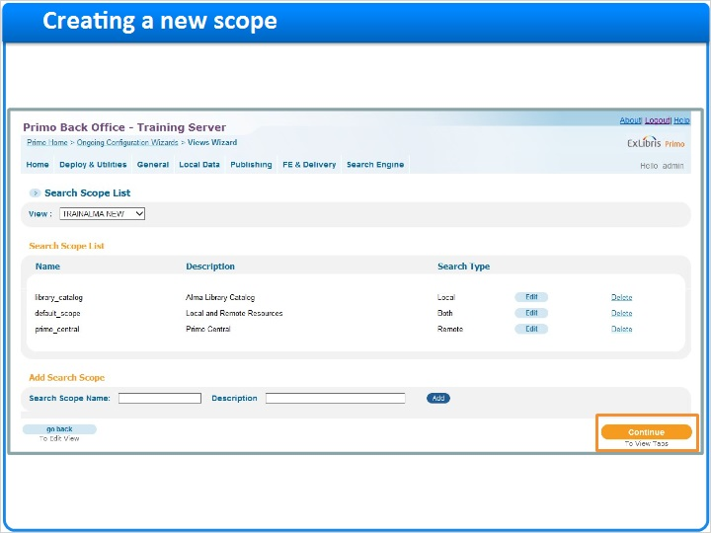

1.12 Editing a tab
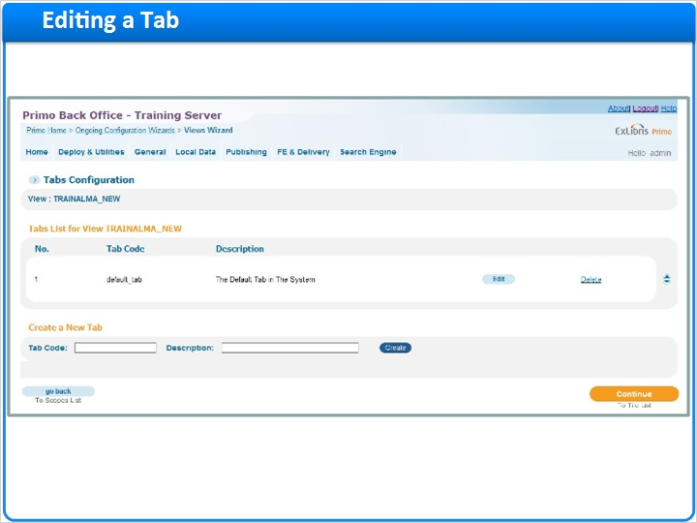
Notes:
To understand what we’re configuring here in the Tabs screen, let’s take another look at the front end of one of our existing views. (contains both scopes and tabs)

While my scopes appear in the dropdown, tabs are displayed as headers above the search box. In this view, I have three tabs - By Data Source, By Library, and By Collection. For the new view we’re creating, I’m going to create two tabs.

Back in the views wizard, let’s edit our default tab first. When I click edit, I’m brought to the tab configuration screen. I’m going to name my tab (All Resources), give it a description (Local and Remote resources), and provide a tooltip (Search across all library resources). The tab name here will only show in the front end if I have more than one tab configured.

The Display Find in Database checkbox is only used when Primo is configured to work with MetaLib.

The next section indicates which scopes are on the tab. By default, we have our default scope. If I only have one scope on a tab, there will be no dropdown. This is how I would like to configure this tab, but I could add scopes by selecting them here and clicking ‘Add’.

Now that our first tab is finished, I’m going to click Save & Continue to be brought back to the tabs list.

Tabs FE (Slide Layer)
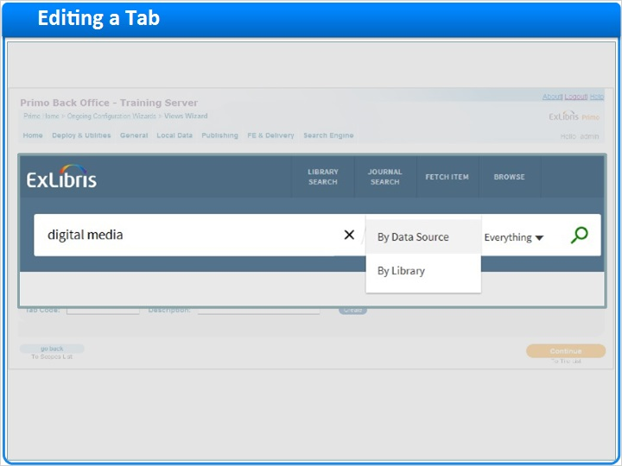

Tabs list (Slide Layer)
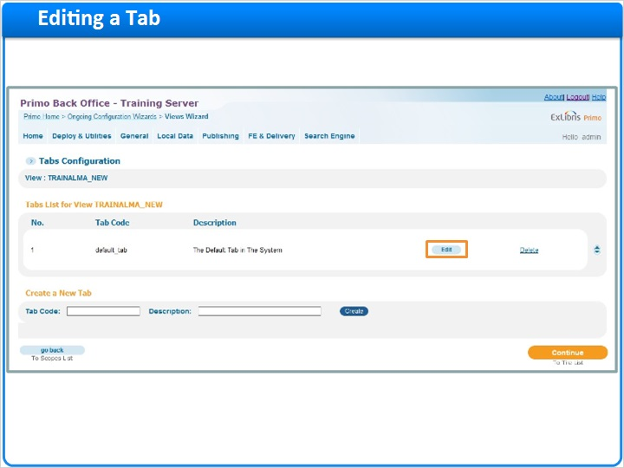

Tab configuration (Slide Layer)
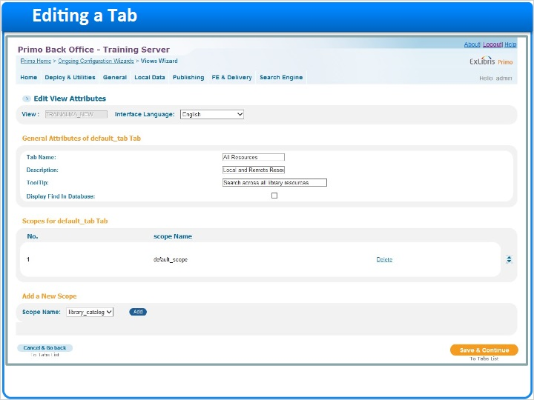

Tab name (Slide Layer)
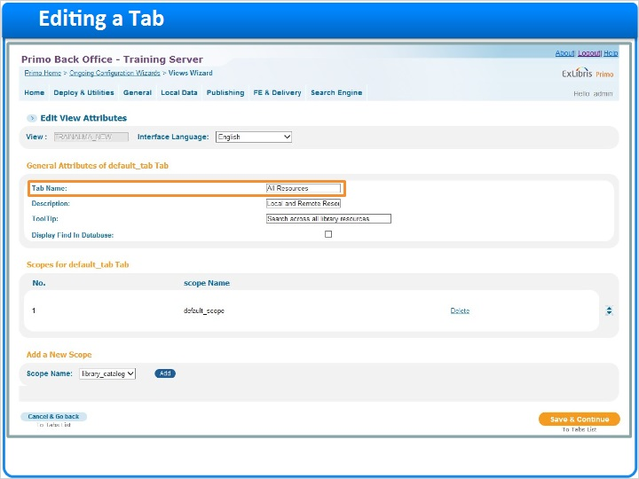

Tab description (Slide Layer)
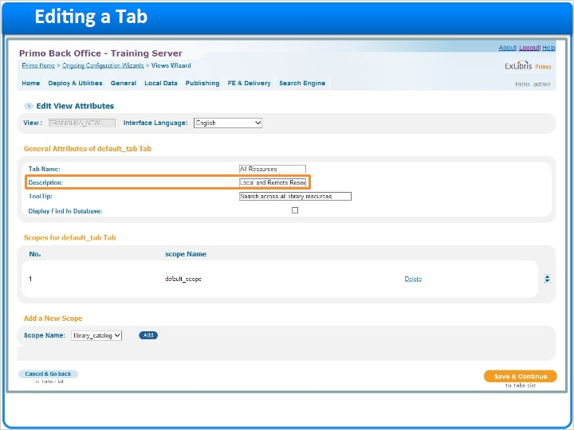

Tab tooltip (Slide Layer)
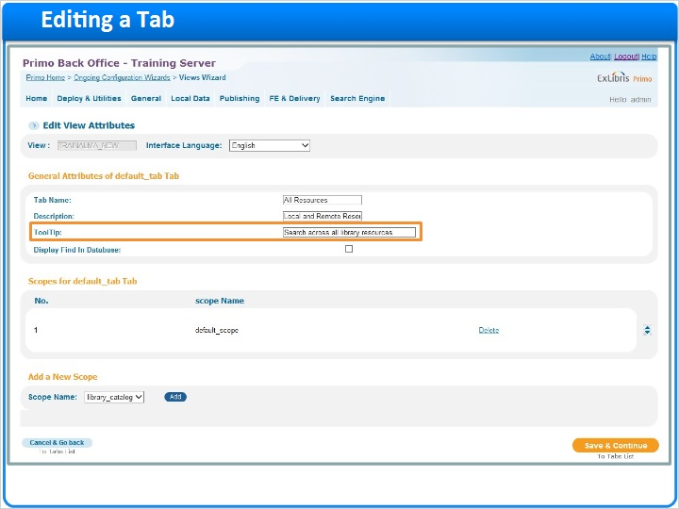

Find database (Slide Layer)
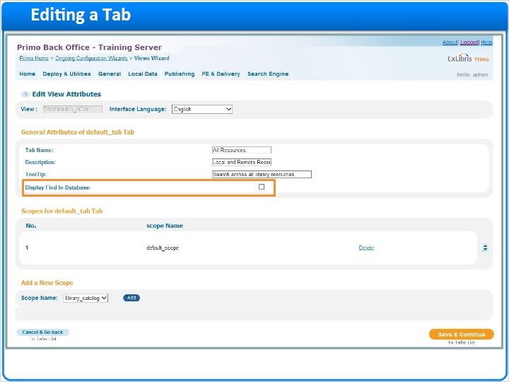

Scopes on tab (Slide Layer)
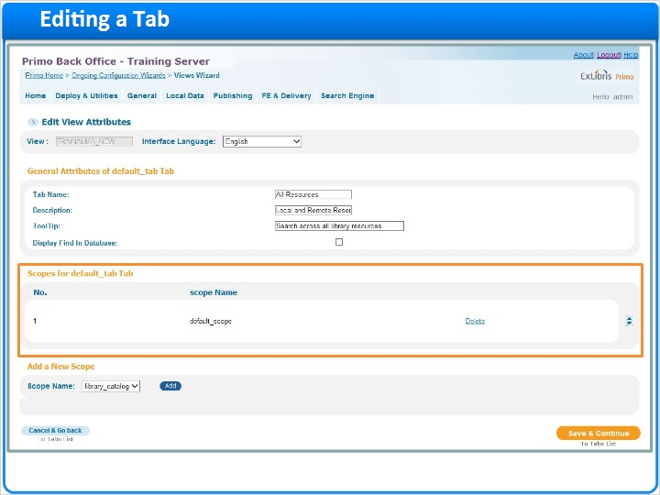

Adding scopes to tab (Slide Layer)
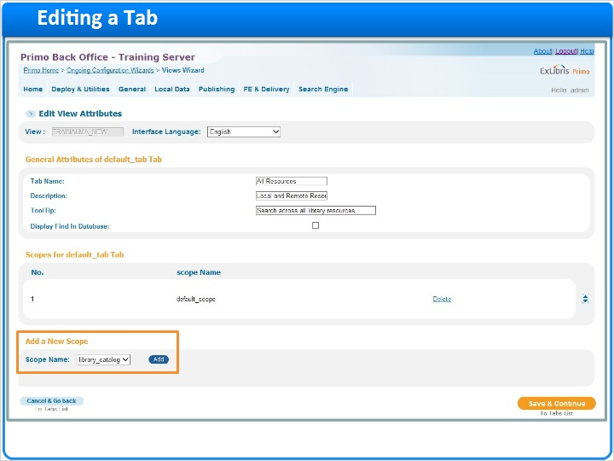

Save (Slide Layer)
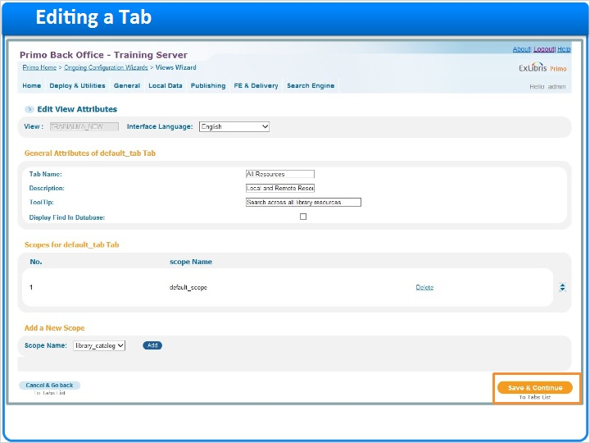

1.13 Creating a new tab
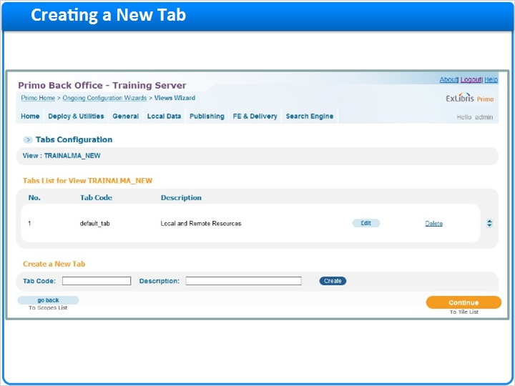
Notes:
From here I can create a second tab by entering in a tab code (by_datasource), a Description (Data Sources tab), then clicking ‘Create’. Again I would fill in my tab name (By Data Source) and tooltip (Search by data source).

Next I would add the scopes I’d like to use. Since I already have my default scope on the first tab, I’m just going to add the library_catalog and primo_central scopes. The scope in the #1 position will be the default, and the order they appear in here will decide the order in which they’re displayed - so if I want to change the order I can use the arrows on the right side of the screen.

Now that our second tab is finished, I’m going to click Save & Continue to be brought back to the tabs list again.

Though my configurations in my new view are not visible in the front end yet, this is what this configuration will look like in the Front End.

Let’s go back to the views wizard and continue on to the Tile List.

Tab code (Slide Layer)
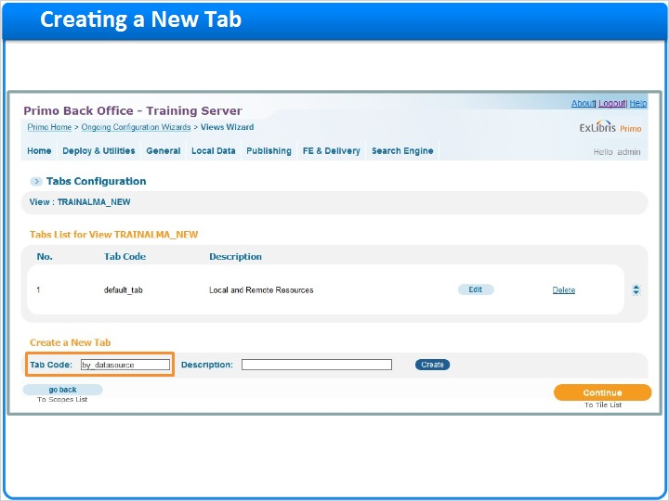

Description (Slide Layer)
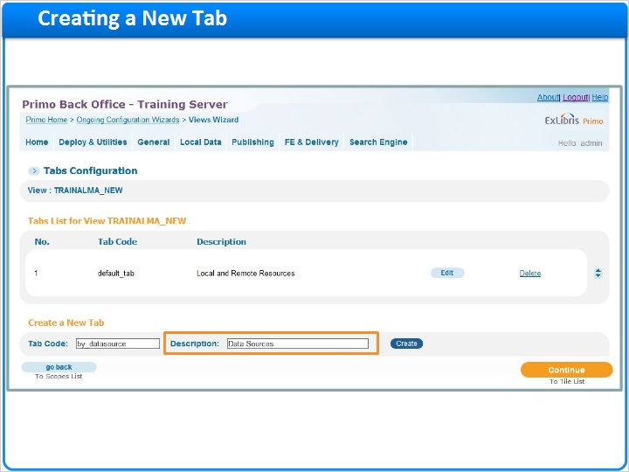

Create (Slide Layer)
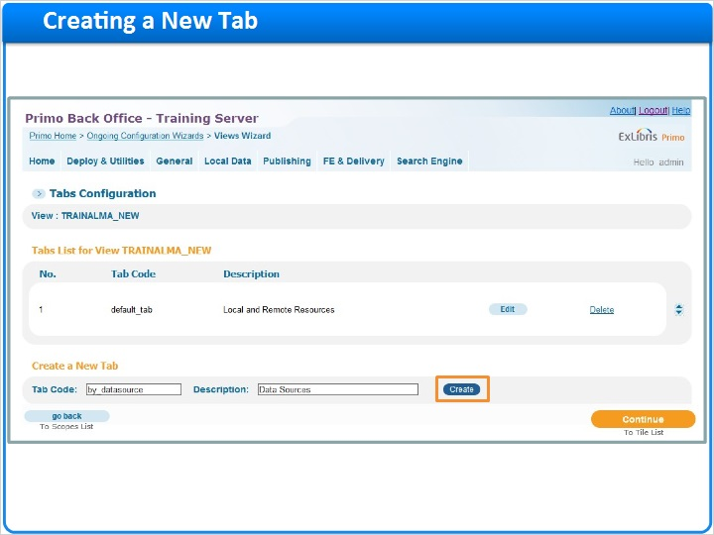

Edit tab (Slide Layer)
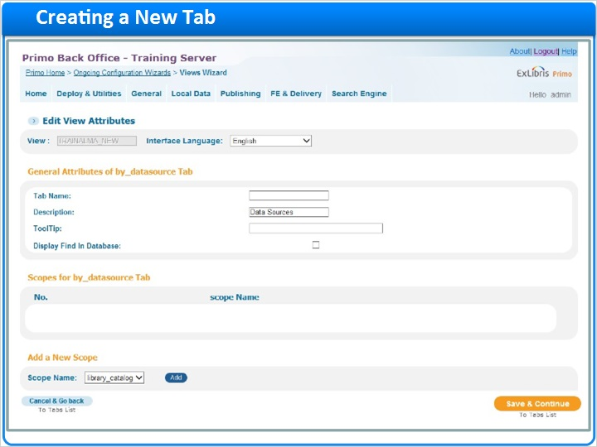

Tab name and tooltip (Slide Layer)
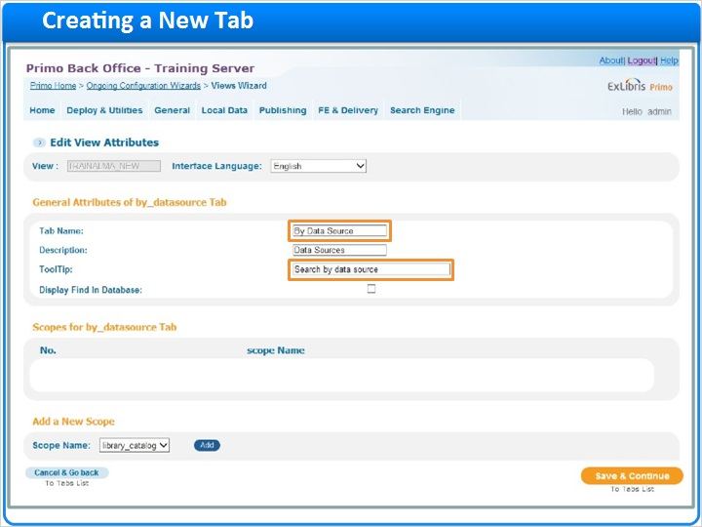

Scopes dropdown (Slide Layer)
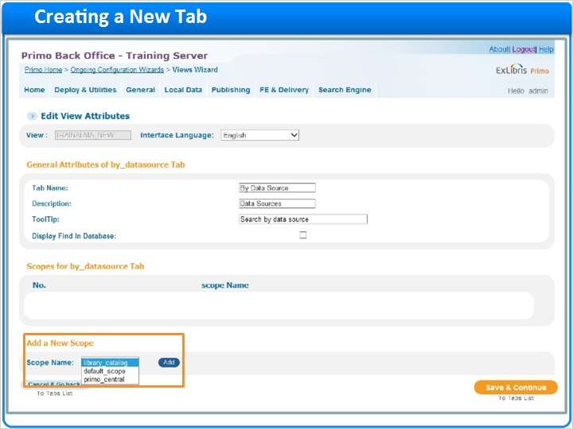

Scopes added (Slide Layer)
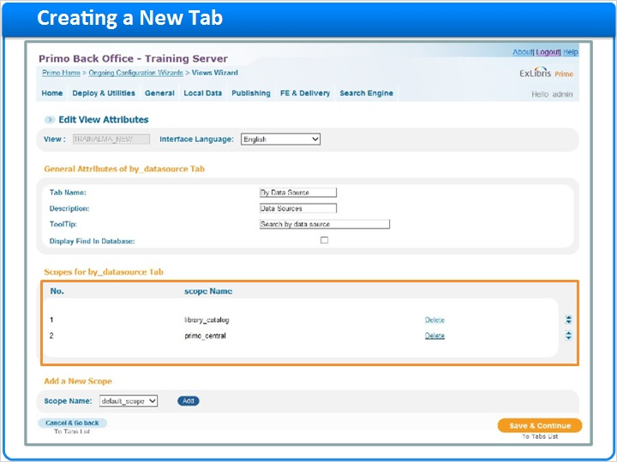

Save (Slide Layer)
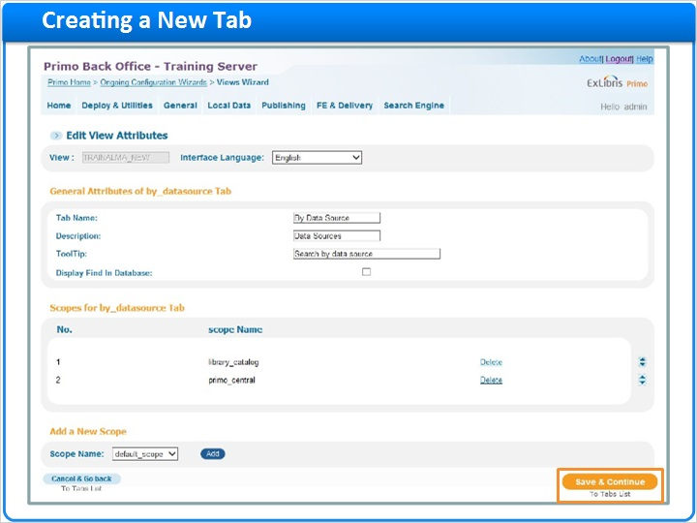

Tabs list (Slide Layer)
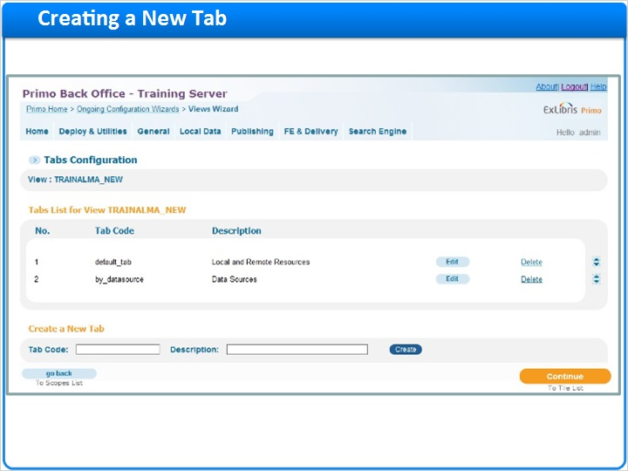

Tabs in FE (Slide Layer)
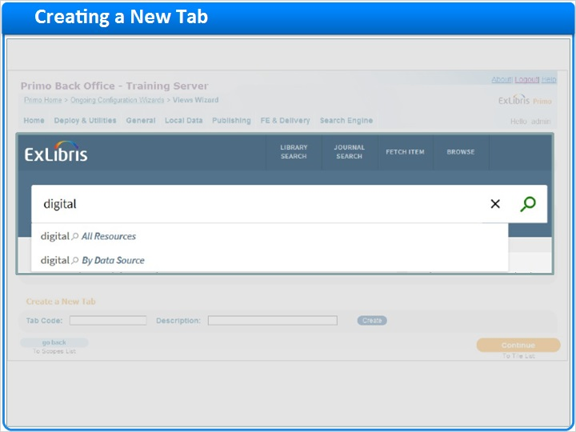

Tabs in FE - by data source (Slide Layer)
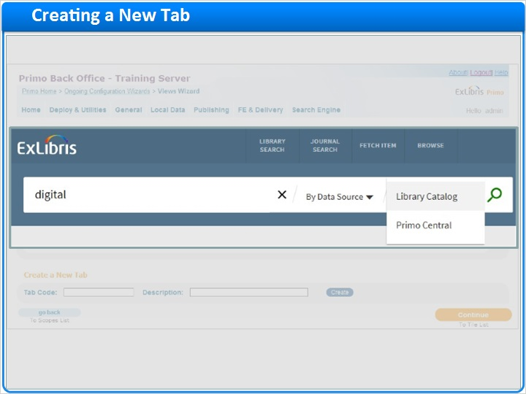

Continue (Slide Layer)
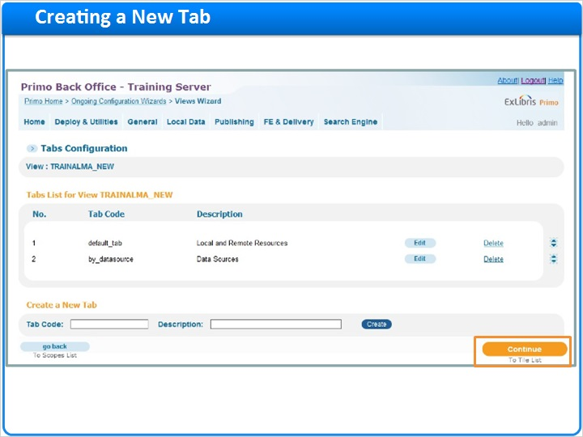

1.14 Tiles Configuration
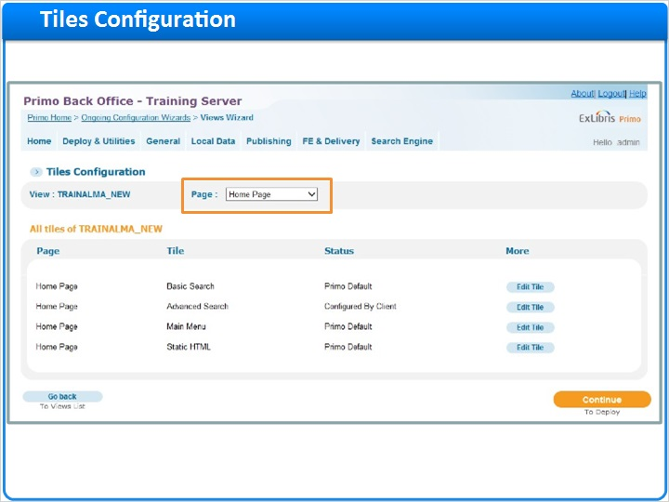
Notes:
The Tiles Configuration contains the rest of the configurations for our view.

There are three areas of the tile configuration - the home page, the full display, and the brief display.

Full display (Slide Layer)
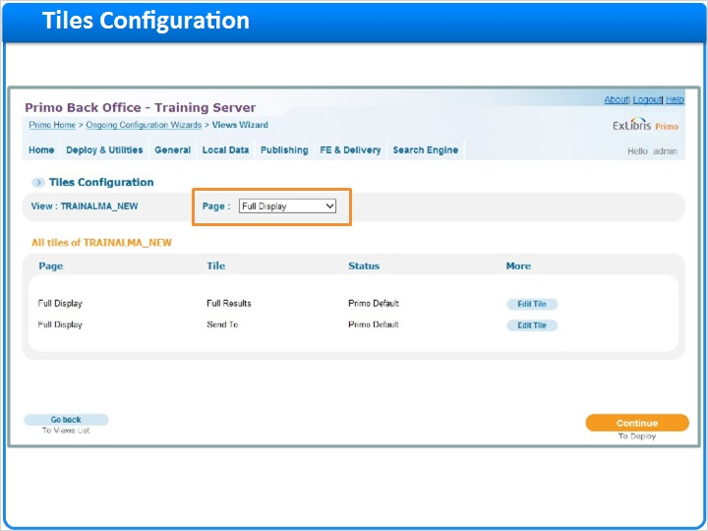

Brief display (Slide Layer)
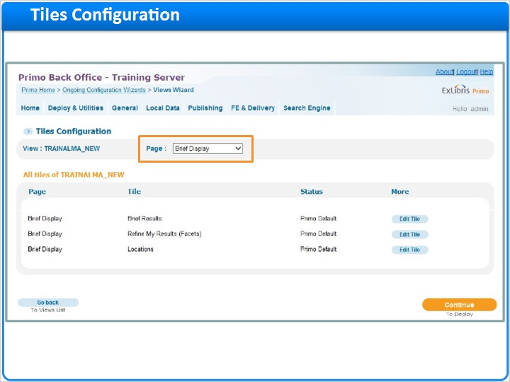

1.15 Home Page
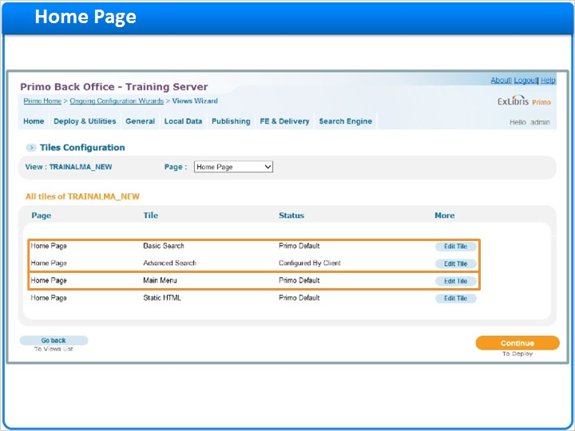
Notes:
In the Home page, we can make adjustments to our searches, and we can update the links in our Main Menu.

1.16 Advanced Search
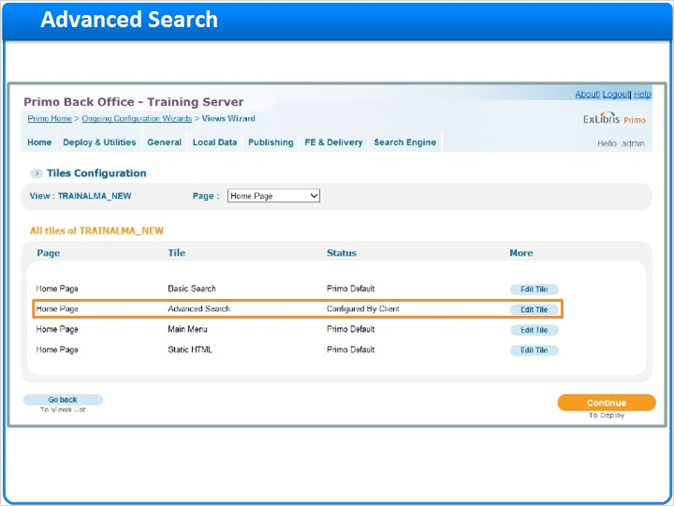
Notes:
If I edit the Advanced Search tile, I can add, reorder or update search boxes and pre-filters.

Again, I can configure each tab separately if needed. In the Front end, we can see the default configurations applied.

Advanced Search Attributes (Slide Layer)
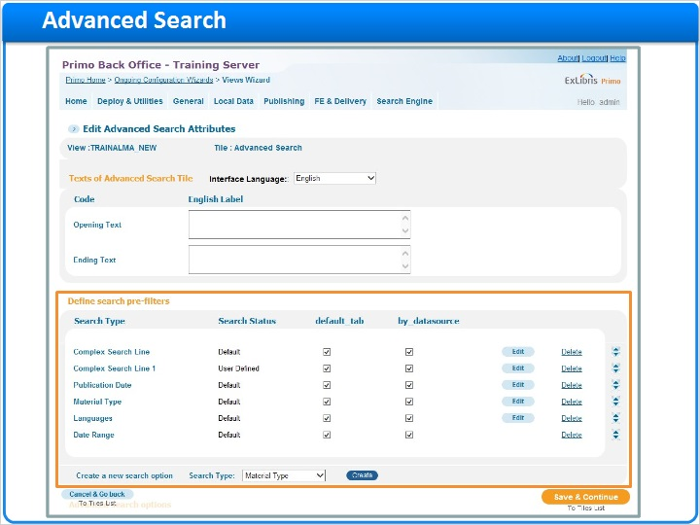

Front End (Slide Layer)
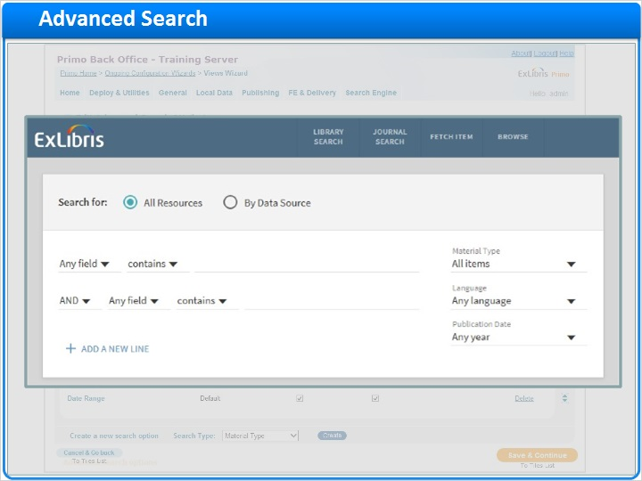

1.17 Main Menu
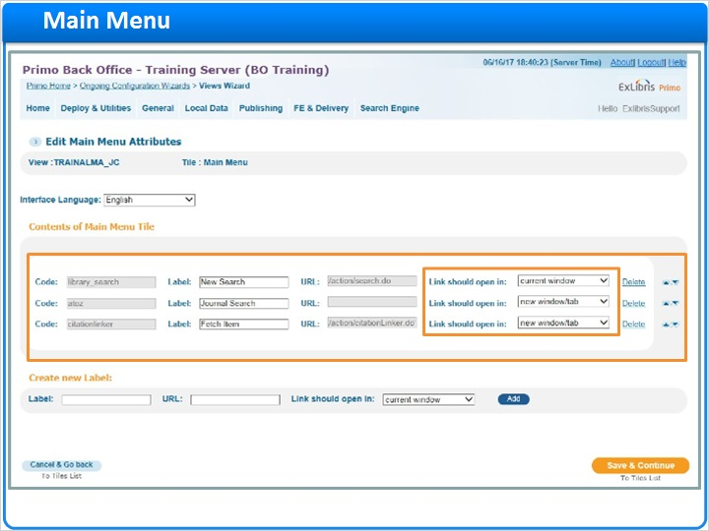
Notes:
In the Main Menu configuration, we can configure which links will show in the Main Menu. We can also determine which order they appear in, and whether or not the links open in the existing or a new window.

In the Front End, the main menu links show at the top right of the screen.

Front End (Slide Layer)
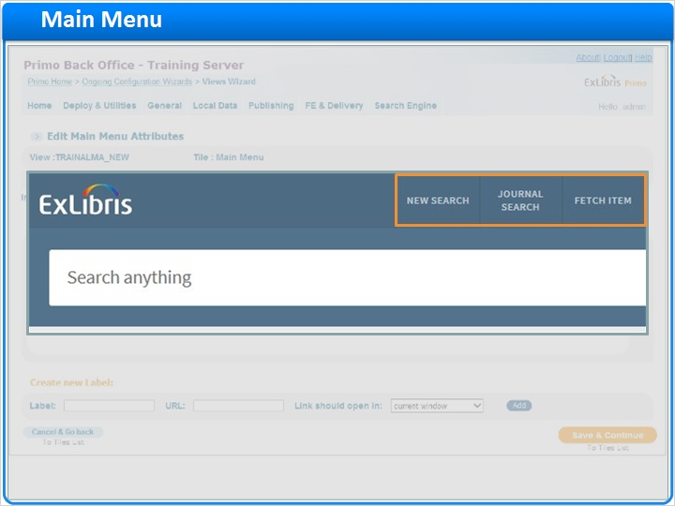

1.18 Full Display
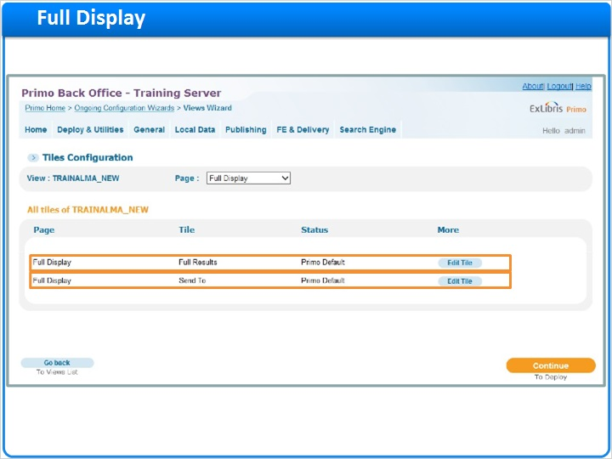
Notes:
In the Full Display area, we can customize the fields that display in the Details section and configure the Send to SMS function.

1.19 Full Results
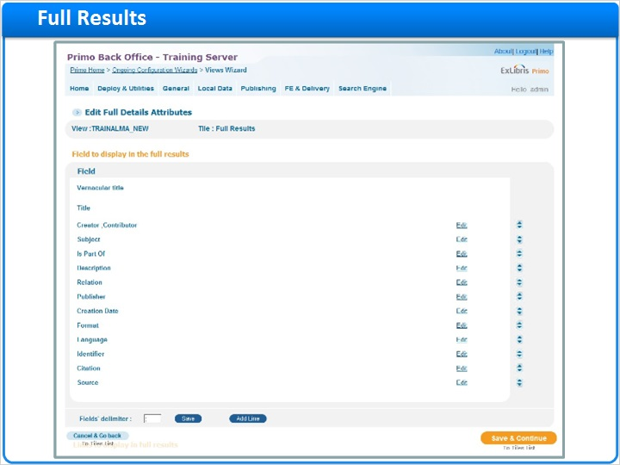
Notes:
Here in the Full Results, each of the fields that can potentially display in the Details section are listed. It is possible to add and remove fields, and change their order.

Below this list, there is a list of the links that can display in the full record. It’s possible to add, remove, and reorder these fields as well.

Links (Slide Layer)
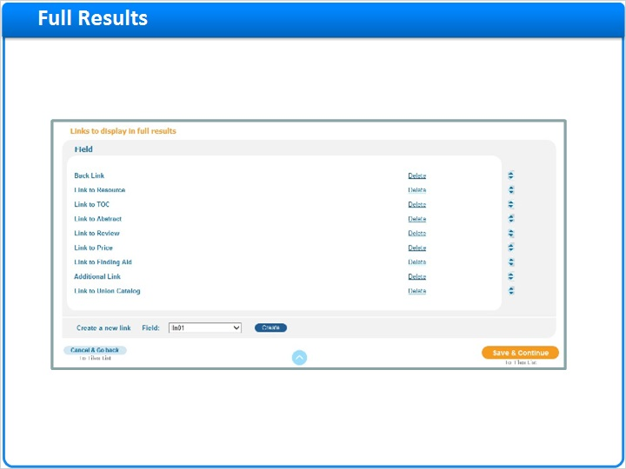

1.20 Brief Display
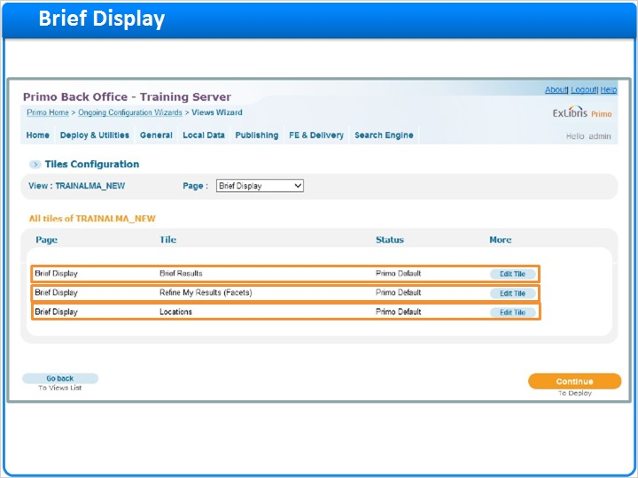
Notes:
In the Brief Display, we can configure the fields that display in the Brief Results list, the facets, and a few location settings including Real-Time Availability.

1.21 Brief Results
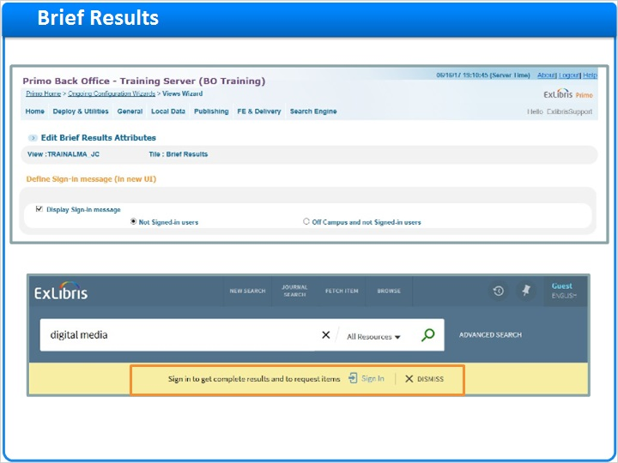
Notes:
The Brief Results are where the list of search results can be customized.

In the new UI, we can determine when the Sign-in message displays. Here we can see the message in the front end - we can display this message when users are not signed in, or we can display it only if they are off campus and not signed in.

We can also determine what fields display in the brief results. Here we can see the title on the first line, and the creator and creation date on the second line.

Lines (Slide Layer)
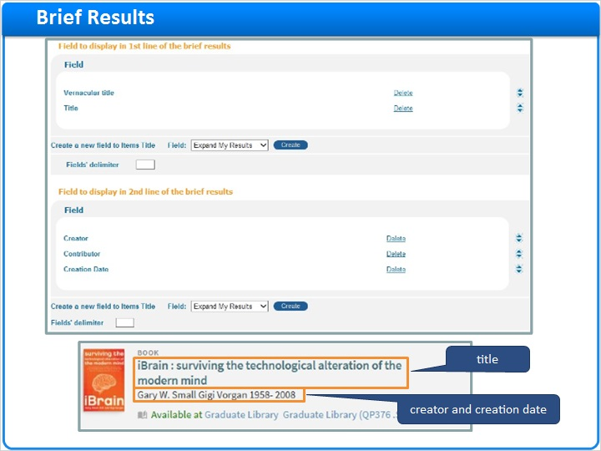

1.22 Refine My Results (Facets)
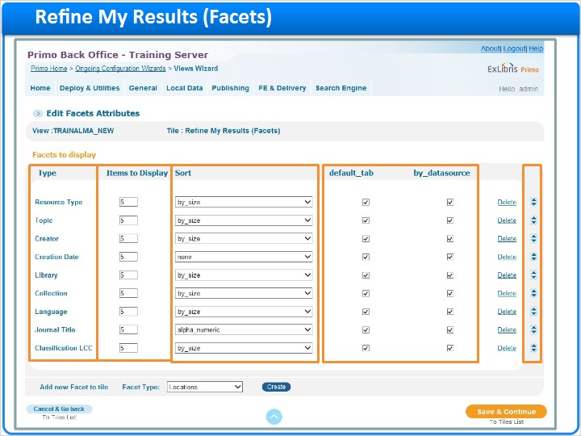
Notes:
In the Refine my Results area we can configure the facets that are displayed, how many items appear under each facet, and how those items are sorted. We can also determine whether or not to add each of the facets to every tab, and we can reorder the facets as well.

1.23 Locations
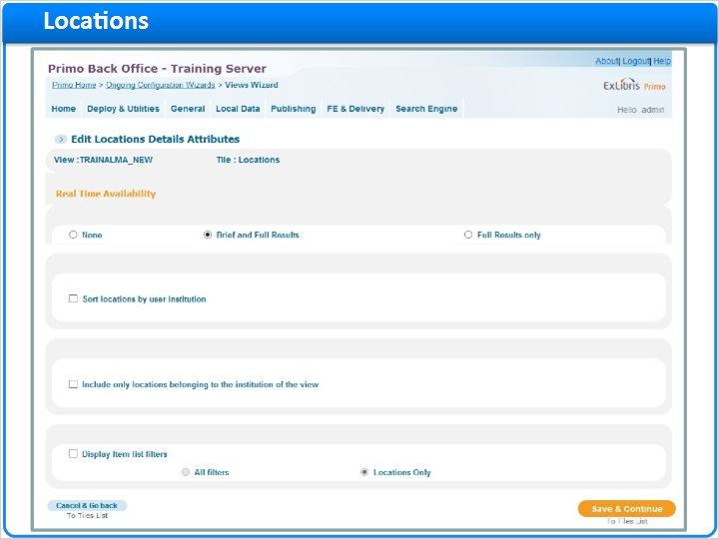
Notes:
And lastly, the Locations area allows us to switch Real-Time-Availability on or off, and provides location configuration settings that may be useful to consortia.

1.24 Deploying a View
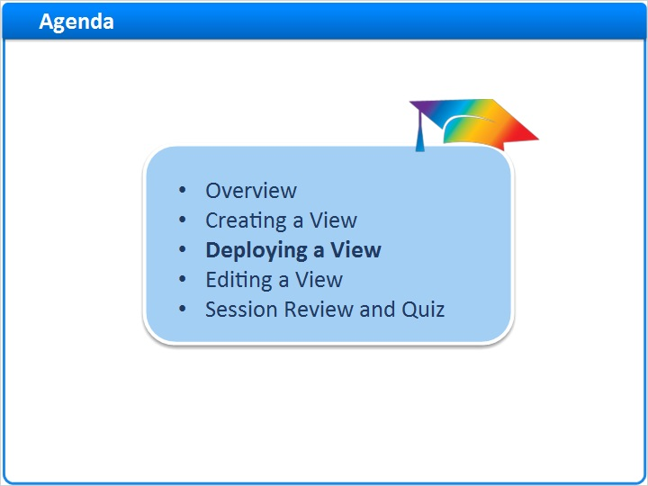
Notes:
Deploying a view

1.25 Deploying a View
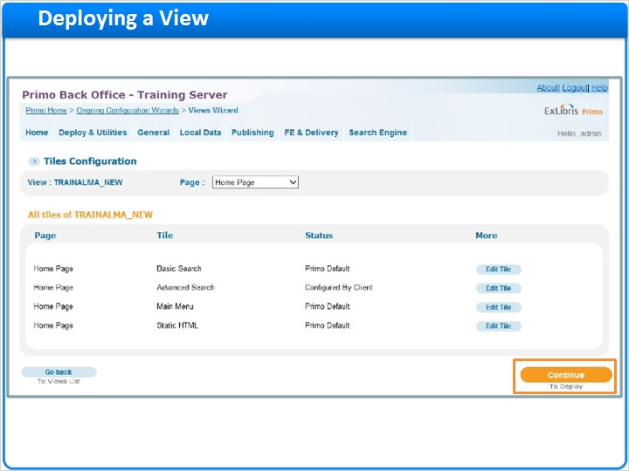
Notes:
Once any changes are made in the Tiles configuration, we can continue to deploy.

In order for the view to be visible in the Front End, we need to deploy it. We do so by clicking deploy, and waiting for the deploy process to finish.

We can monitor the deploy by clicking on the link that confirms that the deploy was submitted.

Depending on other processes that are in progress, the deploy may take several minutes or more. But once it’s finished, we can see the view in the Primo Front end by creating a new URL using the new view code.

To deploy (Slide Layer)
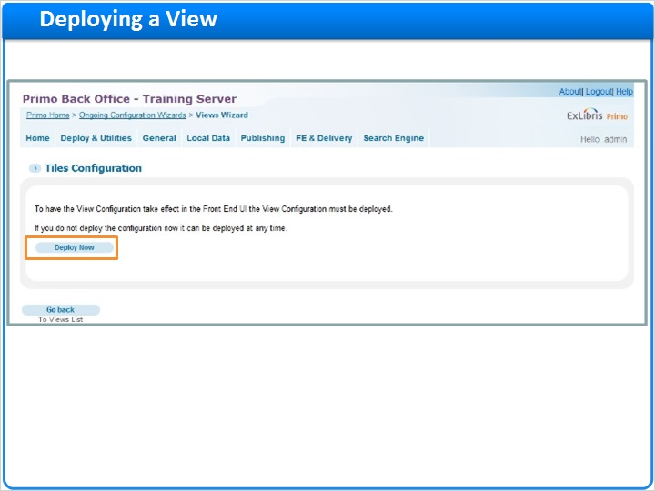

Deployed (Slide Layer)
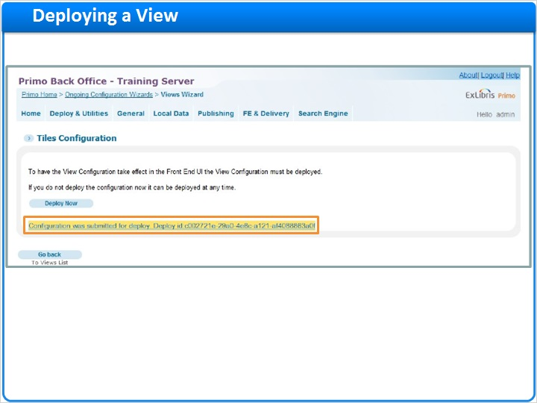

New view (Slide Layer)
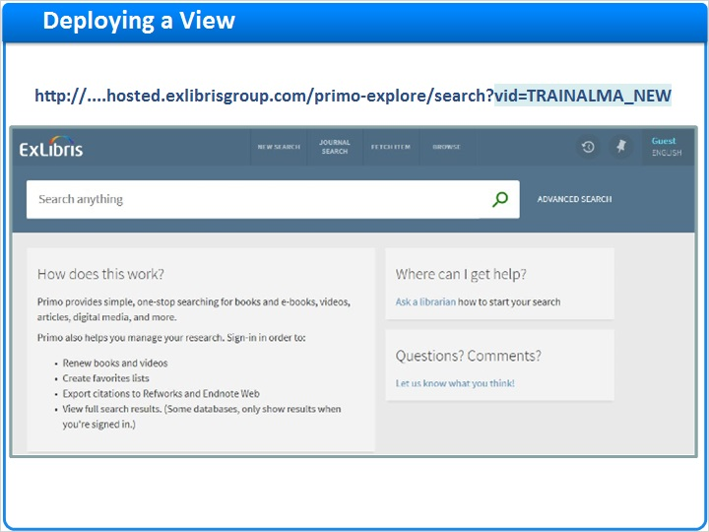

1.26 Editing a View
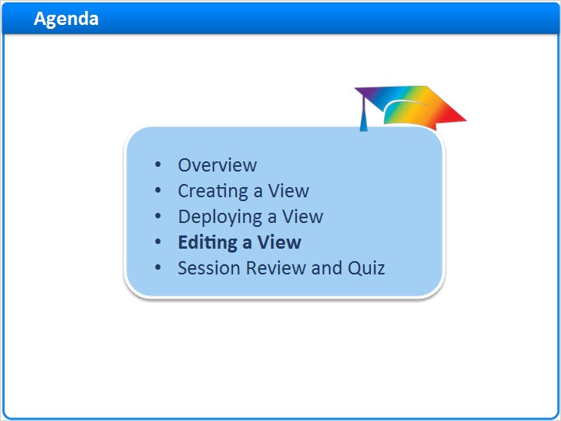
Notes:
Editing a View

1.27 Editing a View
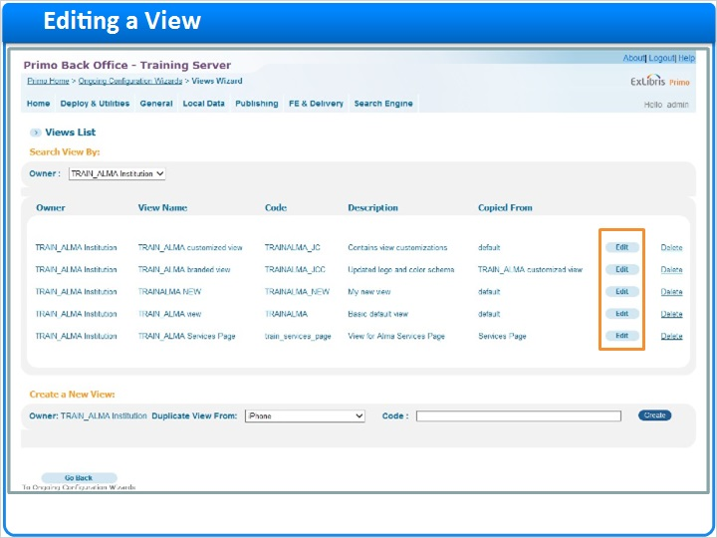
Notes:
If I want to edit an existing view, I can return to the Views List and select edit.

In order to make changes, we will need to go through the attributes, scopes, tabs, and tiles configurations again, even if we are not editing all of them. And once the edits are complete, we would need to redeploy the view for the changes to take effect.

1.28 Summary
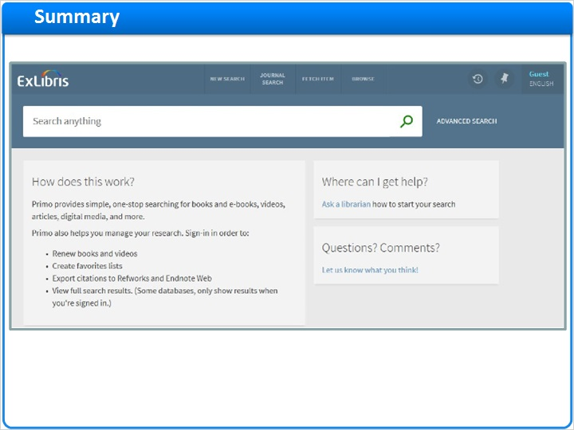
Notes:
And this is how we create and edit Views. Using the Views Wizard, we can create and customize the user interface of Primo for your patrons.

1.29 Session Review and Quiz
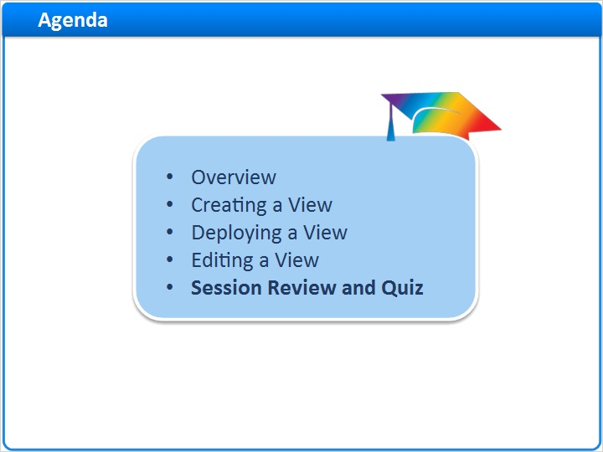
Notes:
Session Review and Quiz

1.30 Session Review
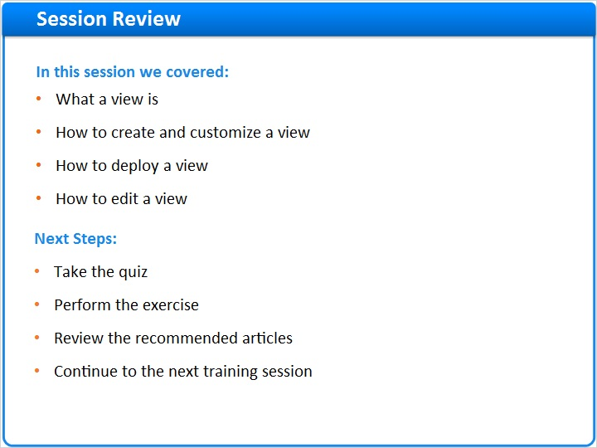
Notes:
In this session we covered what a view is, how to create and customize a view, how to deploy a view, and how to edit a view

After the brief quiz that begins on the next page, please complete the exercise that is provided in the Knowledge Center where you launched this training. Please refer to the Recommended Articles section for additional information.

After finishing the exercise, you can continue on to the next training session in this series.

1.31 Question 1
(Multiple Response, 10 points, 1 attempt permitted)
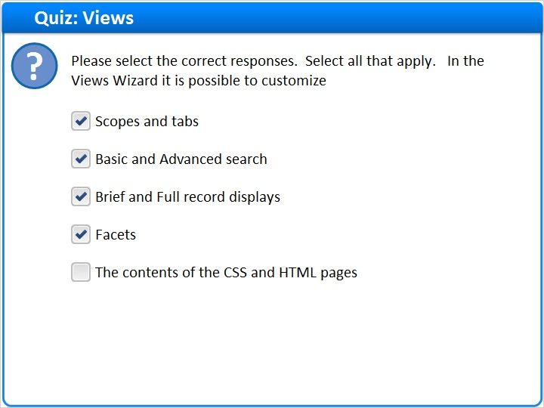
Correct | Choice
X | Scopes and tabs
X | Basic and Advanced search
X | Brief and Full record displays
X | Facets
 | The contents of the CSS and HTML pages
Feedback when correct:
In the Views Wizard it is possible to customize scopes and tabs, basic and advanced search, brief and full record displays, facets, and more. But it is not possible to change the contents of the CSS and HTML pages within the Views Wizard.
Feedback when incorrect:
In the Views Wizard it is possible to customize scopes and tabs, basic and advanced search, brief and full record displays, facets, and more. But it is not possible to change the contents of the CSS and HTML pages within the Views Wizard.

Correct (Slide Layer)
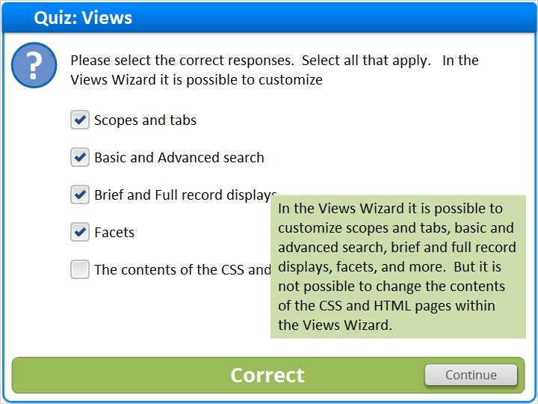

Incorrect (Slide Layer)
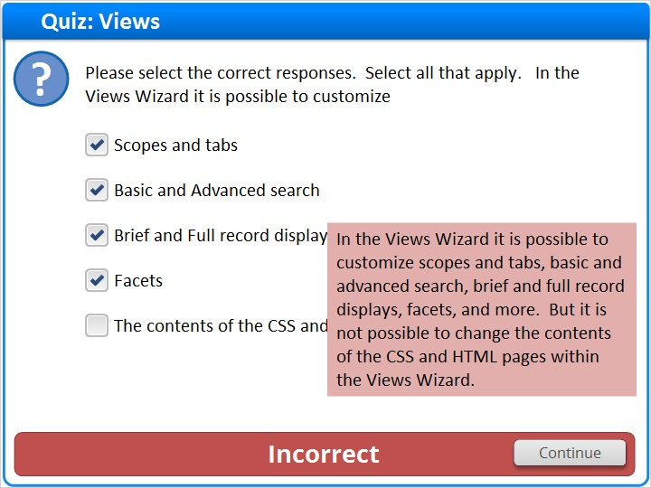

1.32 Question 2
(Multiple Response, 10 points, 1 attempt permitted)
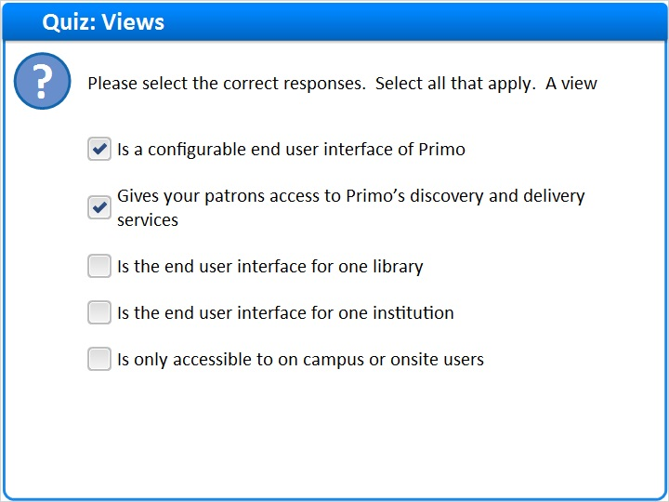
Correct | Choice
X | Is a configurable end user interface of Primo
X | Gives your patrons access to Primo’s discovery and delivery services
 | Is the end user interface for one library
 | Is the end user interface for one institution
 | Is only accessible to on campus or onsite users

Feedback when correct:
A view is a configurable end user interface of Primo that gives your patrons access to Primo’s discovery and delivery services.
Feedback when incorrect:
A view is a configurable end user interface of Primo that gives your patrons access to Primo’s discovery and delivery services.

Correct (Slide Layer)
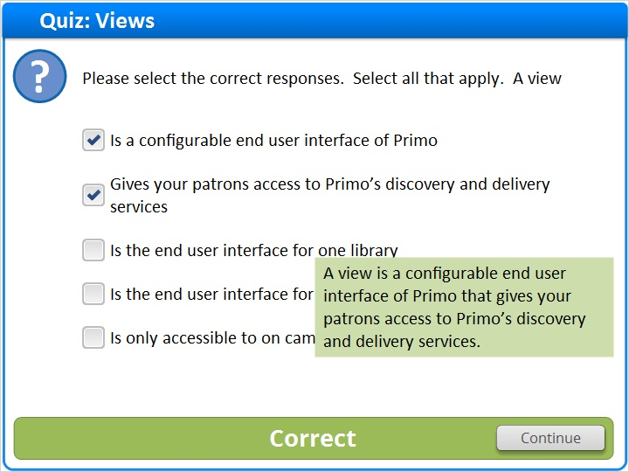

Incorrect (Slide Layer)
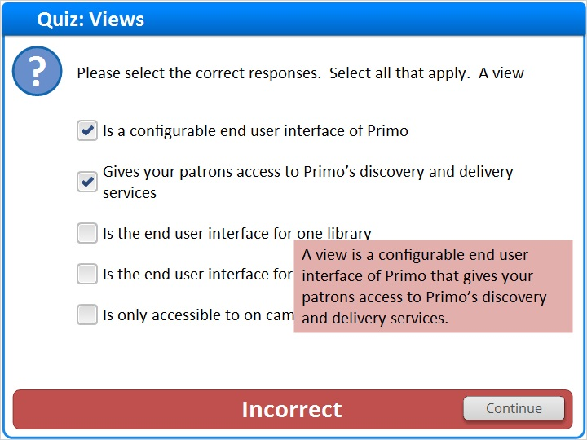

1.33 Question 3
(True/False, 10 points, 1 attempt permitted)
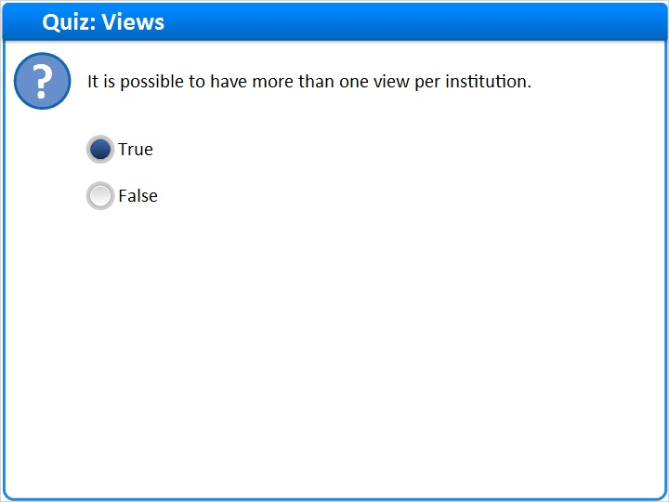
Correct | Choice
X | True
 | False

Feedback when correct:
It is possible to have more than one view per institution.
Feedback when incorrect:
It is possible to have more than one view per institution.

Notes:

Correct (Slide Layer)
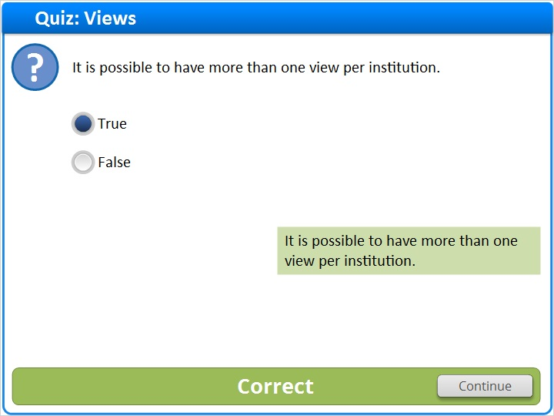

Incorrect (Slide Layer)
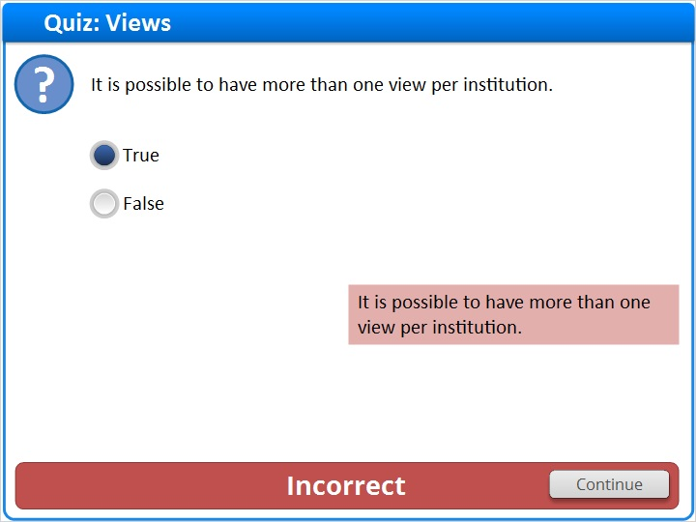

1.34 Thank You!

Notes:
Thank you for joining this session!

1.35 About this Training
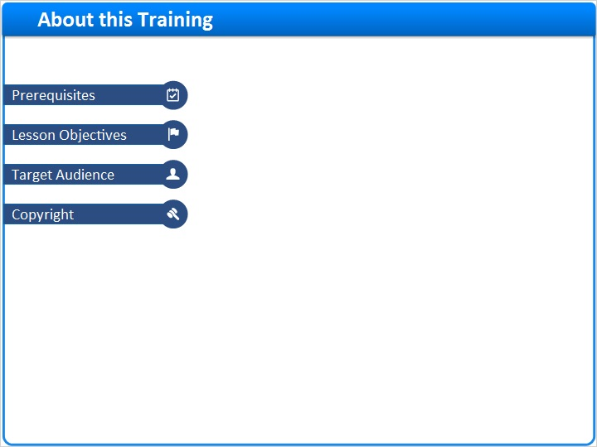
Notes:

1 (Slide Layer)
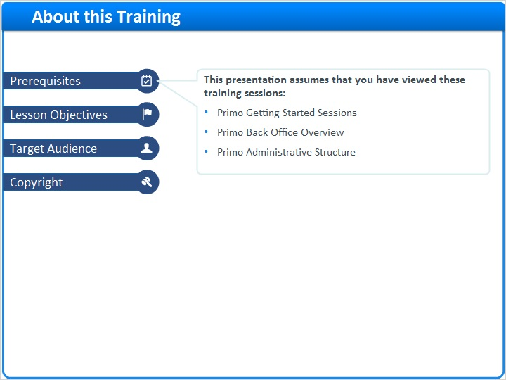

2 (Slide Layer)
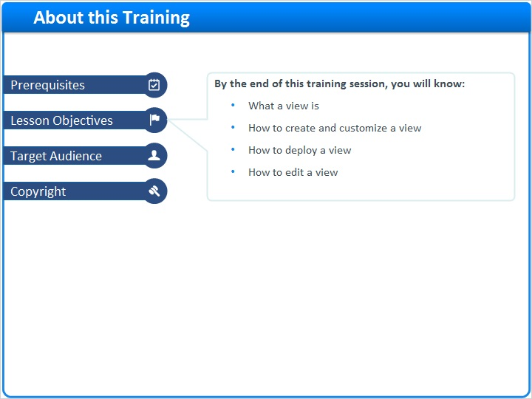

3 (Slide Layer)
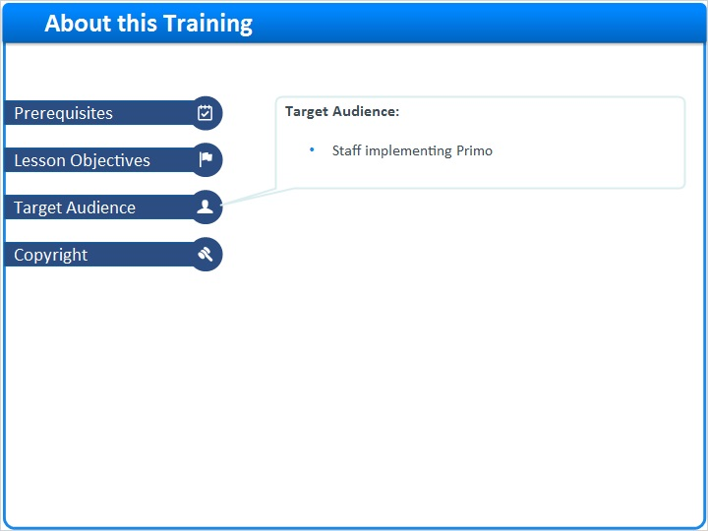

4 (Slide Layer)


