Primo Administration: Updating Display Labels

1. Updating Display Labels

1.1 Primo Administration: Updating Display Labels
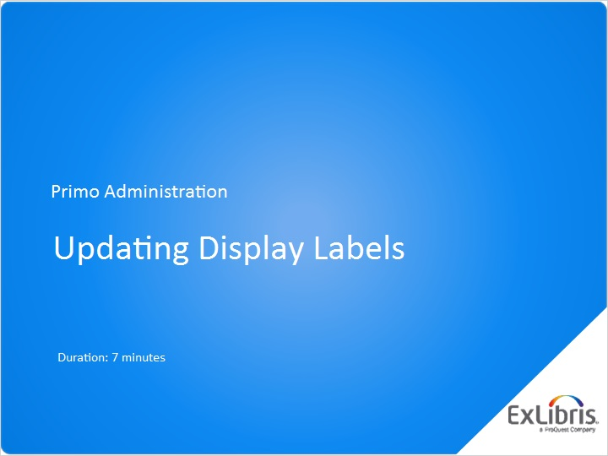
Notes:
Hello and welcome to this session on Updating Display Labels.

1.2 Agenda
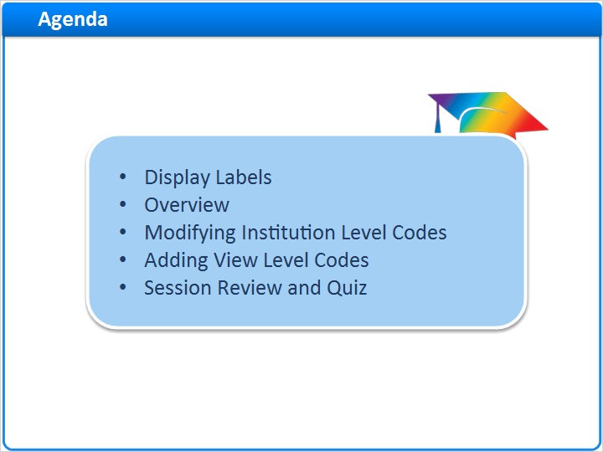
Notes:
Today we’ll get acquainted with display labels in the Primo front end.
We’ll look at the Code Tables, where the label values are defined.
Then we’ll see how to modify codes at the institutional level, and finally we’ll see how to create a code for a given view.

1.3 Display Labels
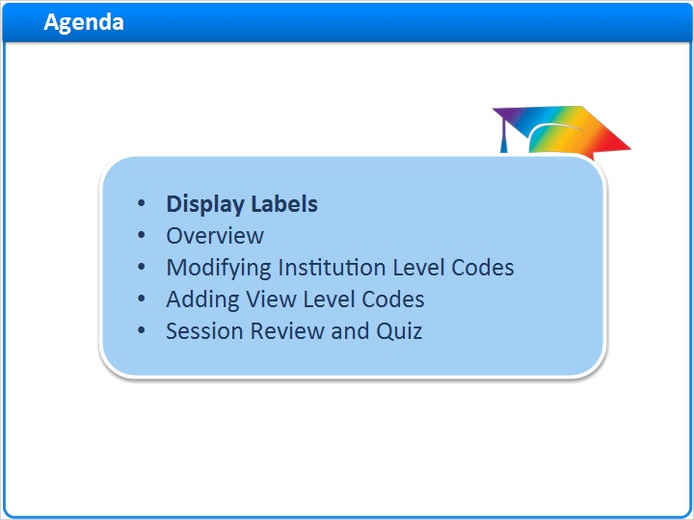
Notes:
Display Labels

1.4 Labels in the Front End
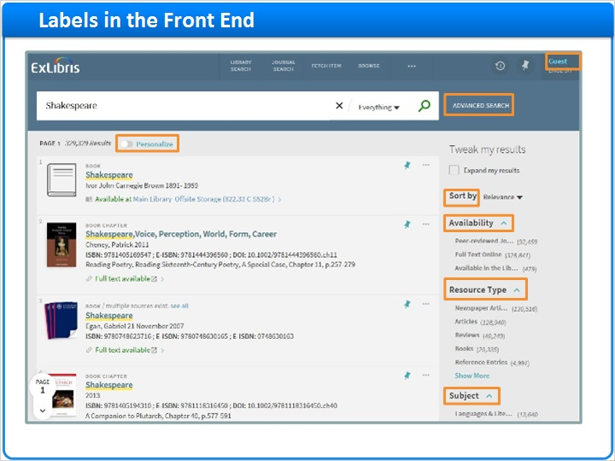
Notes:
A display label is text that is displayed in the Primo Front end on a reoccurring basis
Good labels reflect the terminology of your institution, and the needs of your patrons.
The same label can display different text values to different users, depending on the display language, or the view in Primo.
You can fully configure the values of labels in Primo’s Code Tables.

1.5 Overview
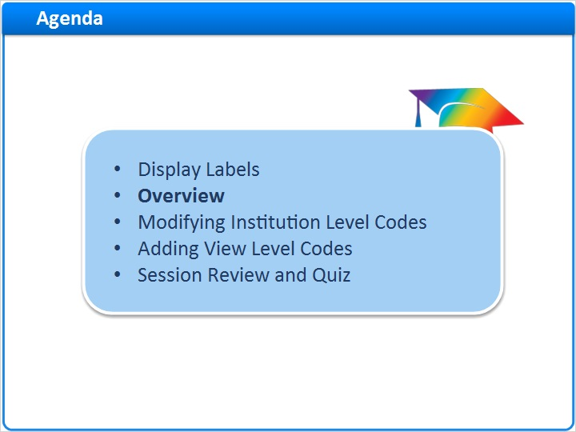
Notes:
Overview

1.6 What are Code Tables
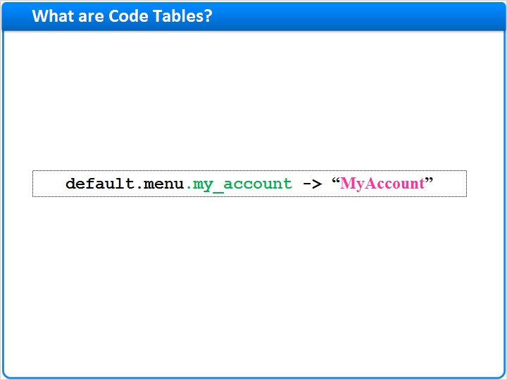
Notes:
A Code Table in Primo maps a code in the system’s software to a free-text label that displays in the user interface.

1.7 Labels and Codes
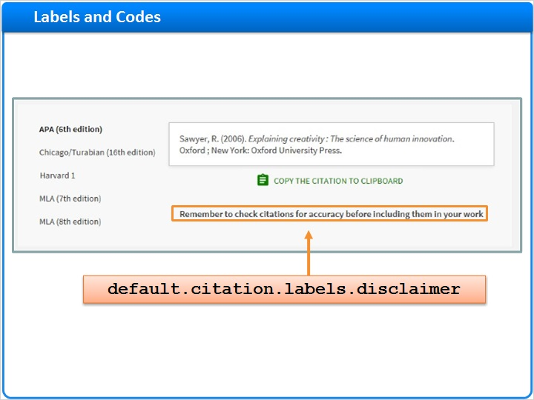
Notes:
For example, when we click on the citation in the full record, we see the message “Remember to check citations for accuracy before including them in your work”.
This comment is the English value of the code default.citation.labels.disclaimer.

1.8 Multiple Languages
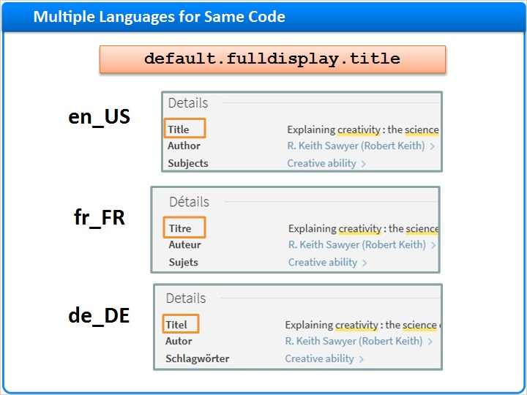
Notes:
Each code may have different values for different languages. That way, changes can be made separately for each language displayed in the Front End.
In this example, we see how the same word “title” appears in the Details tab in three different languages: English, French and German.
So the code default.fulldisplay.title has a different value for each these languages, and many others as well.

1.9 Navigation
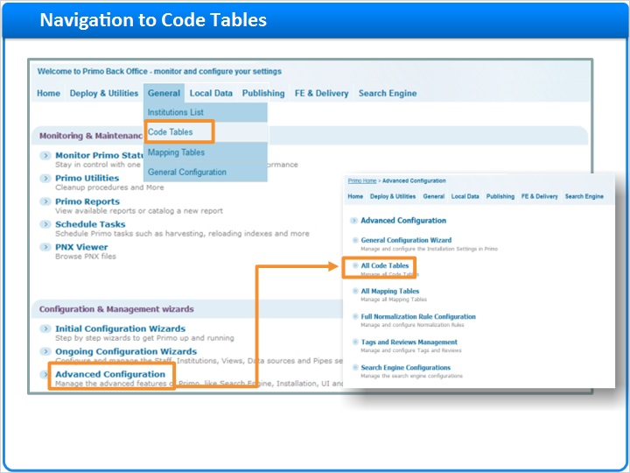
Notes:
Lets see how to navigate to the code tables in the back office. From the back office main page, under the General menu, select Code Tables. You can also click on the Advanced Configuration sub menu, and select All Code Tables

1.10 Searching
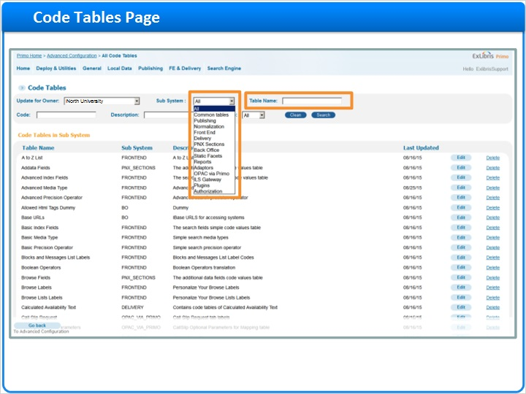
Notes:
In the Code Tables page, we see the main list of code tables. We can filter the list of tables, by selecting a particular Sub System. You can also search for a table by its name, if known.

1.11 By Code or Description
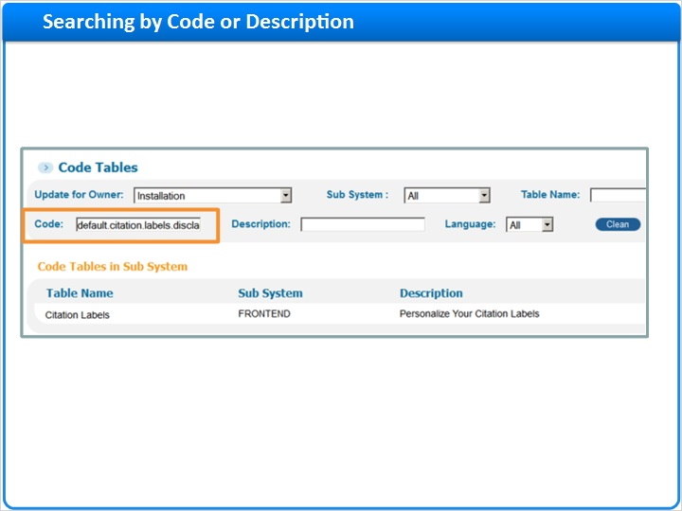
Notes:
You can also search within the code tables for a specific code or display text.
The first example shows a search by code name for default.citation.labels.disclaimer. We can see it is one of the codes in the table “Citation Labels”.
If we know the text value of the label, we can search for it here, in the description. Here we are searching for the label “Titel” (in its German spelling). You can see it is associated with several codes, in different tables.
In both search methods, make sure not to type unnecessary white-space characters, as this will omit desired results.

By Description (Slide Layer)
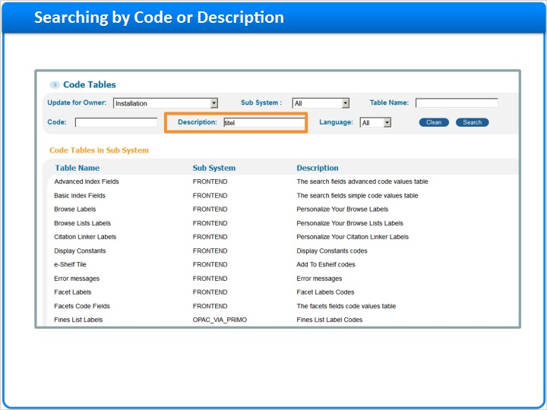

1.12 Modifying Institution Level Codes
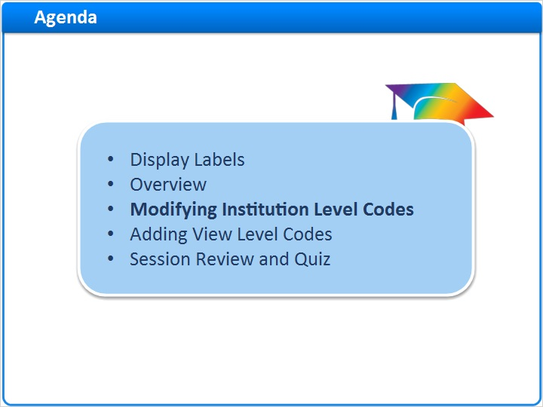
Notes:
Modifying institution level codes

1.13 Example
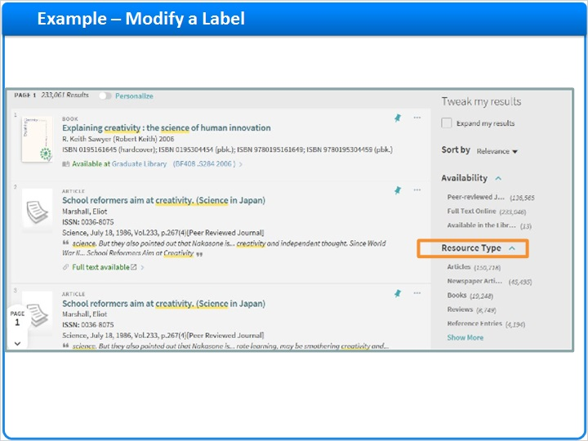
Notes:
First let’s select a label from the Primo front-end to change. In the Facets panel, there is a facet named “Resource type”.
Let’s change it to - “Material type”

1.14 Find the Code Table
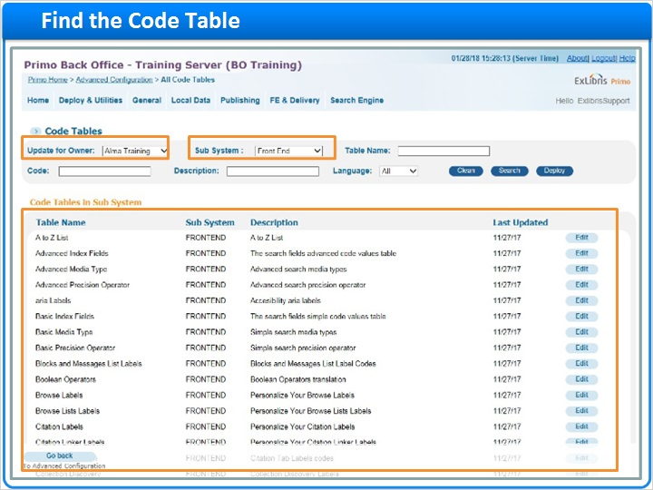
Notes:
The first step is to find the relevant code of this label.
In the code tables page, we select the owning institution from the “Update for owner” drop-down list. Then we select the Front End Sub System.
This will retrieve all of the front end tables, so to refine our search, let’s search for the label “Resource Type”, in the Description Search box. Now we have six tables.
If you are not sure which table to change, you can consult the Online Help or other Primo documentation. In this case the relevant table is “Facet labels”, and so we click on “Edit”.

Resource Type refinement (Slide Layer)
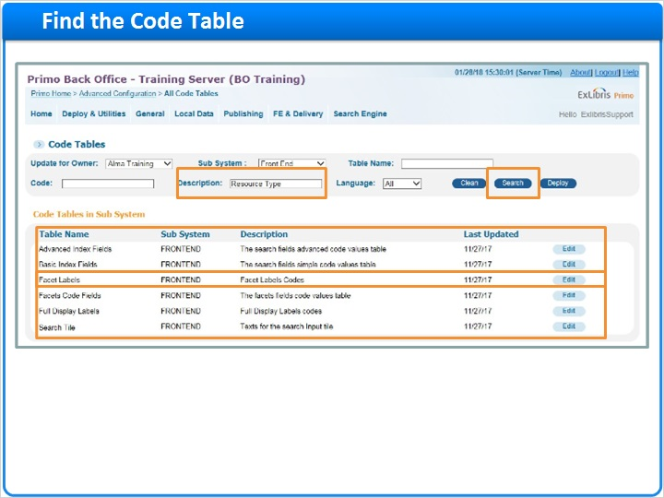

1.15 Edit the Label
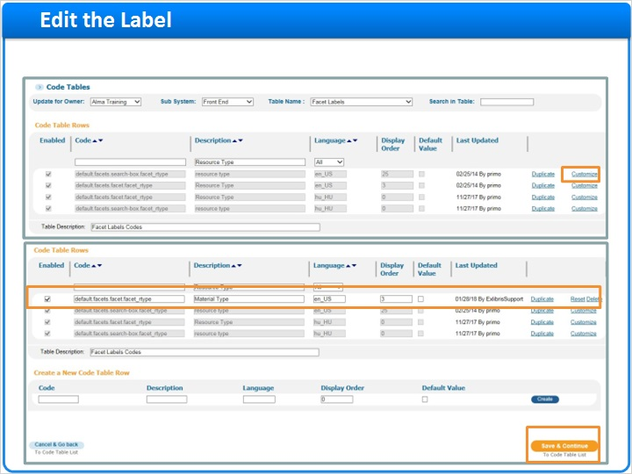
Notes:
The relevant entries in the table are then retrieved. Click “Customize”, and the entry will change from grayed out to editable. Now we can edit the text to read ‘Material Type’. Then we can click Save at the bottom of the page.

1.16 Deploy
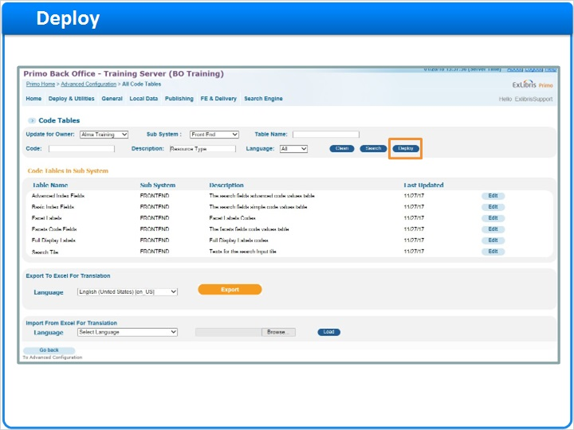
Notes:
After saving, we deploy the change so that it can take effect.

1.17 Label Changed in Front End
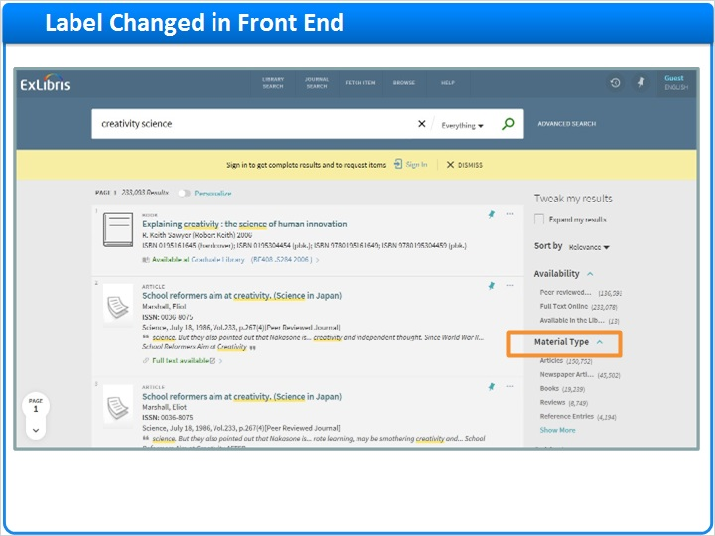
Notes:
Now back at the front end, we can see the new label “Material Type”. Note that you will need to refresh your browser window in order to see the change. Sometimes it is necessary to completely re-load the page by pressing Ctrl+F5.

1.18 Adding View Level Codes
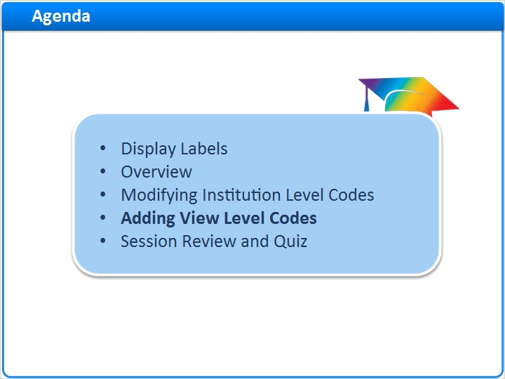
Notes:
Adding View Level Codes

1.19 Syntax of Institution and View Codes
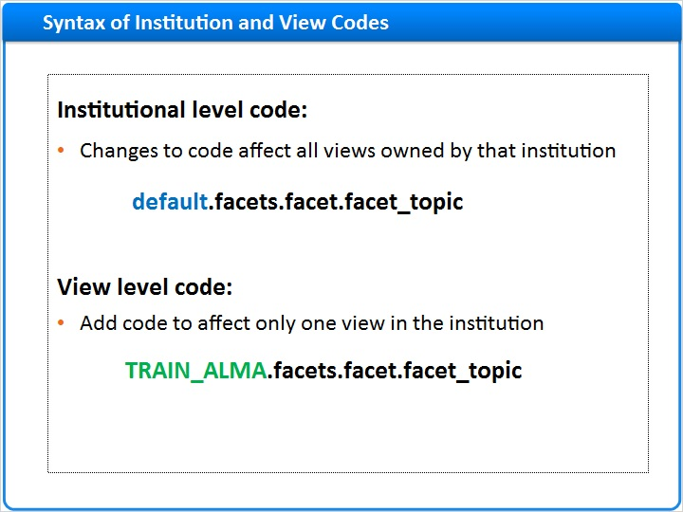
Notes:
Code tables are owned by the institutions. This means that any change in the Institution Code Table affects all views owned by that institution.
In order to update a specific view, it is necessary to add codes at the view level.

Codes on the institution level start with the word “default”. Codes on the view-level start with the view-code. In our example, we will create a new label for the Topic facet, in the TRAINALMA view; so the new code will start with the text “TRAINALMA”. After preparing the code-name, we can add it to the relevant table - namely, that of the institution owning the view TRAINALMA.

1.20 Adding a View Level Code
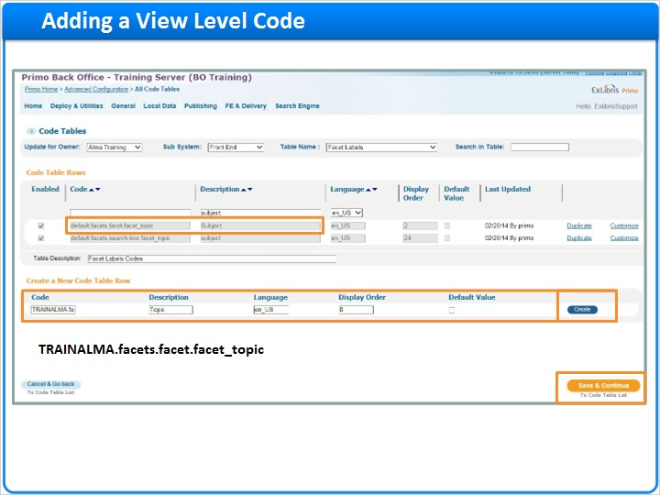
Notes:
In this example, I want to change a facet label to show ‘Topic’ instead of ‘Subject’. I’ve found the institution code and its display text in the Facet Labels table here. Instead of customizing this one, I am going to go to the bottom of the page and add a view code. My new code will be TRAINALMA.facets.facet.facet_topic, based on the institution code. Here I’ve replaced my view name, TRAINALMA, with ‘default’.

I click create, then Save and Continue so that I can deploy the update.

1.21 Result - Label Updated Only in View
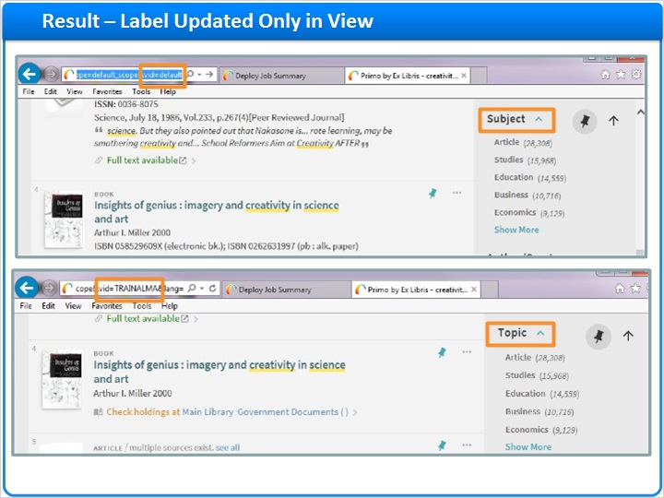
Notes:
Now back at the Front End, you'll see that the default view remains with the default label “Subject”; but when switching to the TRAINALMA view, we see the customized label - “Topic”.

Remember to refresh the browser to see the change.

1.22 Session Review and Quiz
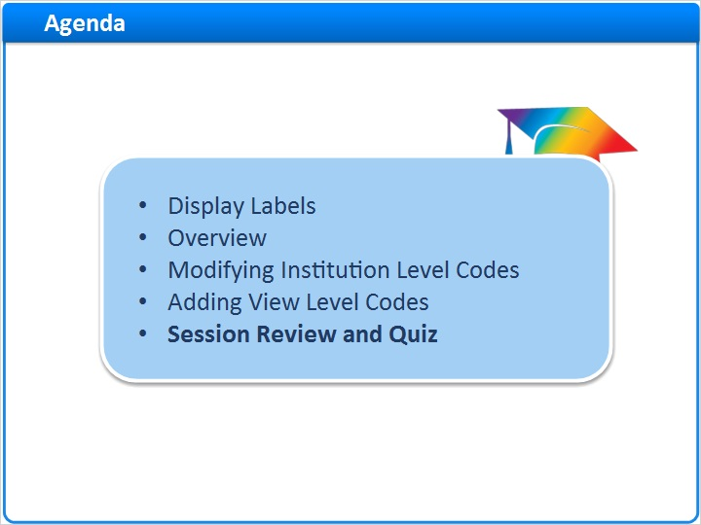
Notes:
Session Review and Quiz

1.23 Session Review
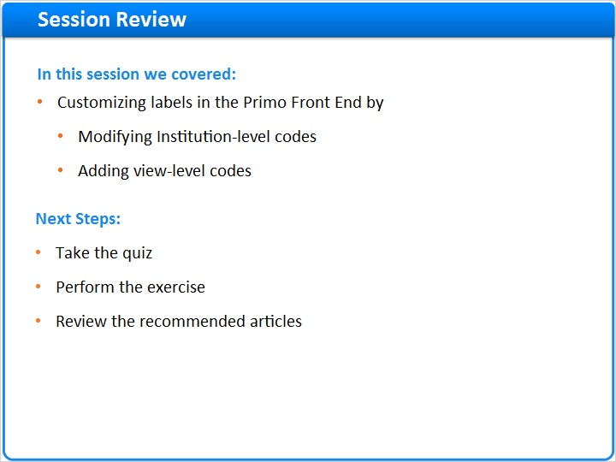
Notes:
In this session we covered customizing labels in the Primo Front End by modifying institution-level codes, and adding view level codes

After the brief quiz that begins on the next page, please complete the exercise that is provided in the Knowledge Center where you launched this training. Please refer to the Recommended Articles section for additional information.

1.24 Question 1
(True/False, 10 points, 1 attempt permitted)
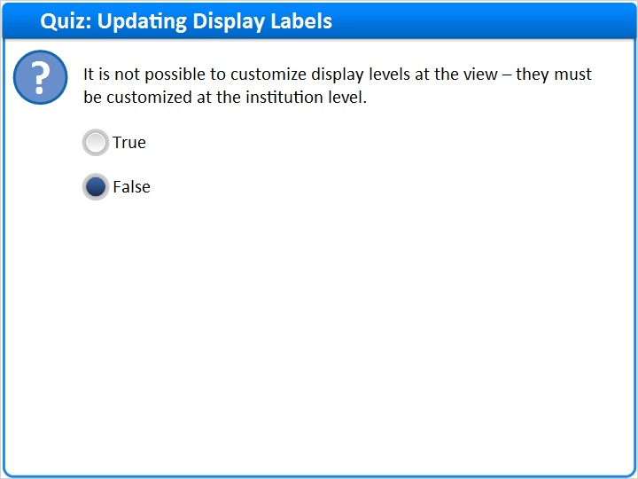
Correct | Choice
 | True
X | False
Feedback when correct:
It is possible to customize display levels at both the view level and the institution level.
Feedback when incorrect:
It is possible to customize display levels at both the view level and the institution level.

Notes:

Correct (Slide Layer)
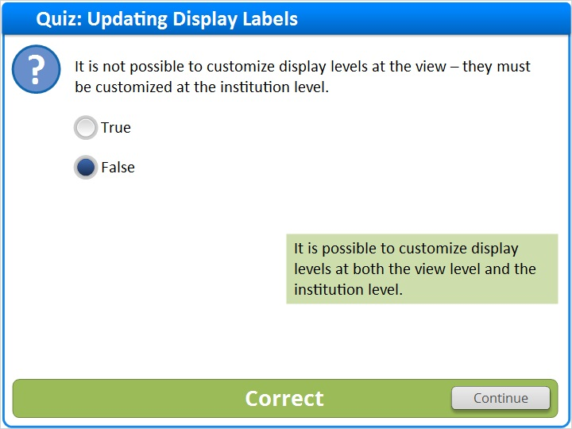

Incorrect (Slide Layer)
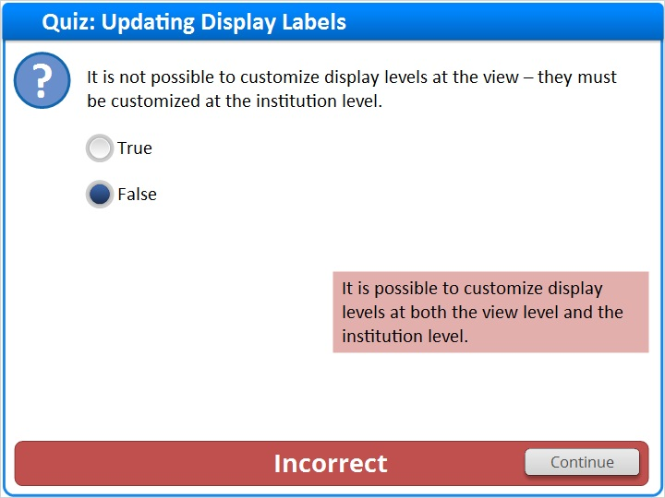

1.25 Question 2
(True/False, 10 points, 1 attempt permitted)
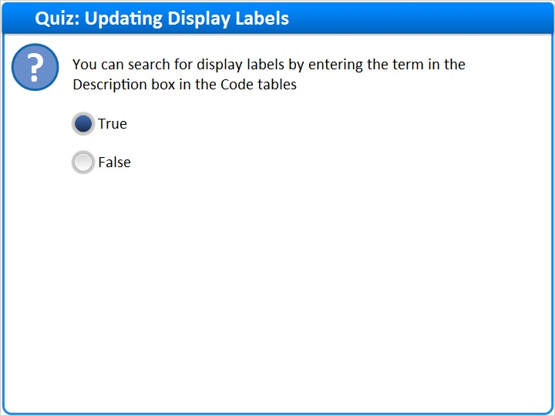
Correct | Choice
X | True
 | False

Feedback when correct:
You can search for display labels by entering the term in the Description box in the Code tables
Feedback when incorrect:
You can search for display labels by entering the term in the Description box in the Code tables

Notes:

Correct (Slide Layer)
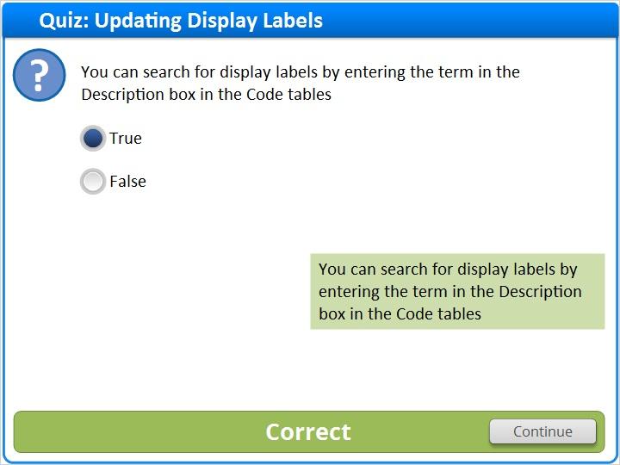

Incorrect (Slide Layer)
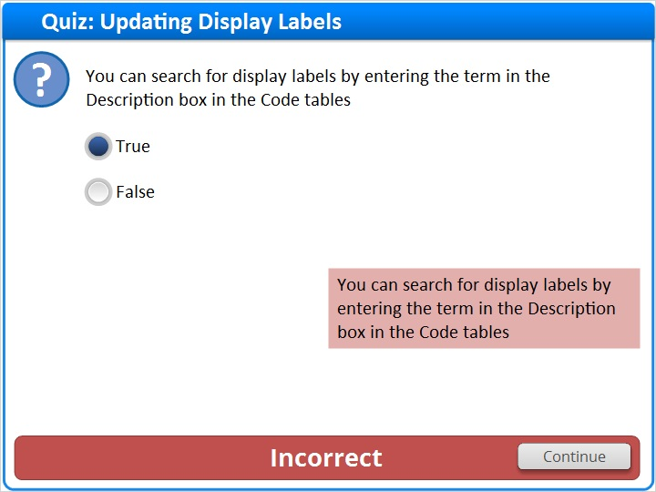

1.26 Question 3
(True/False, 10 points, 1 attempt permitted)
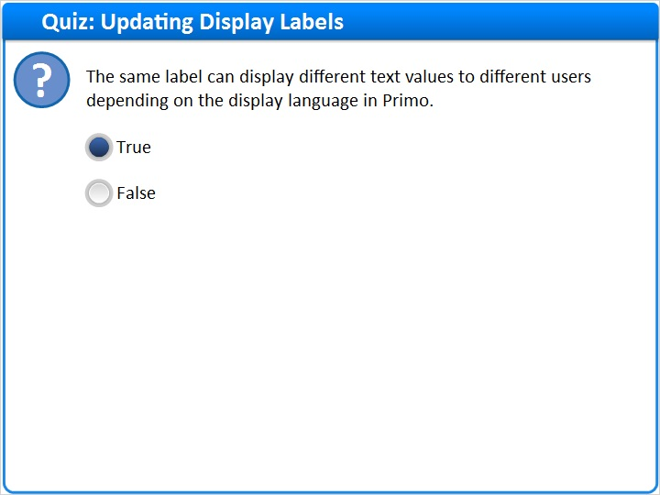
Correct | Choice
X | True
 | False

Feedback when correct:
The same label can display different text values to different users depending on the display language in Primo.
Feedback when incorrect:
The same label can display different text values to different users depending on the display language in Primo.

Notes:

Correct (Slide Layer)
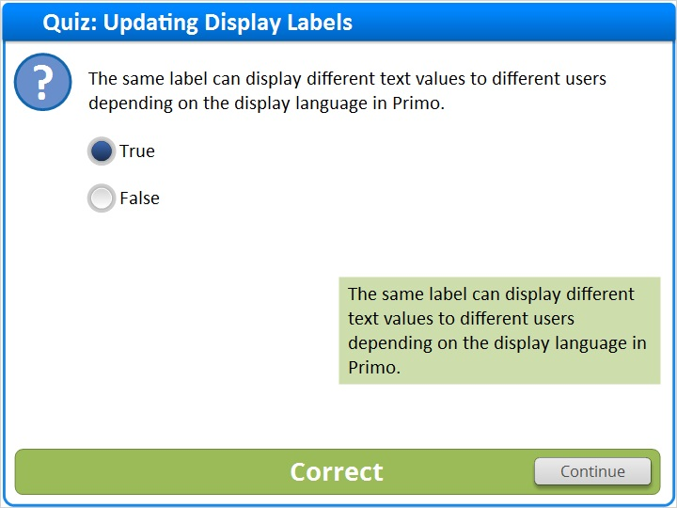

Incorrect (Slide Layer)
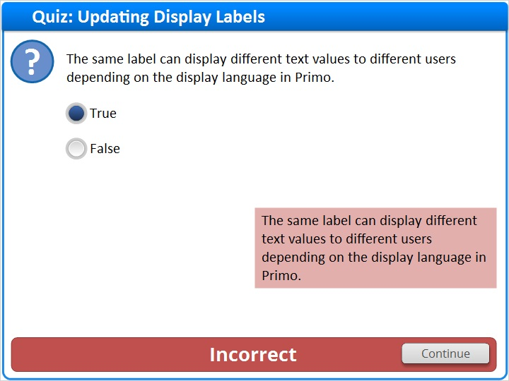

1.27 Thank You!

Notes:
Thank you for joining this session!

1.28 About this Training
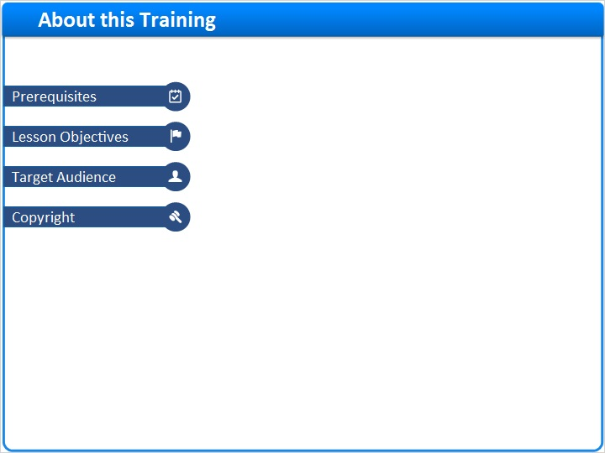
Notes:

1 (Slide Layer)
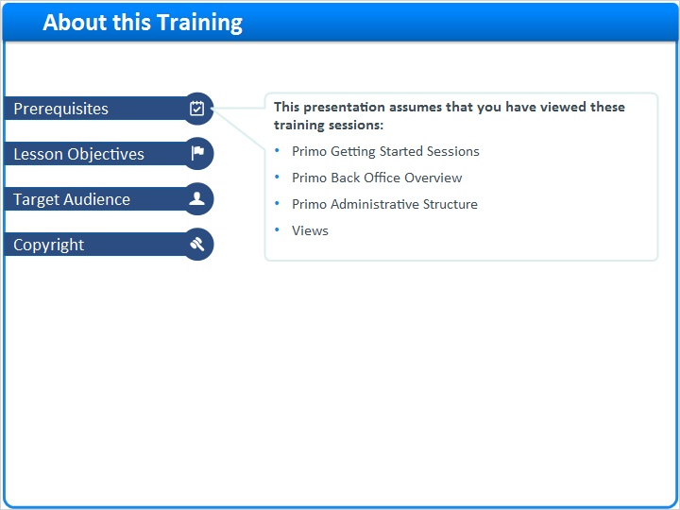

2 (Slide Layer)
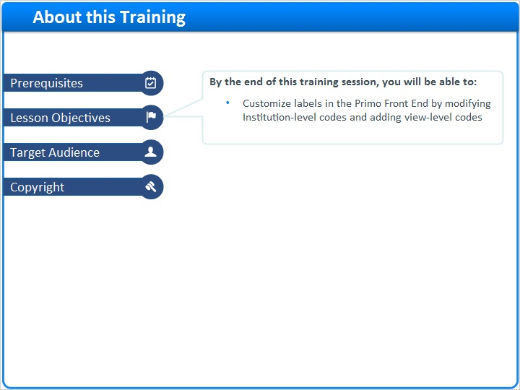

3 (Slide Layer)
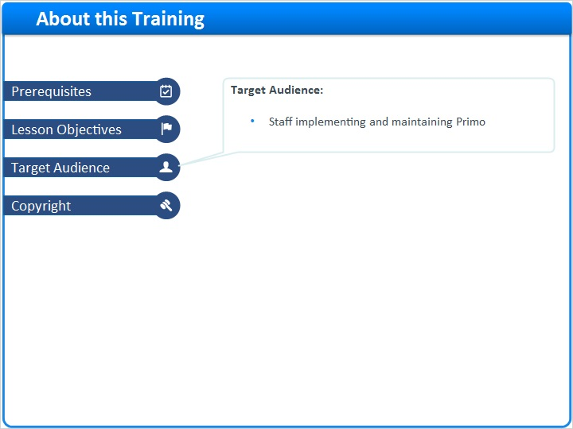

4 (Slide Layer)


