Alma and Primo Interoperability Part 1 (New UI)

1. Primo-Alma Interoperability - Part I

1.1 Welcome
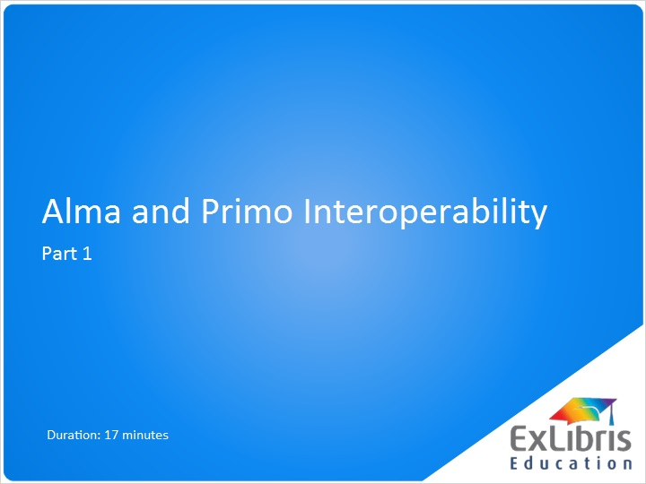
Notes:
Hi, and welcome to this presentation on Alma and Primo interoperability.

1.2 Primo-Alma Main Integration Points
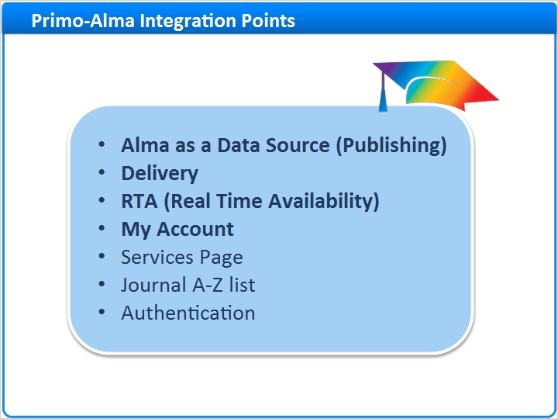
Notes:
These are the main interoperability points between Alma and Primo.

In this session we will discuss the first four:
- Alma as a Data Source (capable of Publishing)
- Delivery between Primo and Alma
- RTA (Real Time Availability)
- My Account

In the next session, we will continue with the additional topics.

1.3 Alma as a Source
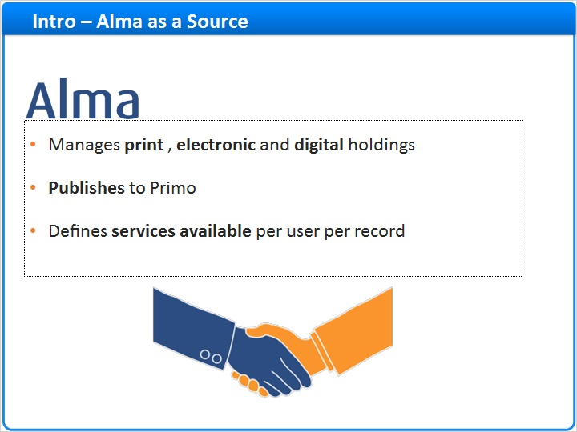
Notes:
Alma manages all of your print, electronic and digital holdings, indicating what you have in your collection, to what you are subscribed, and so on.
Alma serves as a source system supplying the records to Primo.
Alma is responsible for defining services available per user per records, so once a user finds an item they are interested in - Alma will indicate which services are available to the specific user for the specific item; whether it is loanable, accessed online, or requires going to the physical location to find the copy.

1.4 Primo as a Front End
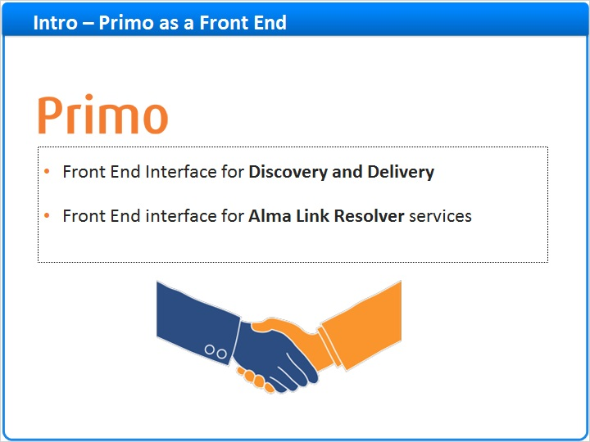
Notes:
Primo serves the following functions:
- Provides the Front End interface, allowing patrons to:
- Search and request services for library resources (that are managed in Alma)
- Search for remote records (such as Primo Central Index, MetaLib etc.) and offer services via the Alma link resolver
- Perform Library Card functions via the My Account
- Primo also provides the Front End interface for Alma link resolver services for searches that are not initiated via Primo ( such as Google Scholar, EBSCOhost, Pubmed etc.)

If you’re a current Primo customer, most of the functions in Primo are still the same when integrated with Alma. For example, Searching, full & brief displays, sort options, facets, user features are not impacted by integration with Alma. In this session we will review which areas are indeed impacted by the integration with Alma.

1.5 Initial Primo Setup
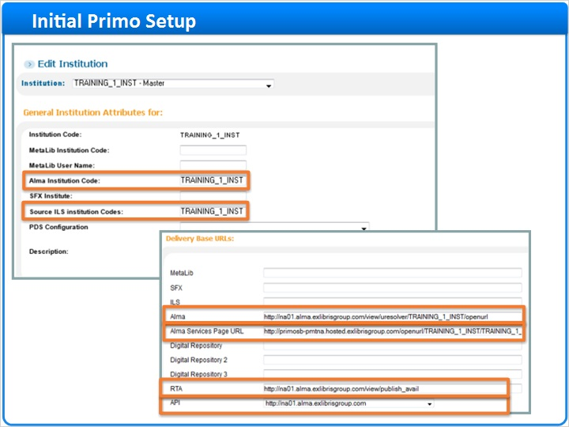
Notes:
Let’s start with looking at the basic configuration in Primo when working with Alma.

In the Primo Back Office under the Institution Wizard section, the Alma connection information is set up. This tells Primo how to communicate with Alma. You will not need to enter or update anything in these fields - it will be done for you by your Ex Libris project team.

The Alma Institution Code is entered into Primo’s General Institution Attributes area. This is the basis for the Primo-Alma interoperability.

Delivery Base URLs are also defined in Primo for the communication between Primo and Alma. You will see the Base URL for Alma itself, as well as RTA (Alma real-time availability), and for the API which helps Primo communicate with Alma to get user information for the My Account section of Primo.

Primo will use these URLs and the institution code for all communication with Alma.

Note also the Alma Services Page URL, this is actually a Primo URL which we will talk about in the “Services Page” section. It is this is the URL that you give to vendors as your new link resolver URL.

Note that the SFX and ILS fields will remain blank when working with Alma.

1.6 Alma as a Data Source
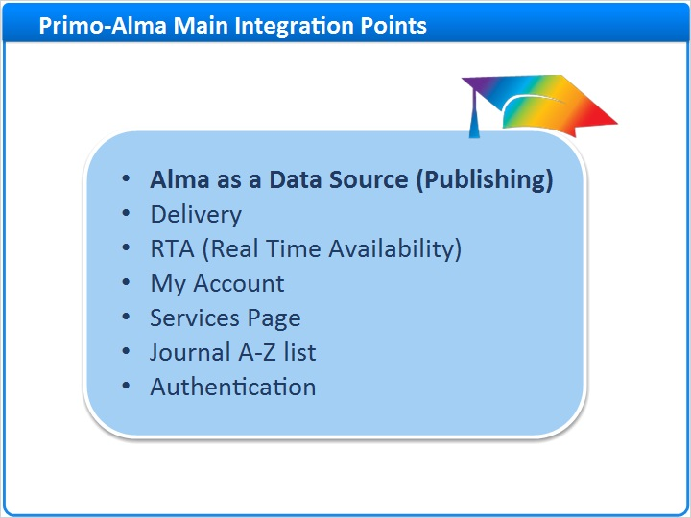
Notes:
Now that we’ve discussed the initial communication setup in Primo, lets start with the 1st integration point of Alma as a Data Source for Primo.

1.7 Alma as Data Source
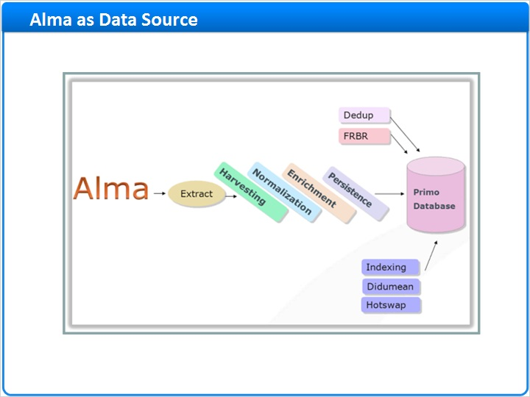
Notes:
Bibliographic records are catalogued in Alma together with all of your print, electronic and digital holdings information indicating what you have in your collection, what you subscribe to, and so on.

This diagram is probably familiar from the Primo Publishing sessions. It explains how Primo’s loading mechanism works and the stages the data goes through when loaded into Primo. We will not be covering the different stages of the Primo publishing mechanism here, but rather focus on the areas where Alma and Primo integrate. For more information about the Primo publishing platform please refer to the Primo publishing sessions.

So let’s talk about how data is published from Alma and loaded into Primo.

Perhaps one of the biggest changes when working with Alma as a source system, as compared to a traditional ILS, is that since Alma is a unified system, Data representing print, electronic and digital is all extracted from Alma and loaded into Primo together as we shall see in the next few slides.

1.8 Alma Published Record
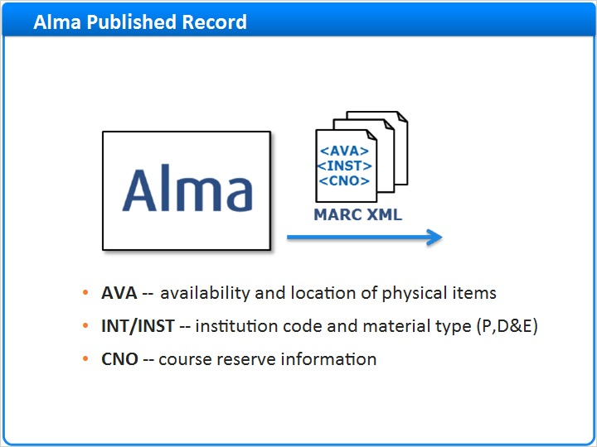
Notes:
Alma publishes bib records in XML format, which are enriched with some special or local fields. These fields are created in order to display holdings information and course reserves information in Primo.

- The AVA fields are created and added to the MARC record published for print holdings, so bib records with associated holdings records, will have the AVA field included. The AVA includes information like the library, collection, call number, and availability of the print record. Note that the AVA is published at the holdings level and not at the item level - so if you have multiple items with the exact same holdings information they will appear once in the bib record.
- The INT or INST fields contain information about the institution that holds the record and information on what type of holdings they have, whether print, online or digital. Primo uses this to define what type of delivery a record should get in the front end.
- The CNO fields contain information about what course a record might be associated with and includes information such as the course name, course code, instructor name, etc.

Full details about the fields is available in the Alma online help, as well as in the Alma-Primo Integration Guide.

Alma initially publishes the full data set to Primo as part of the project. After that Alma will publish to Primo periodical updates, usually daily, of new, changed and deleted records. The publishing schedule can be defined in the ‘Primo Publishing Profile’ in Alma.

1.9 Publishing from Alma
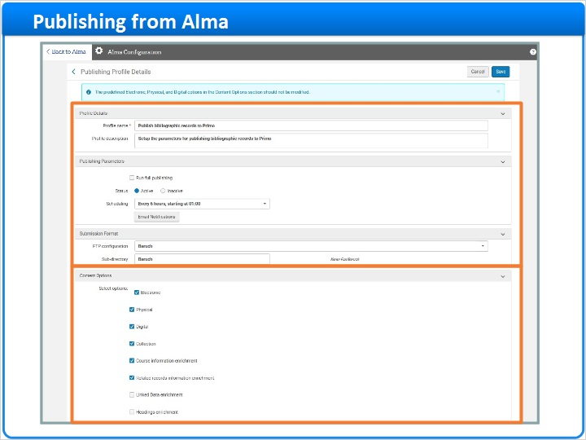
Notes:
In Alma you can find the “Publish bibliographic records to Primo” menu under “Resource Management Configuration” / “Publishing profiles”
Here you can see to where Alma publishes the records, and set the scheduling of the ongoing publishing job.

The Primo Publishing Profile already exists in Alma and there is no need to create it from scratch. It is normally configured by Ex Libris Professional Services during implementation, and we recommend not making any changes to it, such as deactivating it.

Most of the parameters are self explanatory. The final section Content Options defines which records should be published to Primo Electronic, Physical or Digital.

When The Course Information Enrichment parameter is checked, records cited in the reading lists of active courses will be enriched with the course information, and course restricted records will be unsuppressed and published as well.

When related records information enrichment is checked, bib records will be enriched with information regarding their related records, such as the parent of a monographic series, or a journal that changed its name.

1.10 Primo configuration
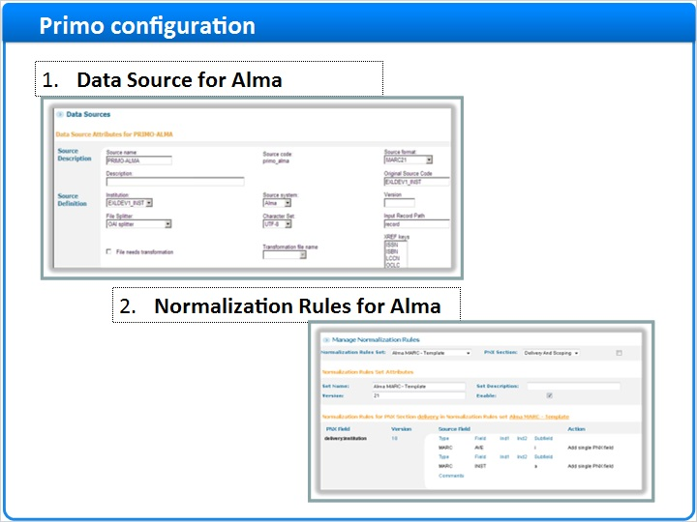
Notes:
In Primo we need to configure a few things before we can load the Alma data, you will most likely see these created as part of your project:

1st configuration: A Data Source specifically for Alma data
2nd configuration: Normalization Rules for Alma

1- Regarding Data Source, Alma needs to be defined as Primo’s data source - so Primo knows where the data is coming from and what it’s structure is. The configuration is done in the Data Sources section of the Primo Back Office. This will be all configured for you as part of the project. You can note that we tell Primo that the data is in UTF-8 and coming from Alma “Source System”.

2- After the records are published as enriched MARC records from Alma to Primo, the source records from Alma need to be converted, or normalized, to Primo Normalized XML (or PNX) records.
A Normalization Rule set will be created as part of the project to take the Alma MARC XML records, with the additional expanded fields - and convert them to the PNX format. Primo includes a template normalization set for Alma MARC, which we can duplicate and use.
Once we have a data source and a Normalization rule set up for Alma we can proceed to create a “pipe”. In the “pipe” we define the Alma data source, the Alma normalization set to use and the location from which Primo will pick up the files containing the records from Alma.

1.11 Alma Published Files
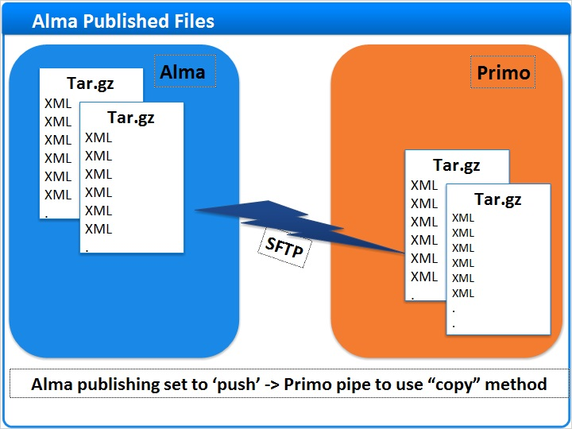
Notes:
When the Alma publish job runs, it creates a MARC XML file for each record - these files are then grouped into tar.gz files.
Since Alma and Primo are both in the Ex Libris cloud, Alma will be set up to send the files directly onto the Primo servers via sftp - allowing Primo to harvest the files via the “copy” method.

1.12 Alma Format Publishing
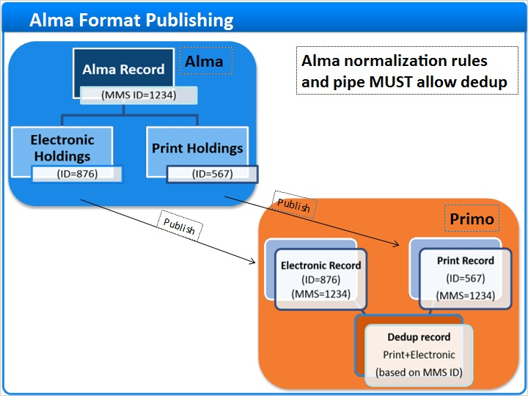
Notes:
In cases of an Alma record that has both Print and Electronic holdings, Alma publishes separate records to Primo for each delivery type
originating from the same MMS record in Alma.

So in our example, Alma record 1234 has both electronic and print materials. Two separate records will be published derived from the same MARC but different holdings information.
Each of these records has it’s own unique ID - but both these records have the same original MMS ID, 1234 in our case, in their 001 field.

Primo will know to merge these records into one deduplicated record with both Print and Electronic services according to the matching MMS ID. In these cases, Primo merges the records according to the shared MMS ID and does not need to compare metadata.
This means that deduplication must be enabled, and that the MMS identifier in the Alma records, 001 in the records from Alma, must be mapped to the dedup/C5 field in the PNX records. You cannot simply ‘turn off’ dedup when working with Alma. If you do feel the need to tweak the metadata dedup fields you may do so but the dedup/C5 rule must remain untouched and the dedup must always be set to run.

1.13 Delivery
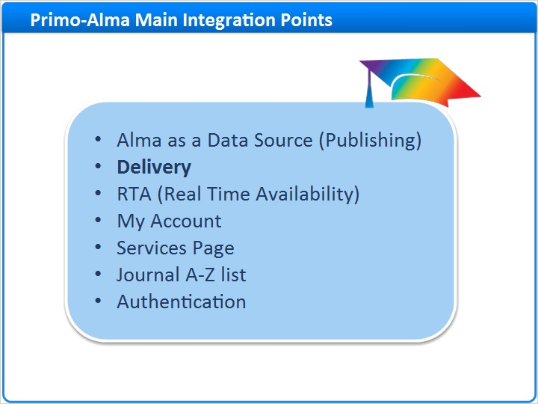
Notes:
Now that we have exported the data from Alma, converted it into PNX, and loaded and indexed it in Primo - it can be seen in the Front End.
Let’s continue and discuss the delivery options between Primo and Alma which our users will encounter.

1.14 Delivery Functions
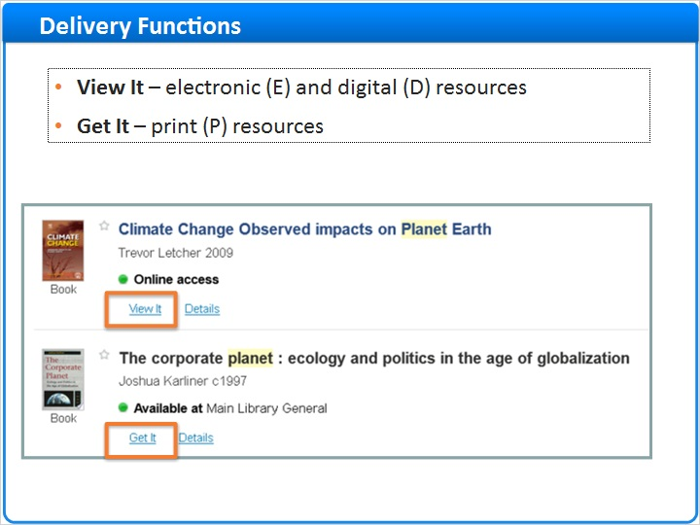
Notes:
Delivery services for the records from Alma will be treated differently depending on if they have Electronic, Digital or Print holdings in Alma.

1. Records that are identified as Electronic or Digital - for which we expect Alma to offer online viewing services (as opposed to physical item requests) - these will have a ‘view it’ button.

2. Records that are identified as “Print” - which means that Alma has a ‘Print material’ holding - will have a “Getit” button.
A Primo record may offer both View It and Get It in cases where the record is both electronic and print.

Sites that had Primo previously may note that when working with Alma there is no ‘Locations’ tab. Alma includes this information within the get-it tab.

1.15 View It Tab
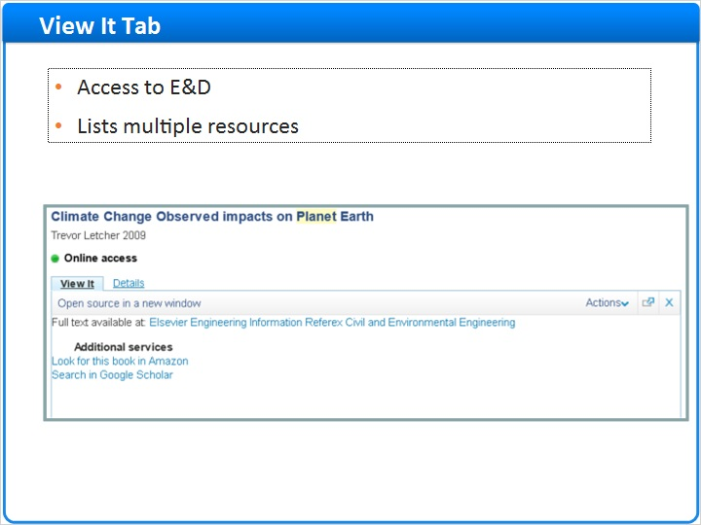
Notes:
Lets look at the View It tab.

The View It tab provides the electronic services which Alma offers for the specific record to our specific user
When multiple services exist for the record, they can all be listed in the View It tab for the user to select. Definitions such as order and display logic may be set up in Alma under the “Fulfillment Configuration”/“Discovery Interface Display Logic” section, to be displayed to the end user in the view it tab.

1.16 Get It Tab
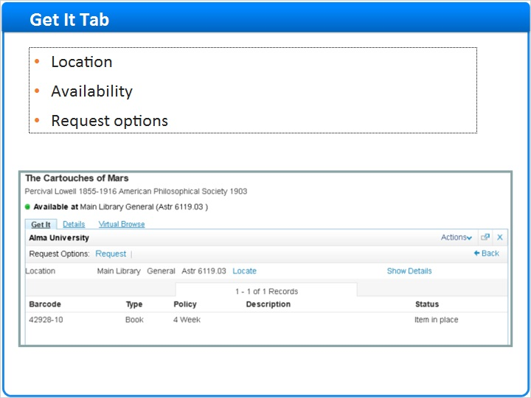
Notes:
Now let’s focus on the Get It tab - which is for print resources.

The Get It tab indicates where a title can be found and if it’s available on the shelf, as well as Request options such as ILL (or Resource sharing) request, and hold requests, according to the definitions in Alma.

This is an example of a record with one single holding - you can see the relevant item information.

1.17 Get It Tab
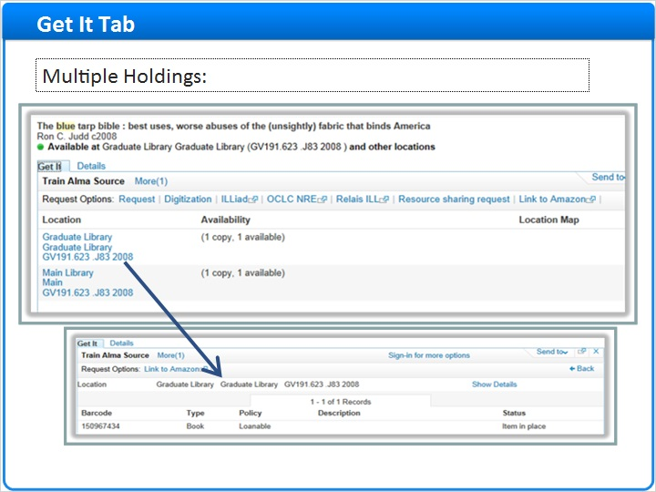
Notes:
In the case of a record with multiple holdings, you’ll see each location and the availability summary of its items.
Clicking on the location will give you the item information for that location.

1.18 Get It Tab
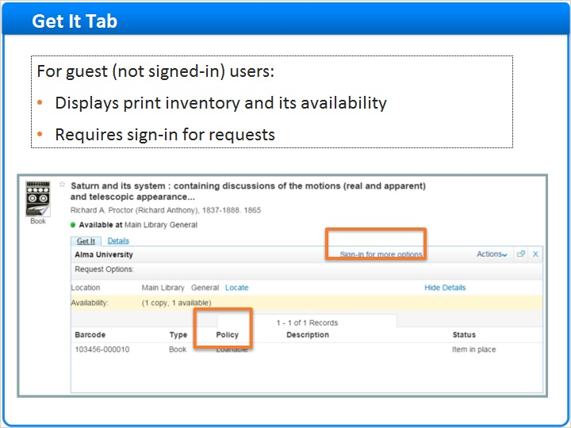
Notes:
Also note that the Get It tab gives information and services relevant specifically for the user.
In the example above the user is not signed in, so you will note that:

1- we do not offer any request services, as we do not know that the user is eligible. Instead we note that they must sign in.
2- we note that the item is loanable - but we do not specify how long for, as again, we do not know that the user is eligible.

1.19 Get It Tab
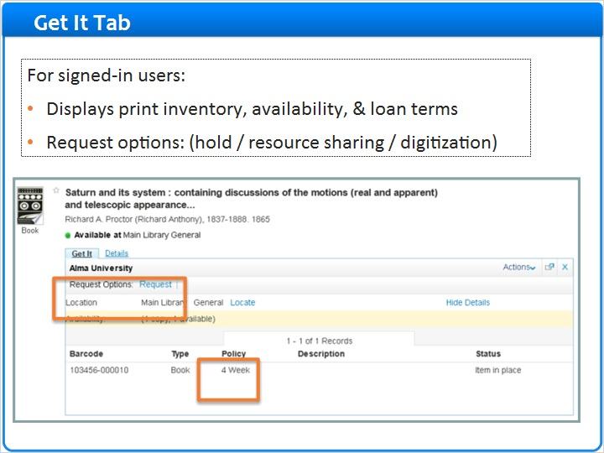
Notes:
Looking at the same record after the user has signed in we can see that:
1- We now offer the user an option to place a request
2- We now can tell the user that for them this item is loanable for up to 4 weeks

1.20 View It/Get It Mashup
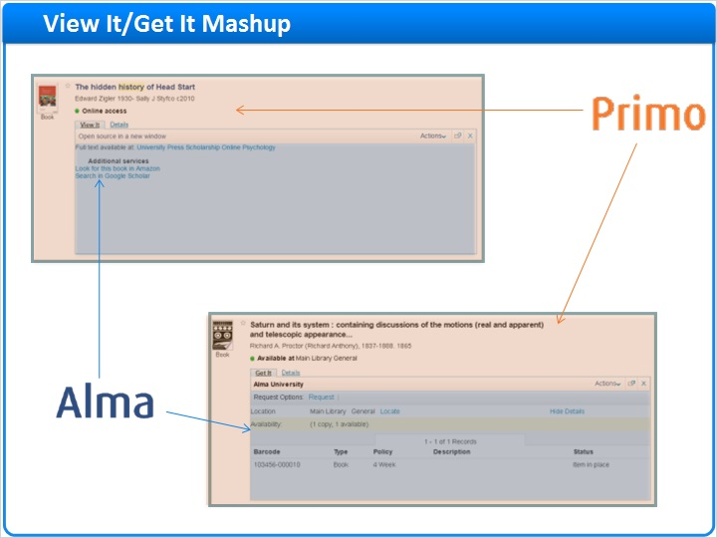
Notes:
Let’s look at the ViewIt and GetIt interfaces and see what can be configured and where.

The ViewIt and GetIt tabs are actually an Alma iframe embedded into the Primo interface. So when the user clicks on the GetIt or ViewIt , Primo sends the request to Alma which then displays the relevant information in the frame directly.

It is all seamless to the end user, but there are actually both Primo and Alma displayed here.

This means that any configuration regarding the order or look and feel of the data inside the tabs, is controlled in Alma and not in Primo. Conversely, everything in the results page outside the tabs is configurable in Primo.

1.21 Real Time Availability
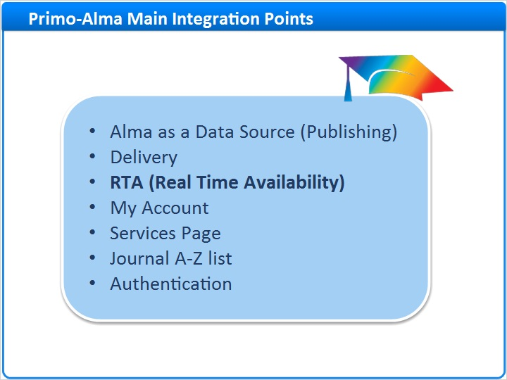
Notes:
Let’s move on to the next integration point - the Real Time Availability or RTA

1.22 Real Time Availability
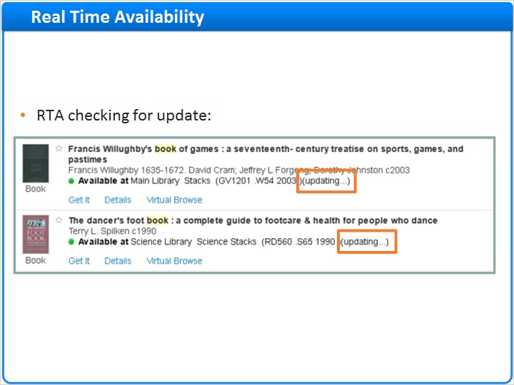
Notes:
RTA is a check that’s done between Primo and Alma whenever a “Print” record is displayed in the Primo results page.

As a record is seen on the screen, Primo sends a check to Alma to see if the availability status has changed recently, if so the status will be updated accordingly. This check is run once every time the results are loaded or refreshed.

So if a record was loaded into Primo and at the time was unavailable on the shelf - Primo checks if this status should be updated and changes the status displayed to the user.

This is only relevant for “Print” records - as online records are always available and are not ‘borrowed’ or ‘missing’ from the library.

For sites that previously had Primo with a traditional ILS, such as voyager or Aleph - the RTA operates the same as it did.

1.23 My Account
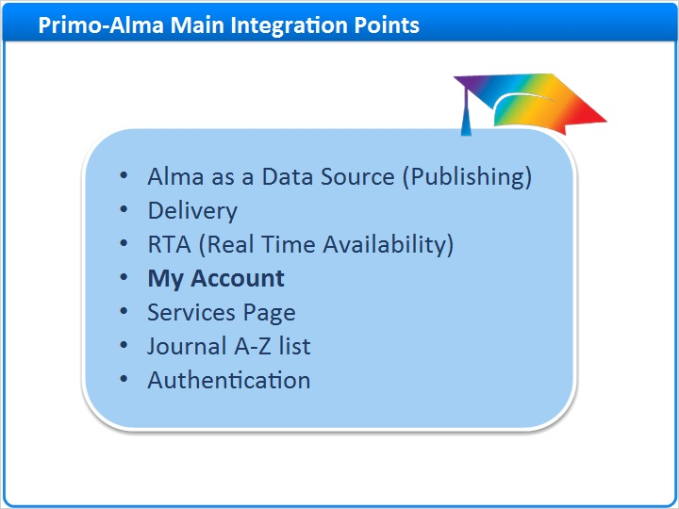
Notes:
Next integration point is the My Account functionality

1.24 My Account
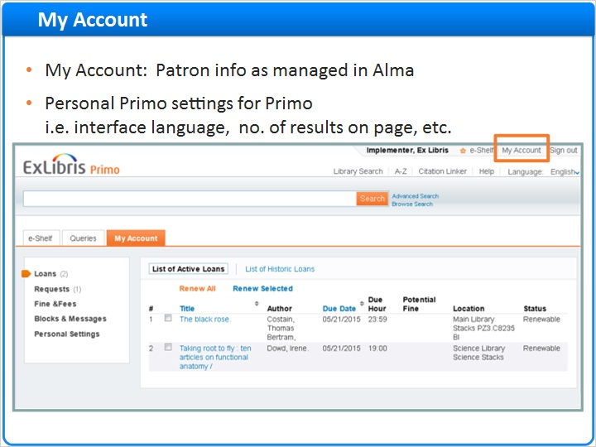
Notes:
My Account is the place for the user to find all of their own personal information and their interactions with the library.

User data, such as user info, loans, fines, fees, and requests, resides in Alma, not in Primo.

Once a user is authenticated and clicks on My Account, Primo requests the information from Alma and displays for the user’s benefit.

For sites that previously had Primo with an ILS - the My Account operates the same as it did with Voyager or Aleph.

1.25 Summary
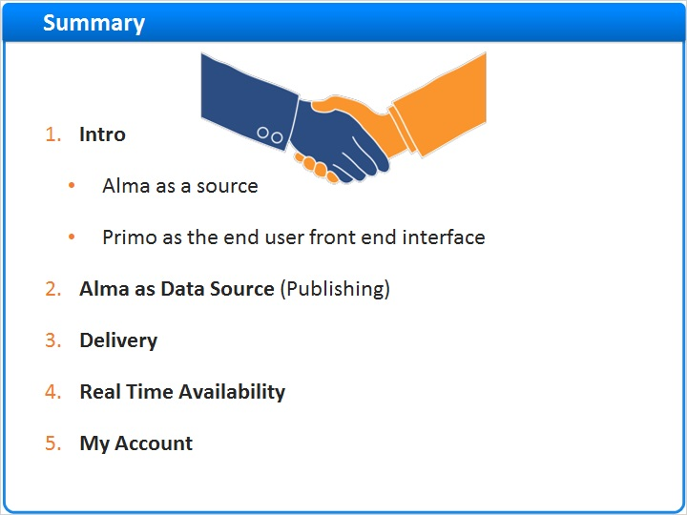
Notes:
Let’s sum up what we discussed in this session.

1. We discussed Alma as a source for both data and delivery definitions - and Primo as the end user interface
2. We discussed the data structure and publishing from Alma and loading into Primo
3. We discussed the GetIt and ViewIt Delivery options in Primo - depending on whether the record is Print, Online or Digital
4. We looked at the Real Time Availability - which updates the availability statement in the end user interface if needed
5. And finally we explained the My Account interface where the end user will see their personal information such as circulation data, fines & fees, blocks etc.

In the next session we will continue and talk about the rest of the integration points:
- Services Page
- Journal A-Z list
- Authentication

1.26 Thank You!

Notes:
Thanks for joining us! Please proceed to the Alma and Primo Interoperability part 2 to continue.

1.27 About this Training
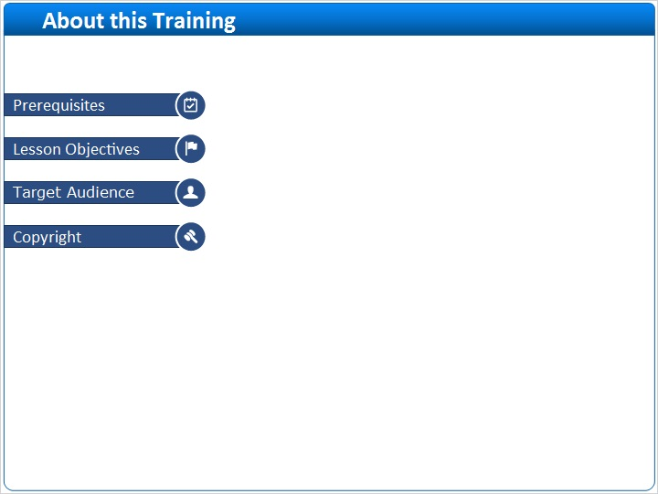
Notes:

1 (Slide Layer)
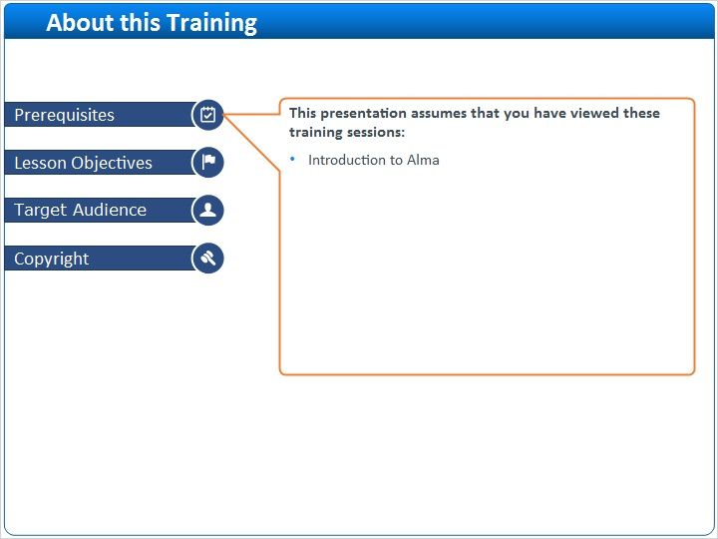

2 (Slide Layer)
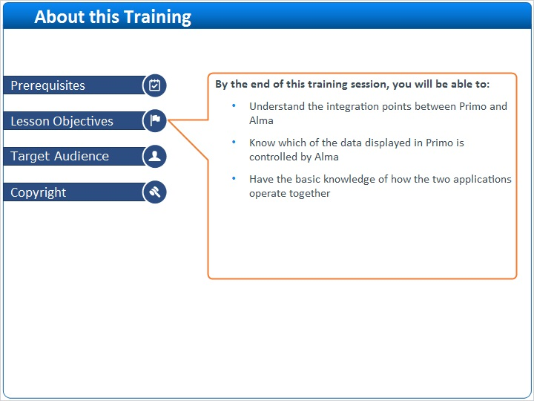

3 (Slide Layer)
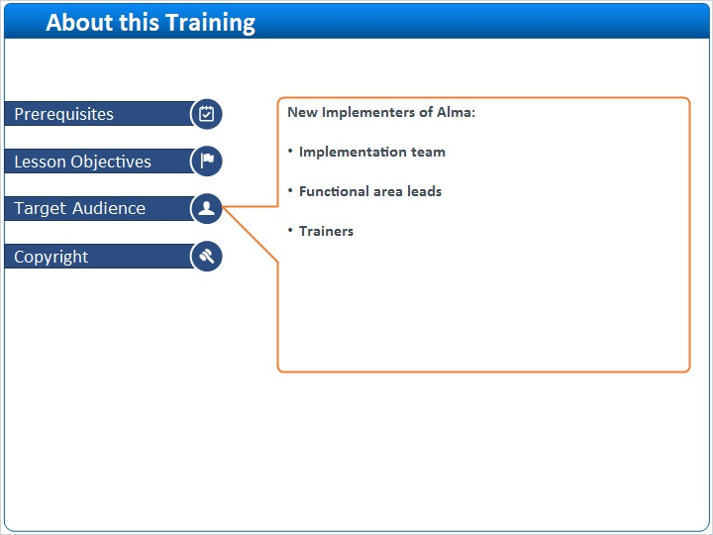

4 (Slide Layer)


