Primo Studio Configuration Options Word doc

1. Primo Studio Configuration Options

1.1 Welcome
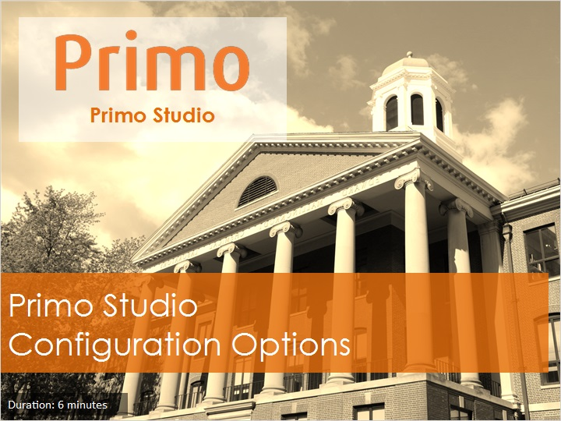
Notes:
Welcome to this session, Primo Studio Configuration Options.

1.2 Objectives
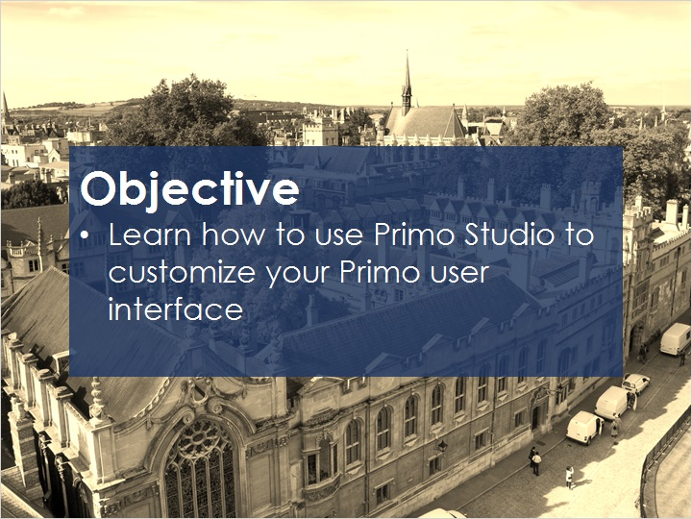
Notes:
In this session, you will learn how to use Primo Studio to customize your Primo user interface.

1.3 Theme
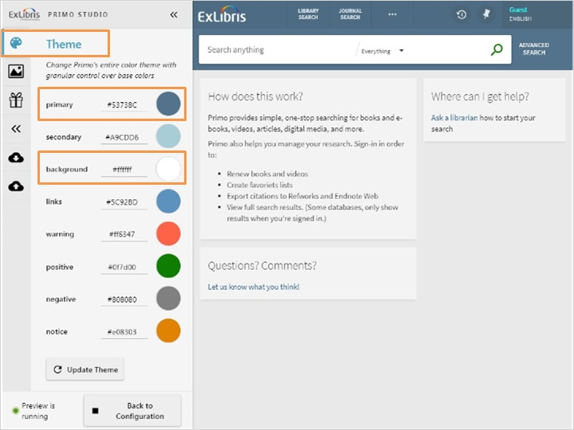
Notes:
The Theme tab allows you to change the colors used in various areas of the UI.
For example, let’s change the primary color and background colors. First, select the new colors - for our primary color let’s go with a maroon red, and for the background let’s select a tan color. Then click Update Theme to apply the changes in the preview pane. There.
For descriptions of each of the color options displayed here, please refer to the documentation in the Knowledge Center.

Change colors (Slide Layer)
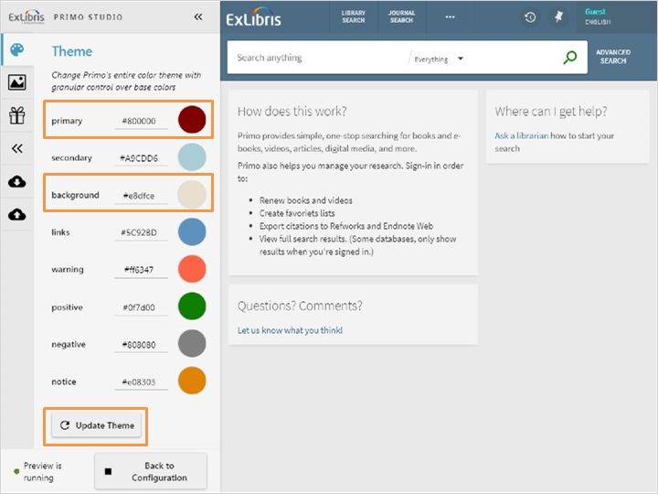

Theme updated (Slide Layer)
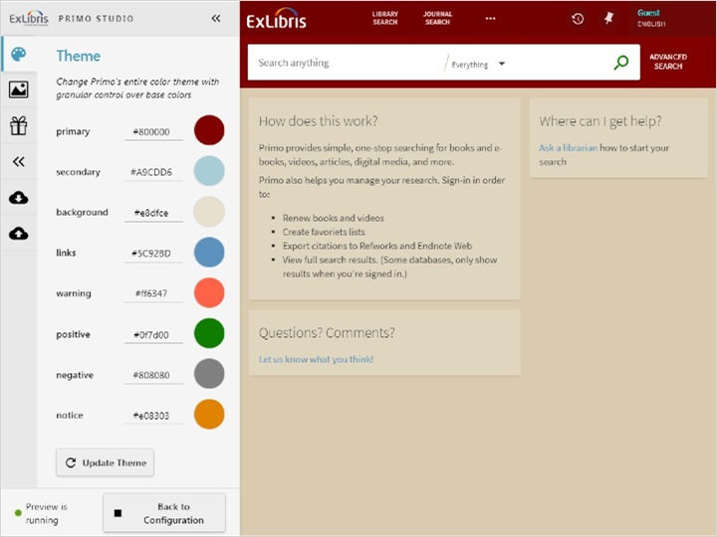

1.4 Images
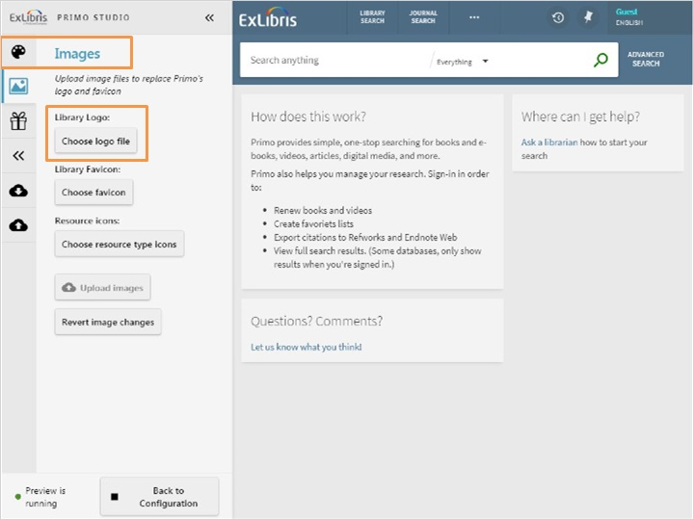
Notes:
The Images tab allows you to upload image files to replace the images used for the logo, favicon, and resource types.
To add your library logo, select Choose logo file and then choose your logo. The logo file must be a PNG and use the following naming convention: <filename>.png (for example, MyLib_logo.png).
The favicon is the icon that displays in the tab in the browser, here at the top of the screen. To add your library's favicon, select Choose favicon and then choose your favicon. The favicon files must have the extension ICO and use the following naming convention: <filename>.icon (for example, favicon.ico).
To add or replace resource type icons, Choose resource type icons and then choose the image files to be used for the resource types. The resource type icon files must be a PNG file and use the following naming convention: icon_<resource_type>.png (for example, icon_book.png).
For now, I’m just going to change the library logo icon. Once the image is selected, I can click Upload images to test them in the user interface.
Please note there is an upload limit of 1MB. If your images exceed 1 MB, you can use multiple uploads to load all of your images.

Logo (Slide Layer)
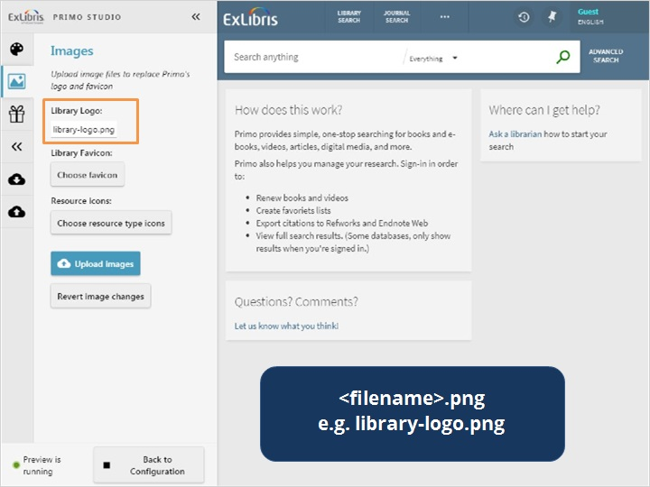

Favicon Tab (Slide Layer)
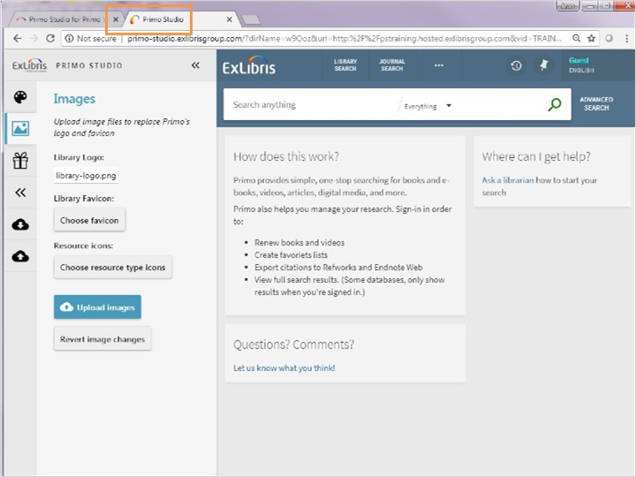

Favicon (Slide Layer)
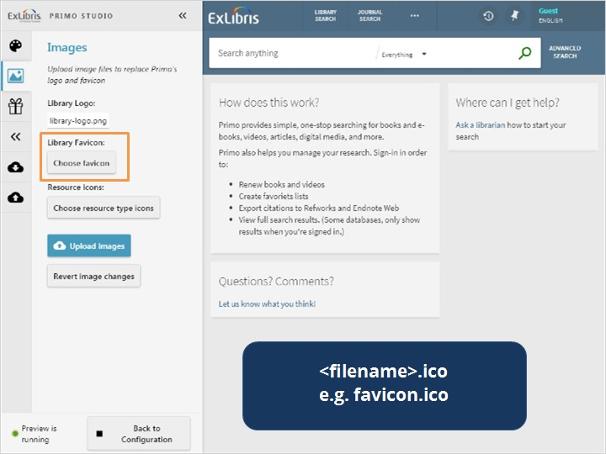

Resource Type (Slide Layer)
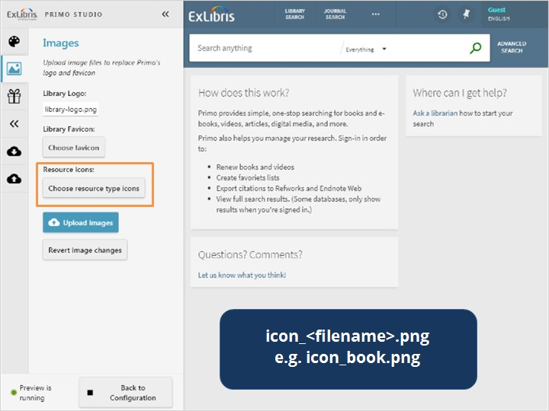

Upload Images (Slide Layer)
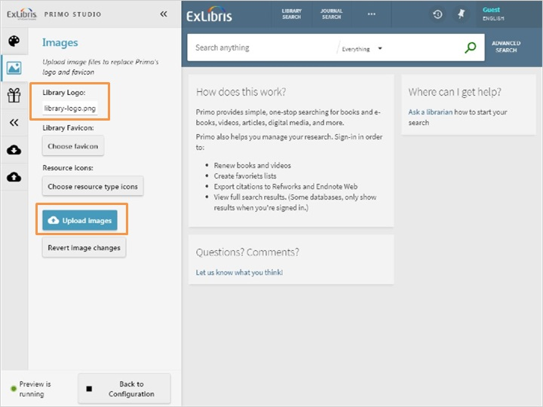

1.5 Features
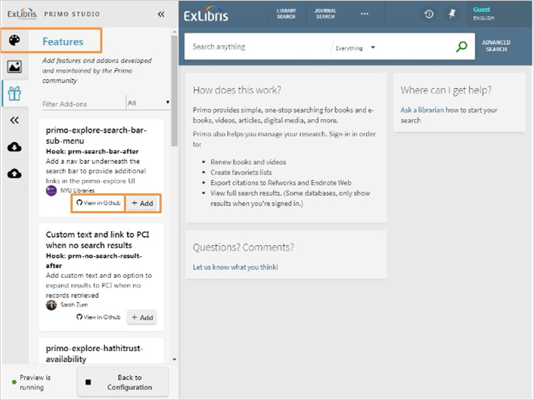
Notes:
The Features tab allows you to apply applications created by users of the Primo community. To view an add-on and read more about configuring it, click on the View in GitHub link here.
To enable the add-on, click the Add button. The changes will be applied instantly unless the add-on requires additional information. In this example, we are adding a navigation bar below the search bar, so we need to add in a few parameters, then click submit.
If you would like to remove an add-on from your test package after it has been selected, just click Remove.

Parameters (Slide Layer)
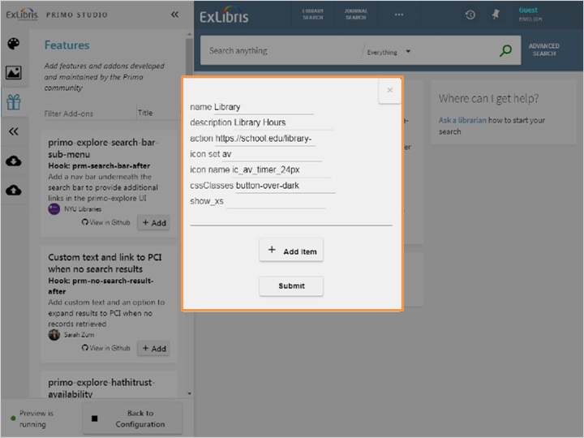

Added Feature (Slide Layer)
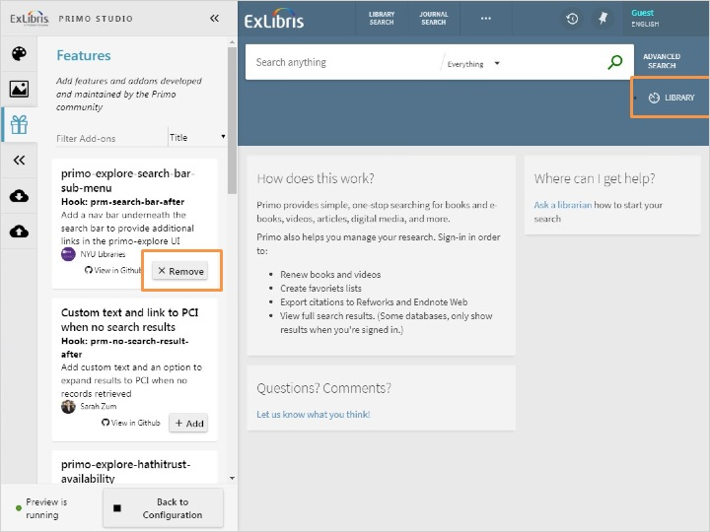

1.6 CSS Editor
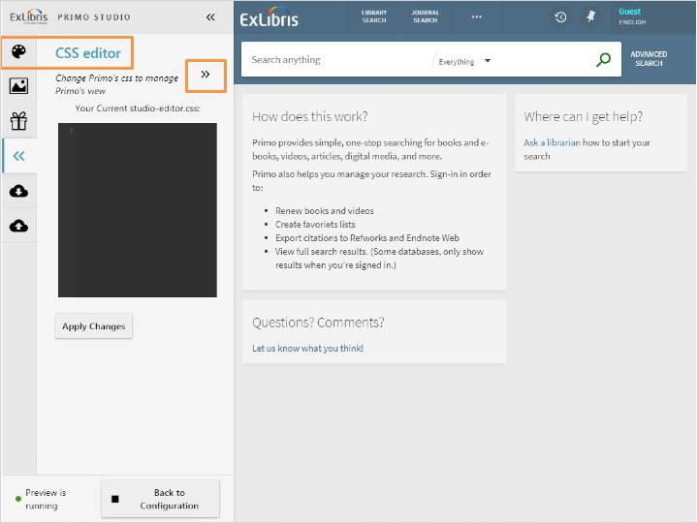
Notes:
In the CSS Editor tab, it is possible to make changes to Primo’s CSS. You can change fonts, colors, and much more here. For example, let’s say that we would like to disable the automatic capitalization that happens in the Main Menu.

We could enter the code directly into this black box, or we can use the arrows here to expand the CSS Editor.

We type in the CSS code, then click Apply Changes to test the code. There - now the Main Menu links are no longer in all caps.

CSS Added (Slide Layer)
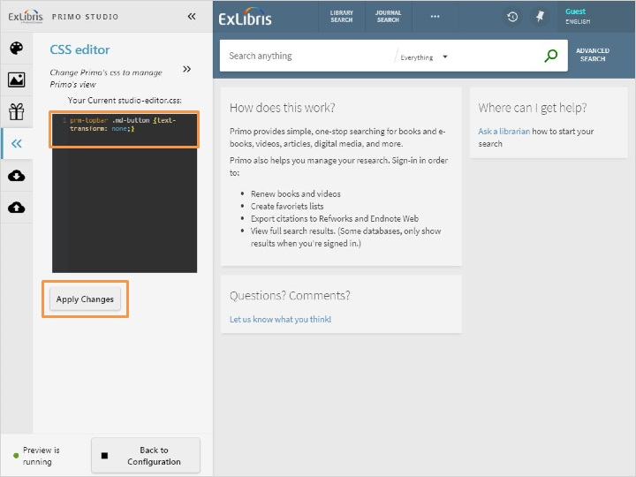

Tested (Slide Layer)
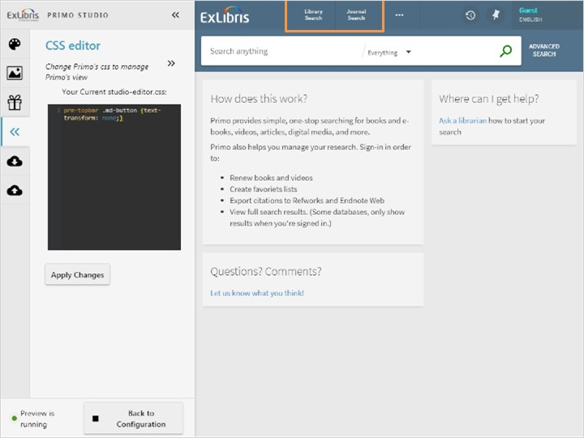

1.7 Download Package
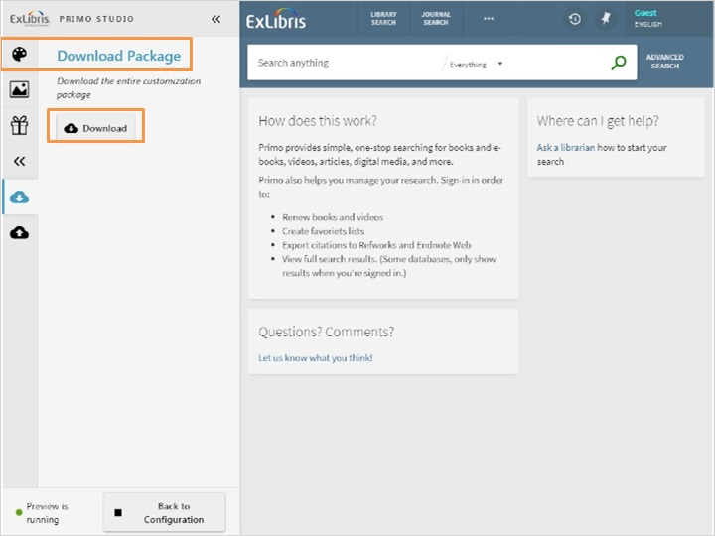
Notes:
The Download Package tab allows you to save your modifications to a customization package on your local machine so that you can either modify the package later in Primo Studio for further changes and testing or you can deploy the package to the Front End for live use.
To save the customization package to your local machine, select Download and then specify a name for your package.
To deploy the package to the Front End, First download package to get a zip file.
If you have Primo VE, you can load it via the Manage Customization Package tab in the View Configuration.
If you use the Primo Back Office to customize Primo, you can load it via the Customization Manager in the Primo Utilities.
More information on deploying the customization package in Primo VE and in the Primo Back Office can be found in the Knowledge Center.

Primo VE (Slide Layer)
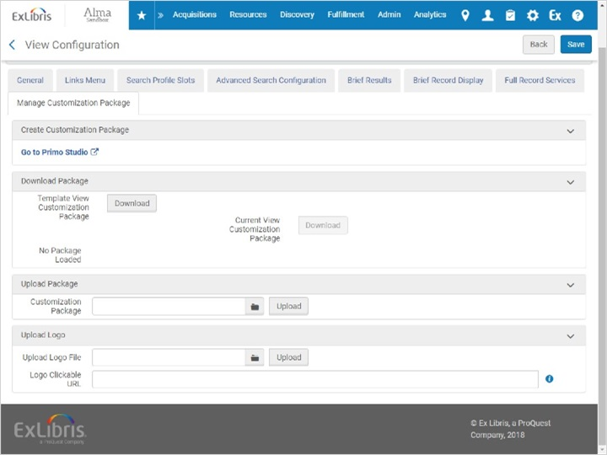

Primo Back Office (Slide Layer)
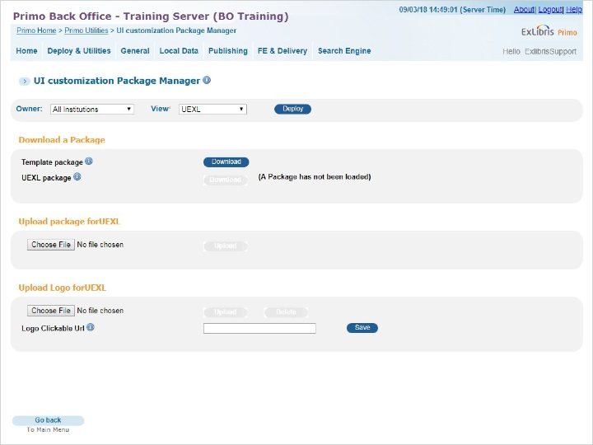

1.8 Upload Package
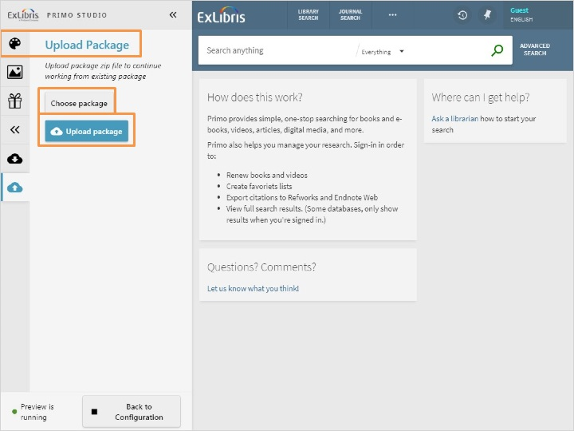
Notes:
The Upload Package tab is used if you've already made customizations to a customization package, and don't want to start from scratch. Here it’s possible to upload a previously customized package and make additional changes.
To upload a package from your local machine, click Choose Package, then specify the name of the package that you want to modify. Then click Upload package. Now you’re ready to continue customizing the Primo UI.

1.9 Review & Quiz
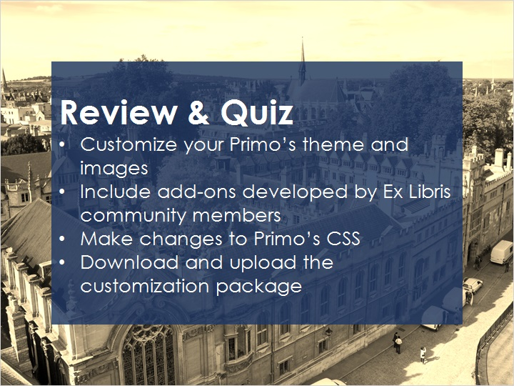
Notes:
Now that you’ve watched this session you should be able to use Primo Studio to customize your Primo’s them and images, include add-ons that have been developed the Ex Libris community, make changes to Primo’s CSS, and download and upload the customization package.

Please take the short quiz to test your knowledge.

1.10 Quiz: Question 1
(True/False, 10 points, 1 attempt permitted)
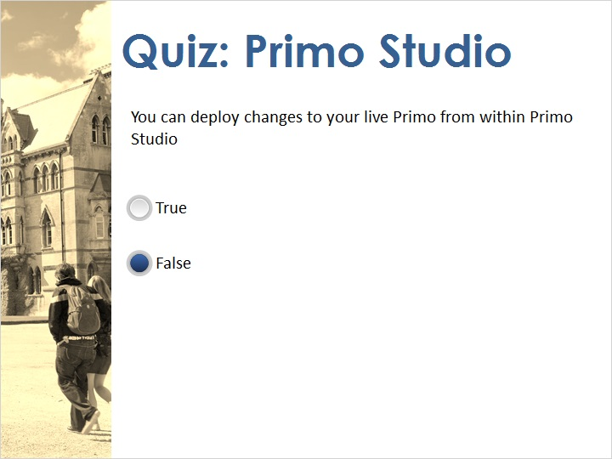
Correct | Choice
 | True
X | False
Feedback when correct:
That's right! In order to apply the changes you have made in Primo Studio, you must download the customized package and deploy the changes in either Primo Back Office’s Customization Manager or Primo VE’s Manage Customization Package tab in the Discovery > Configure Views area.
Feedback when incorrect:
No sorry, that’s not right. In order to apply the changes you have made in Primo Studio, you must download the customized package and deploy the changes in either Primo Back Office’s Customization Manager or Primo VE’s Manage Customization Package tab in the Discovery > Configure Views area.

Notes:

Correct (Slide Layer)
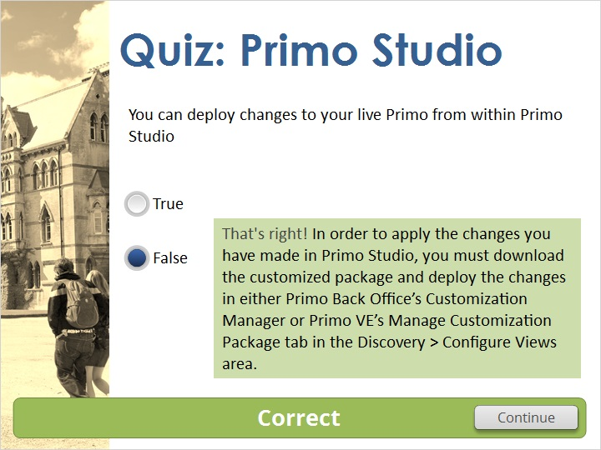

Incorrect (Slide Layer)
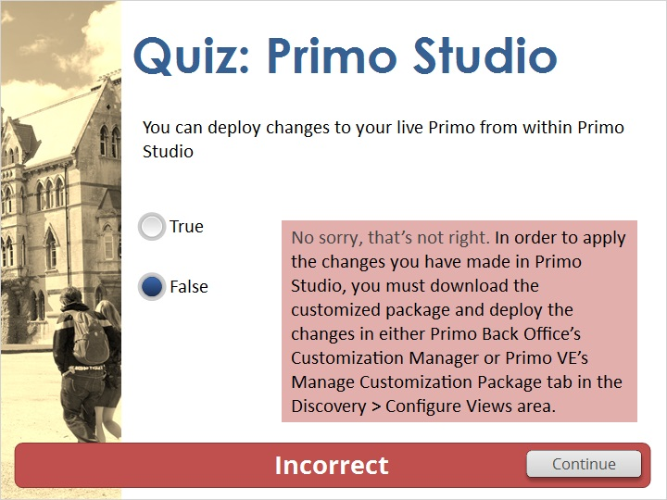

1.11 Quiz: Question 2
(True/False, 10 points, 1 attempt permitted)
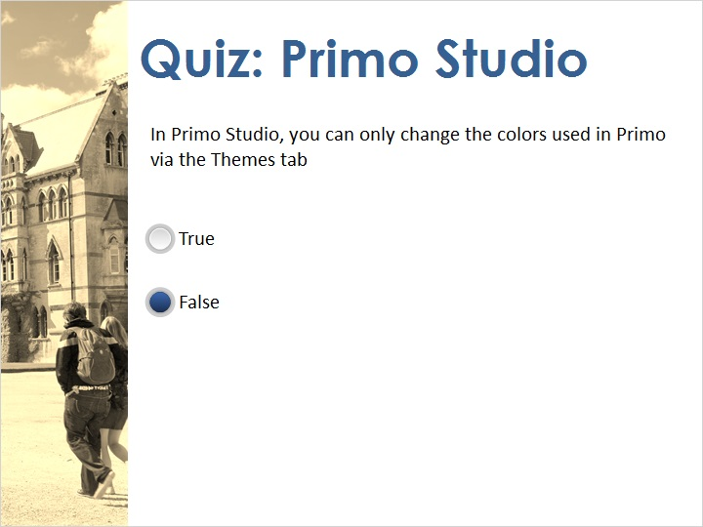
Correct | Choice
 | True
X | False

Feedback when correct:
That's right! You can also make changes to the colors in Primo via the CSS Editor tab.
Feedback when incorrect:
No sorry, that’s not right. You can also make changes to the colors in Primo via the CSS Editor tab.

Notes:

Correct (Slide Layer)
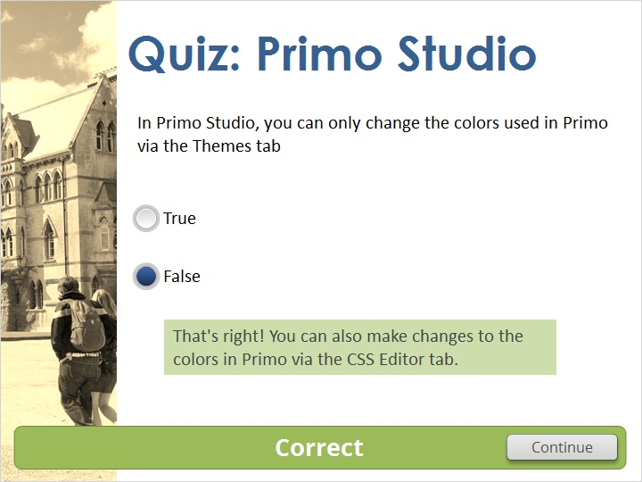

Incorrect (Slide Layer)
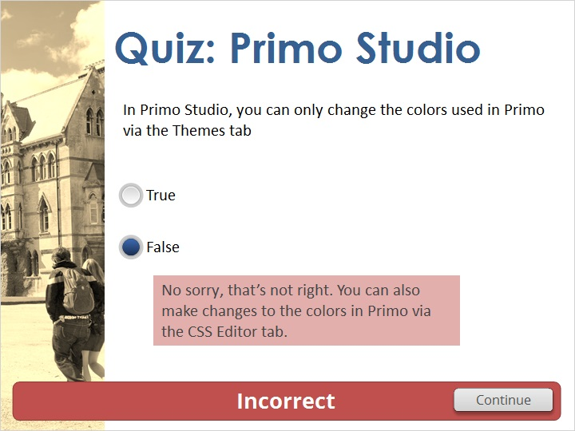

1.12 Thank You!

Notes:
Thank you for joining this session!

1.13 Copyrights

Notes:

2. Quiz Results

2.1 Results Slide
(Results Slide, 0 points, 1 attempt permitted)
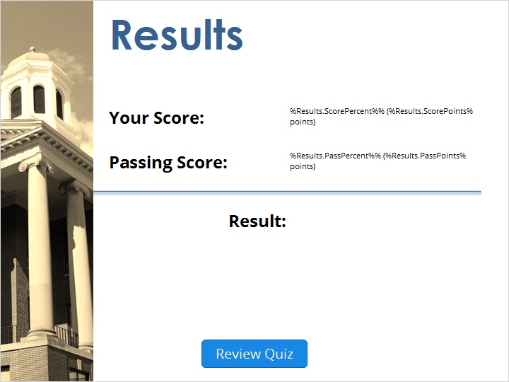

Notes:
fgsfdgsfdgfdg

Success (Slide Layer)
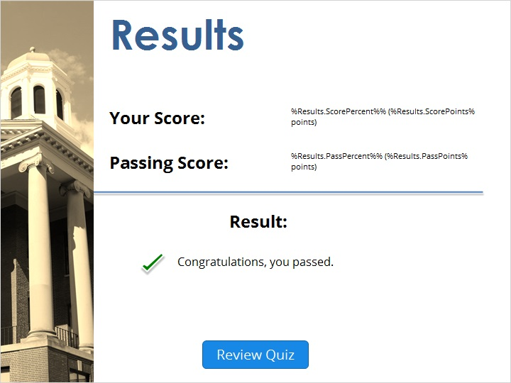

Failure (Slide Layer)


