As an example I took the "Query to patron letter"
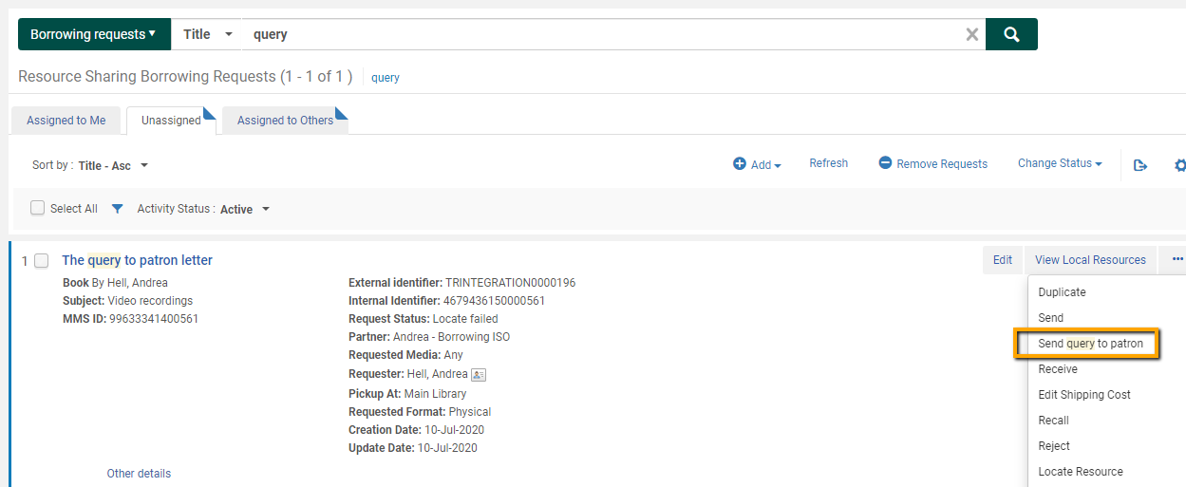

This is how the letter looks now. I want to replace the text "Regarding your request:" by an URL
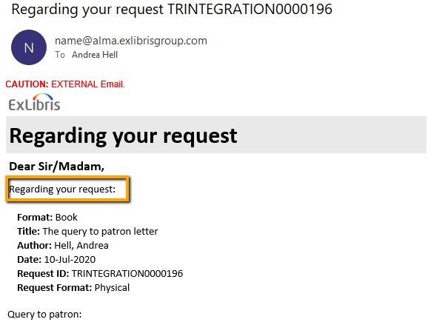

URL has to be added in HTML format
<a href="www.hamburg-tourism.com">Visit Hamburg</a>

GoTo >Configuration >General >Letters Configuration >Letters and select the appropriate letter and tick "Edit".
Open the letter on the "Template" tab and add the URL, in this case I've overwritten
@@requested@@:

How it looks before the change
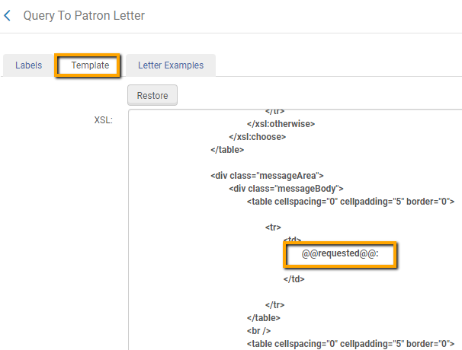

How it looks after the change
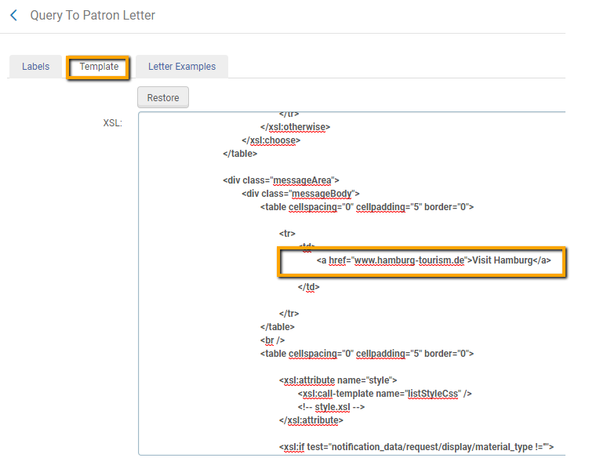

The emailed letter now contains this information and the link can be opened directly
