Naming Conventions of Job History for Import Profiles Configured with Import Protocol FTP

Each import job potentially runs twice:
- The first time, the job attempts to retrieve files from the FTP server. This run appears in the job history with prefix “Metadata Import w/FTP”.
- The second time, the job processes the retrieved files. This run appears in the job history with prefix “Metadata Import” and suffix “(FTP)”.
Note: If on the first run there are no files to retrieve from the FTP server, there is no second run.

For example, on the import profile “JSTOR ebooks Updates FTP”, the import protocol is defined as 'FTP':

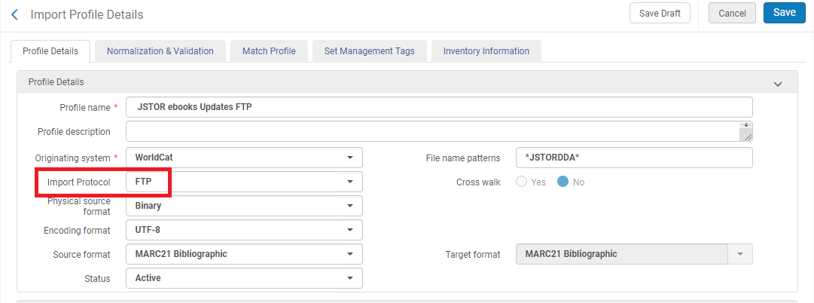

We see in the job history that it ran twice on 26/05 (18 seconds apart) and once on 27/05:

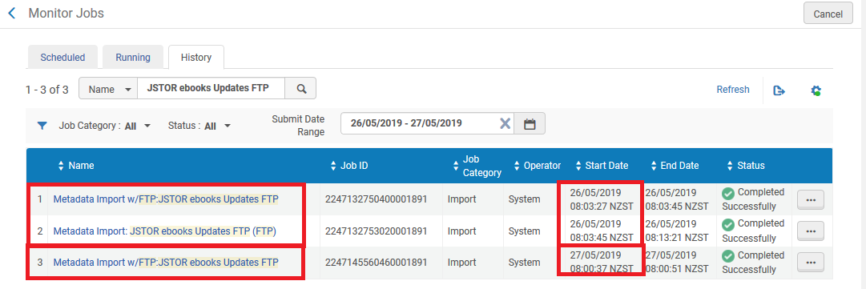

The first time it ran on 26/05, it attempted to retrieve files from the FTP server, and its prefix is “Metadata Import w/FTP”
It retrieved two files:

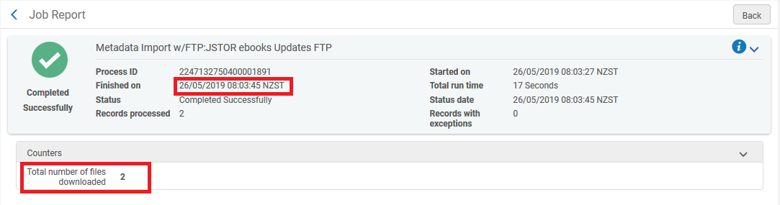

The second time it ran on 26/05, it processed the files from the FTP server and its prefix is “Metadata Import” and suffix “(FTP)”.

On 27/05, it ran once to attempt to retrieve the file from the FTP server and its prefix is “Metadata Import w/FTP”
It did not run a second time on 27/05 because there were no files on the FTP server to process. This is evident in the job report:

