DNS Switch Simulation
Prerequisites
- Identify your current domain (for example, abc-primo.hosted.exlibrisgroup.com).
- Identify your target domain (for example, abc.primo.exlibrisgroup.com).
Procedure
- After you receive notification from Ex Libris that the DNS switch settings are in place, you can simulate the switch with a local Hosts file prior to the final DNS switch:
- Open the Windows Command Prompt application by searching for cmd in the Windows search box.
- Enter the following command to display the IP for Primo VE:
ping -n 1 {target URL} | findstr Pinging
Example:
- Go to windows start button and type in search "C:\Windows\System32\drivers\etc\hosts" (Valid from Windows XP to Win10), open with your favorite text editor.
- Add an entry to the end of the file {target domain IP} {current URL}
Example:
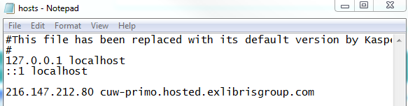
- Save the file. (now your computer is routing traffic from the current URL to the target domain IP)
- Open browser, enter the current URL, validate that everything is working as expected.
  - No Certificate Error
  - Redirect current URL target URL
  - Redirect target URL without URI Full /discovery URL with VID
  - Redirect Custom Customer Domain without URI Full /discovery URL with VID
- Go back to the hosts file, delete or comment out the line that you have added.
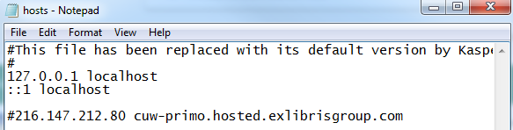
- Save the file.
- DNS Switch Validation:
  - Check DNS switch propagation (https://www.whatsmydns.net/ Example: https://www.whatsmydns.net/#A/cuw-primo.hosted.exlibrisgroup.com)
  - Check configuration and redirection as done before the switch
(Check GUI with https://geopeeker.com/ or https://www.geoscreenshot.com/ )

