Questions and Answers –
Investigate Alma Analytics for Acquisitions

Where can I find the example reports from this presentation?

The example reports we are looking at in this session can all be found under this "Community" folder: Shared Folders/Community/Reports/Shared Reports/Knowledge Days 2020/Acquisitions

Unfortunately, these example reports were accidentally removed and had to be added again, so they will not appear in this folder until the Community folders are synchronized again. This is expected to happen by the end of the day on Friday, May 11th. In the meantime, we have step-by-step instructions for re-creating these reports in the accompanying document for this session. You can find that document from this page: https://knowledge.exlibrisgroup.com/Cross_Product/Conferences_and_Seminars/Knowledge_Days_-_ELUNA/2020_Knowledge_Days

Is there a way to set up the Subscription Cost Change where instead of telling it FY20 and FY19, we say Current FY and previous FY and then do not have to edit it (or recreate it) each FY?

Yes, this is possible and you can still follow the same steps as in our example: just use Fiscal Period Filter instead of Fiscal Period Description and use “Current Fiscal Year” and “Previous Fiscal Year” instead of “FY2020” and “FY2019” respectively.

Can you provide a brief explanation of the difference between the different types of title in the bibliographic details section (e.g., Title (Complete) vs Title vs Title (Normalized)

Please see the following article for an explanation of the differences between the Title, Title (Complete) and Title (Normalized) fields, as well as other fields available in the Bibliographic Details folder: https://knowledge.exlibrisgroup.com/Alma/Product_Documentation/010Alma_Online_Help_(English)/080Analytics/080Shared_Dimensions/010Bibliographic_Details

Where do we find the SQL codes like TSI_Day?

A list of the available SQL codes such as SQL_TSI_DAY can be found in this Oracle documentation under the TIMESTAMPADD section: https://docs.oracle.com/cd/E21764_01/bi.1111/e10544/appsql.htm#BIEUG555

Can this be turned into a dashboard without starting over and recreating the query?

It is possible to add the report to a dashboard without needing to re-create the query. Please see this article for more information: https://knowledge.exlibrisgroup.com/Alma/Product_Documentation/010Alma_Online_Help_(English)/080Analytics/010Introduction/The_Basics_of_Working_with_Analytics/060Creating_a_Dashboard

Can you show us how to get the RSS feeds?

This question was out of scope for our presentation, however we recommend starting with this article: https://knowledge.exlibrisgroup.com/Alma/Knowledge_Articles/Set_Up_RSS_Feed_for_New_Items

Is there a way to query against the MARC directly or do we have to use the columns that have been pulled out (like Title (Complete)) ?

Many MARC record fields have been mapped to Analytics columns and our documentation will often confirm which MARC fields are mapped to Analytics fields (for example, see the Mapping from MARC column of this table in the Physical Items subject area documentation). Since not all MARC fields have been mapped to Analytics fields, we also offer the ability to map up to 10 bibliographic record fields to the Local Param fields and 10 holdings record fields to the Holding Local Param fields. Please see this article for more information: https://knowledge.exlibrisgroup.com/Alma/Knowledge_Articles/Add_bibliographic_fields_to_Alma_Analytics

Is there a way to add cost of material to the physical material report?

Yes, by adding the column for Net Price from the PO Line folder.

Are these specific reports available for us to copy and try using our data? Thanks!

Yes! The example reports will all be made available under this "Community" folder: Shared Folders/Community/Reports/Shared Reports/Knowledge Days 2020/Acquisitions. When you run the reports from your environment the report will display your data rather than the data shown during the presentation from our training environment.

Is it possible to add the item price for these from the expenditures table (and not the price in the item)

Yes, by adding the column for Net Price from the PO Line folder.

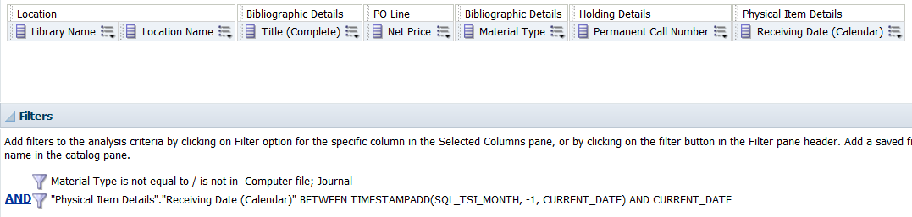

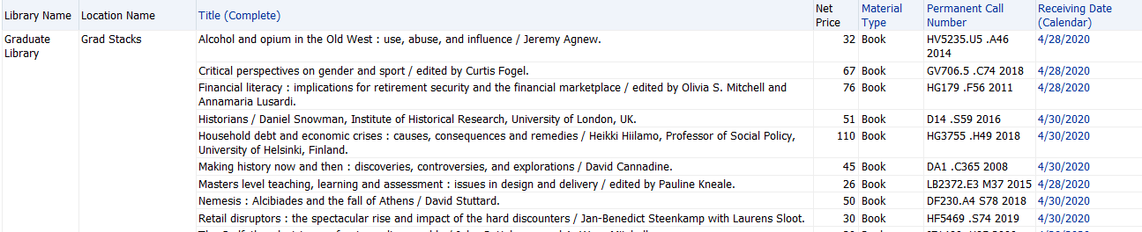

Is there a way to just get a count of these, instead of a list?
Yes, it possible to get a count only. See the screen captures below for how I modified the analysis.

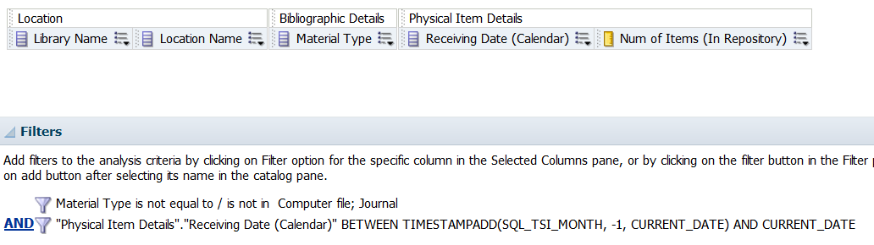

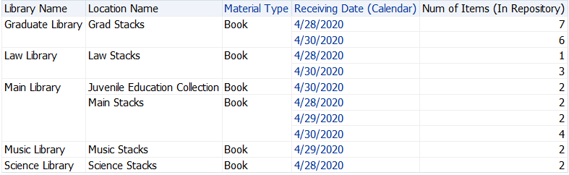

On the first report I did not understand how the percentage column what changed from 2 empty columns to one. Is there documentation for this?

Yes, for more information, see https://docs.oracle.com/en/cloud/paas/bi-cloud/bilug/modify-layout-data-views.html#GUID-0C106632-0431-46F7-B0E0-6EA8210EBD67.

Can you also add the purchase order line number by title?

Yes, by adding the column, PO Line Reference, from the PO Line folder. See the

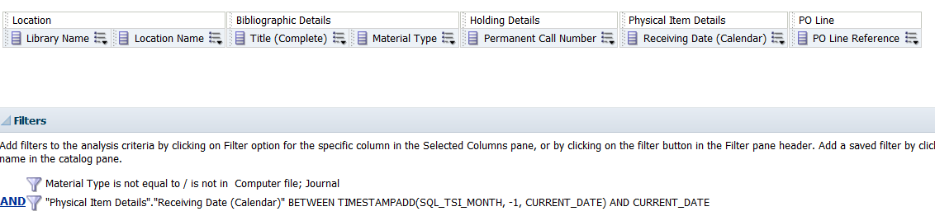

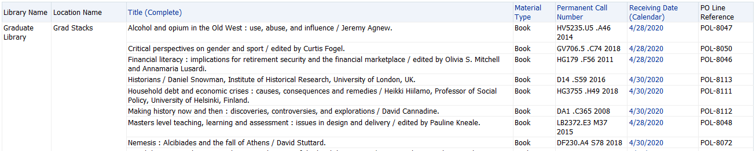

How do we access the document with the budget summary analysis?

You can access it here: https://knowledge.exlibrisgroup.com/Cross_Product/Conferences_and_Seminars/Knowledge_Days_-_ELUNA/2020_Knowledge_Days.

How can I produce a subscription cost trends of 5 years in a line chart? Thanks.

Firstly, the Fiscal Period Description filter will need to be either removed or changed to include the past 5 years. This will cause the pivot table to show all of the expenditures across that time period (note that the % Change will still only be calculating between the two fiscal period input in the column formula).
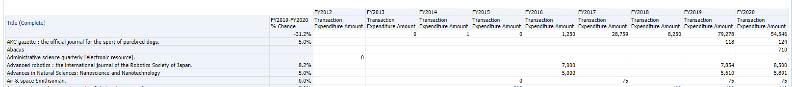

You’ll then want to add a new view to the analysis, selecting Graph, then Line Graph.

While editing the graph view, the % Change field can be moved to the “Excluded” section, since it does not apply to all Fiscal Years and will not show on the graph.

You likely also want to select “Title (Complete)” as a Graph Prompt, since displaying lines for each title at the same time will result in a graph that is difficult to read.

Graph configuration:
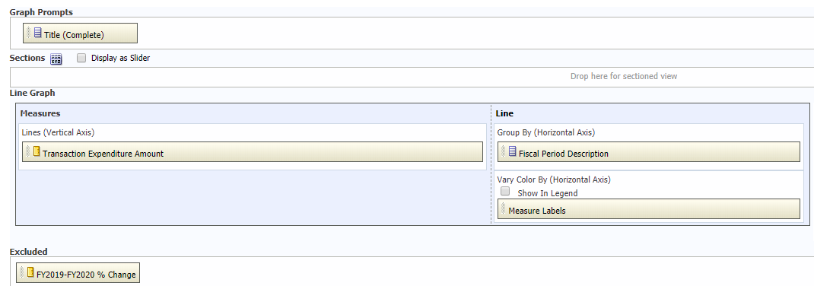

It will then be possible to select a title from the drop-down menu and view the expenditure trend as a line graph across multiple fiscal years:
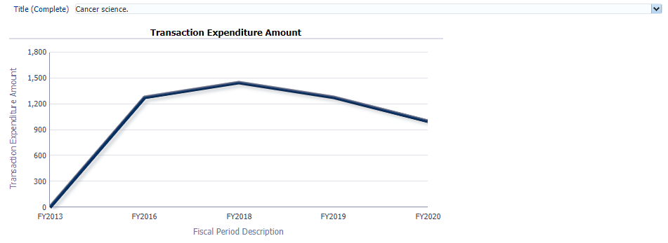

Can you please explain how the Reporting Codes within POs work on the Analytics side?

Reporting codes are intended to be other characteristics that help to identify how a purchased item has come to be in the library’s collections. Each institution can set up three types of Reporting Codes (via Acquisitions configuration): basically Primary, Secondary and Tertiary. This means that you will be grouping like things together. For example, Primary Reporting Code might represent the Colleges/Schools at your institution (e.g. Arts and Humanities, Sciences, Music, etc.). The Secondary Reporting Code might represent academic departments (e.g. History, Chemistry, Music Performance, etc.). The Tertiary Reporting Code might represent a faculty member or library liaison name (e.g. Hilbert, Bellavia, Fernandez, etc.) How a library sets up its Reporting Codes is completely up to that library.

When all three levels are present, PO Lines, expect all three Reporting Codes to be used. See the screen captures below.

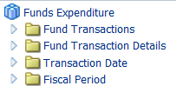

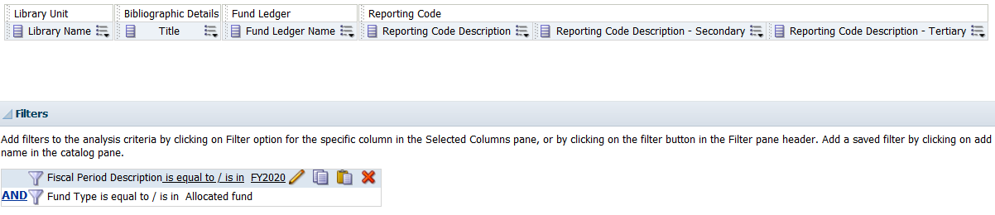

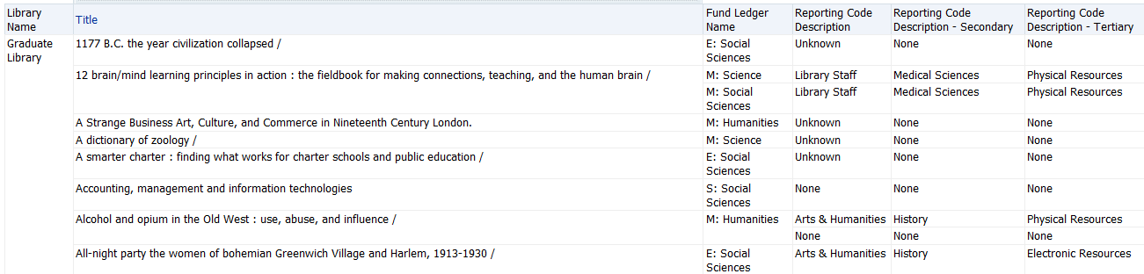

When is it better to use a pivot table rather than a table?

There is no one rule for when to use a pivot table, but pivot tables can help when the goal is to see a summary of the data versus drilling down row by row.

If a primary purpose of an analysis is to see counts, and you want to see how these counts compare across common limiters, like Fiscal Year or Item Location, a pivot table may help show an overview of that data.

When looking at the Cost Changes of Subscriptions report in a regular table view, each Title has two rows, one for each Fiscal Year:
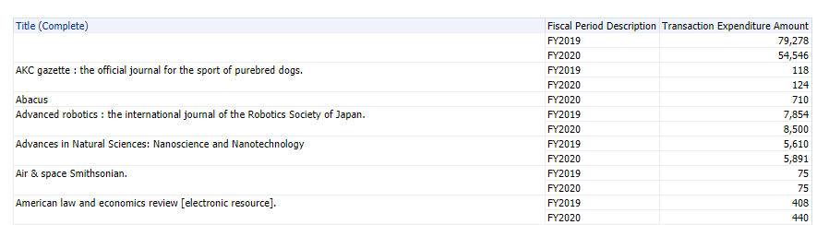

This makes it a lot harder to see the difference between two years at a glance. If a report has multiple rows of corresponding data like this, it’s a good time to try a pivot table to format the data in a more readable way!

One more quick question, can you mention again where we can locate the bonus report, "budget summary"?
You can access it here:

https://knowledge.exlibrisgroup.com/Cross_Product/Conferences_and_Seminars/Knowledge_Days_-_ELUNA/2020_Knowledge_Days.

How do I explore the difference between measures & rows?

The best way is to play with the pivot table configuration a bit. Edit the pivot table view, and drag fields back and forth to see how that changes the display.

Generally, in a pivot table, measures will be calculated according to both the row and the column. If a field does not apply to both the row and the column, then it should probably be a row.

In the case of the % Change field, when included in the Measures section of the pivot table, the field appears twice, once for each Fiscal Year:
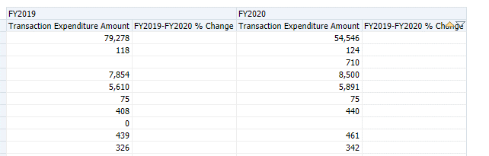

The math for this field, however, requires values from both FY2019 and FY2020. When separated in the pivot table according to Fiscal Year, half of the data is missing for the calculation, so the field is empty.

As such, the % Change field needs to be a row, so that it can use the expenditure amounts per title for both FY2019 and FY2020 to perform the calculation.

