This session will investigate Analytics for Acquisitions. Assumes that the basics of the Analytics infrastructure and roles, navigation and creating/modifying analyses are understood.

Contents
Copying the Example Reports 1
Cost changes of subscriptions 3
Electronic Resources Activated in the Past Month 16
Physical Titles received in the past month 19
Bonus Analysis: Budget Summary 25

Copying the Example Reports

You will be able to find copies of these example reports saved to the Community folder. The example reports for this session can all be found under the Shared Folders/Community/Reports/Shared Reports/Knowledge Days 2020/Acquisitions folder (please note that the synchronization among data centres may not yet have occurred, so the reports may not appear in this folder yet). If you would like to follow along and complete the exercises, we ask that you first copy these reports to your My Folders section or a folder under your institution’s directory in the Shared Folders section and work on the copies. To do this, click on the Catalog link in Analytics:

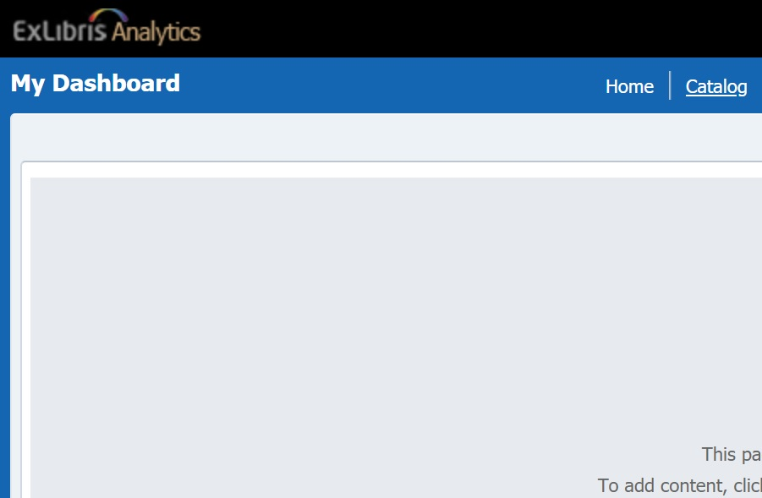

Navigate to the Shared Folders/Community/Reports/Shared Reports/Knowledge Days 2020 folder:
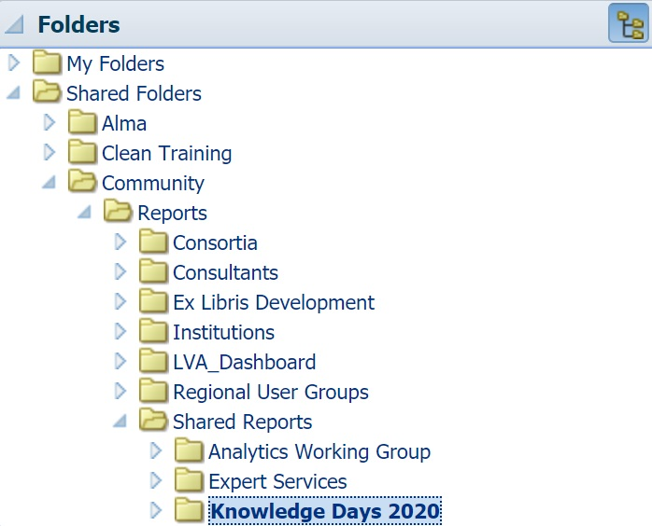

Under the Acquisitions folder, click More and then Copy:
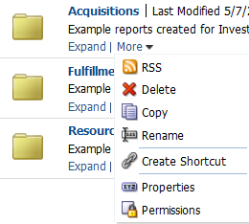

Navigate to a directory in your institution’s folder (our training environment’s institution name is “Clean Training”) and click on the Paste icon to copy the folder and all the reports inside to the desired directory:

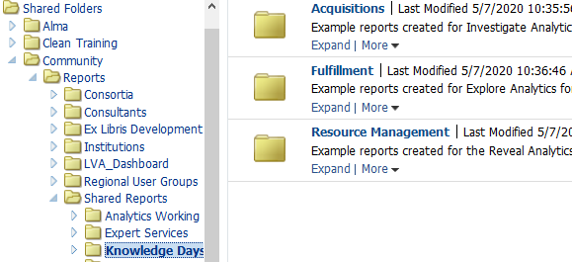

Cost changes of subscriptions

Scenario:

- Goal is to see how the cost of subscriptions have changed over the years
- Let’s focus on a two-year range to be able to observe the percent difference

Using the Funds Expenditure Subject Area…
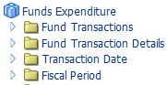

…add these columns to the analysis and view the results.
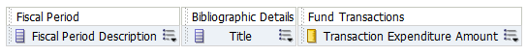

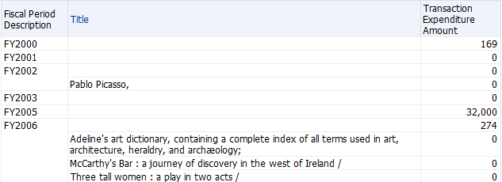

Save the analysis as Cost Changes of Subscriptions.

Click on the Funnel icon on the far right to add a filter without displaying the column of data and select More Columns…
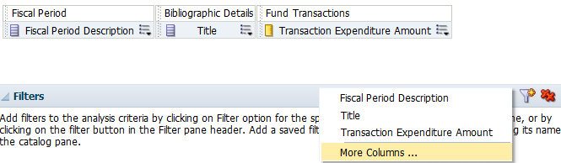

Open the PO Line Type folder and select Continuity before clicking on the OK button…
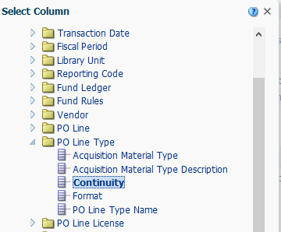
..and identify CONTINUOUS as the value for this filter.
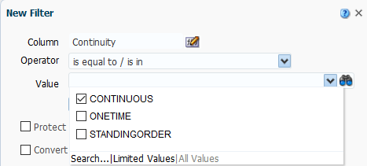

From the Fiscal Period Description column…
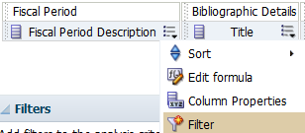

…apply a filter…
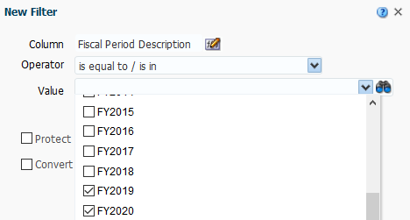

…to show this addition.
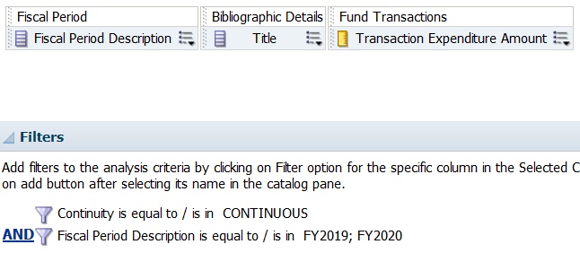

Add one more filter, this time for status of the PO so that we are seeing Active orders only. Go to the Funnel icon on the right, open the PO Line folder and select Status.
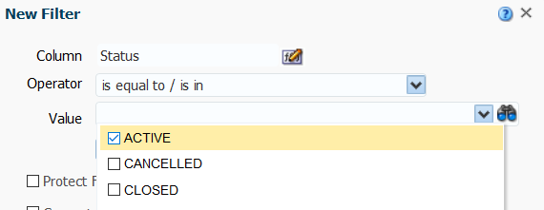

Save the analysis and view the results.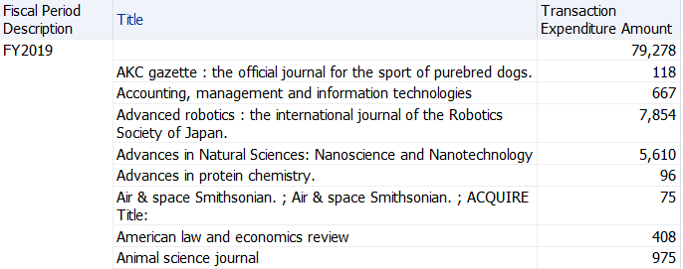
Via the menu above the analysis…
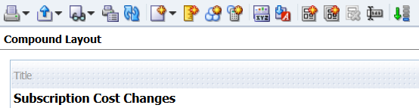

…click on the drop-down for New View (looks like a piece of paper with a gold star) and select Pivot Table. The Pivot Table view is added to the analysis and is located below the Table view.
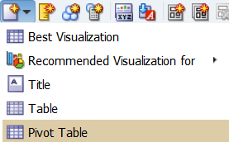

Click on the X to delete the Table view, so that we are seeing only the Pivot Table view.

Save the analysis and view the results.
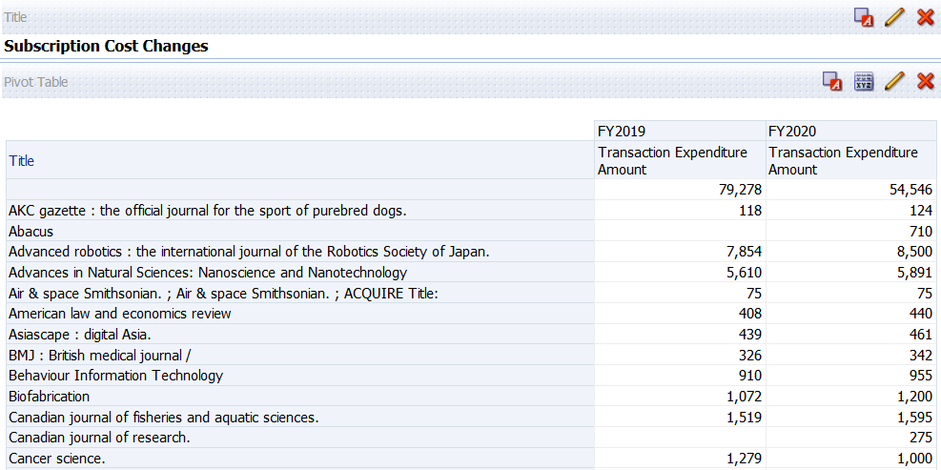

To identify the percentage difference, return to the Criteria tab and add another instance of the Transaction Expenditure Amount column to the analysis.
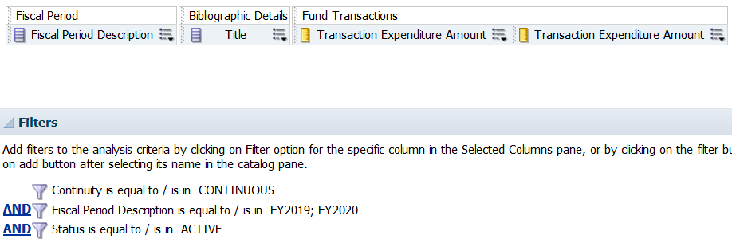

Open the menu for the second instance of the Transaction Expenditure Amount column and select Edit formula to perform the mathematical actions to give us percentage difference.
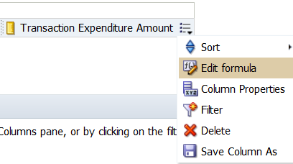

With the data in the Column Formula canvas selected…
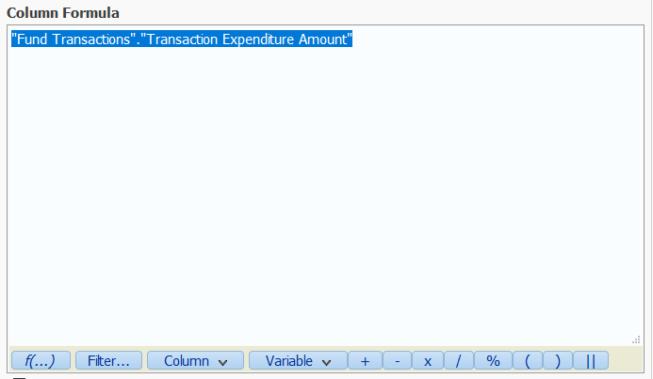
…we will apply a filter to the data by clicking on the Filter button, opening the folder for Fiscal Period and double-clicking on Fiscal Period Description…
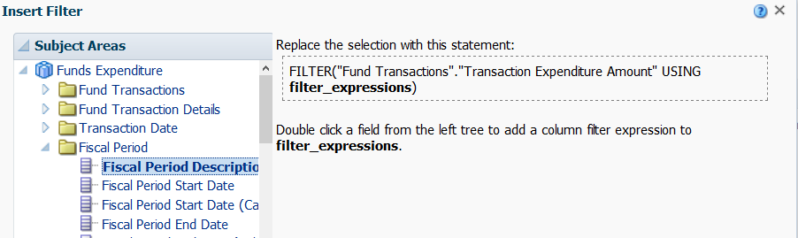

…and selecting FY2020 (the current fiscal period) from the available values in the drop-down.
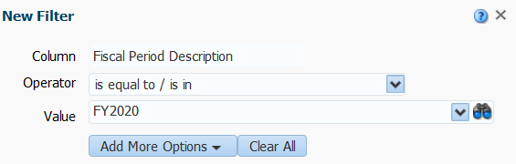

Click on the OK button twice to see the filter applied to the formula.
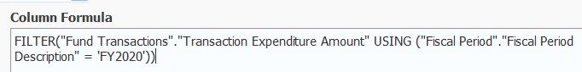
Insert a minus sign (-) at the end of the information currently in the Column Formula canvas before we proceed to add more data and another filter.
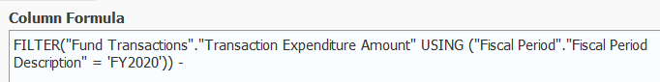

From the Subject Areas section on the left, open the Fund Transactions folder and select Transaction Expenditure Amount before clicking on the > to add it to the Column Formula canvas.
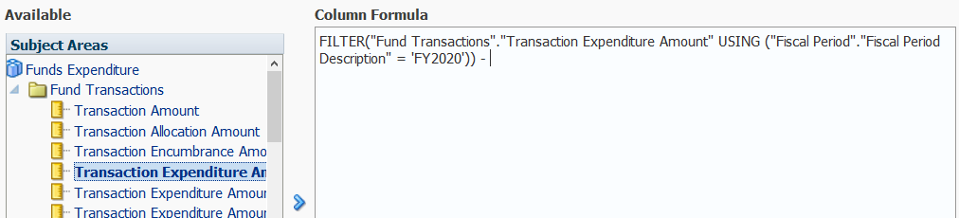

With the new column of data in place and selected, we’ll apply another filter.
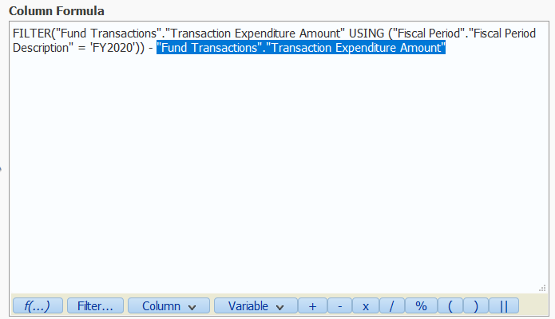

Double-click on Fiscal Period Description again…
…and select FY2019 (the previous fiscal period). Click on the OK button twice…
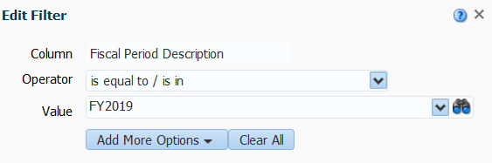

…to see the second filter applied to the formula.
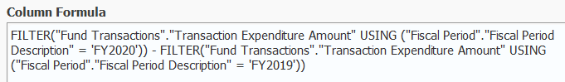

Next step is to insert the divide by (/) symbol into the formula before we add one more column of data with a filter.
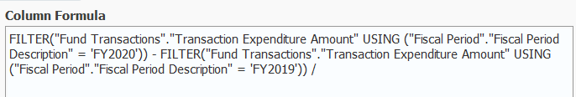

Use Copy to select the column and filter we just added and Paste it after the divide by symbol.
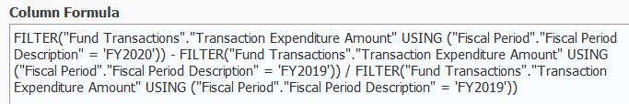

Insert a multiply by (*) 100 to complete the math. Click on the OK button and Save the analysis.
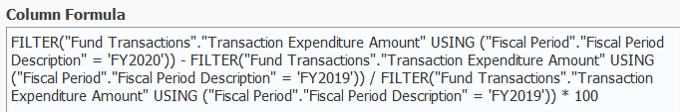

One more thing to do with this formula…insert parentheses…left parentheses ( to the left of FILTER in the first position and a right parentheses ) following the first filter for the previous fiscal year and before the divide by symbol. Remembering the order of actions and including parentheses will make sure that the math works correctly.
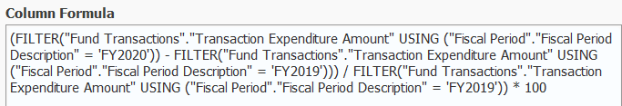

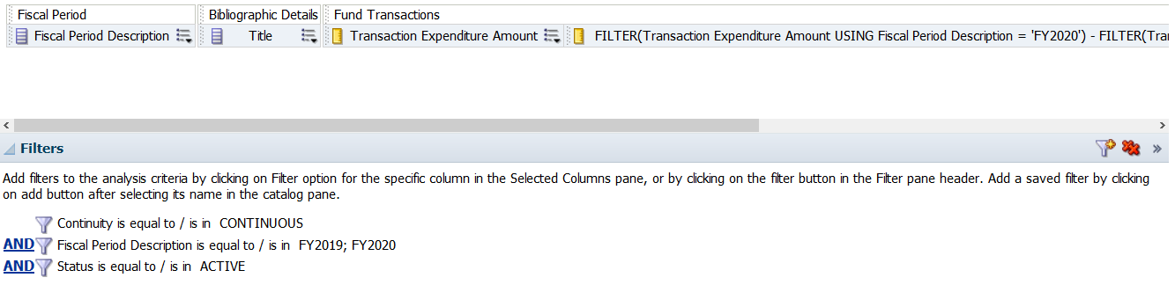

View the results. The analysis now displays with a rather unwieldy column headings. We can modify this column heading when we apply one more change to the data.
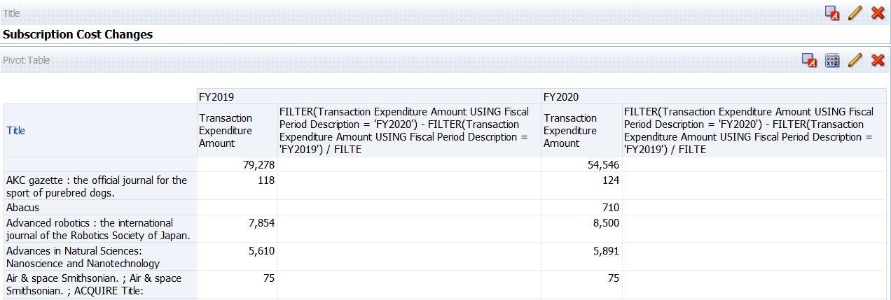

Back at the Criteria tab, open the menu for the unwieldy column and select Column Properties.
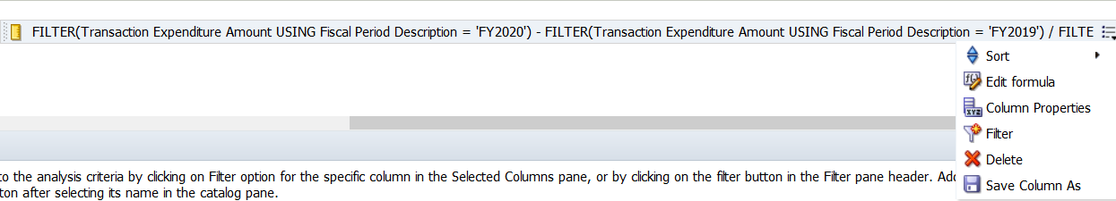
On the Column Format tab…
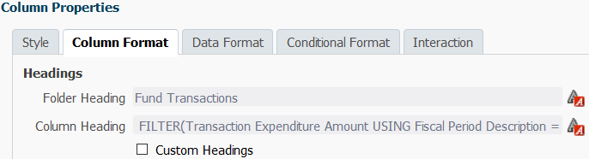

…place a check inside the box beside Custom Headings and modify the text.
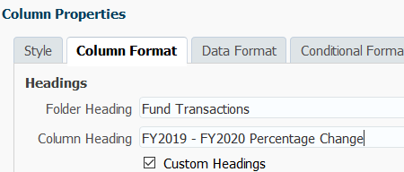

Move to the Data Format tab…
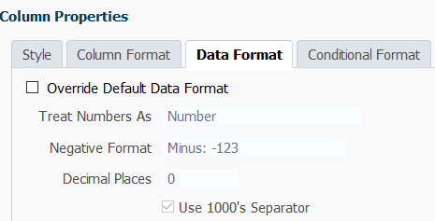

…to place a check in the box next to Override Default Data Format changing from Number to Percentage and selecting how many Decimal Places you prefer. Click on the OK button and Save the analysis.
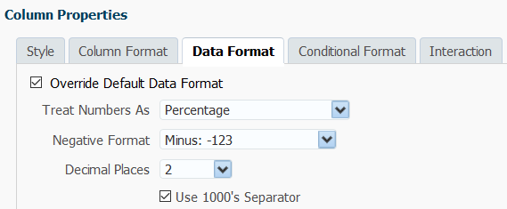

See the change…
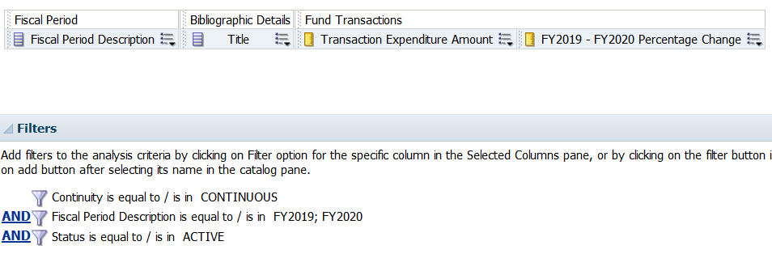

…and view the results. There is one more change we need to make so that we can view the percentages. In this case, we’ll edit the Layout by clicking on the Pencil Icon in the second row.
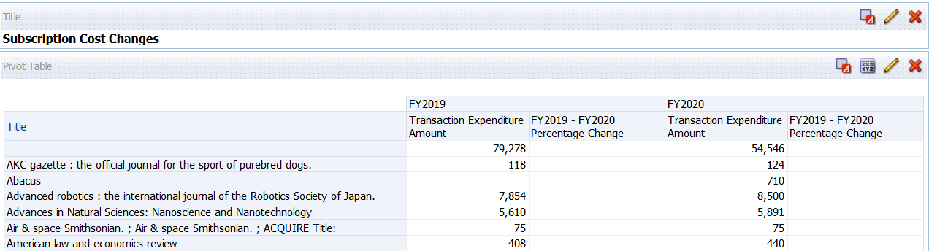

We’ll take the column, FY2019 – FY2020 Percentage…, from the Measures section…
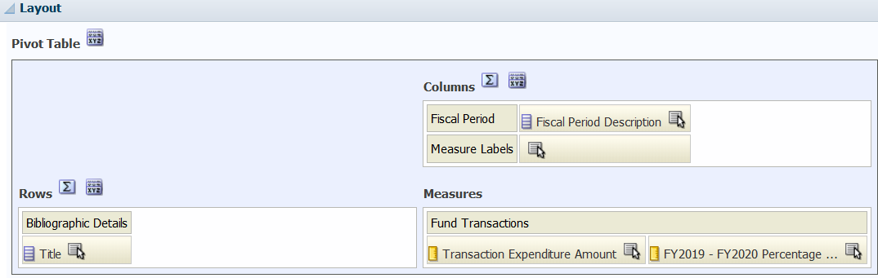

and move it next to the Title column in the Rows section. In the upper right corner, click on the Done button and Save the analysis.
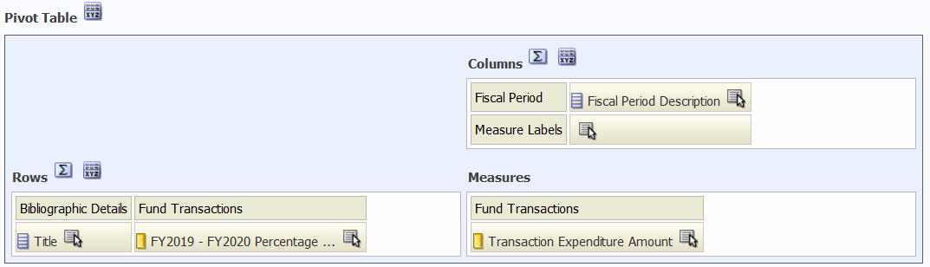

View the results.
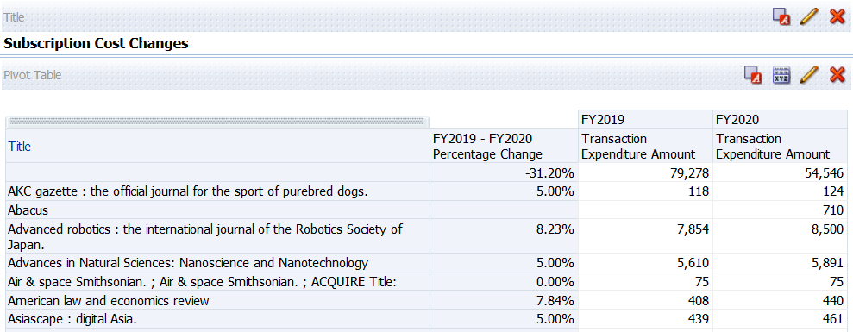

Electronic Resources Activated in the Past Month

Scenario:

- Library liaisons would like a monthly report of electronic resources newly added to the library’s collections

Using the E-Inventory Subject Area…
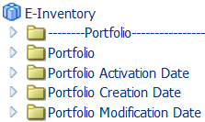

…add these columns.

View the results.
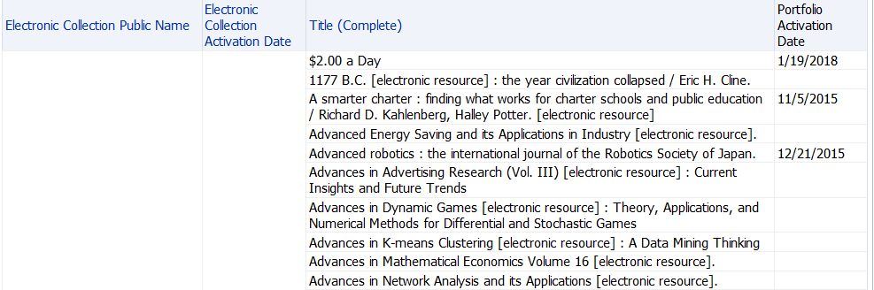

Save the analysis as Electronic Resources Activated in the Past 30 Days

Apply a filter to the Portfolio Activation Date column…
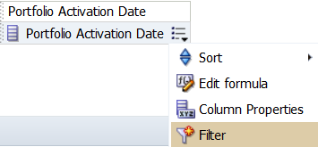

…for a date approximately one month ago and click on the OK button.
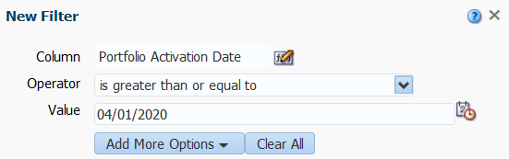

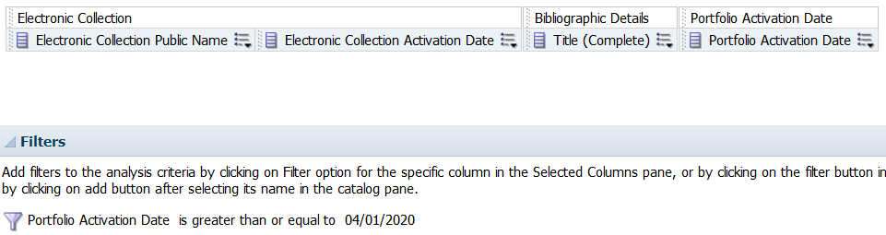

Save the analysis and view the results. By choosing the Portfolio Activation Date, we are also able to see results for portfolios that are not part of Electronic Collections.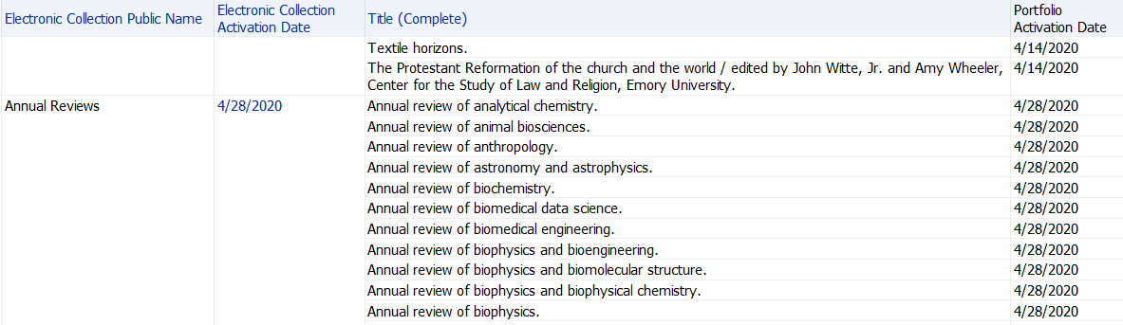
Return to the Criteria tab to edit the filter for Portfolio Activation Date…
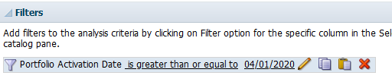

…and place a check in the box for Convert this filter to SQL and click on the OK button.
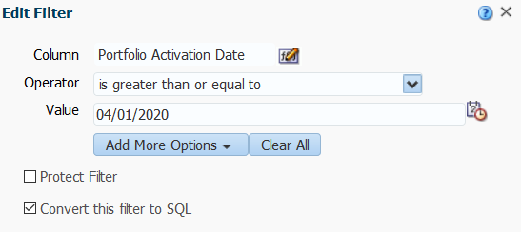

Modify the SQL Filter…
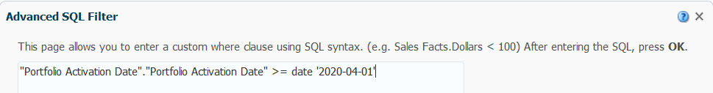

…to this TIMESTAMPADD statement and click on the OK button.
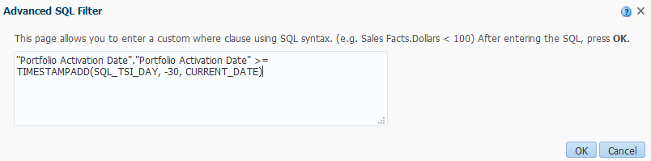

Another way to write the TIMESTAMPADD is "Portfolio Activation Date"."Portfolio Activation Date" >= TIMESTAMPADD(SQL_TSI_MONTH, -1, CURRENT_DATE)

This is how the back end of the analysis looks now.
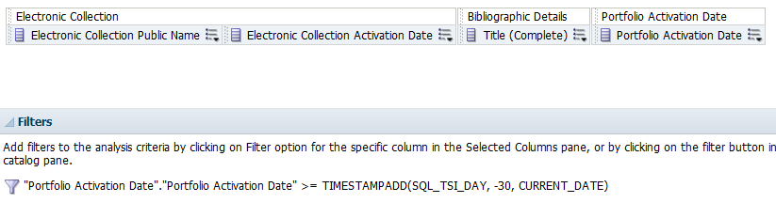

This is the SQL filter: "Portfolio Activation Date"."Portfolio Activation Date" BETWEEN TIMESTAMPADD(SQL_TSI_DAY, -30, CURRENT_DATE) AND CURRENT_DATE

Save the analysis and view the results.
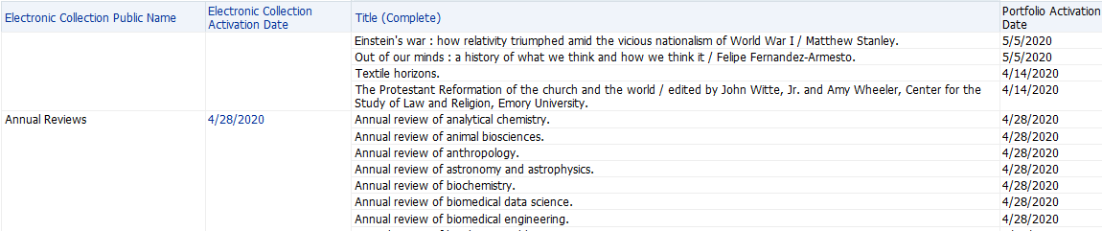

For more information on Date and Time functions, go to Date/Time Functions.

Physical Titles received in the past month

Scenario:

- Library liaisons would like a monthly report of physical titles newly added to the library’s collections
- Should not include journals

Using the Physical Items Subject Area…
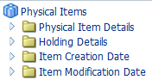

…add these columns…
…and view the results.
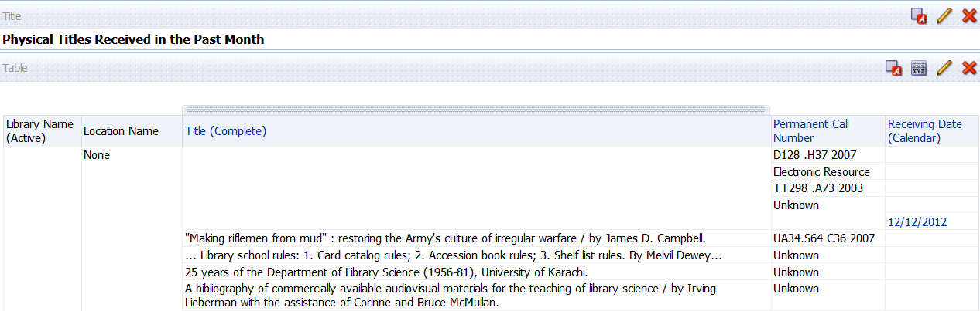

Save the analysis as Physical Titles Received in the Past Month.

Add another column for Material Type and a filter…
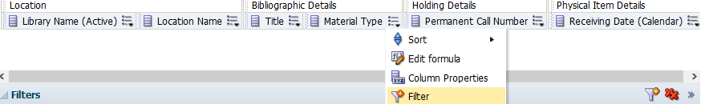

..to open Bibliographic Details…
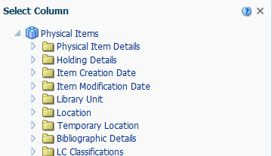

…and select Material Type and click on OK…
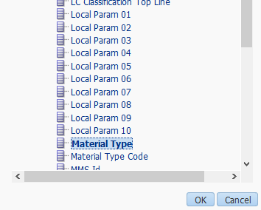

…to exclude Material Type = Journal from the results.
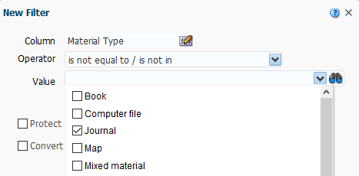

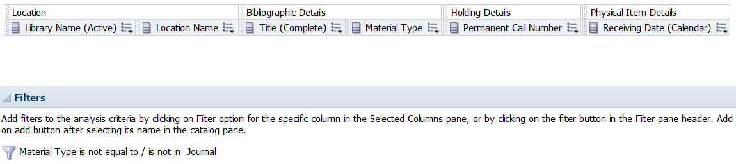

Save the analysis and view the results.
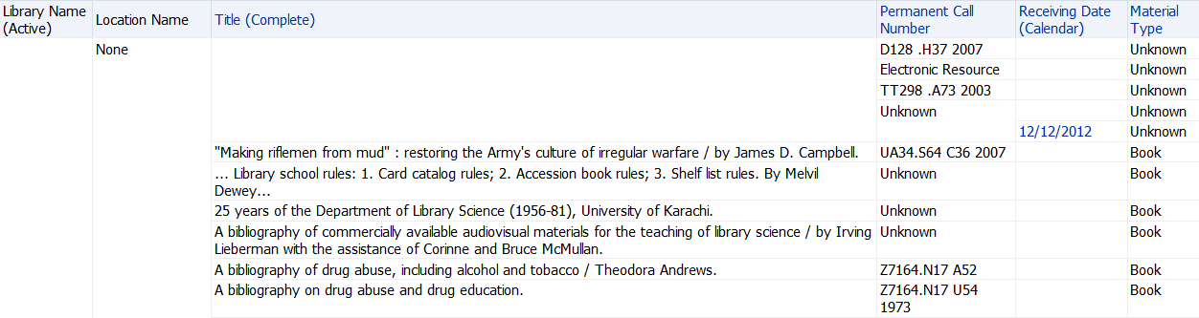

Apply a filter to the Receiving Date (Calendar) column…
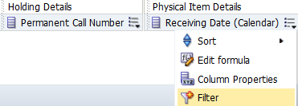

…filtering to is greater than or equal to a date in the past.
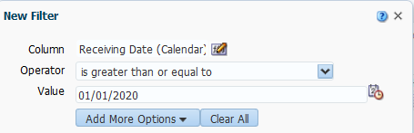

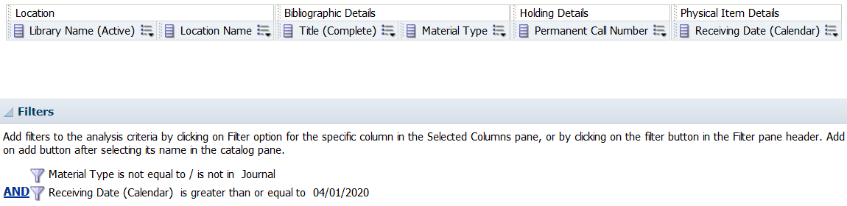

Save the analysis and view the results.
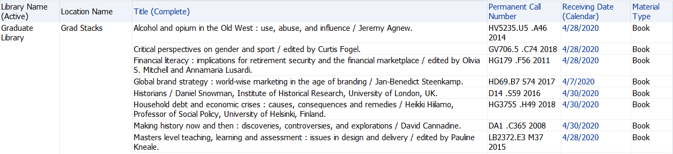

Return to the Criteria tab to edit the filter for Receiving Date (Calendar)…
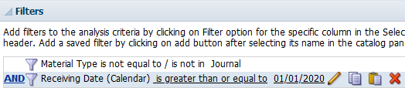

…and place a check in the box for Convert this filter to SQL and click on the OK button.
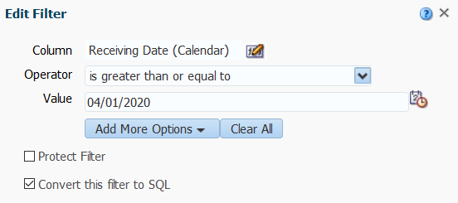

Modify the filter as displayed…
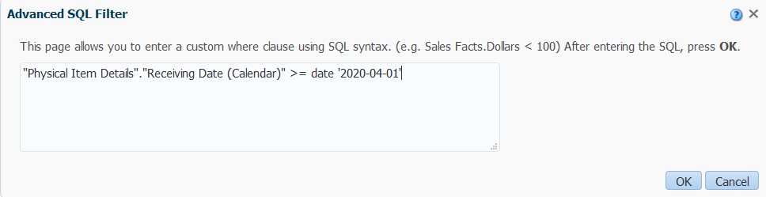

…to insert a TIMESTAMP.
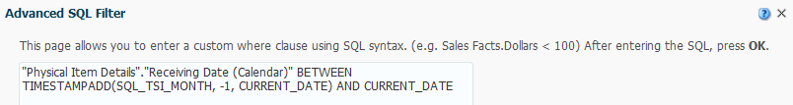

Another way to write the TIMESTAMP is "Physical Item Details"."Receiving Date (Calendar)" BETWEEN TIMESTAMPADD(SQL_TSI_DAY, -30, CURRENT_DATE) AND CURRENT_DATE.

This is how the back end of the analysis looks now.
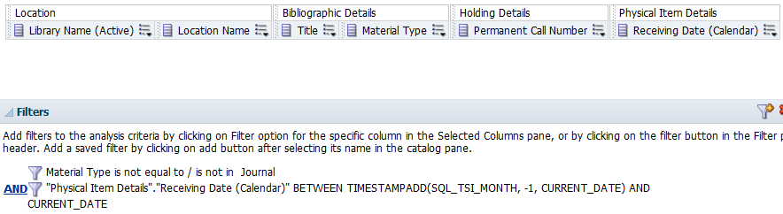

Save the analysis and view the results.
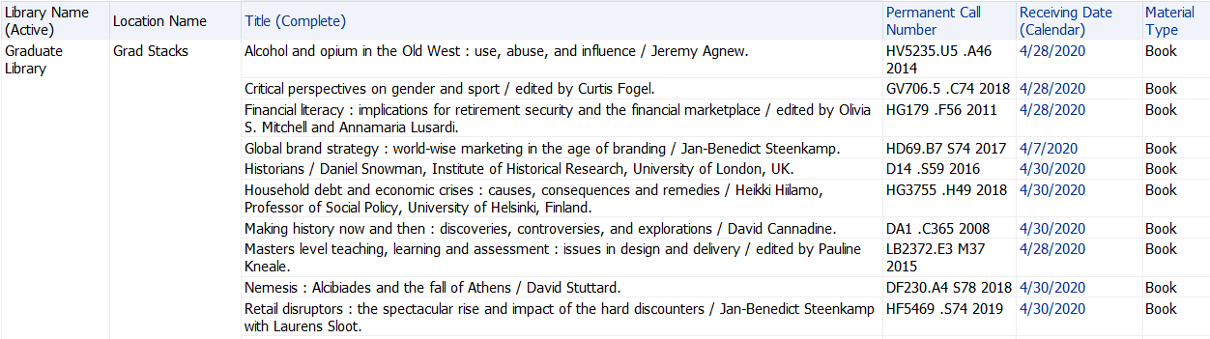

The analysis could be reorganized to obtain an alphabetical list, rather than organizing by library and location. To do so, move the Library Name (Active) and Location Name columns to the right of the Permanent Call Number column.
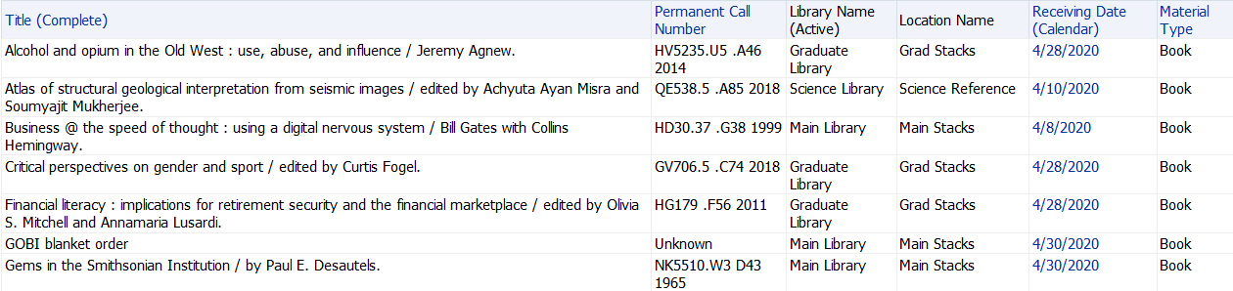

Bonus Analysis: Budget Summary

Scenario:

- Library director would like an overall budget summary that shows the original allocations of funds along with encumbrances and expenditures
- A nice addition would be a column showing balance remaining
- A further “nice-to-have” is showing percentage relationships between allocations and encumbrances and/or allocations and expenditures

Using the Funds Expenditure subject area…
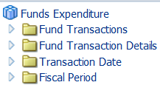

…add these columns…

…and apply a filter for Fiscal Period Description.
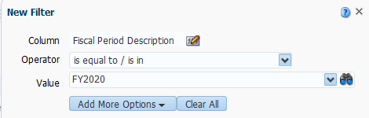

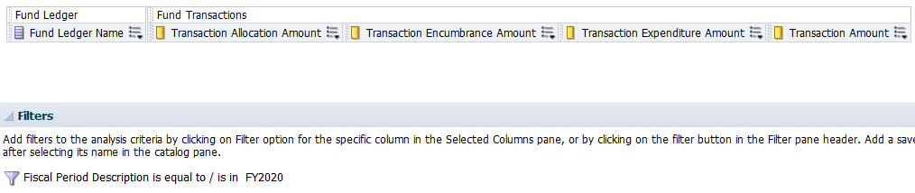

Save the analysis as Budget Summary 2020.

To maximize the real estate for the analysis, let’s edit the Column Properties for the measures columns to rename them.
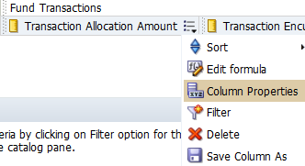

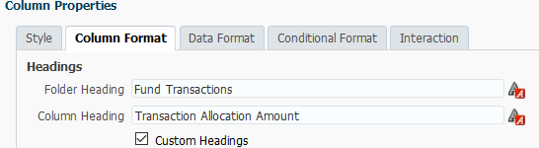

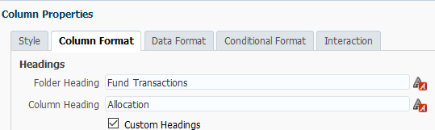

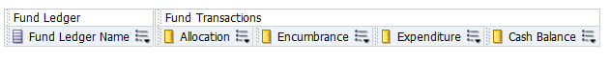

View the initial results. You can see from the results that we are seeing data for Ledgers, Summary and Allocated funds.
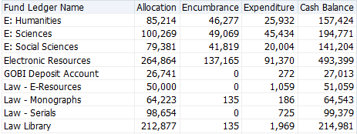

Transactions are performed again Allocated funds only, so let’s return to the Criteria tab to apply a filter limiting what we’re looking at to Allocated funds. Using the Funnel located at the right, choose More Columns…
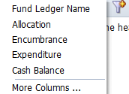

…and select Fund Type from the Fund Ledger folder and click on the OK button…
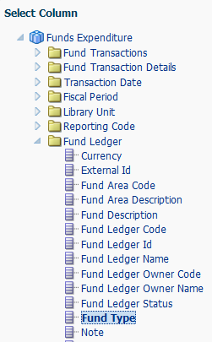

…to select Allocated fund from the available values.
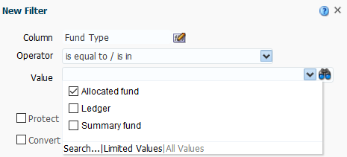

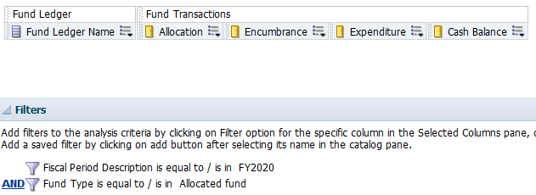

Save the analysis and view the results.
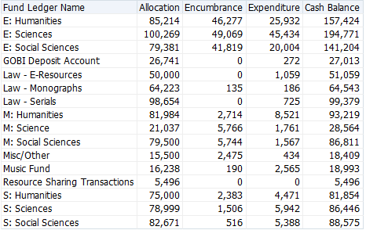

We need to work on the Cash Balance column so that the math will be performed correctly and display an accurate balance. Return to the Criteria tab to edit the formula for the Cash Balance column.
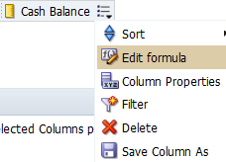

Delete the column information that displays…
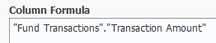

…replacing with
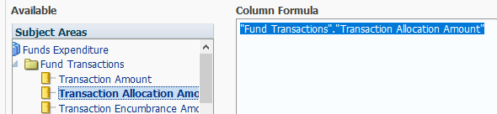

Insert a minus (-) sign and left parentheses ( before adding Transaction Encumbrance Amount
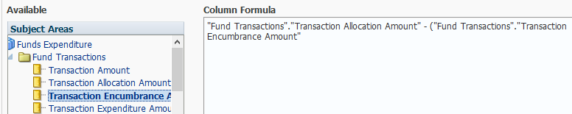

Insert a plus (+) before adding Transaction Expenditure Amount and a right parentheses )
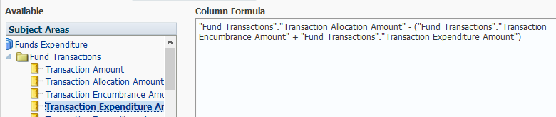

Click on the OK button and save the analysis before viewing the results.
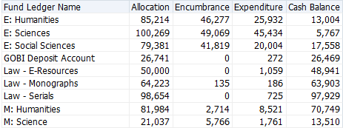

In this report, we are seeing rounded dollar values. For those who prefer to see actual dollar values, we can edit the Column Properties to display that detail.
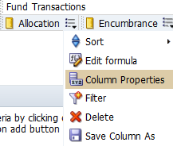

Go to the Data Format tab to override the default data format…
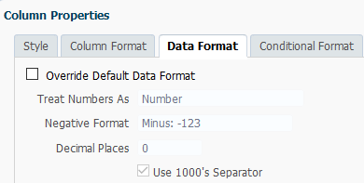

…changing it to treat numbers as Currency, including a currency symbol (if preferred) and so on.
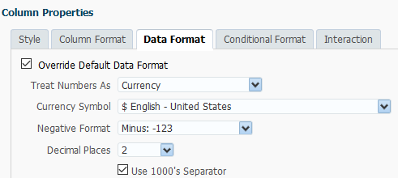

Perform this change for each measures column. Save the analysis and review the results.
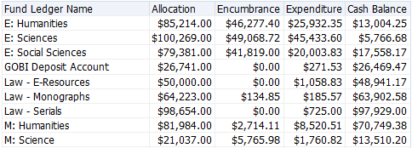

Then, to get to percentages, we have several steps to complete. Begin by adding the Transaction Amount column to the analysis and opening the Column Properties…
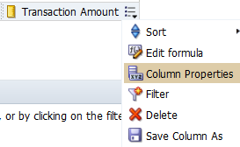

…to customize the Column Heading…
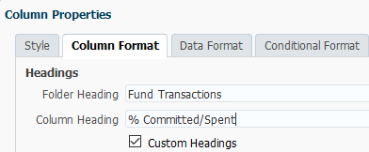

…and Override Default Data Format, treating the numbers as Percentage and selecting 2 decimal places. Click on the OK button and save the analysis.
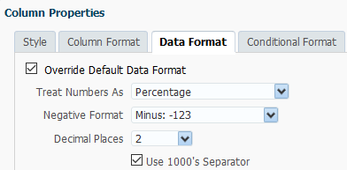

To obtain the percentage, we will Edit formula for the % Committed/Spent column.
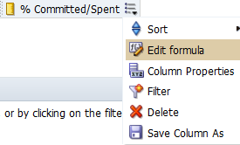

With the column formula, “Fund Transactions”.”Transaction Amount” selected, click on the Filter button at the bottom.
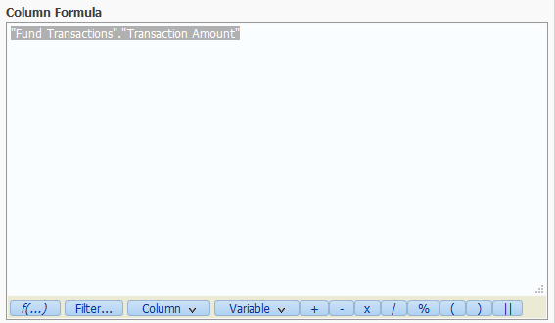

Open the Fund Transaction Details folder and double-click on Transaction Item Type…
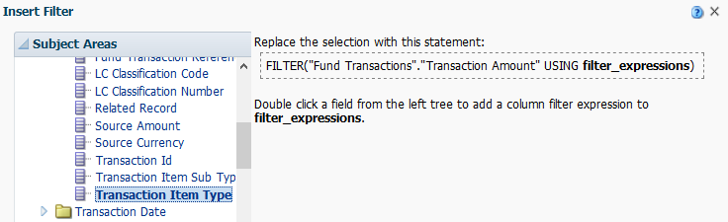

…and select Encumbrance and Expenditure from the values available in the drop-down and click on the OK button, twice.
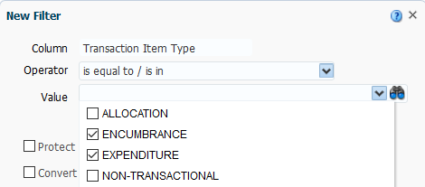
To this information, we add a divide by (/) symbol...
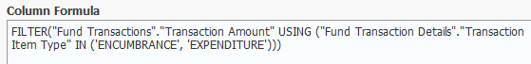

…and include the column, “Fund Transactions”.”Transaction Amount”. With this entry selected, click on the Filter button…
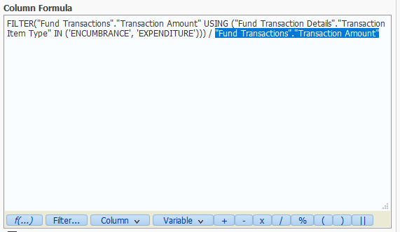

…and open the Fund Transaction Details folder and double-click on Transaction Item Type…
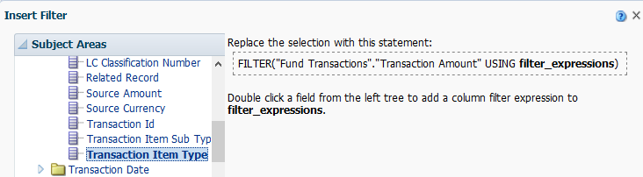

…selecting Allocation from the values in the drop-down list.
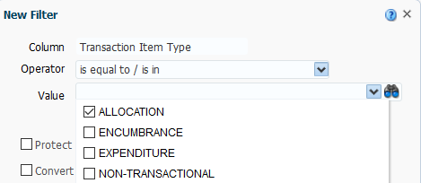

Click on the OK button twice to view the formula.
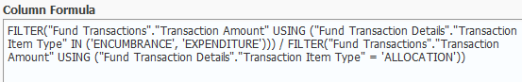

To complete the formula, we’ll add X 100 at the end. Click on the OK button and save the analysis.
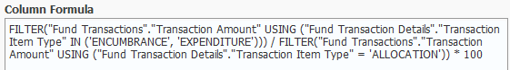

This is the final formula: FILTER("Fund Transactions"."Transaction Amount" USING ("Fund Transaction Details"."Transaction Item Type" IN ('ENCUMBRANCE', 'EXPENDITURE'))) / FILTER("Fund Transactions"."Transaction Amount" USING ("Fund Transaction Details"."Transaction Item Type" = 'ALLOCATION')) * 100

Review the results.
