Getting to Know Alma: Users

- Log into Alma with the AlmaAdmin user | 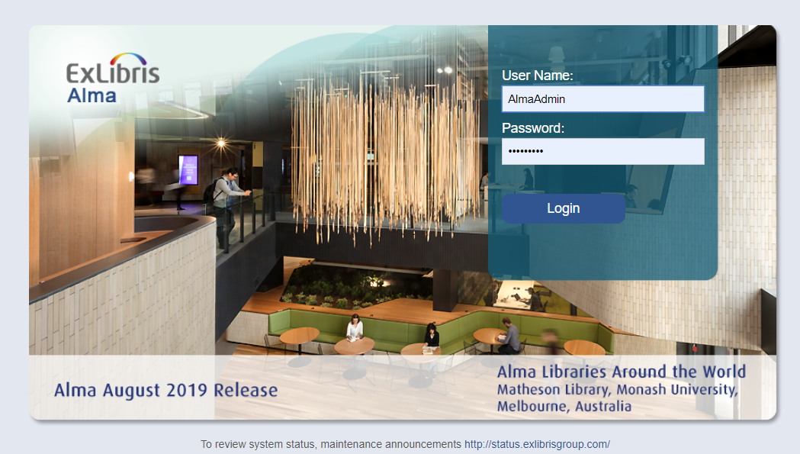
- Go to Admin > User Management > Manage Users | 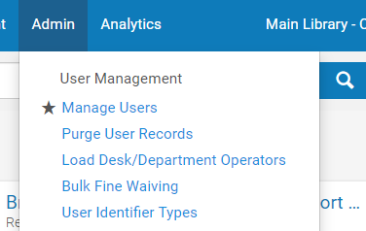
- Click on the “Staff” tab | 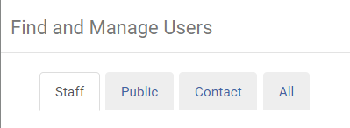
- Select an Internal User  - Click on the ellipses icon at the right  - Select Edit | 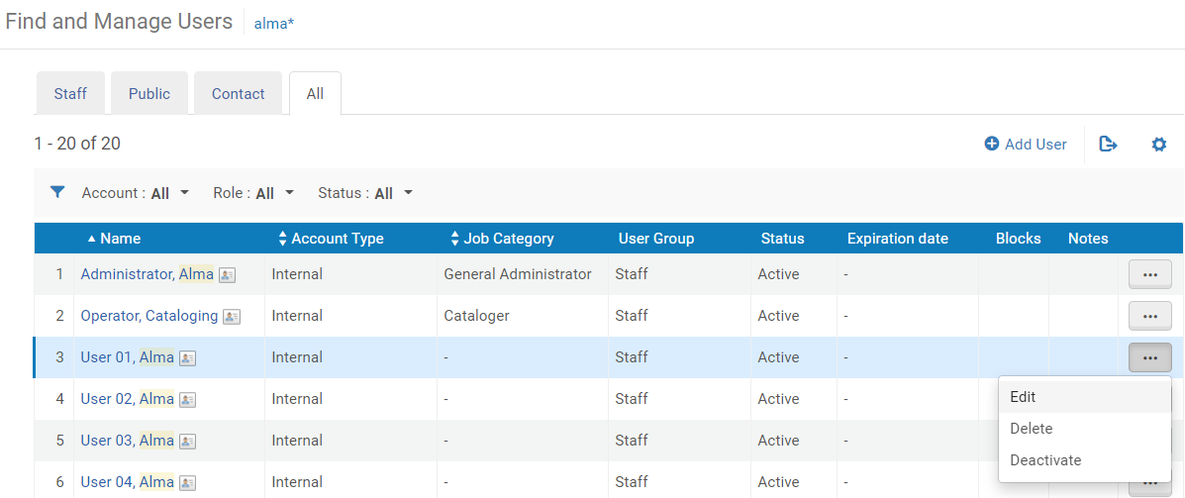
- Examine the User Details. | 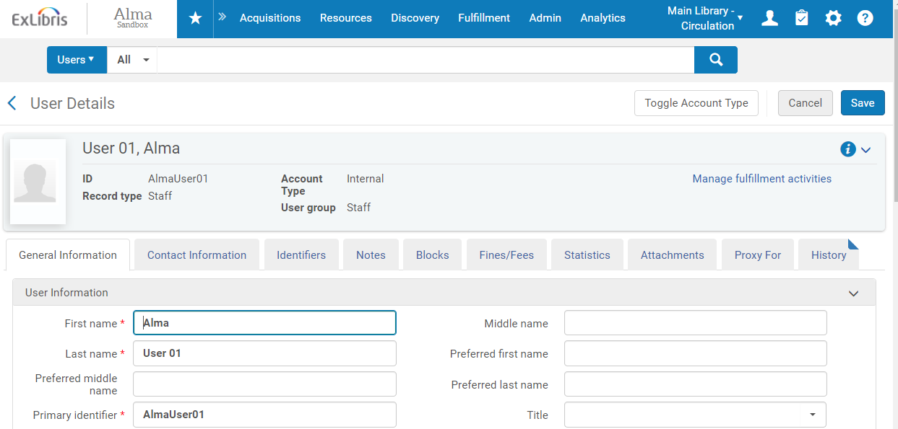
- Scroll down and examine the User Roles | 