Getting to Know Alma: User Roles and Profiles

- Log into Alma with the AlmaAdmin user | 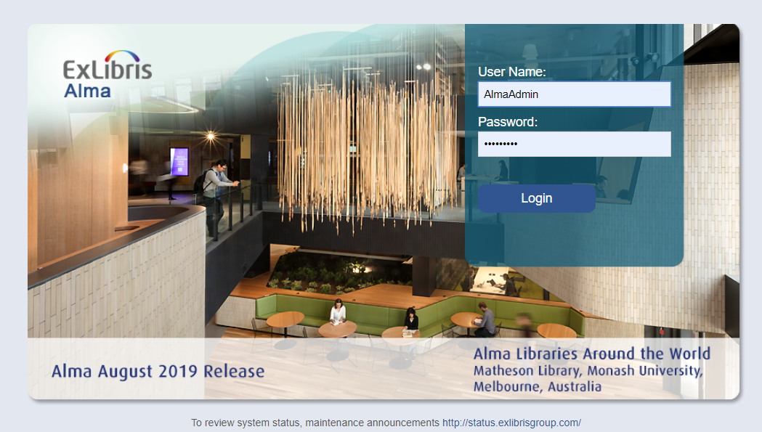
- Go to Alma Configuration (click on the gear icon) | 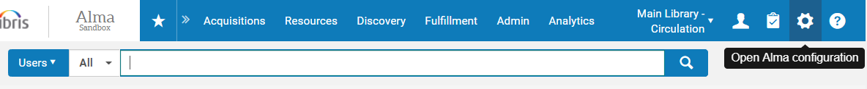
- Go to User Management > Roles and Registration > Profiles | 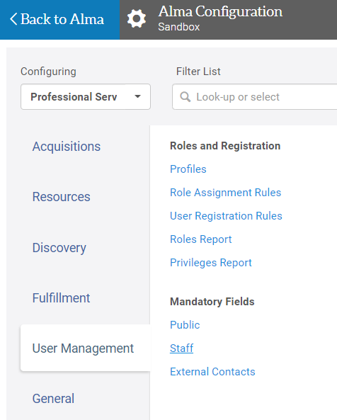
- Mouse over the “Included Roles” column.  - Note that you can see the full list of roles that are included in each profile.  - Click on the Back arrow to go back to the Configuration Menu | 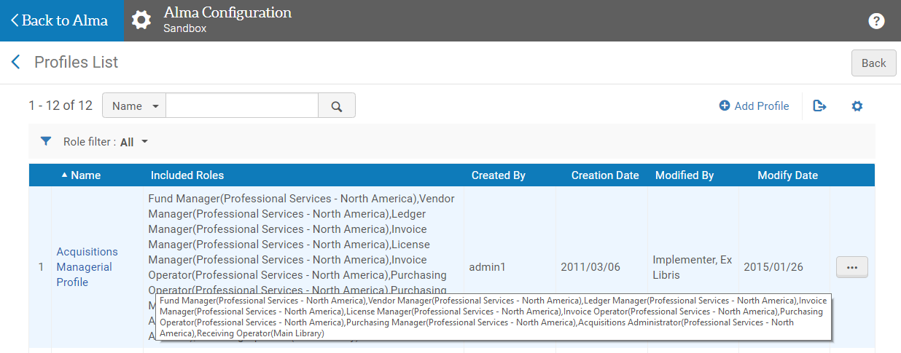
- Go to User Management > Roles and Registration > Role Assignment Rules
- Click on the ellipses icon on one of the rules to see the actions available  - Click on “Edit” | 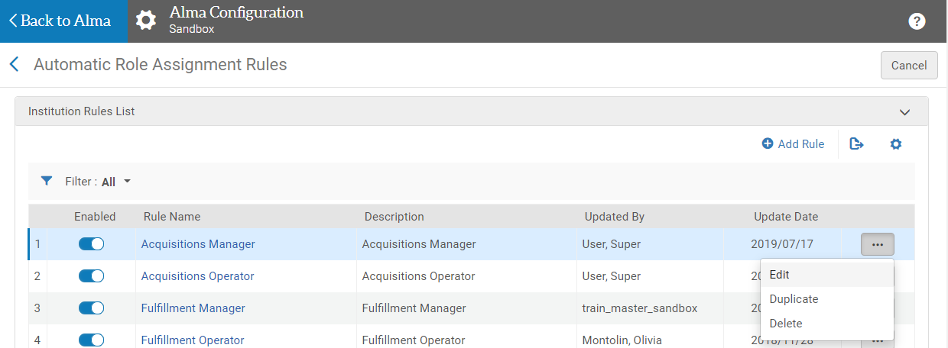
- Note that the way the rule is written, when the Job Category is set to a specific value, a previously configured profile will be assigned to the user.  - Go Back to Alma | 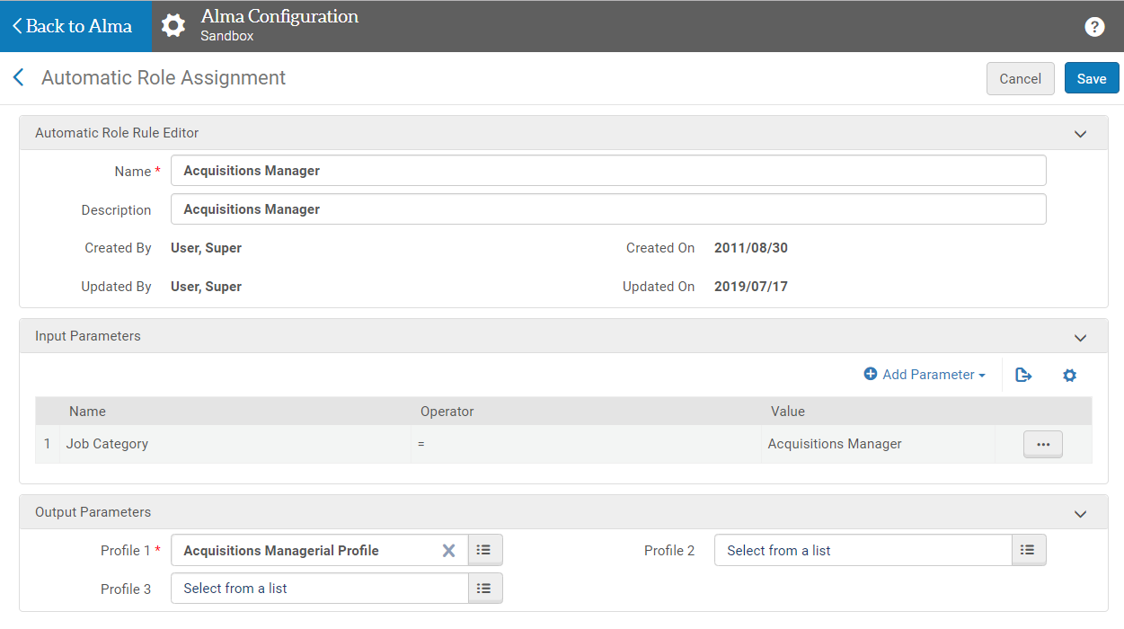
- Sign out of Alma by clicking on the person icon in the Alma Main Menu, then selecting “Sign Out” | 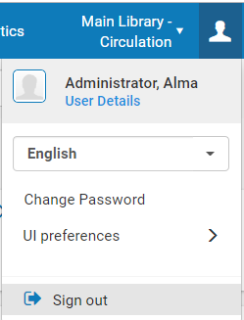
- Log in with the AlmaUser01 user | 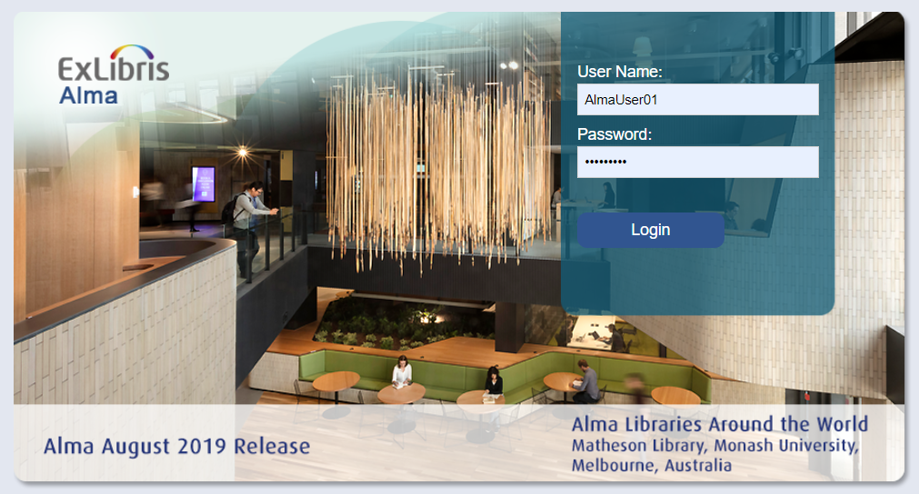
- Note that the functional areas in the Main Menu may be slightly different
- Also note that the default location is different
- Click on the Alma Configuration gear icon
- Note that there are no configuration options available to this user  - Go Back to Alma | 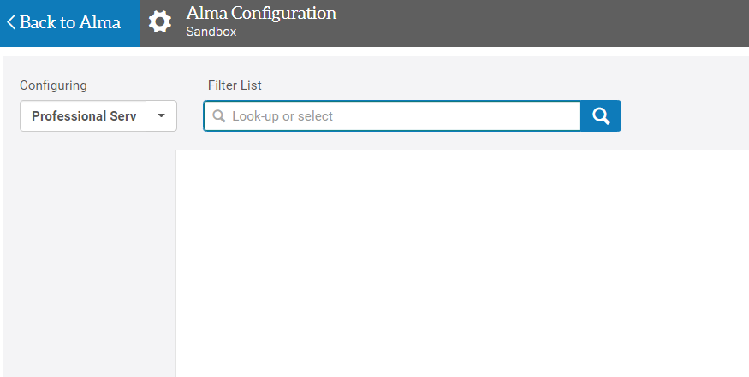
- Sign out of Alma by clicking on the person icon in the Alma Main Menu, then selecting “Sign Out” | 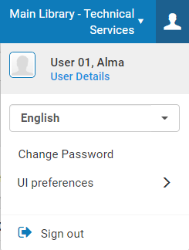
- Log back into Alma using the Alma Cataloging Operator | 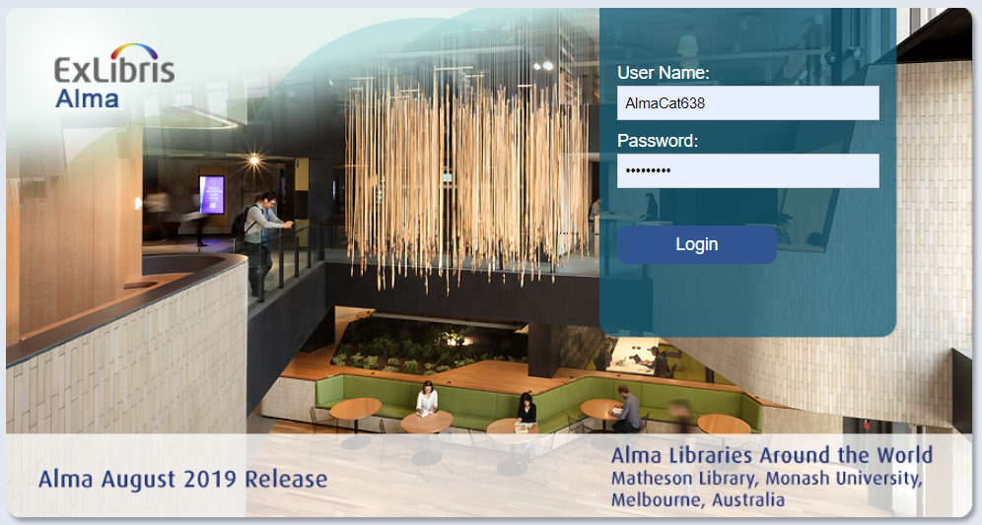
- Note that the functions in the Main Menu are even more limited for this user. | 