Getting to Know Alma: Purchasing Physical and Electronic Items

Purchasing a Physical Item (Book)
- Log into Alma with the AlmaUser01 user | 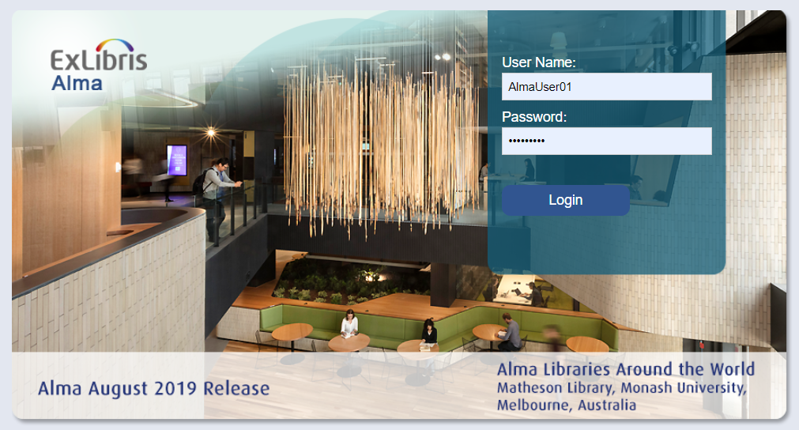
- Conduct a search for physical title (e.g. Wildflowers of North America).  - From the row actions list of the title in the results, select “Order” | 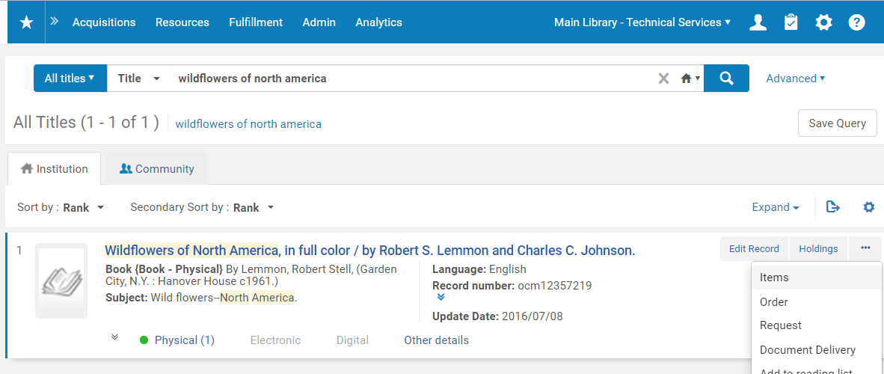
- In the PO Line Owner and Type screen, set the PO Line type = “Print Book – One Time”  - Set the PO Line Owner = “Main Library”  - Click “Create PO Line” | 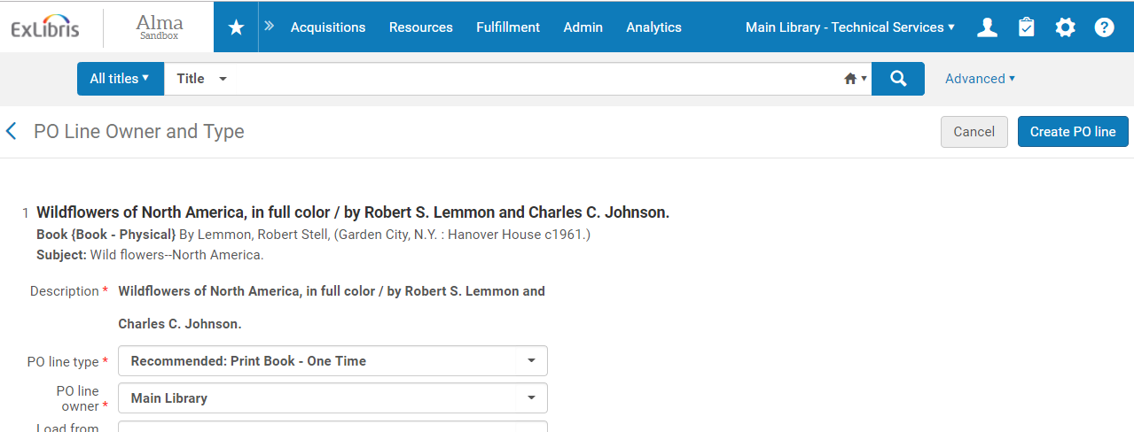
- Note that the Confirmation Message will say that the item already exists in the inventory  - Click Confirm to continue making the PO Line. | 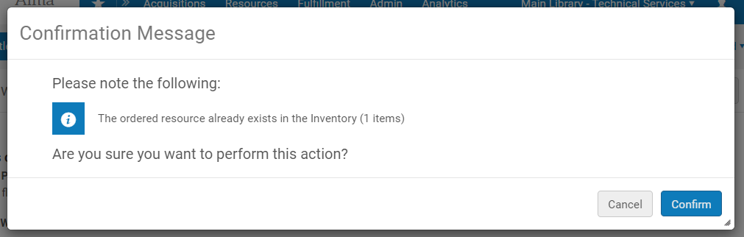
- In the Vendor information section, select a Material Supplier (e.g. Coutts Information Services)  - Fill in the List Price  - Keep Quantity for pricing set to 1 | 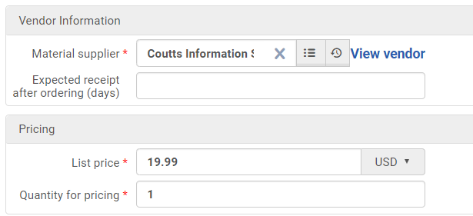
- In the Funding section, Select + Add Fund  - Select a Fund (e.g. Mock Print Fund)  - Click the Add Fund button | 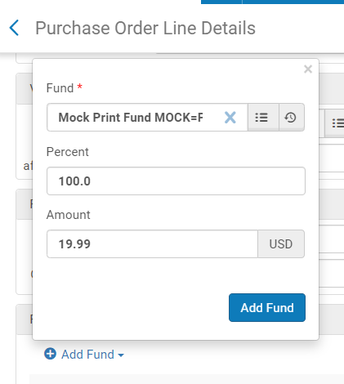
- In the PO Line Details section, set the Acquisition method = Purchase at Vendor System  - Assign the Reporting code, secondary reporting code, and tertiary reporting codes as you like. | 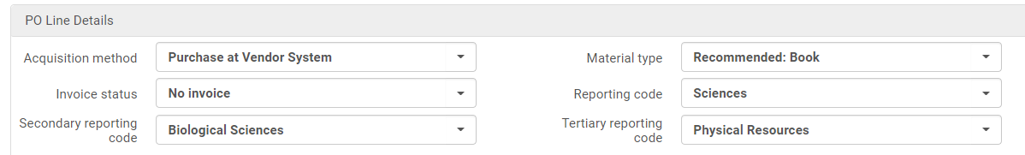
- Click the “Order Now” button | 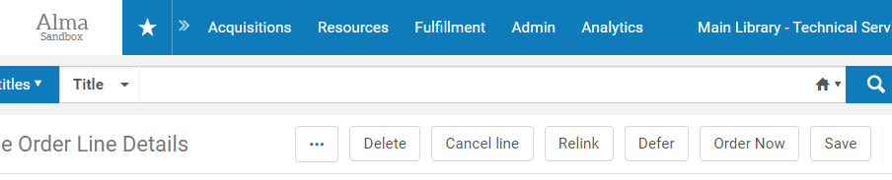
- Click Confirm to send the PO line and create the purchase order. | 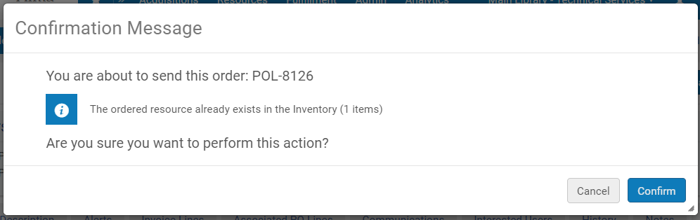
- Search for the title in the Order lines.
- Note that the PO Line and the PO have been assigned identifiers and that they are both “Sent” | 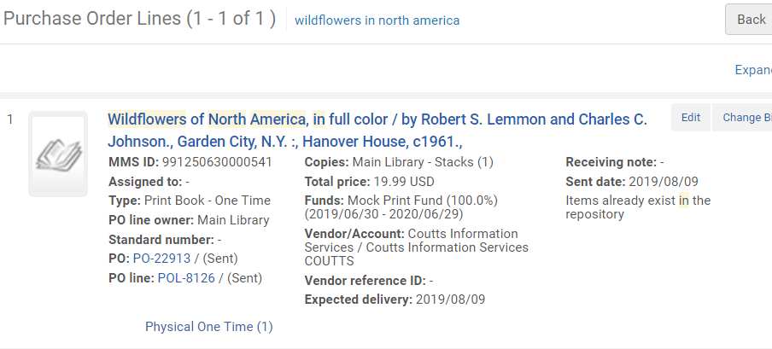
Purchasing an Electronic Collection
- Conduct a search for “ProQuest Historical Newspapers” in Electronic Collections in the Community Zone | 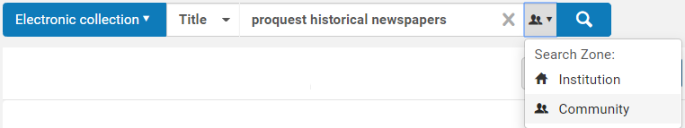
- Choose one of the electronic collections that does not have the institution icon (i.e. the collection is not part of your local inventory).  - In the row actions list, select “Order” | 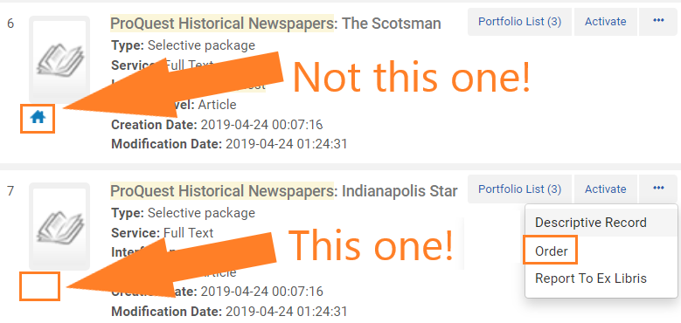
- In the PO Line Owner and Type screen, set the PO Line type = “Electronic Collection - Subscription”  - Set the PO Line Owner = “Main Library”  - Click “Create PO Line” | 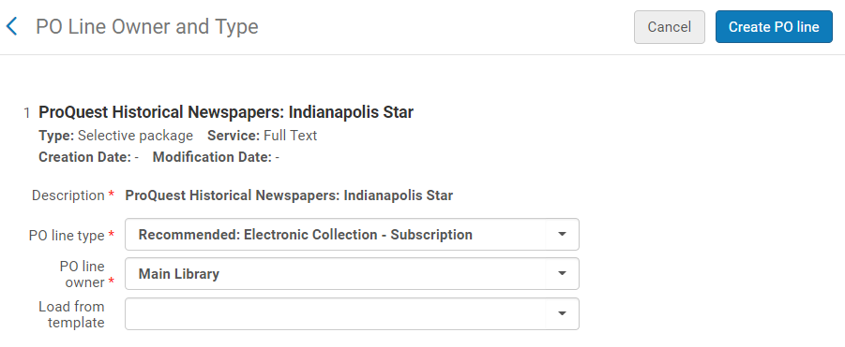
- In the PO Line Details screen in the Ordered Items section, select “ProQuest” for the License, Material Supplier, and Access Provider. | 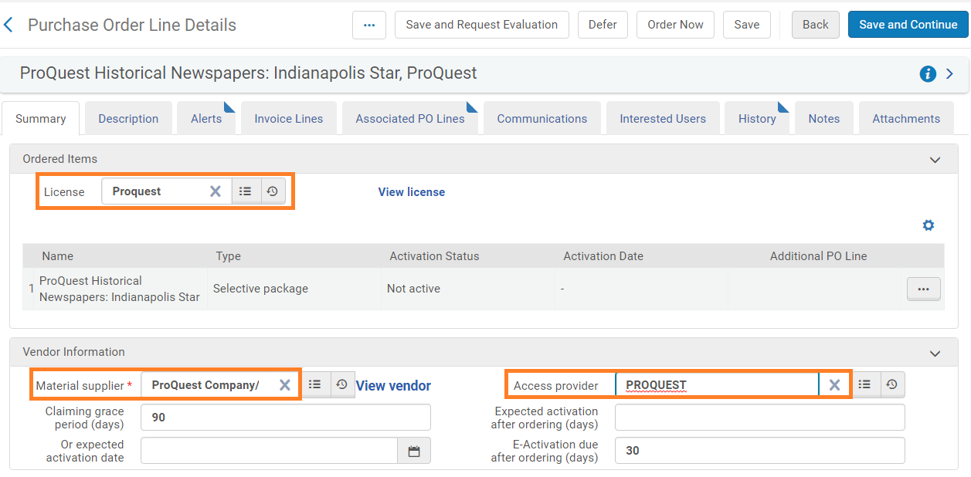
- In the Pricing section, enter in a List Price and keep the Quantity for pricing set to 1.  - In the Funding section, Add a Fund to cover the cost of the electronic collection | 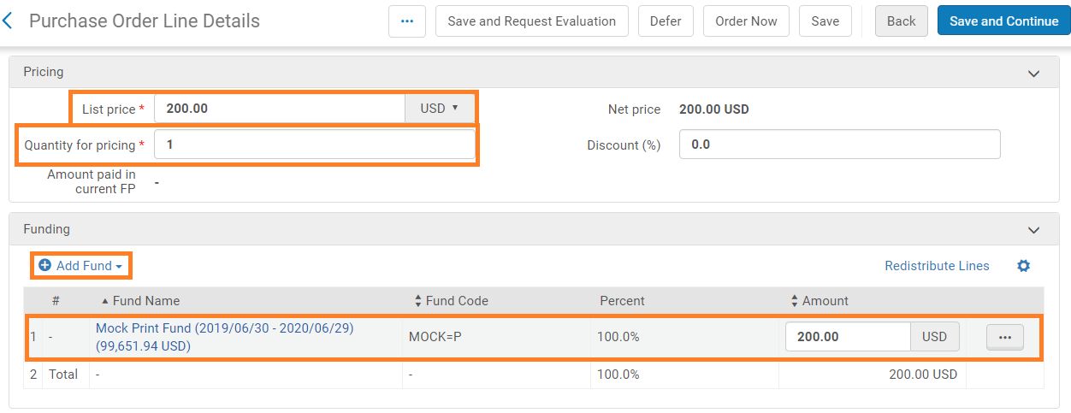
- In the PO Line Details, set the Acquisition Method = Purchase at Vendor System  - Assign Reporting Codes as you like. | 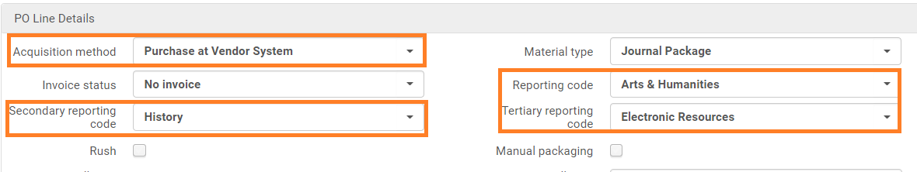
- In the Renewal section, set the Renewal date to a date in the future (i.e. a year from now)  - Set the Renewal reminder period to 30 days  - Click “Order Now” | 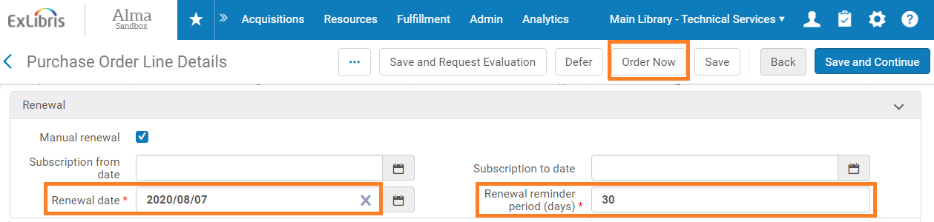
- Click Confirm to place the order and create the purchase order. | 