Getting to Know Alma: Receiving a Physical Item

Note: You will need to download and complete the instructions in the handout in the last session Purchasing Physical and Electronic Items before proceeding with this exercise.

- Log into Alma with the AlmaUser01 user | 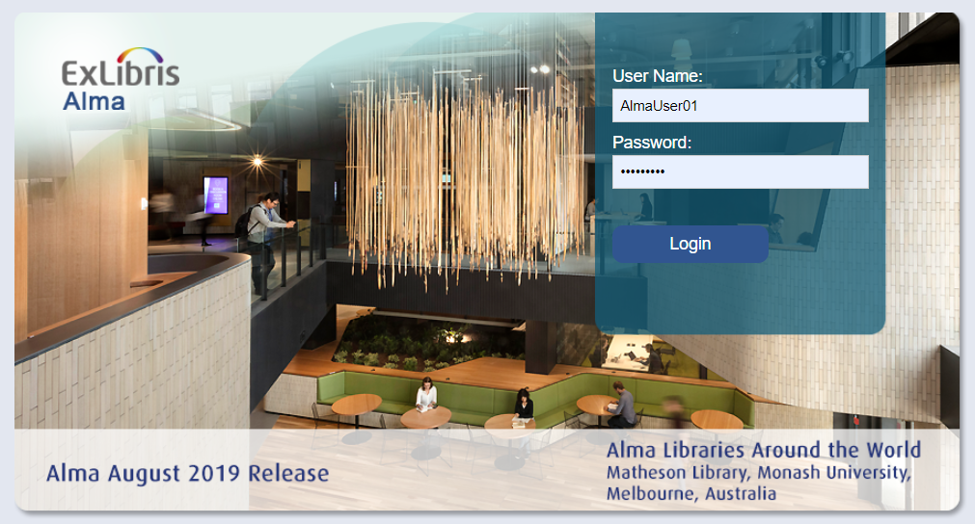
- Ensure that the Location is set to “Main Library – Technical Services” | 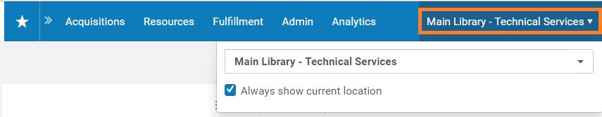
- Go to Acquisitions > Receiving and Invoicing and click on the “Receive” link. | 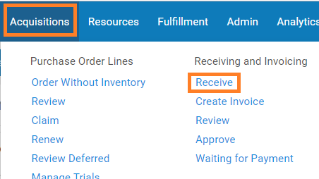
- Search for the physical item you ordered in the Purchasing Physical and Electronic Items exercise. (e.g. Wildflowers in North America)  - Keep the Received Date set to today  - In the results list, view the row actions list for the title and select “Receive” | 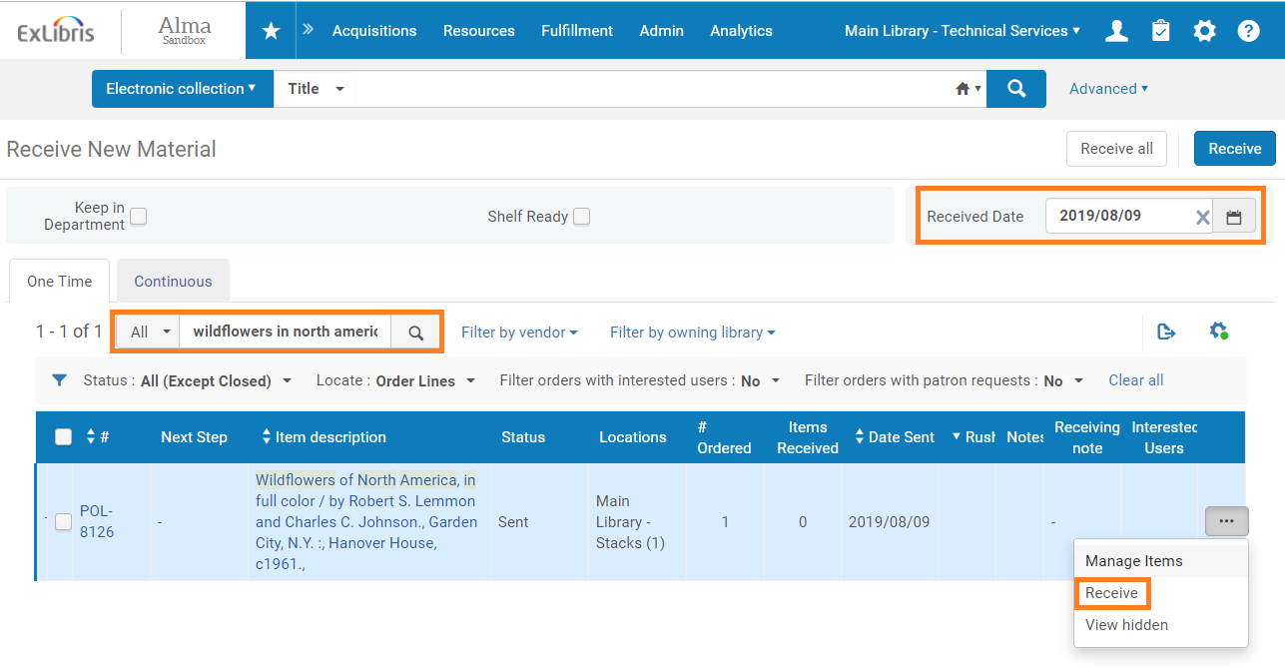
- Search for the title in Order Lines  - Note that the title now shows that the PO has been “Sent”, and the PO Line is “Waiting for Invoice” | 