Getting to Know Alma: Editing Bibliographic Records

- Log into Alma with the AlmaAdmin or the CatAdmin user (the user will need to have cataloging privileges) | 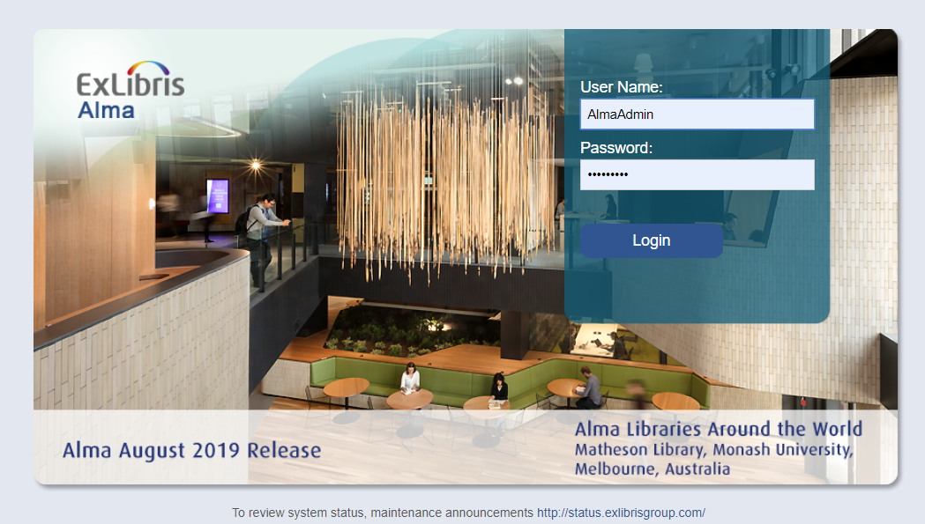
- Conduct an All Titles > Keywords search for the title “Rockets, satellites, and probes”  - Click “Edit Record” | 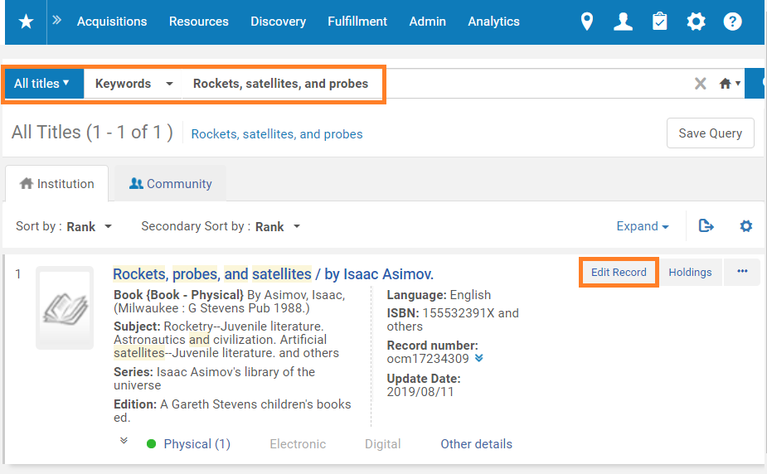
- In the MD Editor, note that the bottom frame contains several alerts for missing data in the 008 field.  - Click on the 008 field to select it. | 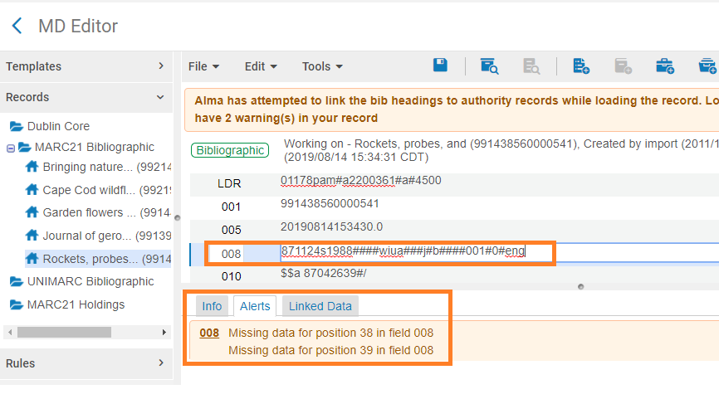
- Go to Edit > Open Form Editor or click Ctrl+F | 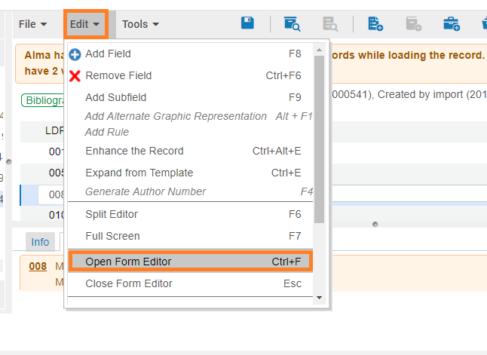
- In the Form Editor, select values to fill in for the 38 and 39 positions.  - Hit ESC to close the Form Editor. | 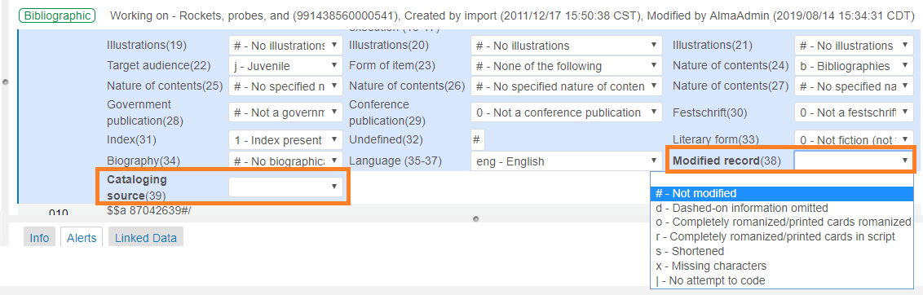
- Now let’s add a 650 field.  Click on one of the 650 fields | 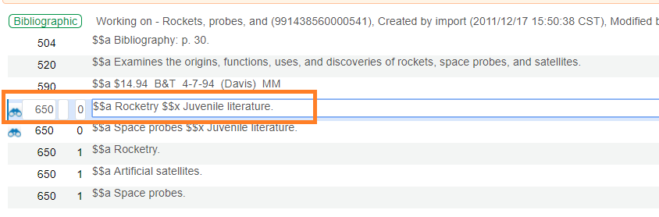
- Go to Edit  - Select Add Field | 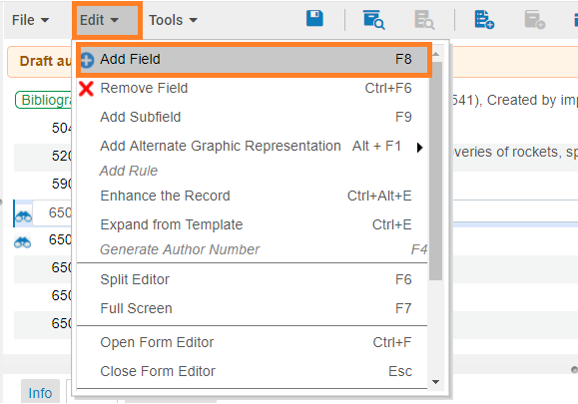
- Type 650 for the field number  - Type 0 in the second indicator field  - Type space, then hit F3 | 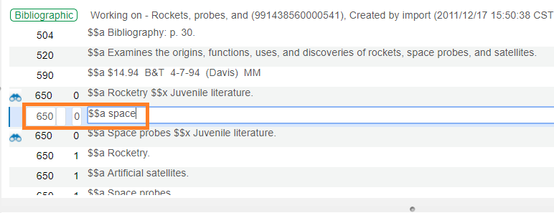
- This opens the Library of Congress subject headings list. Select “Space age” | 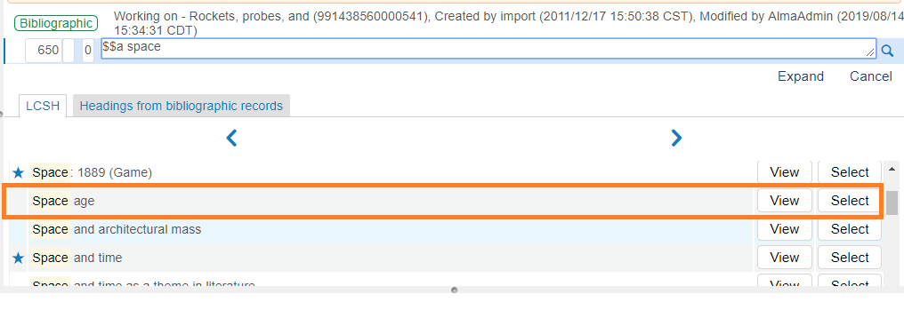
- Note that the new field now reads “Astronautics and civilization” because “Space age” is not an authoritative term. | 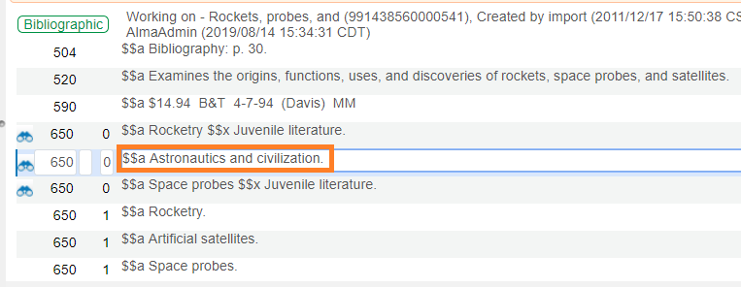
- Go to File  - Select “Save and Release Record” | 