Getting to Know Alma: Activating Electronic Collections

- Log into Alma with the AlmaAdmin or the CatAdmin user (the user will need to have cataloging privileges) | 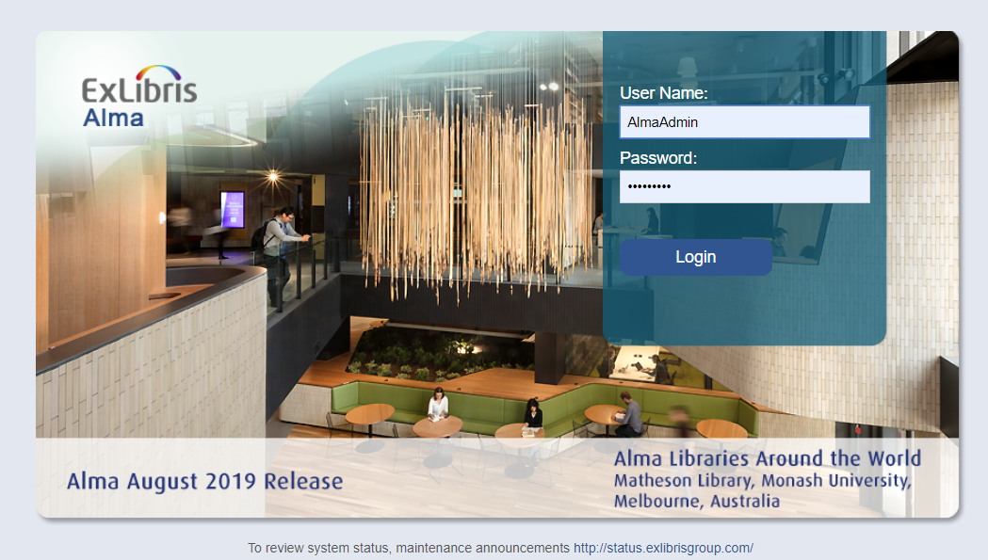
- Search for Electronic Collection > Title > “Alexander Street Press Human Rights Studies Online Text” in the Community Zone.  - In the Results list, click “Activate” | 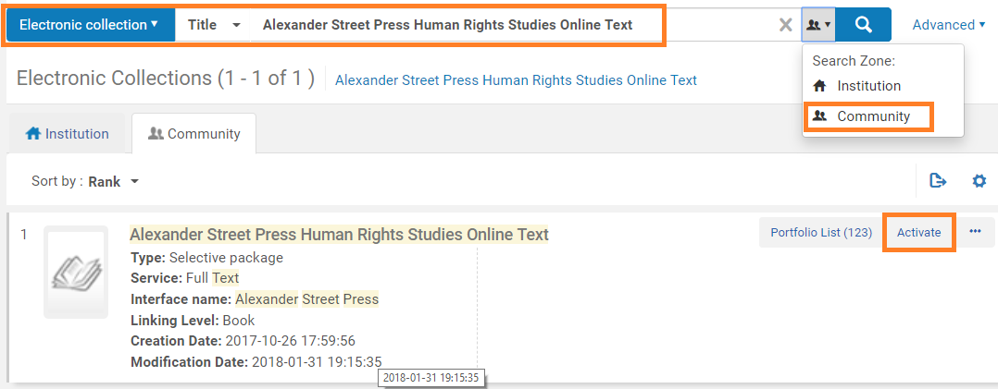
- In the Activation Wizard, under Full Text Service, check the “Activate this electronic collection service”  - Click “Next” | 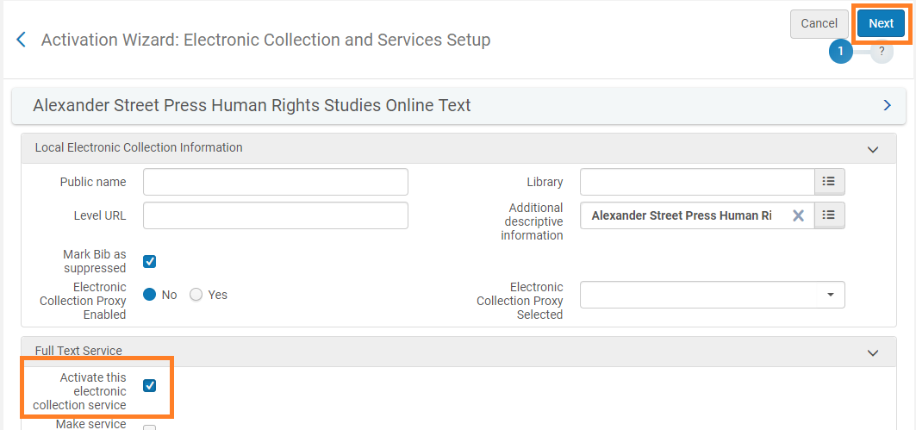
- In the second step, click “Next” | 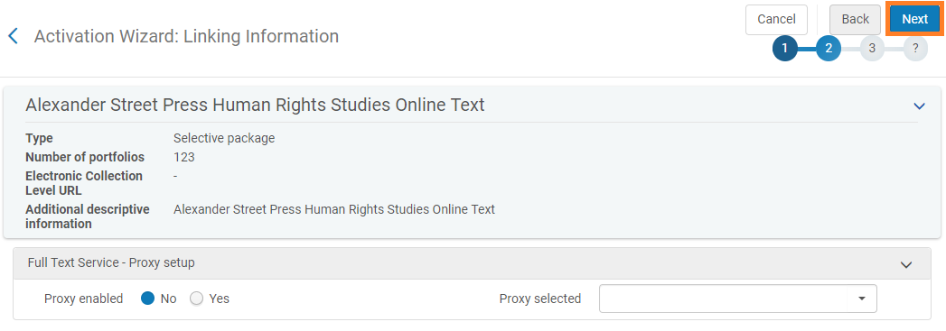
- In the third step, keep the Activation Type set to “Activate All”  - Click “Next” | 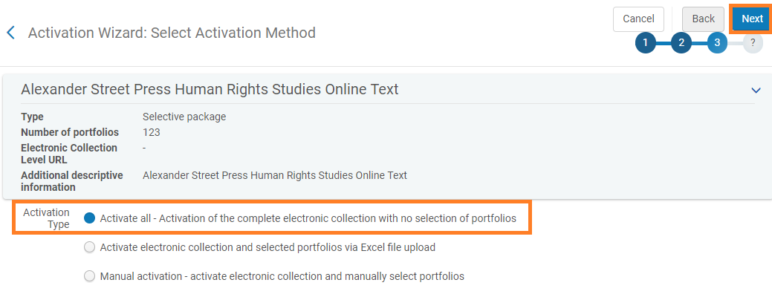
- In the fourth step, click “Activate” | 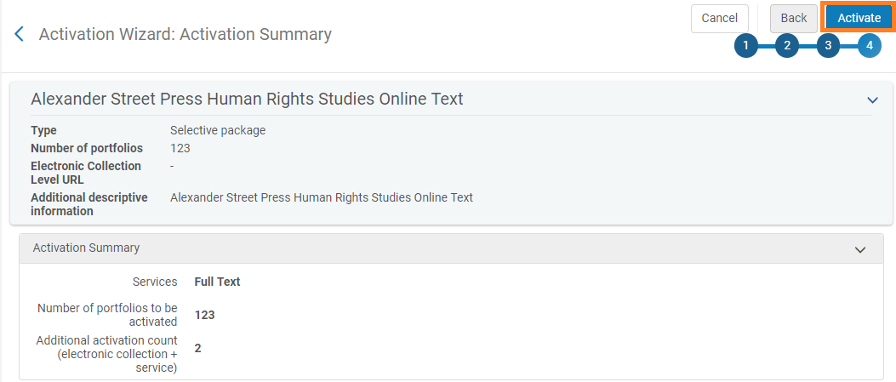
- Go to Admin > Monitor Jobs | 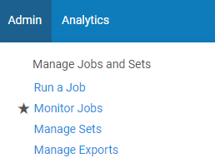
- Monitor the job on the “Running” tab until it disappears.  - Go to the “History” tab and confirm the job ran successfully. | 