Getting to Know Alma: Adding Bibliographic Records

- Log into Alma with the AlmaAdmin or the CatAdmin user (the user will need to have cataloging privileges) | 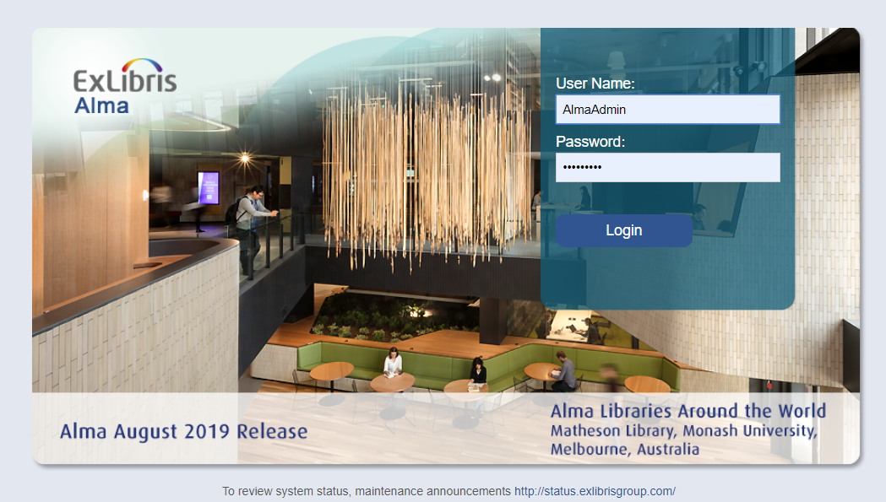
- Go to Resources > Search External Resources | 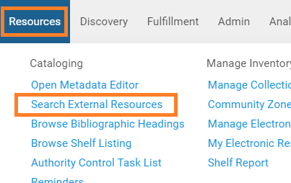
- Select Library of Congress from the dropdown | 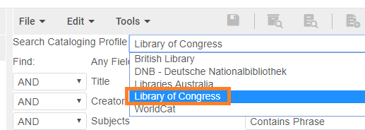
- Search LOC for a resource that is not currently in the sandbox’s local catalog (e.g. 1584653191, 0878423370) | 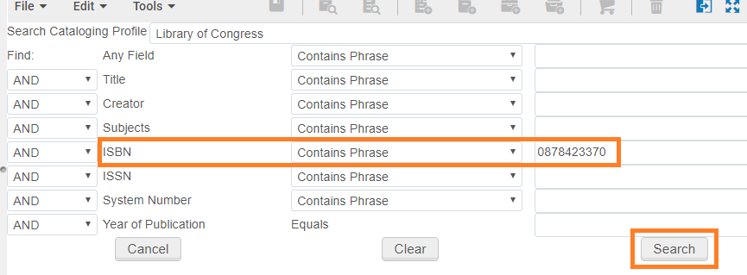
- Select “Import” | 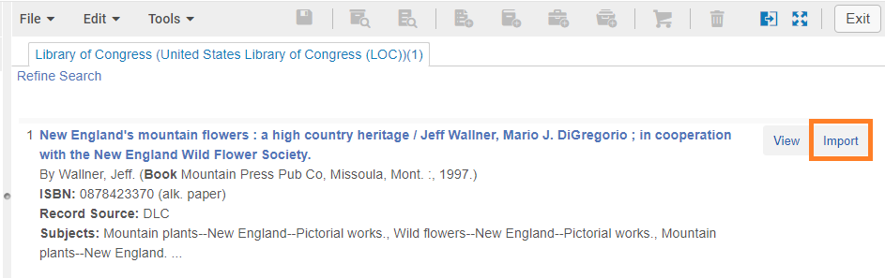
- In the Form Editor, go to File > Save Record | 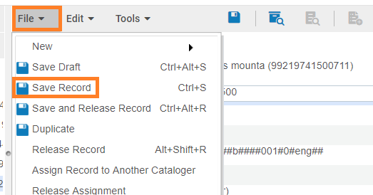
- Select the “Add holdings record” icon | 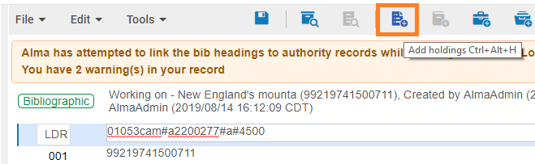
Optional Steps  - Click on the 852 field  - Click Ctrl +F to open the Form editor  - Adjust the Sublocation and Shelving Locations if you like.  - Hit ESC to close the Form editor. | 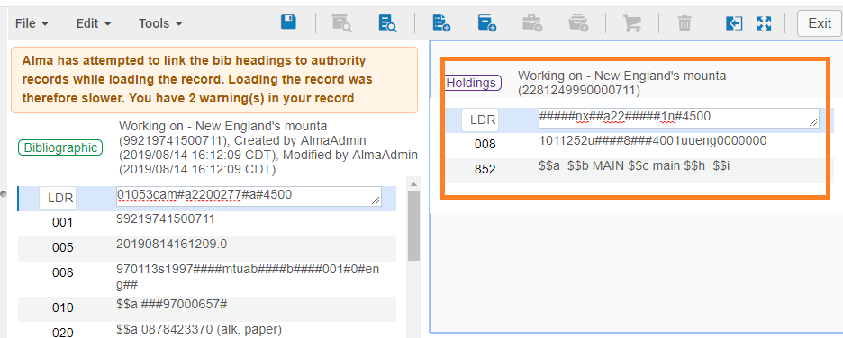  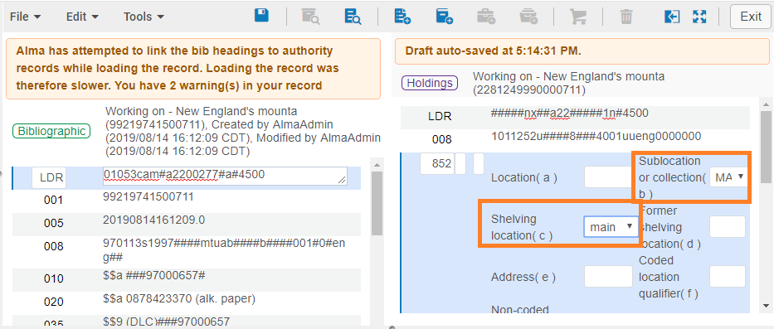
- Go to Edit > Save Record | 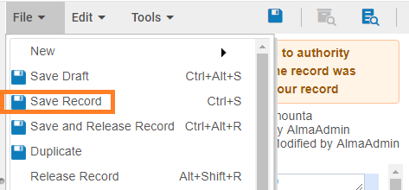
- Click on the “Add Item” icon | 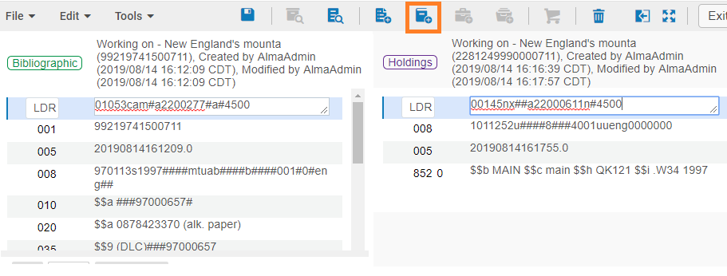
- In the Physical Item Editor, click “Generate” to create a barcode for the item  - Click “Save” | 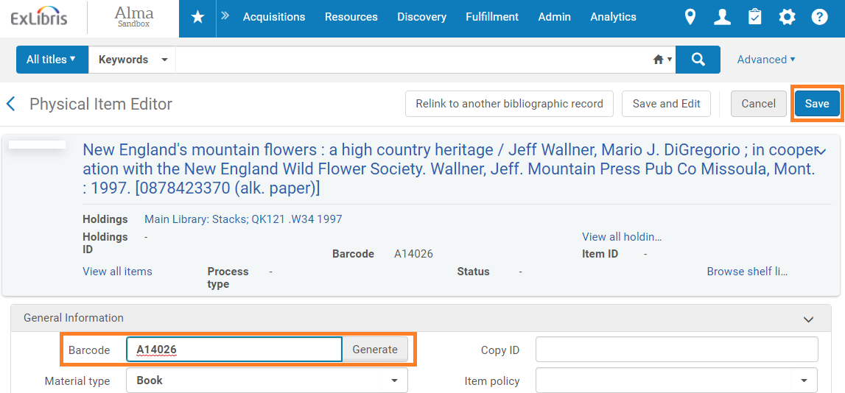
- Go to File > Save and Release Record | 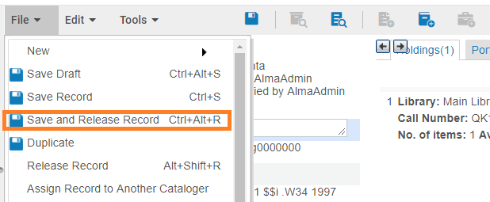
- Search Alma for the title you just added. | 