Getting to Know Alma: Returning Items

- Log into Alma with the AlmaAdmin or the CircAdmin user (the user will need to have Fulfillment privileges) | 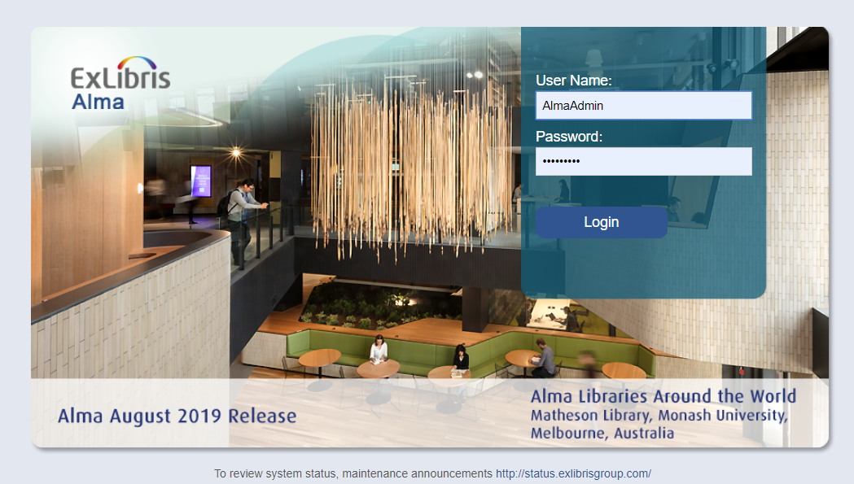
- Go to Fulfillment > Return Items | 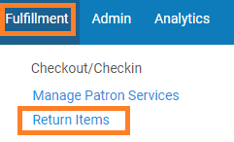
- Enter in the barcode: 33356  - Click “OK” | 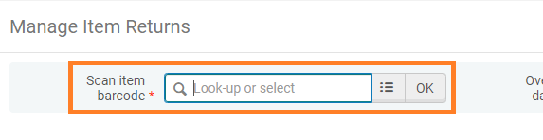
- Enter in the barcodes below to return those items  Will need to be re-shelved  33356, 13141, 74275, 92214  Will need to be routed to another library  1686499, 04882, 14748110, 150323373  Will need to be routed to the hold shelf  88482, 89295, 2351048702, 2031547846 | 