Getting to Know Alma: Checking out and renewing items

- Log into Alma with the AlmaAdmin or the CircAdmin user (the user will need to have Fulfillment privileges) | 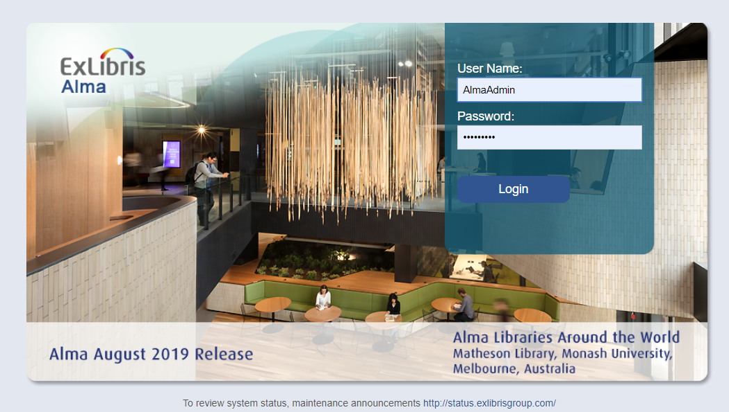
- Select the Main Library > Circulation Desk as your Location | 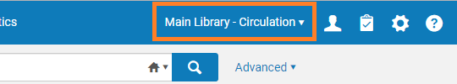
- Go to Fulfillment > Manage Patron Services | 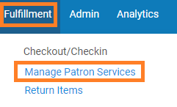
- Start typing the patron’s name into the search box (e.g. Ben Valdez)  - Select the name as it appears in the box below.  - Click Go. | 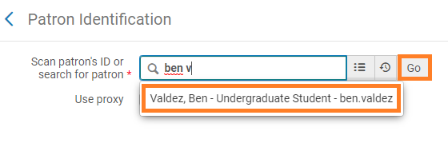
- In the Patron Services screen, enter in a barcode for a book to check out, or search for it by clicking on the list icon…  - …and searching for it in the popup screen.  - Click on the book to select it.  Title examples: Predictably irrational, The Color of food, Stuff Brits like, Plant Tropisms | 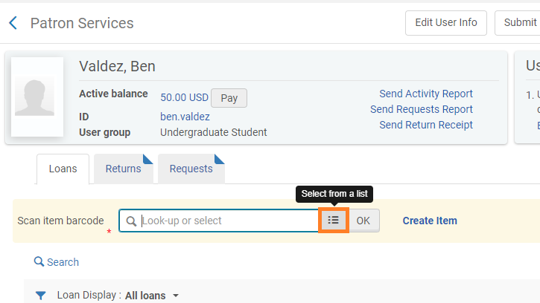  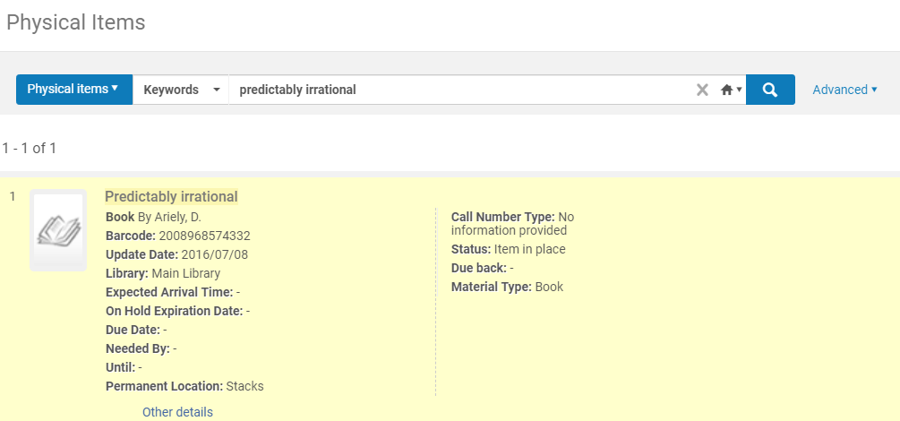
- This populates the box with the barcode for the item. Click “OK” | 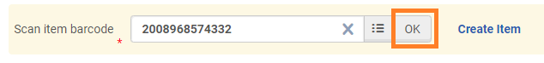
- Note that the book is now on loan.  - Click on the row actions list to see the option to “Renew” the item or “Change Due Date”  - Click “Done” | 