Personal Copy Workflow for Multiple Libraries
Alma includes enhanced workflows to enable instructors to lend their personal copies of items to the library for circulation. This allows the library to catalog instructor-owned copies, track which instructor owns the item, and easily re-use previous items in subsequent terms. Watch this video to see the full workflow.
It is possible to use the personal copy workflow with multiple libraries. In order to enable this workflow, you must configure the Personal Copy Library (Fulfillment > General > Other Settings), which is the Library in Alma where the personal copy locations (by instructor name) will be created.
The Personal Copy Library does not need to be a physical library, and in fact, the intended workflow is that items in an instructor location are not currently part of the library collection and are physically stored with the instructor.
Instead, you can configure a new library in Alma where all personal copy locations will be created:
This will keep all instructor copy locations separate, and also prevent the instructor copy locations from interfering with any one library’s existing locations.
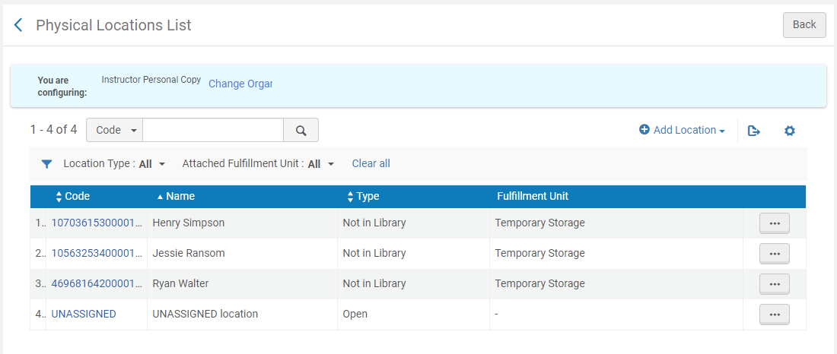
See: https://knowledge.exlibrisgroup.com/Alma/Product_Documentation/010Alma_Online_Help_(English)/050Administration/050Configuring_General_Alma_Functions/020Managing_Institutions_and_Libraries#Adding_a_Library
When configuring the new Instructor Library, you can also configure reshelve without transit rules, since items will not actually be scanned in at the instructor library.
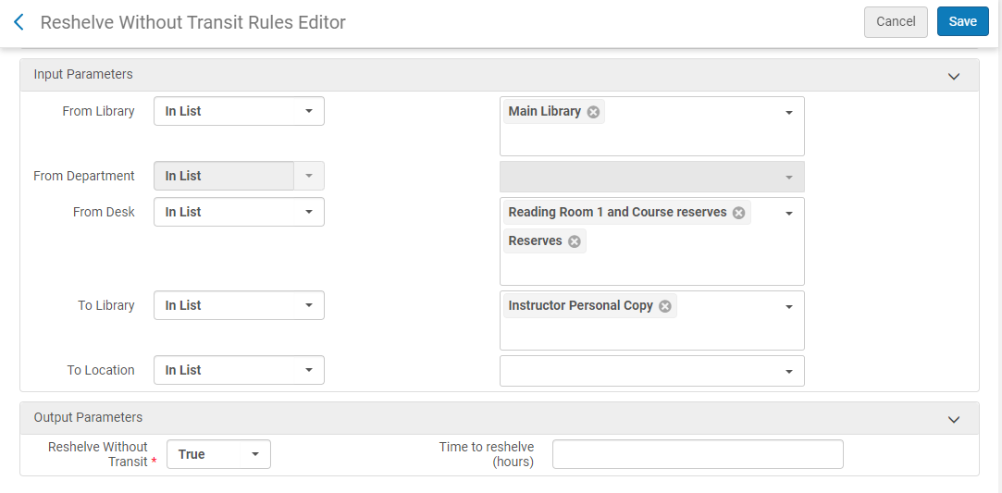
See: https://knowledge.exlibrisgroup.com/Alma/Product_Documentation/010Alma_Online_Help_(English)/030Fulfillment/080Configuring_Fulfillment/020Library#Configuring_Reshelve_Without_Transit_Rules
Additionally, it’s possible to configure the transit slip letter to display the instructor name when the item is removed from the course reserves location and routed back to the instructor.

For more information about the Personal Copy Workflow in Leganto, see:
A video showing the full workflow
Alma workflow and configuration information
New UI: Adding personal copies in Leganto
Instructor Personal Copy Management in Leganto (June 2020 Release Notes)

