Configuring “On Order” Citation Statuses in Leganto
The library can configure Leganto to automatically mark citations as “On Order” when a purchase request has been submitted. Instructors and the library will see this status, but students will not.
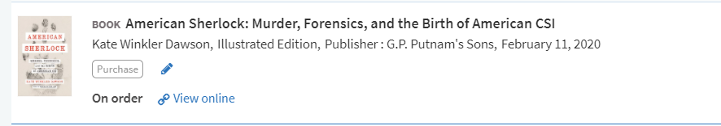
Library Configurations:
You can configure custom citation statuses, including an “On Order” status, or other language that reflects the library processes.
Go to Configuration Menu > Fulfillment > Courses > Additional Reading List Citation Statuses to define additional statuses. Note that the text you put in the “Description” column is the text that will display to the library and instructors, but the Code is what you’ll put in the Course Reserves Automatic Statuses configuration table as described directly below.
See: Configuring Additional Reading List Citation Statuses

Once you have configured the “On Order” status, configure that citations will receive this status automatically once the purchase request has been submitted.
Go to Configuration Menu > Leganto > List Management > Course Reserves Automatic Statuses and set the parameter citation_purchase_request_submitted to the code of your customized “On order” status.
See: Configuring Default Statuses for Citations/Reading Lists

