|  |  |
| --- | --- |
| **What happens to the user who appears in the history tab after he or she is deleted** |  |



**Yoel Kortick**

**Senior Librarian**

**Question:**

After a user is deleted, what would happen in Alma, e.g. in the history tab of a record which he or she changed? For example in the history tab of a user record which he or she changed? If a staff user who made changes would be deleted, would they still be displayed as "operator"?

**Answer:**

After a user is deleted he or she still appears in the history tab of an entity which he or she changed. However, instead of his or her name appearing, his or her Primary Identifier would appear instead.

Here is a live example.

ONE

User John Smith edited a user and added a middle name. In the history tab of that user record the operator appears as “John Smith”

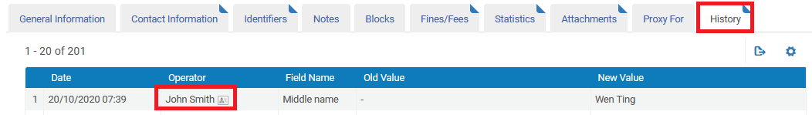

TWO

Delete user John Smith

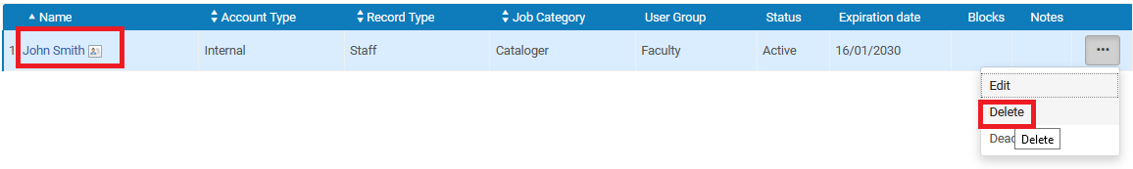

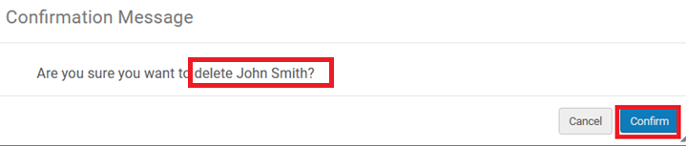

THREE

In the history tab of the user that John Smith changed we now see the Primary Identifier instead of the name.

