|  |  |
| --- | --- |
| **How to make user pictures appear in Alma when using Chrome** |  |



**Yoel Kortick**

**Senior Librarian**

As explained in detail at [How to configure the display of user pictures on the User Details and Patrons Services page in Alma](https://knowledge.exlibrisgroup.com/@api/deki/files/74740/Fulfillment_-_How_to_configure_the_display_of_user_pictures_on_the_User_Details_and_Patrons_Services_page_in_Alma.pptx?revision=1), it is possible to display user pictures in Alma.

However, there may be Chrome browser settings which prevent the display of the picture. If this is the case, the place where the picture should appear may appear as follows:

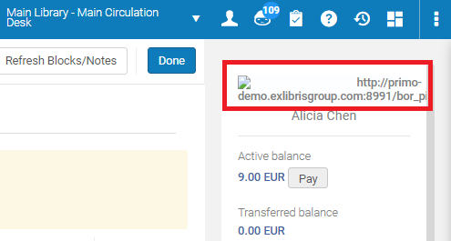

If this is the case when using Chrome, it can be rectified as follows. This is a one-time change to the browser:

**ONE**

Click the lock next to the URL



**TWO**

Click “Site Settings”

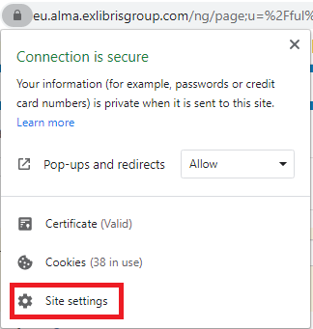

**THREE**

Scroll down to “Insecure Content” and change to “allowed”

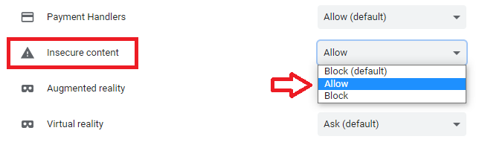

**FOUR**

Now after refreshing the browser the patron pictures will appear

