Creating courses automatically via LTI
When instructors click on the Leganto link from a course that doesn’t already exist, they are prompted to create the course. Leganto will use the course code from the LMS, and also add the course code as the course name. Instructors can change the course name, dates, number of participants, and academic department, then create the course.
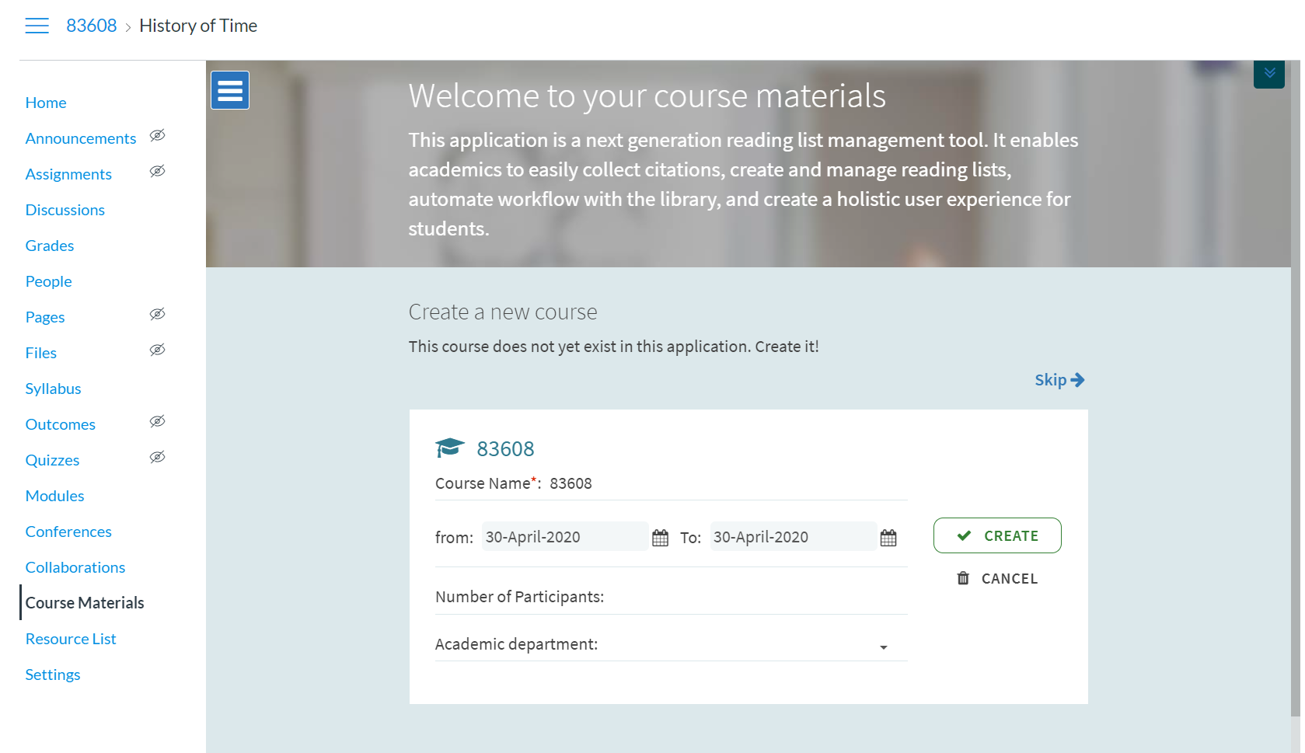
To enable this, ensure that the cms_entry_actions parameter (Configuration—Leganto—LTI—Settings) is either set to “all” or includes the word “course.”
See: https://knowledge.exlibrisgroup.com/Leganto/Product_Documentation/Leganto_Online_Help_(English)/Leganto_Administration_Guide/Configuring_Leganto_UI_Elements/05_Configuring_Leganto_UI_Elements#Configuring_Whether_Instructors_Can_Create_or_Modify_Courses
It is possible to bypass this screen for your instructors, and have courses created automatically with the course code and course name coming from the Learning Management System. In this case, the course is created automatically in Alma, and the first screen the instructor sees is the one directly below.
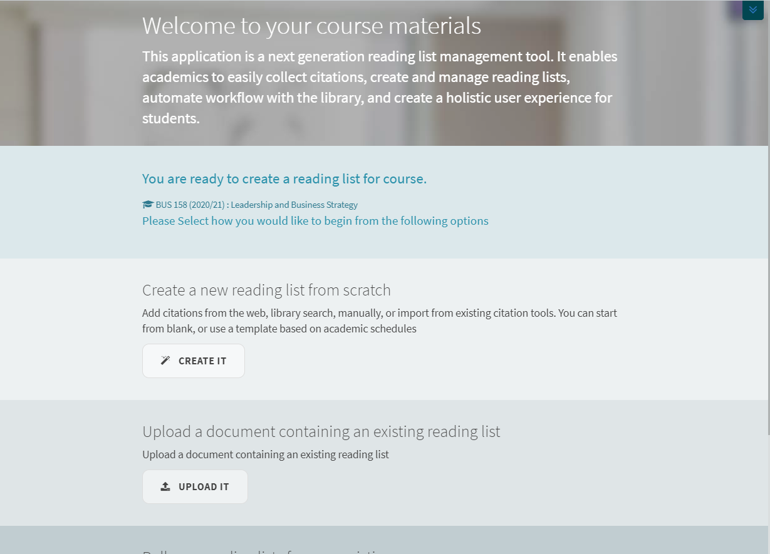
Essentially, by having the course created automatically you're eliminating one of the screens that instructors have to click through to get to the reading list. If courses are not created automatically, the instructor has to click "create" three times before they can start building their list. We find that instructors often don't understand that they are creating a course in Alma as part of this process. They believe that they're already in their course (in the LMS) and don't know why they're being asked to create a new one.
This is configured in Leganto Configuration--LTI--Settings. If you don't want courses to be created automatically, set the parameter create_course_automatically to false. If you do want courses created automatically, set it to true.
Note that you must also configure a default processing department and specify the LMS parameter that holds the course name in the LTI integration profile.
See: https://knowledge.exlibrisgroup.com/Leganto/Product_Documentation/Leganto_Online_Help_(English)/Leganto_Administration_Guide/Configuring_Leganto_UI_Elements/05_Configuring_Leganto_UI_Elements#Creating_Courses_Automatically_from_an_LTI_Link

Additionally, it is possible to configure default start and end dates for your courses, and these dates will be used when creating courses automatically.
This is configured in: Configuration—Fulfillment—General—Other Settings
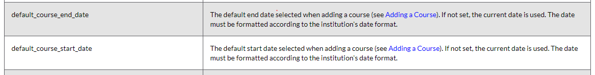
https://knowledge.exlibrisgroup.com/Alma/Product_Documentation/010Alma_Online_Help_(English)/030Fulfillment/080Configuring_Fulfillment/110General#mapping_table_CustomerParameters_fulfillment
When enabled, the instructor is not prompted to enter course information and the course is created in Alma using the course code and course name from the LMS, and using the course dates configured in Alma.

