Student Discussions in Leganto
In the move to online learning, instructors may be looking for new ways to communicate with students. Leganto discussions can be a nice way for students to give feedback, ask questions, collaborate with their peers, and ask for help accessing resources.
Options for the Instructor:
Instructors can choose to hide or show the Leganto student discussion thread, and can also edit the header which will display to students.
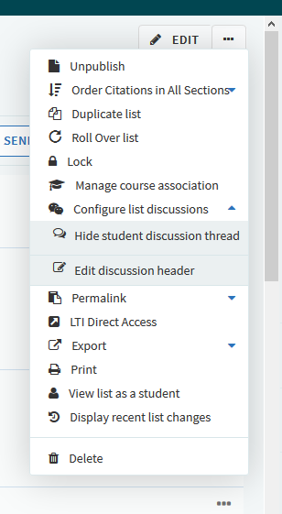
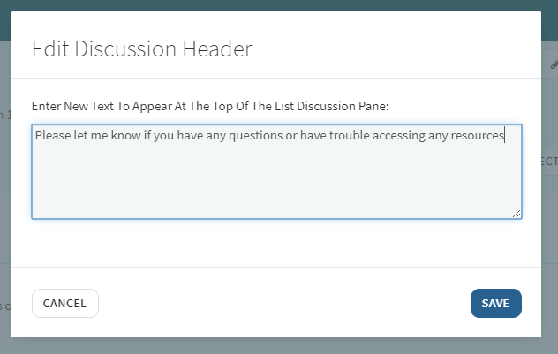
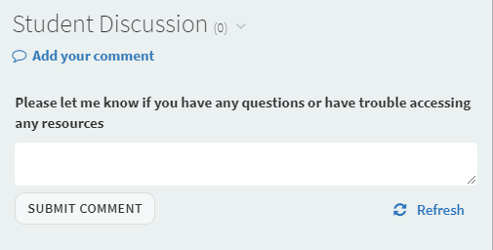

Library Configurations:
Note that student discussions can be enabled or disabled at the institution level.
In the Leganto Features table (Configuration Menu > Leganto > Features > Leganto Features), set the parameter student_discussions to enabled, disabled, or instructor_enabled. When set to instructor_enabled, the instructor can enable or disable the student discussion for each list and its citations, as shown above.

Note that you may also need to enable configure_list_discussion in the Leganto list menu: (Configuration Menu > Leganto > UI > List Menu).
The library can also configure the default header that appears in the student discussion panels:
To enable/disable student discussion headers in all reading lists, in the Leganto Features table (Configuration Menu > Leganto > Features > Leganto Features), configure the parameter discussion_header_enabled (true/false).
To set the default value of the student discussion header for all reading lists, configure the parameter discussion_header_default_text (Configuration Menu > Leganto > Features > Leganto Features). Enter the text you would like as the default. This is the text that will display if the instructor doesn’t change it. You can also leave this blank.
Examples:
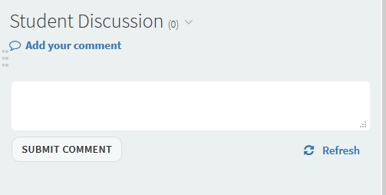

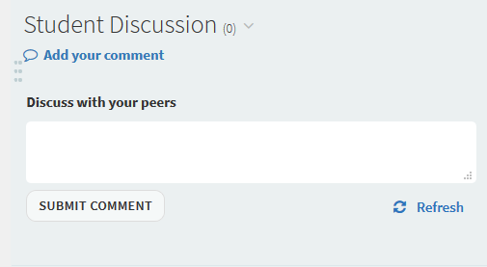

You may also want to remind instructors that the library won’t monitor this discussion. If students are having trouble accessing resources, they (students or instructors) can use the Mark as Broken link, or the instructor can add a comment in the library discussion.

