Configuring Templates in Leganto
Background:
Templates make it easy for instructors to build lists and create a consistent student experience across courses. We recommend you use only a few templates based on the way that instructors typically structure their courses. Instructors can always create their own list structure, or modify one of the templates to meet their needs.
Suggested Templates:
Weekly (with dates and/or without dates): Build a template that has a week for each week of the term. If you are willing to create a new template for each term you can even add the dates of each week, which can help students quickly and easily navigate the list. Some libraries provide a weekly template with dates and one without dates.
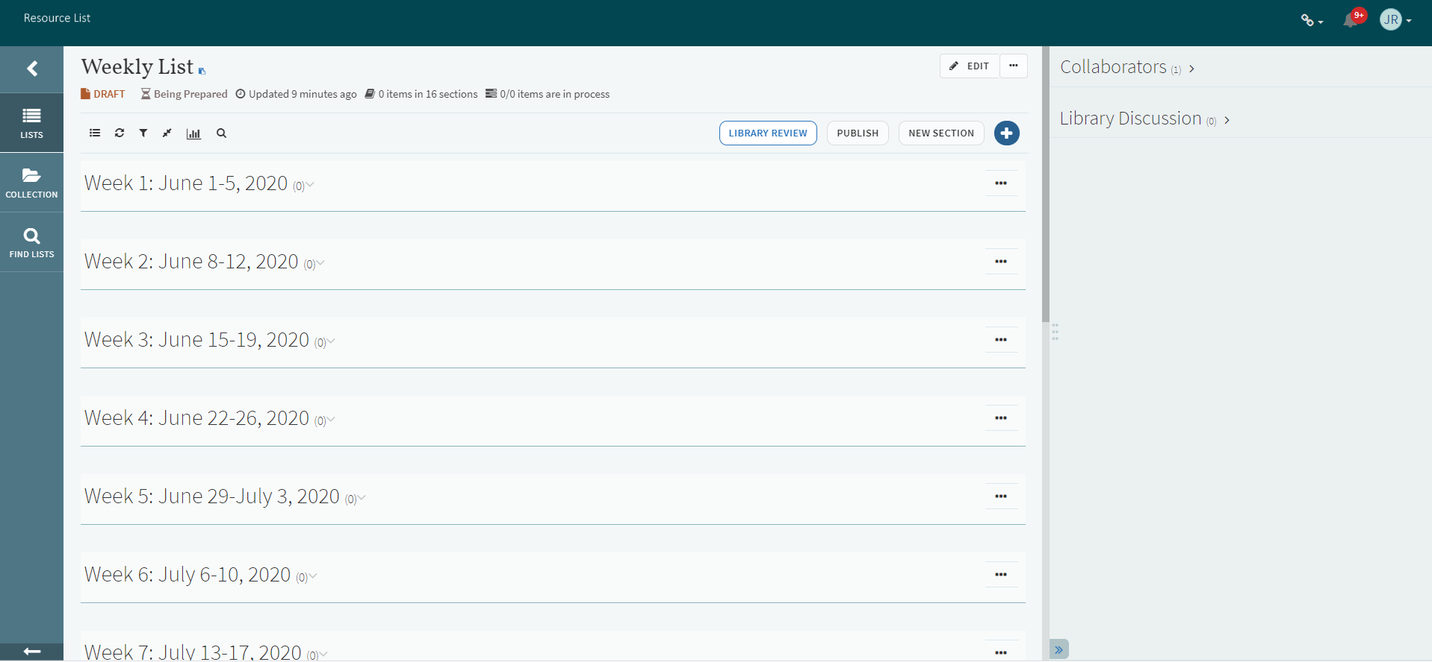
Priority: Many instructors break out resources by priority such as essential/recommended/further reading or (required/optional). You can change the language to meet your local needs, but we recommend a list to help organize resources by priority.
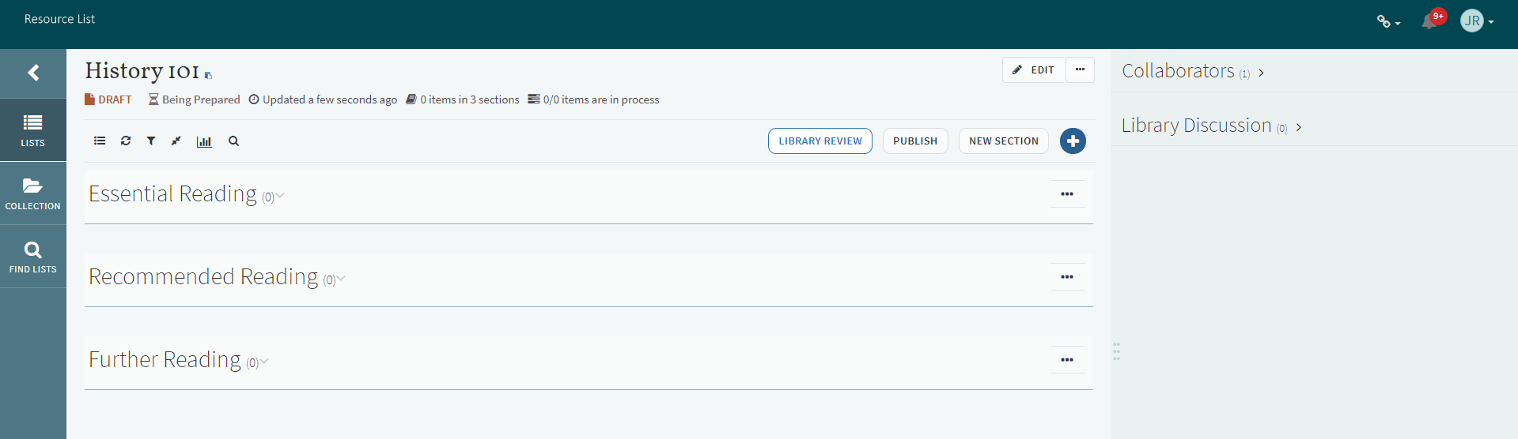

Additional Templates:
If you would like to include a few additional templates, consider the following:
Resource Types: (Books, articles, chapters, videos, etc)
Modules: (Module 1, Module 2, etc)
One section: Course Resources
Adding Templates:
The library can create templates in the Leganto interface. Instructors cannot create their own templates.
Using Leganto, build or open a list that has the sections that you want to copy. For example, you may want to build a list with each of the weeks of the upcoming term.
In the list menu, select “Save list structure as template”
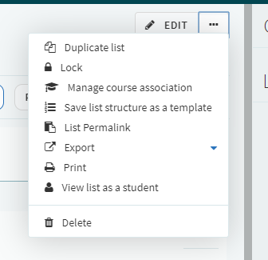
Name your template and fill in the description. This is the only information that instructors will see, so you will want to be clear.
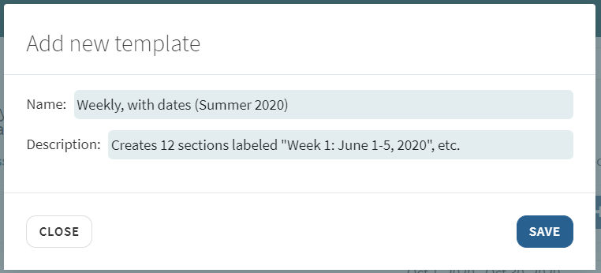

Tip: When creating templates, remember to use a name and description that will make it clear to instructors what the template will do so they will feel confident they are choosing the correct template for their course.

Managing Templates:
To view or remove templates, create a new list.
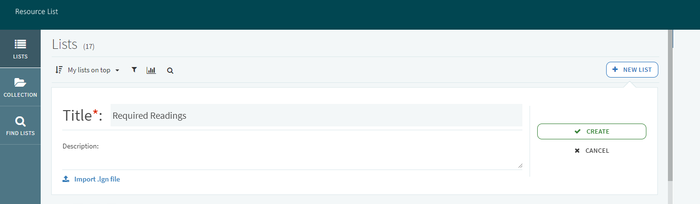
When you get to the template screen, click on the X in the top right of any template to remove it.
